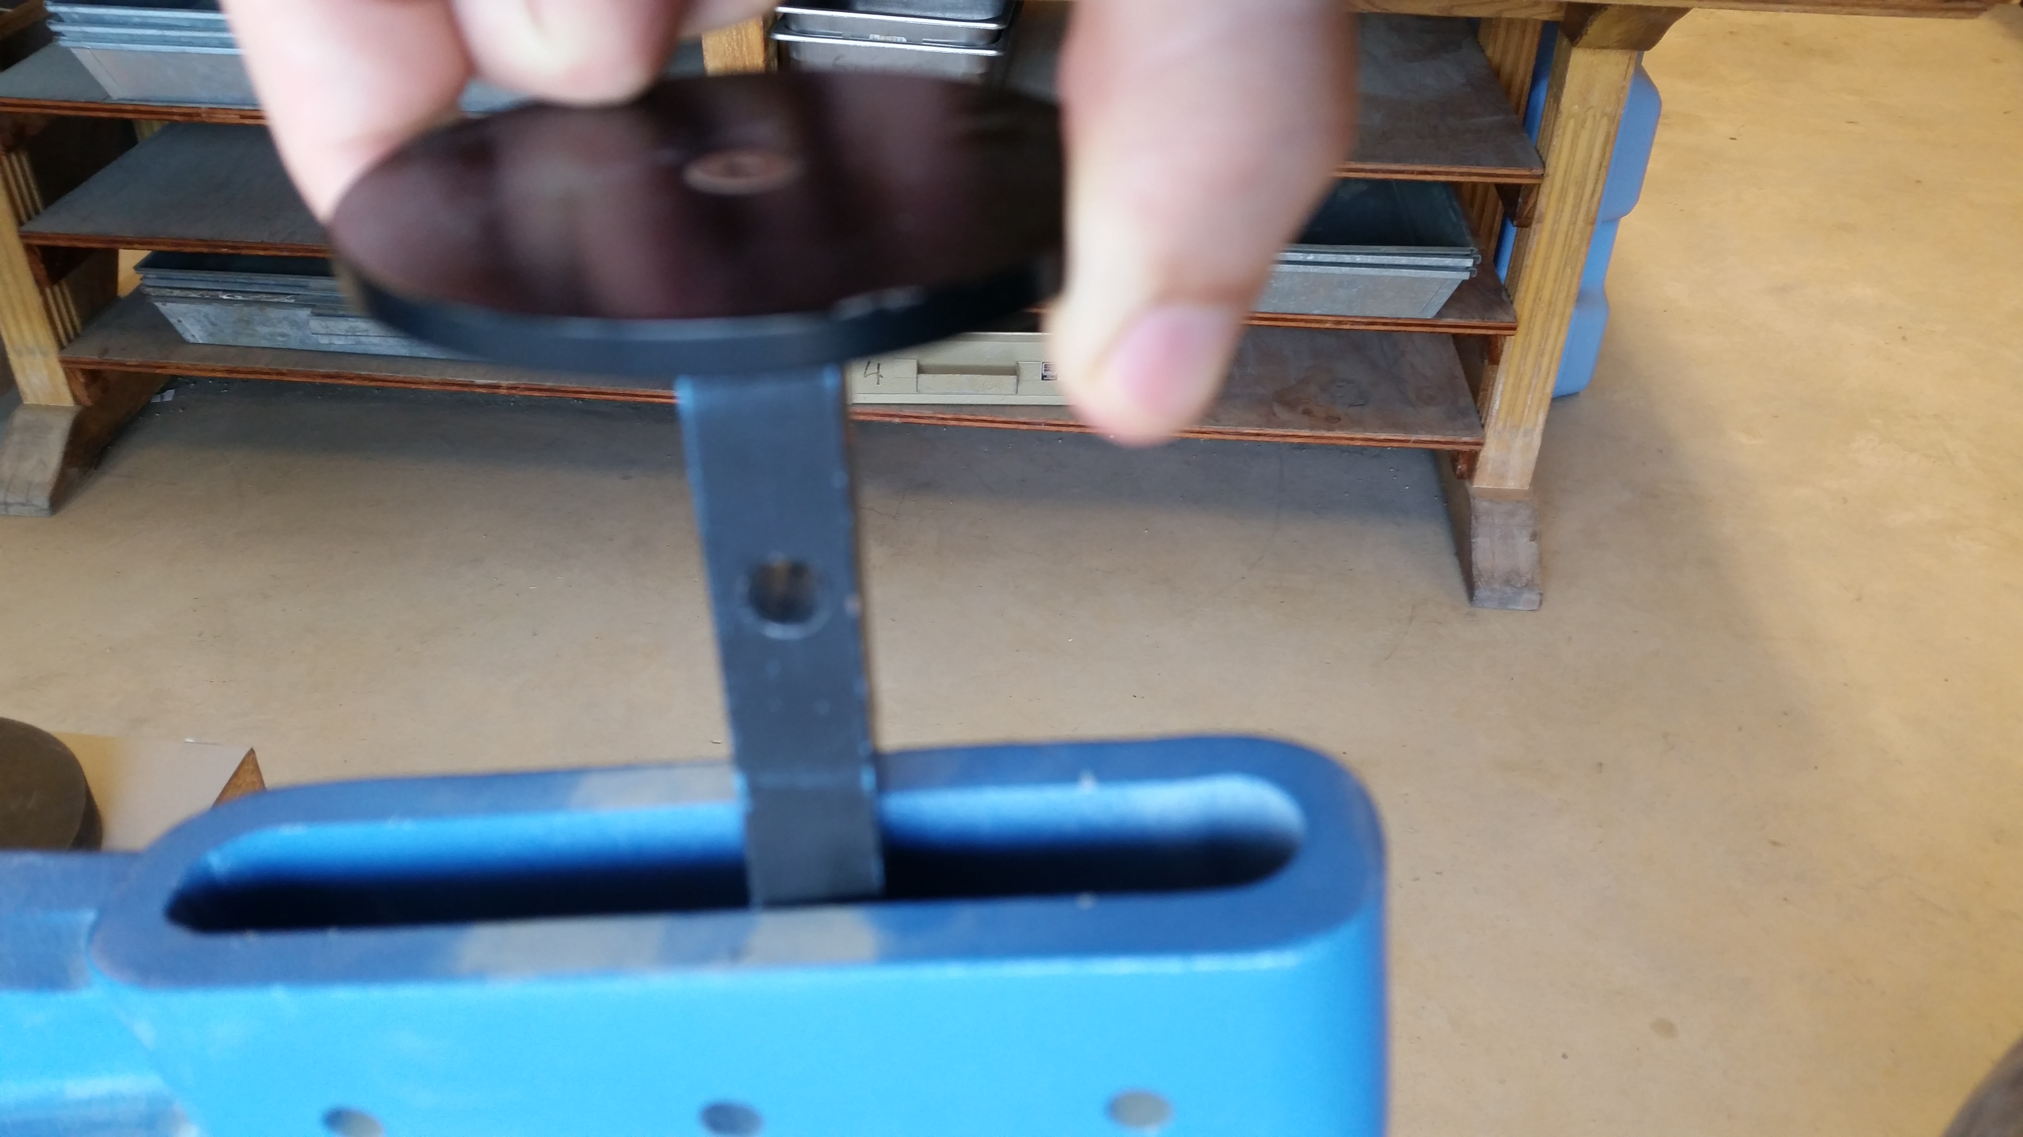
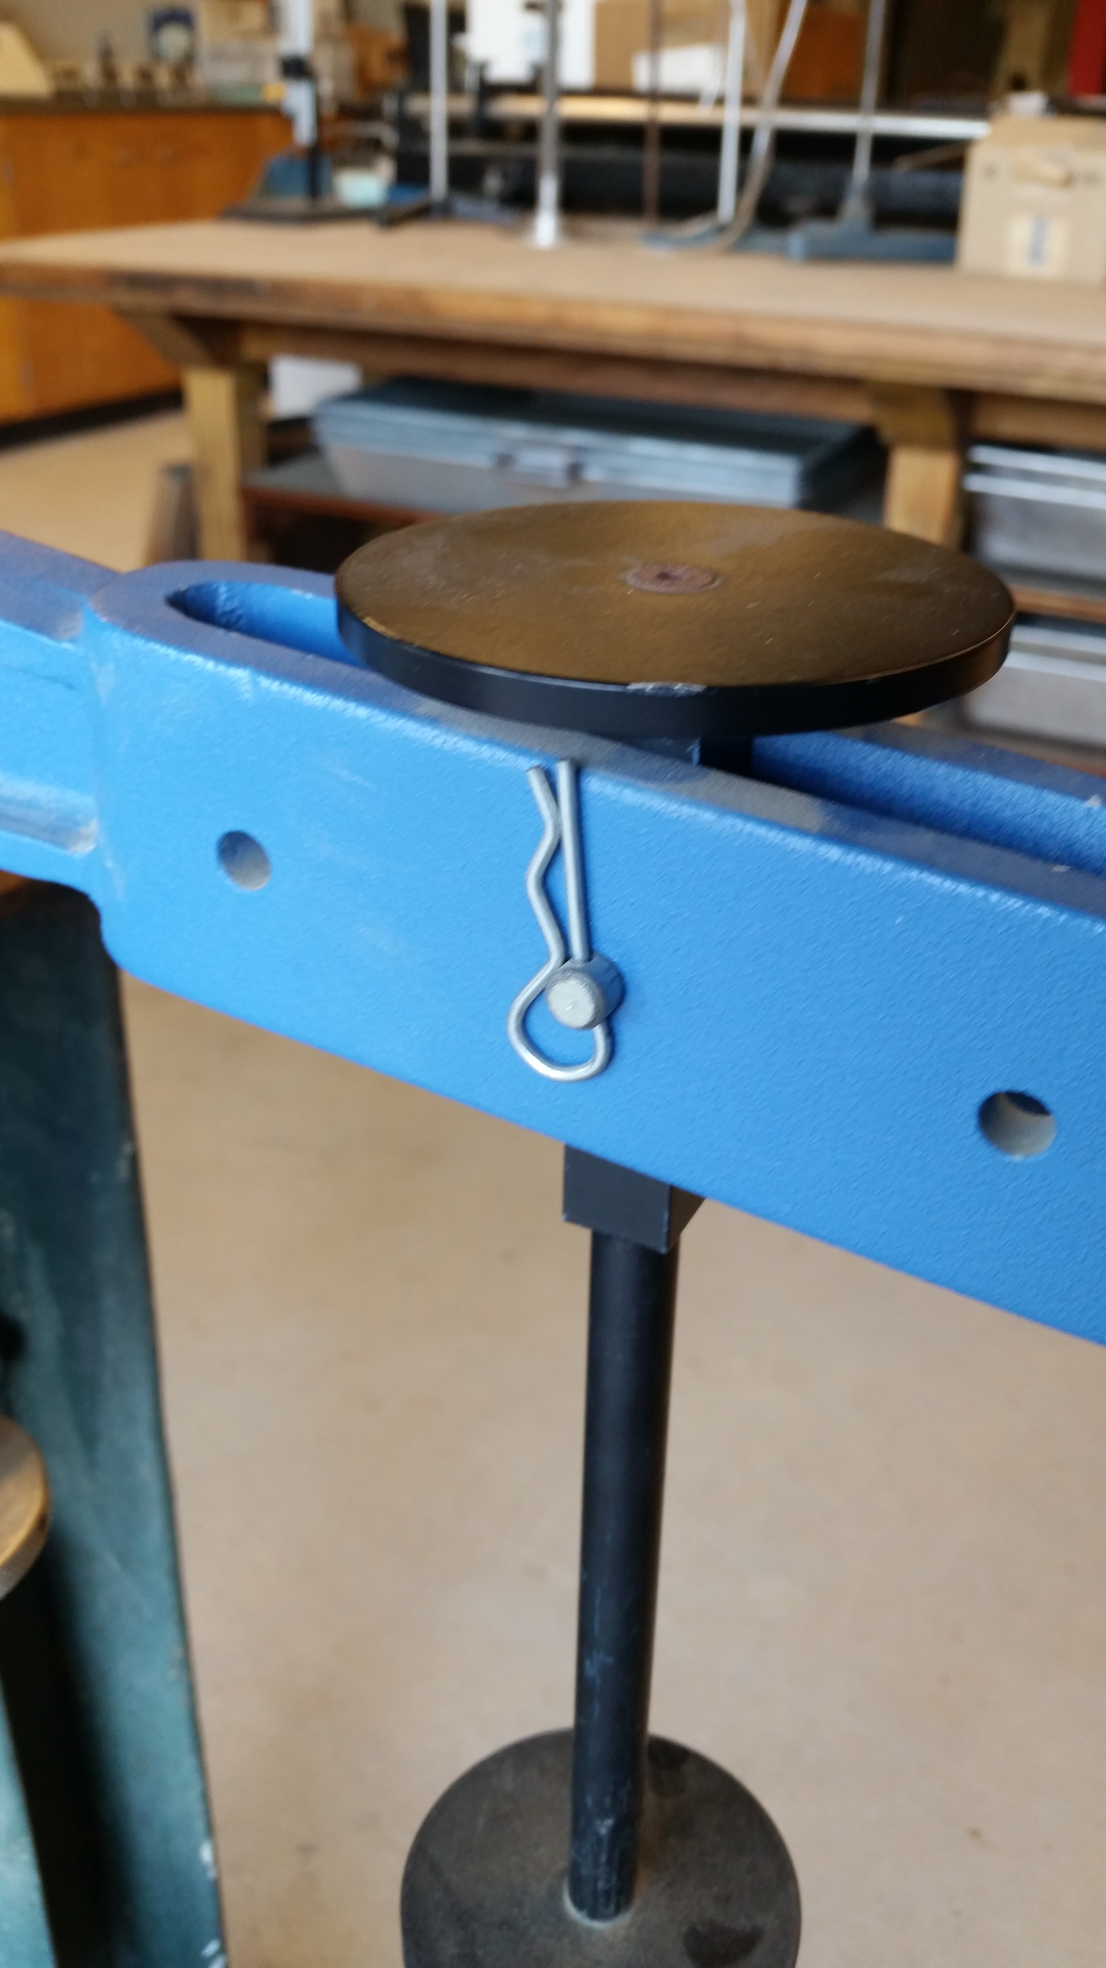
The oedometer has a lever that gets loaded with weights. It's attached with a metal pin that runs through the lever and the weight rack. One potential idea I had for mounting the load cell was to put a pin through the lever arm hole and the upper hole of the the rack, and then a cable through the lower hole of the load cell and the rack hole. The weight rack will hold up to 50 kg of weights.

Oedometer pictures. Note the top disc would probably need to be removed with an allen wrench
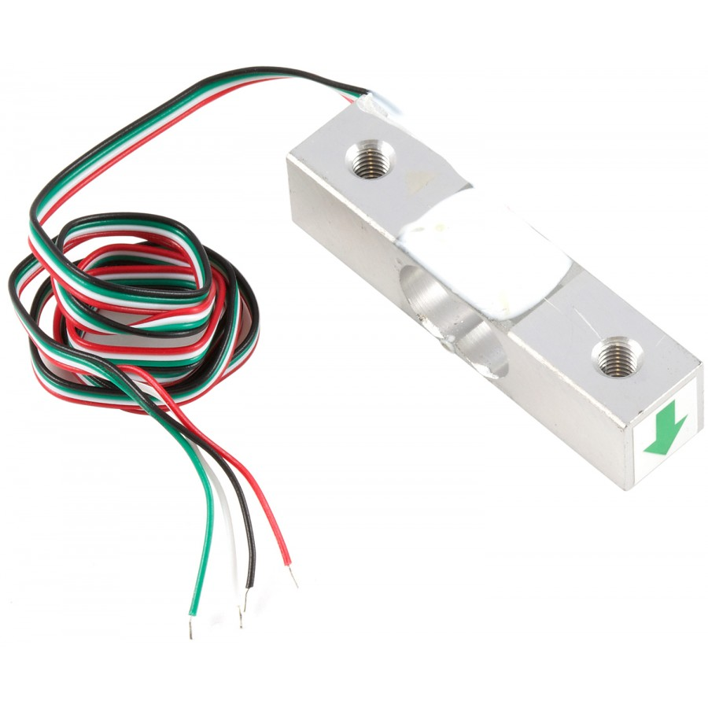

The load cell

The alternative idea I had was to use the load cell as a scale similar to this configuration:


