Internet of Things Soil Mechanics Lab Documentation

Richard Muri
Master's student
ECE Department

Paul Fortier
Faculty
ECE Department May 21, 2018
Introduction

Modern technology is changing the way engineering work is performed. The proclivity of Internet of Things (IoT) devices has improved our ability to perform laboratory exercises. In order to expose undergraduate civil engineering students to this concept, the Soil Mechanics Consolidation test was updated to reflect modern sensor capabilities. Internet connected sensors were added to the existing test apparatus to provide data logging functionality, and a database gives students access to the experiment results from anywhere on campus.

Soil consolidation uses an oedometer, as shown in Figure 1 below:
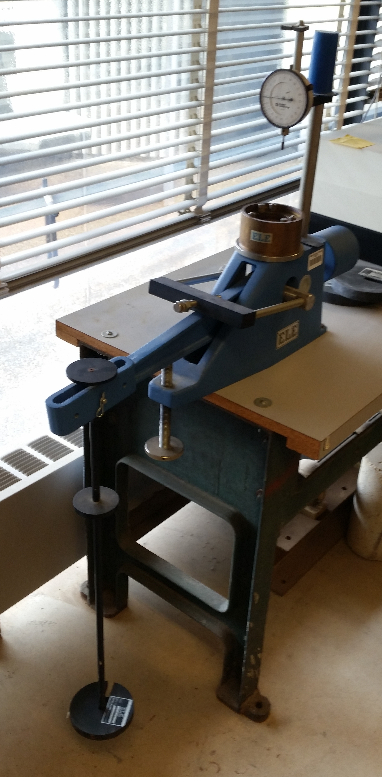
Figure 1: Unmodified oedometer

Weights are loaded onto the black holding rack. A soil sample is placed beneath the dial gauge, which is compressed by the lever arm proportional to the weight loaded on the holding rack. The dial gauge indicates the linear displacement of the soil.

A basic block diagram of how the data collection system works is shown in Figure 2 below:
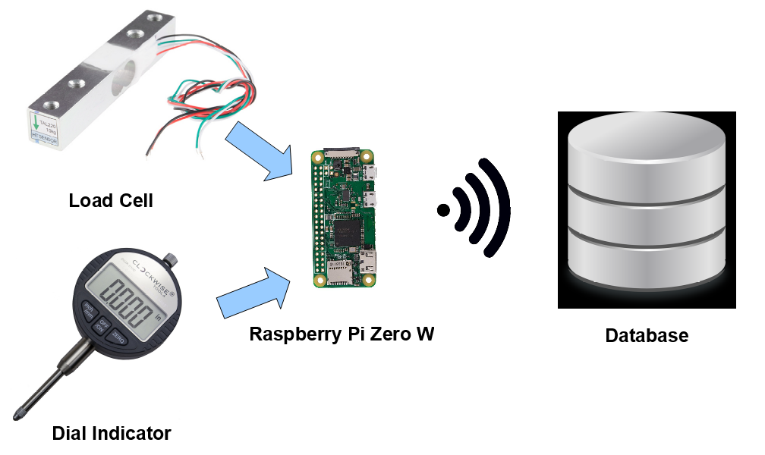
Figure 2: System block diagram

A load cell measures the amount of weight currently on the rack. A dial indicator measures the linear displacment of the soil as it is compressed. Both of these values are communicated to a Raspberry Pi Zero W computer on a chip, which is connected to the eduroam WiFi network. Experiment results are time stamped and recorded to a database accessible by any student with a school login. The database may be accessed at the following url: https://webapps.umassd.edu/cen/telemetry/. All entries are stored in csv format, and may be selected by experiment title.

Note: Late in this project it was determined the load cell is unnecessary. Instead a button is pressed by the technician anytime the load is changed, and the software updates to the next known load value. The load cell was scrapped because mounting it on the equipment was not worth the trouble, when the desired functionality could be replaced with a simple button.

The next section of this report describes how to use the system, and assumes the user understands how a soil consolidation experiment works but no other special knowledge. Other sections assume some knowledge of Raspberry Pis, Python, and Linux environments.

Using the System

First ensure the dial indicator is connected to the keyboard converter, and the keyboard converter is connected to the Pi. The keyboard converter is a gray box with an side labelled "In" and a side labelled "Out". Ensure the dial indicator is connected to "In" and the "Out" end is connected to the Pi USB On-the-Go cable. Plug the Pi power adapter into the micro USB power port, and the wall.

Set up the soil sample and oedometer as desired, so that it may be started immediately after running the program on the Pi.

In order to use the system, connect to the Pi using SSH. The client PuTTY is recommended. This section assumes a user trying to use the original Pi Richard used to develop the project in May 2018. If this is not the case, subsitute the appropriate values for usernames, passwords, MAC address etc.

The ip address assigned on eduroam is currently 172.18.8.214 and has been for a few months; this could change in the future. If a connection can't be established, search eduroam for a device with MAC address B8:27:EB:18:FA:24. An easy way to do this is with the Linux utility arp-scan; on Windows, nmap could be used to check a subnet for a device with the correct MAC address.

If all else fails, the easiest way to find the ip address is to plug the Pi into a monitor and keyboard, open a terminal and run ifconfig. The ip address is listed as inet under wlan0 as shown below.
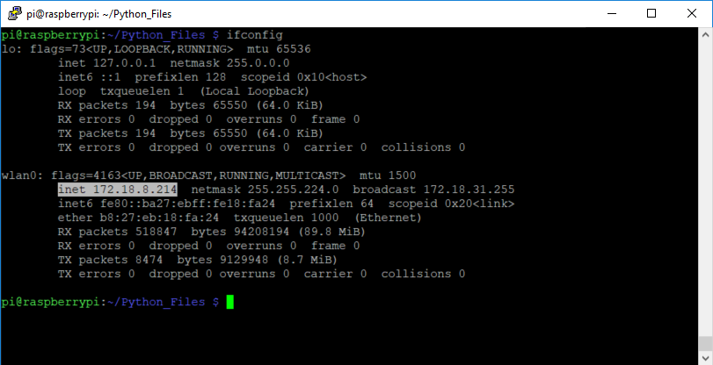

The user name is pi and the password is civiliot. Change directory to ~/Python_Files, and run the command sudo nohup python3 soil.py <experiment_id> &, substituting the desired experiment name. The program is running in the background, and will continue to run even if the SSH session is disconnected. The number listed in the terminal is the process id controlling the oedometer experiment. Make note of this number.

Run the oedometer test as normal. When it is time to end the experiment, end it with the command sudo kill -15 <process id>, substituting the process id that was displayed when starting the program. If the experiment is not ended manually, it will end itself automatically after 9.5 days.

Picture Tutorial

1. Plug all cables in as shown below, in the order presented.

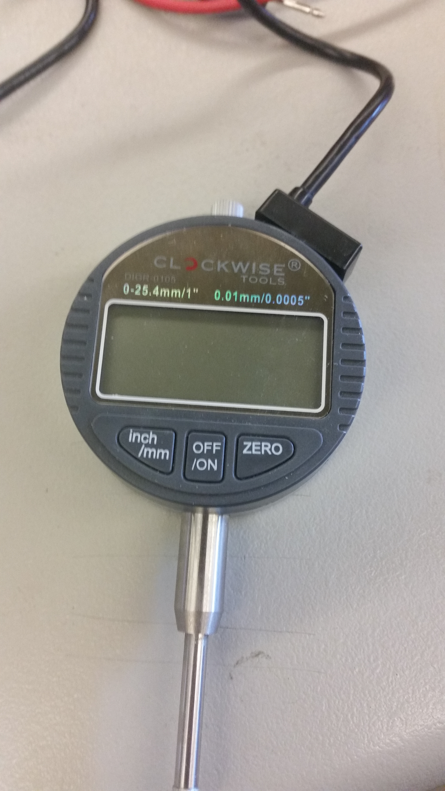
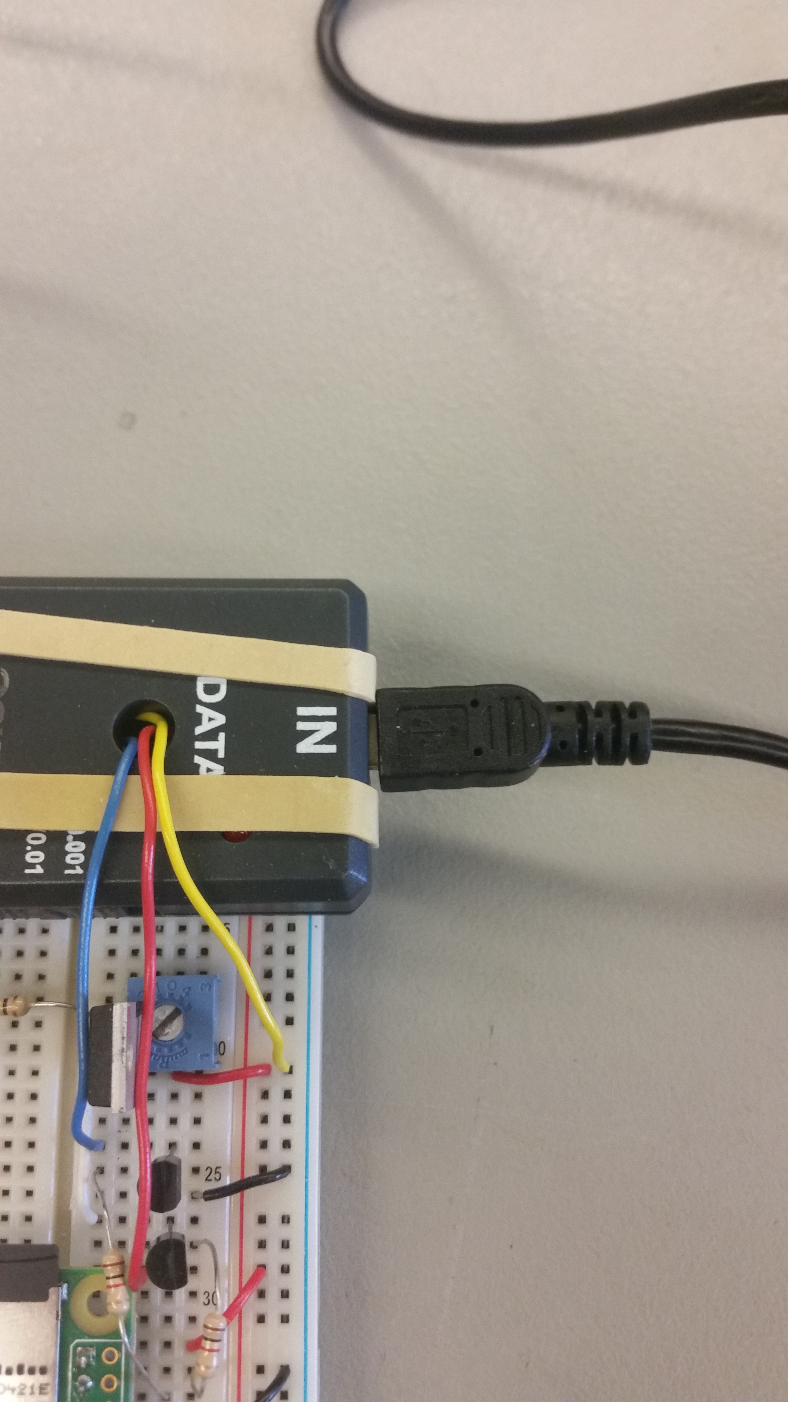

Dial indicator cable is connected from the dial indicator to the keyboard converter "IN" (Mini USB)

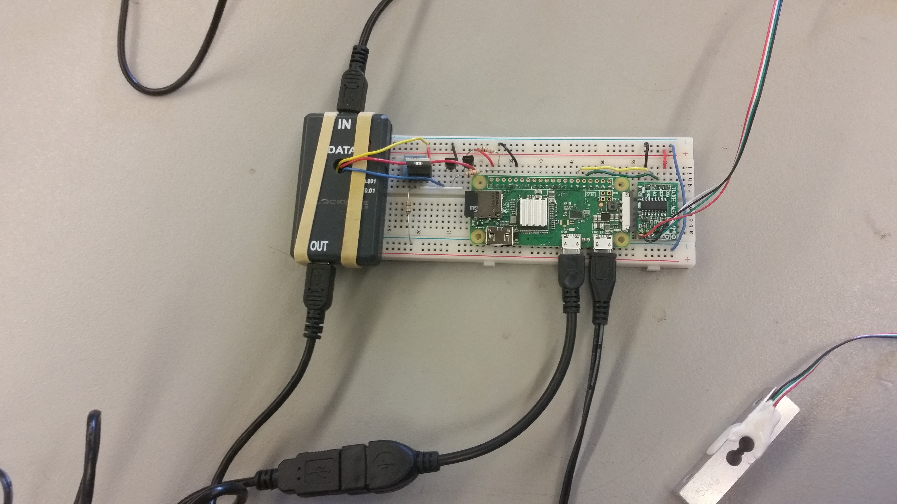

Keyboard converter "OUT" (Mini USB) is connected to USB On the GO which is connected to Pi on the port labelled USB (Micro USB)

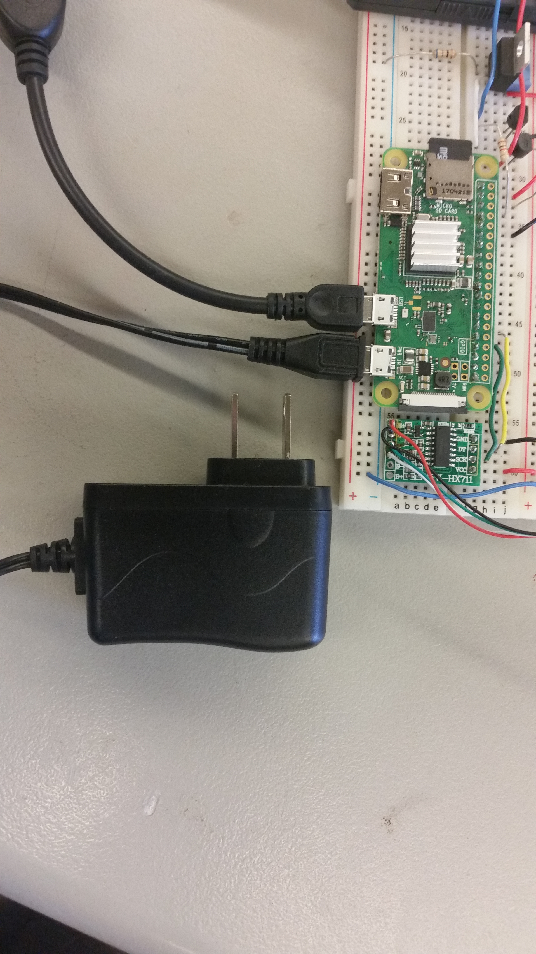
Power adapter is connected to port labelled PWR IN (Micro USB). Plug the power adapter into an electrical socket

2. Open PuTTY. (Download here). Type the Pi's IP address in the Host Name field. Select the SSH radio button. Type 22 into the Port field. Select open. NOTE: You must be on eduroam for this to work.
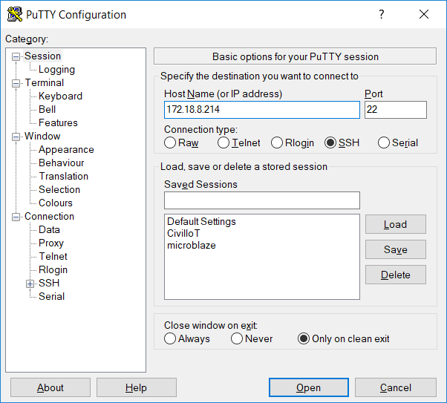

A terminal should appear prompting login information. Type the appropriate user name and password (pi and civiliot respectively at the time of writing this report).
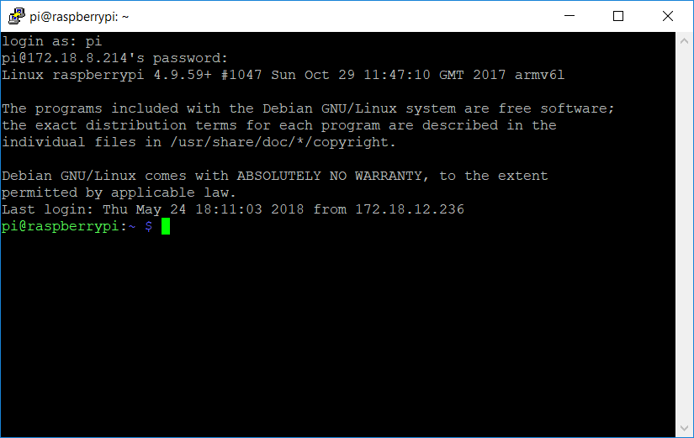

3. Run the following commands, substituting in the desired experiment name for <experiment_id> (Note that experiment id should be a valid Unix style file name; stick to letters, numbers, and underscores):

cd ~/Python_Files
sudo nohup python3 soil.py <experiment_id> &

Make note of the output number after running the Python script. This is the process id. If you need to end the experiment early, use the following command. Otherwise, it will end automatically after 9.5 days.

sudo kill -15 <process id>

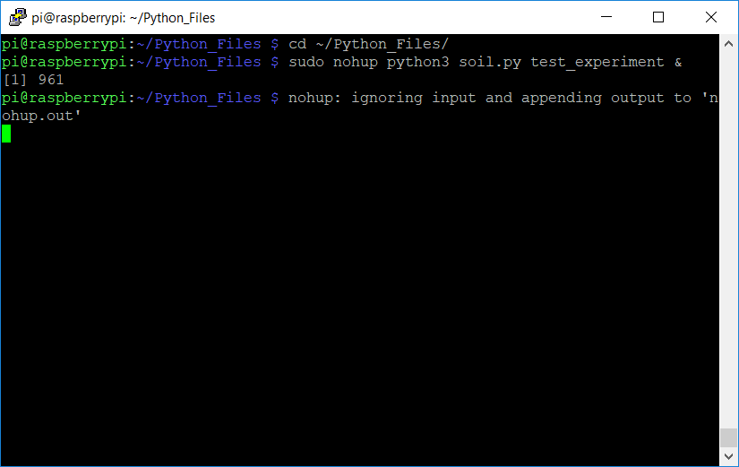

4. Ensure the dial indicator is mounted as desired. Begin the soil consolidation experiment. Wait for the dial indicator to turn off, and then turn back on. After this happens, place the first weight on the lever arm.

5. Whenever it is time to add weight to the lever arm, press the button on the breadboard to inform the software. Wait for the dial indicator to turn off and turn back on, as in step 4. Add the desired weight. Note the button will not allow itself to be pressed more often than every 5 minutes. More frequent presses will be ignored. Walk away and wait 9 days. PuTTY can be closed.

6. The experiment can be monitored by checking https://webapps.umassd.edu/cen/telemetry/index.html, where the information is POSTed, or through the log file on the Pi called <experiment_id>. In order to access the files on the Pi, WinSCP is recommended. Connect to the Pi through WinSCP using the same credentials as PuTTY (step 2).

7. At this point the experiment can be allowed to run its course. PuTTY can be closed. It will end automatically after 9.5 days. Repeat step 5 as necessary.
Wiring
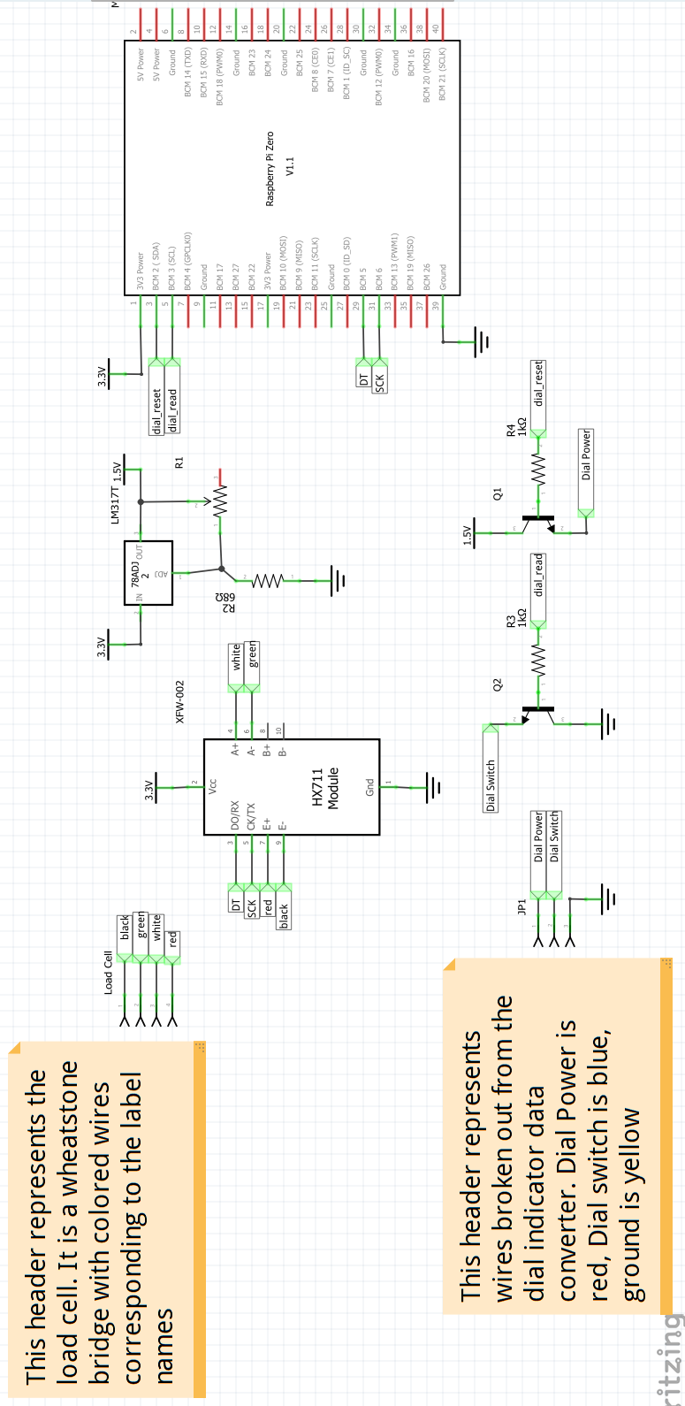
Figure 3: Wiring Schematic

Figure 3 above shows a wiring schematic for the system. Pi pin names are based on this website. There are two sections of the wiring: load cell wiring, and dial indicator wiring.

Load Cell

The load cell acts as a wheatstone bridge that is connected to the HX711 breakout board. The excitation plus and excitation minus (E+ and E-) are connected to the red and black wires respectively. A+ and A- describe channel A, which will change values to match a percentage of the range set by the excitation voltage. In this case, white is A+ and green is A-. SCK and DT are connected to pins BCM 6 and 5 respectively on the Pi. The HX711 is powered with 3.3V Vcc, coming from one of the Pi 3.3V pins.

NOTE: The load cell was not used in the end, due to adding complexity not necessary to meet the project requirements. Instead, a button was placed on BCM pin 17. When the button is pressed, an index in software is incremented. This index is an index of a table containing the tons per square foot (tsf) the oedometer currently exerts on the sample.

Dial Indicator

The dial indicator has two functions that must be controlled by the Pi: resetting and reading. The dial indicator times out after approximately five minutes and shuts down, which is not suitable for a nine day experiment. In order to combat this, power is turned off to the indicator for a few seconds every four minutes, which causes the internal timer to reset. Additionally, the dial indicator is designed to provide readings on a manual button press. This has been bypassed by soldering a wire to the switch positive terminal.

Three wires are broken out of the dial indicator keyboard conversion box. The red wire is soldered to the mini usb Vcc pad and is supplies power to the dial indicator. The blue wire is soldered to the positive connection of the 3mm jack and triggers the keyboard conversion box to provide a reading. The yellow wire is soldered to ground. The red wire is connected to the collector of an NPN transistor in a high side switch configuration. When the base voltage is high, the dial indicator is powered by the LM317T voltage regulator 1.5V output. When the base voltage is low, the dial indicator is turned off.

The blue wire is connected to an NPN transistor emitter as a high side switch. When the base voltage transitions from high to low, the blue wire shorts to ground and the conversion box outputs a reading to the USB input of the Pi.

The dial indicator is powered using an LM317T voltage regulator. Figure _ shows how the regulator is configured:
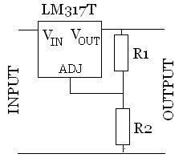
Figure 4: LM317T voltage regulator
R2 has a value of 68 Ohms, R1 is a potentiometer that was adusted until the output was at 1.5V.
Configuring the Pi

This guide assumes a working Pi with terminal access and super user privileges. If this is not the case, follow this tutorial, ignoring the section on WiFi. In order to connect to eduroam, /etc/wpa_supplicant/wpa_supplicant.conf and /etc/network/interfaces need to be modified as described in Table 1 below:

/etc/wpa_supplicant/wpa_supplicant.conf:

ctrl_interface=DIR=/var/run/wpa_supplicant GROUP=netdev
update_config=1

network={
ssid="eduroam"
scan_ssid=1
key_mgmt=WPA-EAP
group=CCMP TKIP
eap=PEAP
identity="username@umassd.edu"
password=my_password_here
phase1="peapver=0"
phase2="MSCHAPV2"
}

/etc/network/interfaces:

auto lo
iface lo inet loopback

auto wlan0
allow-hotplug wlan0
iface wlan0 inet dhcp
pre-up wpa_supplicant -B -Dwext -i wlan0 -c /etc/wpa_supplicant/wpa_supplicant.conf
post-down killall -q wpa_supplicant

auto eth0
allow-hotplug eth0
iface eth0 inet dhcp
Table 1: Network Configuration files

Substitute a valid username for the identity field, and a valid password for the password field. Exit the text editor by typing Ctrl + X and then enter.

WARNING: This requires storing a password in plain text. Email communication from CITS below. This should be updated when possible.
Hi Richard,
Will follow up later once there are more details, but the current answer is that, for now, the device will need to use someone's credentials. At some point later in the semester it should be possible to register it to be able to use the wireless network without being tied to someone's credentials but it is't possible at the moment.
----
Matthew Robinson
Director of Information Systems
Computing & Information Technology Services
ref:_00D37J0z0._50037VfYnZ:ref

Run the command sudo shutdown -r now to restart the Pi, then reconnect your SSH session and run the following commands:

sudo apt-get update
sudo pip3 install keyboard
sudo pip3 install statistics
sudo pip3 install requests
sudo raspi-config

Raspi-config brings up a menu with configuration options. Set boot options/Desktop to Console, interfacing options/SSH to enabled, and interfacing options/Remote GPIO to enable. Select finish, and when prompted to reboot select yes.

Libraries

This project uses the following libraries:
HX711Py3
keyboard
Rpi.GPIO
requests

Additionally HX711Py3 requires the statistics library. All other libraries are included by default, and can be imported without installation.

Code

The code operates using two timers inside a loop to handle the hardware. The first timer determines when a reading is taken from the equipment. Whenever it triggers, the GPIO pins are set to cause the dial indicator to take a reading. Then, keyboard input is taken from the dial indicator and converted into an entry, along with the current weight and time. The entry is POSTed to https://webapps.umassd.edu/cen/telemetry/index.html, where it is stored and can be downloaded as a csv.

The second timer causes power to be cut from the dial indicator every four minutes. This prevents a watchdog timer inside the device that causes the indicator to turn itself off.

The final component is a button used to increment the weight reading. The weight is given by a table that expresses how many tsf the oedometer currently exerts on the sample, starting at 0.25 tsf. Every time the button is pressed, the index location of the table of values used during the test is incremented.

The code can be found at github.com/RichardMuri/CivilIoT. It is well commented, and should be read for greater detail than provided here. The entire program is contained in the soil.py Python file.

There are four parameters defined as global variables at the top of soil.py. FREQUENT_READING_INTERVAL defines how many seconds between readings whenever a weight is first added to the oedometer. FREQUENT_READING_REPETITIONS defines the number of times readings are repeated on that interval. For instance, the default values are 5 and 24 respectively. This means a reading will be taken every 5 seconds for 120 seconds (5 * 24).

READING_INTERVAL is the period of readings for the regular part of the experiment. If it is defined as 60, then the test will take a reading once every 60 seconds.

LIVE is a boolean value that determines if the experiments are posted to the web, or if they are only logged locally. If LIVE is True, all readings are POSTed to the website. If LIVE is False, readings are only logged locally.

# Whenever weight is added, take readings more frequently.
# Take reading every FREQUENT_READING_INTERVAL seconds,
# repeat FREQUENT_READING_REPETITIONS times
FREQUENT_READING_INTERVAL = 5
FREQUENT_READING_REPETITIONS = 24

# Normal reading interval in seconds after weight has settled
READING_INTERVAL = 60

# True if results are posted to University database
# False if results are logged only locally
LIVE = True

Components

Component | Data sheet/Website | Description
DIGR-0105 Digital Dial Indicator | Website | 1" dial indicator
Data cable for dial indicator |  | Connects to dial indicator, converts dial indicator reading to USB keyboard
HX711 Load Amplifier | Data sheet | Sense amplifier for a wheatstone bridge configuration load cell. This project uses the XFW-002 breakout board
3135 Micro Load Cell | Data sheet | Load cell
Raspberry Pi Zero W | Data Sheet | Computer on a chip
1A Power supply |  | 1A 5V Micro USB power supply
Micro SD card |  | At least 8 gigabyte Micro SD
USB On the Go cable |  | Male Micro USB to female USB A cable
KN2222 NPN transisor | Data Sheet | 2x NPN transistors used in high side switches
Trimpot |  | 0 to 1k Ohm potentiometer
Resistors |  | 2x 1k Ohm resistors  1x 68 Ohm resistor
Breadboard

