# Containerizing the Video Streaming Microservice

## About Containers

A *container* is a way of virtualizing a server:

* Provides a way of virtualizing both the operating system and the hardware
* Allows us to abstract (or *virtualize*) the resources required by our microservice
* Provides a way to divide resources on a server to be shares among microservices
* Makes it cost effective to run microservices

Containers isolate our microservices to prevent them from interfering with one another (ports…)

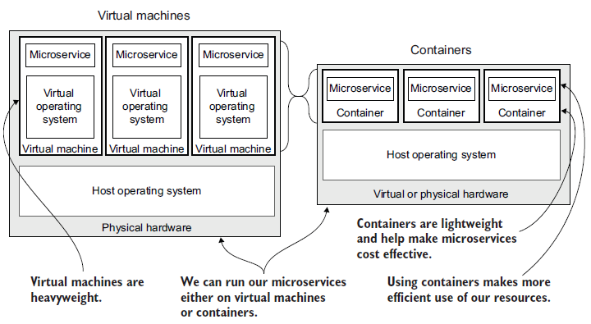

## About Images

An *image* is a snapshot of something:

* A bootable snapshot of a server (in our case, a microservice), including all the code, dependencies, and assets that it needs to run (a snapshot of our video-streaming microservice)
* Images are *immutable* (Containers are not immutable)
  + Once an image has been instantiated to a container, the contents of its filesystem can be modified.
* A dormant version of a microservice, a way of storing it prior to running it (a state waiting to be booted as a container)

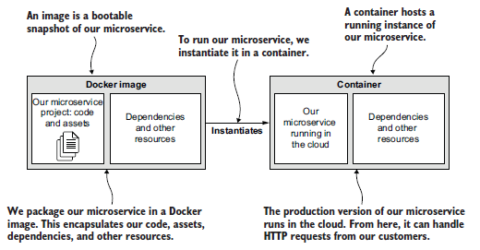

## About Docker

We’ll use Docker to:

* Package our microservice into a Docker image
* Publish our image to our private container registry
* Run our microservice in a container

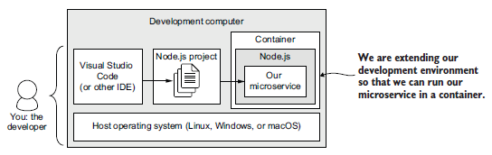

## Step 1: Install Necessary Tools

### 1.1 Install Docker

Docker is required to containerize and run the microservice.

Check if Docker is installed:

docker --version

If missing, download and install from: https://www.docker.com

## Step 2: Create the Dockerfile

Inside the `video-streaming-microservice` folder, create a file named `Dockerfile` and add the following content:

FROM node:18.17.1  
  
WORKDIR /usr/src/app  
COPY package*.json ./  
RUN npm ci --omit=dev  
COPY ./src ./src  
COPY ./videos ./videos  
  
CMD npm start

## 

## 

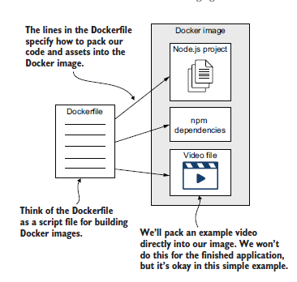

## Step 3: Build and Run the Docker Container

### 3.1 Build the Docker Image

Run the following command to build the Docker image:

docker build -t <your-name-for-the-image> --file <path-to-your-Dockerfile> <path-to-project>

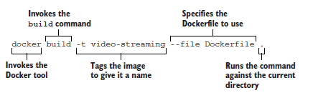

docker build -t video-streaming-microservice .

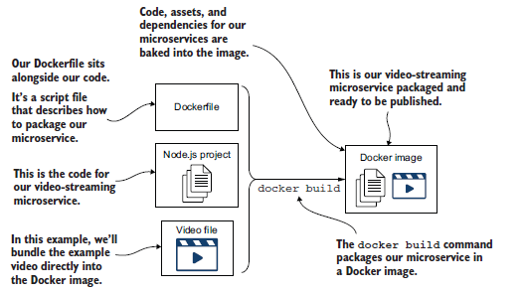

Check that the docker image was created:

docker image list

### 3.2 Run the Container

Run the container with the required environment variable:

docker run -d p <host-port>:<container-port> -e <name>=<value> <image-name>

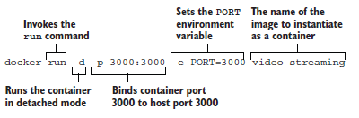

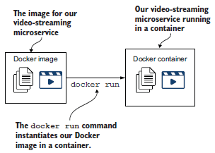

docker run -p 3000:3000 -e PORT=3000 video-streaming-microservice

To Check that the docker container was created:

docker container list

Open a browser and visit: http://localhost:3000/video

You should see a streamed video being played.

check the logs of the microservice:

docker logs <CONTAINER_ID>

To shell into it the container and inspect it: open a shell into our container like this:

docker exec -it <CONTAINER_ID> bash

## Step 4: To Stop and Remove the Docker Container

To stop the running container, first find its Container ID:

docker ps

Stop and remove the container:

docker stop <CONTAINER_ID>  
docker rm <CONTAINER_ID>