# Data_Management_for_Microservices

This guide provides a step-by-step approach to implementing a microservices-based video streaming application using Docker Compose, AWS S3, and MongoDB.

We will:

* Add file storage for our application to store its videos.
* Add a database to record the metadata for each video

We will have three containers:

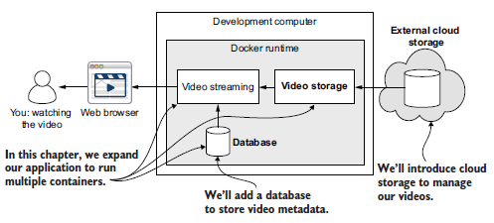

With more than one microservice we will start using Docker Compose

* A convenient way to build, run, and manage multiple microservices in development. (to avoid having to open multiple terminals (one for each microservice) and then running each microservice separately using Node.js)

The ***Docker Compose*** *file* is a script that specifies how to compose an application from multiple Docker containers.

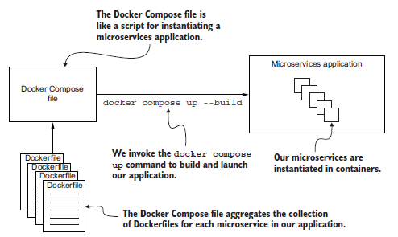

The folder ‘using_docker_compose’ is an example of docker compose applied to our previous application, we have:

* Moved the Dockerfile and code for our microservice into a new subdirectory ‘video-streaming’ (to match the name of the microservice as each microservice is moved into its own subdirectory)
* Created our Docker Compose file ‘docker-compose.yaml’ in the root directory of

our microservices application:

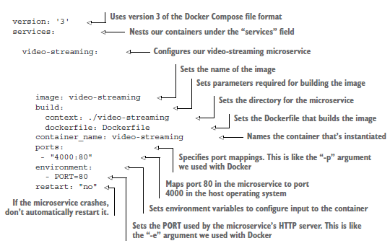

version: '3'

services:

video-streaming:

image: video-streaming

build:

context: ./video-streaming

dockerfile: Dockerfile

container_name: video-streaming

ports:

- "4000:80"

environment:

- PORT=80

restart: "no"

## Step 1: Set Up MongoDB and Microservices

### Define docker-compose.yml

version: '3'  
services:  
  
 db:  
 image: mongo:7.0.0  
 container_name: db  
 ports:  
 - "4000:27017"  
 restart: always  
  
 aws-storage:  
 build: ./aws-storage  
 ports:  
 - "4001:80"  
 environment:  
 - PORT=80  
 - STORAGE_ACCOUNT_NAME=${STORAGE_ACCOUNT_NAME}  
 - STORAGE_ACCESS_KEY=${STORAGE_ACCESS_KEY}  
  
 video-streaming:  
 build: ./video-streaming  
 ports:  
 - "4002:80"  
 environment:  
 - PORT=80  
 - DBHOST=mongodb://db:27017  
 - DBNAME=video-streaming  
 - VIDEO_STORAGE_HOST=video-storage  
 - VIDEO_STORAGE_PORT=80  
 depends_on:  
 - db

## Step 2: Set Up the Video Streaming Microservice

### 2.1 Install Dependencies

npm install express mongodb http

### 2.2 Create index.js

const express = require("express");  
const http = require("http");  
const mongodb = require("mongodb");  
  
const PORT = process.env.PORT || 80;  
const VIDEO_STORAGE_HOST = process.env.VIDEO_STORAGE_HOST;  
const VIDEO_STORAGE_PORT = process.env.VIDEO_STORAGE_PORT;  
const DBHOST = process.env.DBHOST;  
const DBNAME = process.env.DBNAME;  
  
const client = new mongodb.MongoClient(DBHOST);  
  
async function getVideoPath(id) {  
 await client.connect();  
 const db = client.db(DBNAME);  
 const video = await db.collection("videos").findOne({ _id: id });  
 return video ? video.videoPath : null;  
}  
  
const app = express();  
app.get("/video/:id", async (req, res) => {  
 const videoPath = await getVideoPath(req.params.id);  
 if (!videoPath) return res.status(404).send("Video not found");  
  
 http.get(`http://${VIDEO_STORAGE_HOST}:${VIDEO_STORAGE_PORT}/video/${videoPath}`, (storageRes) => {  
 res.writeHead(storageRes.statusCode, storageRes.headers);  
 storageRes.pipe(res);  
 });  
});  
app.listen(PORT, () => console.log(`Video Streaming running on ${PORT}`));

## Step 3: Set Up the AWS Storage Microservice

### 3.1 Install Dependencies

npm install express @azure/storage-blob

### 3.2 Create index.js

const express = require("express");  
const { BlobServiceClient } = require("@azure/storage-blob");  
  
const PORT = process.env.PORT || 80;  
const STORAGE_ACCOUNT_NAME = process.env.STORAGE_ACCOUNT_NAME;  
const STORAGE_ACCESS_KEY = process.env.STORAGE_ACCESS_KEY;  
  
const app = express();  
app.get("/video/:filename", async (req, res) => {  
 const blobServiceClient = BlobServiceClient.fromConnectionString(STORAGE_ACCOUNT_NAME);  
 const containerClient = blobServiceClient.getContainerClient("videos");  
 const blobClient = containerClient.getBlobClient(req.params.filename);  
 const downloadBlockBlobResponse = await blobClient.download();  
  
 res.setHeader("Content-Type", "video/mp4");  
 downloadBlockBlobResponse.readableStreamBody.pipe(res);  
});  
app.listen(PORT, () => console.log(`Azure Storage running on ${PORT}`));

## Step 4: Initialize MongoDB with Sample Data

### 4.1 Insert Video Metadata

mongo --host localhost --port 4000 --eval '  
db = db.getSiblingDB("video-streaming");  
db.videos.insert({ _id: "123", videoPath: "sample.mp4" });  
'

## Step 5: Run the Application

docker compose up --build

## Conclusion

This guide demonstrates how to build a microservices-based video streaming application that integrates cloud storage and a database using Docker Compose.