Solution Definition
Copyright © ​, Oracle and/or its affiliates
​
Oracle Cloud VMware Solution

​ | Version 0.1
Contents
Document Control 4
1.1 Version Control 4
1.2 Team 4
1.3 Abbreviations and Acronyms 4
1.4 Document Purpose 4
Business Context 5
2.1 Executive Summary 5
2.2 Workload Business Value 5
Workload Requirements and Architecture 5
3.1 Overview 5
3.2 Non-Functional Requirements 6
3.2.1 Regulations and Compliance 6
3.2.2 Environments 6
3.2.3 High Availability and Disaster Recovery Requirements 6
3.2.4 Security Requirements 6
3.3 Current State Architecture 6
3.3.1 Current State IT Architecture (VMware) 6
3.3.2 Current VMware Inventory On-premises 7
3.3.3 Total VMware Resources For All Locations 7
3.3.4 Resource Utilization 8
3.4 Future State Architecture 8
3.4.1 Mandatory Security Best Practices 8
3.4.2 OCI Secure Landing Zone Architecture (OCVS) 12
3.4.3 Physical Architecture 13
3.5 Solution Considerations 16
3.5.1 High Availability and Disaster Recovery 16
3.5.2 Security 18
3.5.3 Networking 21
3.5.4 Operating Model, Monitoring, and Management 24
3.5.5 OCVS Migration 24
3.6 Sizing and Bill of Materials 26
3.6.1 Target OCVS Architecture Sizing 26
3.6.2 Summary Of Target Architecture Sizing 26
Project Implementation (Only for Oracle Implementations!) 27
4.1 Solution Scope 27
4.1.1 Disclaimer 27
4.1.2 Overview 27
4.1.3 Business Value 27
4.1.4 Success Criteria 27
4.2 Workplan 28
4.2.1 Deliverables 28
4.2.2 Included Activities 28
4.2.3 Recommended Activities 28
4.2.4 Timeline 29
4.2.5 Implementation RACI 29
4.2.6 Assumptions 29
4.2.7 Obligations 30
4.2.8 Risks 30
4.2.9 Transition Plan 31
Annex 32
5.1 Oracle Security, Identity, and Compliance 32
5.2 References 32
5.3 Compliance and Regulations 32
5.4 Additional Resources 32

Document Control

Version Control
Version | Author | Date | Comment
​ | ​ | ​ | ​

Team
Approver | E-Mail | Role | Company
​ | ​ | ​ | ​
Project Team Member | E-Mail | Role | Company
​ | ​ | ​ | ​
Name | E-Mail | Role | Company
​ | ​ | ​ | ​

Abbreviations and Acronyms
Term | Meaning
OCVS | Oracle Cloud VMware Solution
OCI | Oracle Cloud Infrastructure
VCN | Virtual Cloud Network
DRG | Dynamic Routing Gateway
CPE | Customer Premises Equipment
FC | OCI Fast Connect Connection
IPSec | OCI IPSec VPN Connection
SL | Security List
NSG | Network Security Group
RT | Route Table
CMP | Compartment
IGW | Internet Gateway
NGW | NAT Gateway
SGW | Service Gateway
VM | Virtual Machine
BM | Bare Metal
VSS | VMware vSphere Standard Switch
VDS | VMware vSphere Distributed Switch
ESXi | VMware vSphere Hypervisor (ESXi)
VC | VMware vCenter Server
vSAN | VMware Virtual SAN (vSAN)
NSX-T | VMware Network Virtualization (NSX-T)
HCX | VMware Hybrid Cloud Extension (HCX)

Document Purpose
Customer name | ​
Legal customer name | ​
Project name | ​
Document version | 0.1
Generation date | ​
Document author | ​
Author e-mail | ​
Version comment | ​
Assessment name | ​
Assessment date | ​
RVTools source | ​
Source datacenters | ​
Source vCenters | ​
Business scenario | ​
This document provides a high-level solution definition for the Oracle solution and aims at describing the current state, and to-be state as well as a potential high-level project scope and timeline for Lift.
The document may refer to a ‘Workload’, which summarizes the full technical solution for a customer (You) during a single engagement. The Workload is described in the chapter Workload Requirements and Architecture.
This is a living document, additional sections will be added as the engagement progresses resulting in a final Document to be handed over to the Lift.

Business Context
​

The mission-critical application workloads are hosted primarily in VMware. The customer is looking for quick and seamless migration to the cloud with minimal interruption to the services. They have decided to use the Oracle Cloud VMware Solution for quick migration of the VMware workloads before their current data center contract expires. The Oracle Cloud VMware Solution offers flexible, highly scalable, and cost-effective solutions to host the Customer's critical workloads without disrupting their core business.

Executive Summary

Workload Business Value
​
the Customer is running a strategic program in the approved programme period called the customer programme. As part of their initiative, one pillar is dedicated to their IT cost saving. the Customer is planning to reduce their IT estate spending by 15% in the current FY. Oracle can help the Customer by reducing the VMware deployment complexity and operations while optimizing IT costs. the Customer IT department wants to innovate other LoBs and enable quick-time-to-market for various applications and business needs. This allows the Customer to stay ahead in a competitive market.
The Oracle Cloud VMware Solution is a customer-managed Software-defined Data Center solution offering customers a choice to run flexible infrastructure to host mission-critical workloads. The customer can seamlessly move their workloads from the on-premises VMware environment to Oracle Cloud VMware Solution promptly with the help of the native migration tool offered with the solution. Since the platform remains the same for migrated workloads there are no efforts required to re-factoring the application rather customer can focus on the digital transformation journey.

Workload Requirements and Architecture

Overview
​
Oracle will support the Customer in setting up the target OCVS architecture based on customer business and technical requirements. Oracle will move selected VMs of the on-premise VMware workload to Oracle Cloud Infrastructure in the region.
Thus, the objectives of this document are to:
- Review together the existing on-premise architecture, map it to relevant Oracle OCI services, and propose a high-level tailored cloud architecture design.
- Define the Oracle Cloud Lift Services scope to help the Customer to physically migrate the agreed workload to the target cloud platform.
The goals of this document are to:
Additionally, the Document Purpose these are the high-level goals for this document:
- Provide the architecture guidelines as per the Customer needs for the target cloud OCI architecture.
- Fitting the solution into the Customer the OCI ecosystem.
- Address all OCVS-related aspects at security, network, compute, storage, and other levels for implementing the target cloud architecture.
- Set up the OCVS cloud environment according to the agreed design & architecture.
- Define the scope of the potential LIFT services migration of the the Customer workload.

Non-Functional Requirements
Business requirements | ​
Technical requirements | ​
Success criteria | ​
High availability requirements | ​
Disaster recovery requirements | ​
Security requirements | ​
Compliance requirements | ​

Regulations and Compliance
At the time of this document creation, no Regulatory and Compliance requirements have been specified.

Environments
Environment | Scope | Location | Assessment coverage
​ | ​ | ​ | ​

High Availability and Disaster Recovery Requirements
At the time of this document creation, no high availability and disaster recovery requirements have been specified.

Security Requirements
At the time of this document creation, no security requirements have been specified.

Current State Architecture
The current state architecture covers the current on-premises workloads.

Current State IT Architecture (VMware)
the Customer current environment is running in a data center () based on hardware () infrastructure and VMware vSphere Hypervisor (ESXi).
The Current VMware footprint consists of:
- VMware vSphere with 7.0 release
- VMware vSAN Storage (Optional)
- VMware NSX or NSX-T as a networking solution (Optional)
- Backup Solution
Below is the current high-level architecture of the customer's on-premises VMware environment.
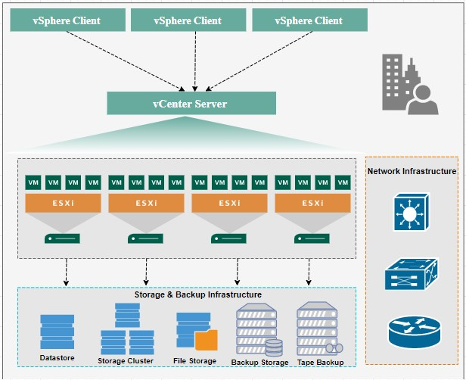
Current State Architecture

Current VMware Inventory On-premises
Source cluster | VMs | vCPU | RAM GB | Storage TB | Powered on | Powered off
​ | ​ | ​ | ​ | ​ | ​ | ​
VM resource allocations per location:
Operating Systems:
- Windows Server 2019
- Oracle Linux 8
- Red Hat Linux
- Windows Server 2008 R2
Database Systems:
- Microsoft SQL AlwaysON
- Microsoft SQL Cluster
- Oracle 12c Database

Total VMware Resources For All Locations
Selected VMs | Powered on | Powered off | vCPU | RAM GB | Storage TB | Operating systems
​ | ​ | ​ | ​ | ​ | ​ | ​

Resource Utilization
vCPU per OCPU | CPU headroom | RAM headroom | Storage headroom | vSAN usable | Block Volume VPU/GB
​ | ​ | ​ | ​ | ​ | ​

Future State Architecture

Mandatory Security Best Practices
The safety of the the Customer's Oracle Cloud Infrastructure (OCI) environment and data is the the Customer's priority.
The following table of OCI Security Best Practices lists the recommended topics to provide a secure foundation for every OCI implementation. It applies to new and existing tenancies and should be implemented before the Workload defined in this document will be implemented.
Workload-related security requirements and settings like tenancy structure, groups, and permissions are defined in the respective chapters.
Any deviations from these recommendations needed for the scope of this document will be documented in the chapters below. They must be approved by the Customer.
the Customer is responsible for implementing, managing, and maintaining all listed topics.
CATEGORY | TOPIC | DETAILS
User Management | IAM Default Domain | Multi-factor Authentication (MFA) should be enabled and enforced for every non-federated OCI user account.  - For configuration details see Managing Multi-Factor Authentication.  In addition to enforcing MFA for local users, Adaptive Security will be enabled to track the Risk Score of each user of the Default Domain.  - For configuration details see Managing Adaptive Security and Risk Providers.
 | OCI Emergency Users | A maximum of three non-federated OCI user accounts should be present with the following requirements:  - Username does not match any username in the Customer’s Enterprise Identity Management System  - Are real humans.  - Have a recovery email address that differs from the primary email address.  - User capabilities have Local Password enabled only.  - Has MFA enabled and enforced (see IAM Default Domain).
 | OCI Administrators | Daily business OCI Administrators are managed by the Customer’s Enterprise Identity Management System. This system is federated with the IAM Default Domain following these configuration steps:  - Federation Setup  - User Provisioning  - For configuration guidance for major Identity Providers see the OCI IAM Identity Domain tutorials.
 | Application Users | Application users like OS users, Database users, or PaaS users are not managed in the IAM Default Domain but either directly or in dedicated identity domains. These identity domains and users are covered in the Workload design. For additional information see Design Guidance for IAM Security Structure.
Cloud Posture Management | OCI Cloud Guard | OCI Cloud Guard will be enabled at the root compartment of the tenancy home region. This way it covers all future extensions, like new regions or new compartments, of your tenancy automatically. It will use the Oracle Managed Detector and Responder recipes at the beginning and can be customized by the Customer to fulfill the Customer’s security requirements.  - For configuration details see Getting Started with Cloud Guard. Customization of the Cloud Guard Detector and Responder recipes to fit the Customer’s requirements is highly recommended. This step requires thorough planning and decisions to make.  - For configuration details see Customizing Cloud Guard Configuration
 | OCI Vulnerability Scanning Service | In addition to OCI Cloud Guard, the OCI Vulnerability Scanning Service will be enabled at the root compartment in the home region. This service provides vulnerability scanning of all Compute instances once they are created.  - For configuration details see Vulnerability Scanning.
Monitoring | SIEM Integration | Continuous monitoring of OCI resources is key for maintaining the required security level (see Regulations and Compliance for specific requirements). See Design Guidance for SIEM Integration to implement integration with the existing SIEM system.
Additional Services | Budget Control | OCI Budget Control provides an easy-to-use and quick notification on changes in the tenancy’s budget consumption. It will be configured to quickly identify unexpected usage of the tenancy.  - For configuration details see Managing Budgets

OCI Secure Landing Zone Architecture (OCVS)
All the above OCI and OCVS networking and security services and principles are implemented through the concept of a Landing Zone. The following diagram illustrates the Landing Zone reference architecture specific to the deployment of OCVS.
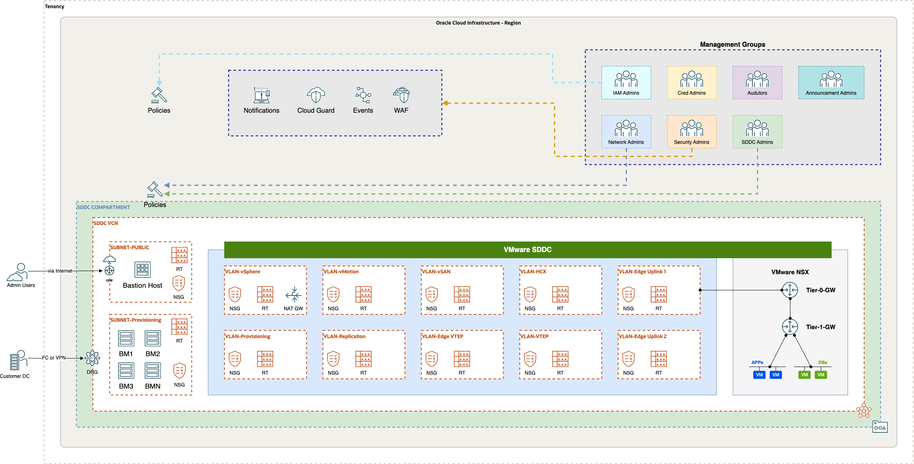
OCVS landing zone
This architecture is designed specifically for Oracle Cloud VMware Solution which sits on top of the OCI core services such as Bare Metal Compute, and VCN networking. The architecture starts with the compartment design for the tenancy along with groups and policies for the segregation of duties.
In Landing Zone, tenancy should have a dedicated compartment for VMware SDDC deployment. The existing tenancy can also be used but it is recommended to segregate the VMware SDDC environment from other OCI resources. The VMware SDDC Compartment is assigned a group with appropriate permissions for managing resources in the compartment and for accessing required resources in other compartments. As a best practice, it is recommended to create a dedicated compartment for VCN leveraged by the OCVS deployment to keep the networking resources completely separated in a dedicated compartment.
The VMware SDDC compartment will be utilized to deploy the SDDC service. The SDDC network compartment will host dedicated VCN resources to maintain the isolation of the VMware and network resources and thus use the IAM policies for network resource and access management. Oracle Cloud VMware Solution deployment workflow is a fully automated process and takes care of provisioning of required to compute & networking resources maintaining the security standard.
The Landing Zone for OCVS includes pre-configured networking resources such as subnet, VLANs, Network Security Group, Security List, and Route Tables maintaining the security posture needed for enterprise VMware workloads. Also, it includes pre-configured Compute Bare Metal services required for VMware hypervisor operation. Additionally, VMware NSX as a Software Defined Networking is pre-configured but isolated in an overlay network zone.
Additional OCI services such as Cloud Guard, Events, Notifications, and WAF can be used to operate and monitor OCI resources for Oracle Cloud VMware Solutions such as OCI Compute, and OCI Network. The Notifications are set using Topics and Events for alerting administrators about changes in the deployed resources for this environment.
Please Note The VMware workloads can use limited OCI services when it comes to integration of VMware SDDC workloads to OCI. Low-level design of Landing zone with the Customer's relevant specific technical details will be provided during the architecture Design discovery process. The network for the SDDC network should not overlap with the existing networks in the Customer's tenancy. The SDDC can be scaled up to a maximum of 64 hosts with /21 SDDC CIDR range.
Note: The table is a representation of the sample network layout for the /22 network however based on the SDDC CIDR range selected we can expect an automated network layout created by the SDDC provisioning operation with different network range for VLANS. SDDC workload CIDR will be identified as a part of the low-level design during the implementation.

Physical Architecture
The future state architecture covers the current on-premises workloads to be hosted on Oracle Cloud VMware Solution(OCVS). The OCVS is deployed at the Availability Domain (AD) in the OCI region and spans across 3 Fault Domains (FD) in the region. The OCI Bare Metal (BM) instances utilized by the service are spread across the Fault Domain (FD) in a round-robin fashion offering complete redundancy to the OCVS workloads. The OCVS comes with two distinct architectures as represented below.
- OCVS with DenseIO server - This architecture primarily uses vSAN Storage leveraging NVMe drives from the local Bare Metal (BM) servers.
- OCVS with Standard Shapes - This architecture is completely based on the OCI Block Storage as a primary storage option for the VM workloads.
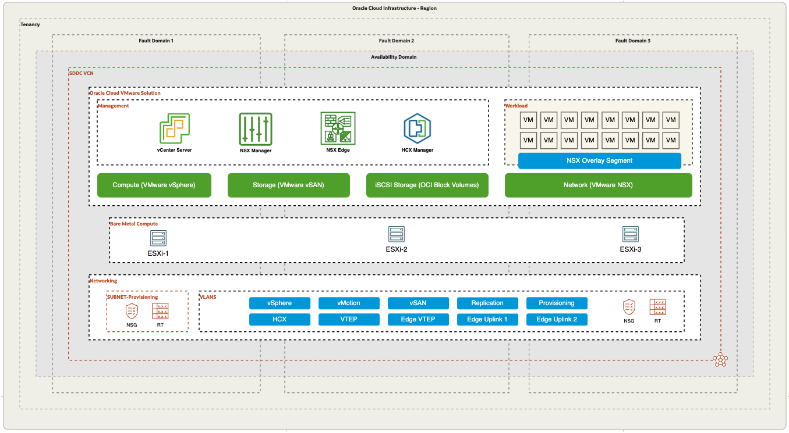
Future State Architecture
Oracle Cloud VMware Solution is the central part of this deployment and provides a fully automated implementation of a VMware software-defined data center (SDDC) within your Oracle Cloud Infrastructure tenancy. The solution runs on Oracle Cloud Infrastructure Bare Metal Compute and contains the following VMware components:
- VMware vSphere Hypervisor (ESXi)
- VMware vCenter Server
- VMware vSAN
- OCI Block Storage
- VMware NSX-T
- VMware HCX Advanced
High-level OCVS-based cloud architecture for the Customer target cloud deployment is outlined in the picture below.
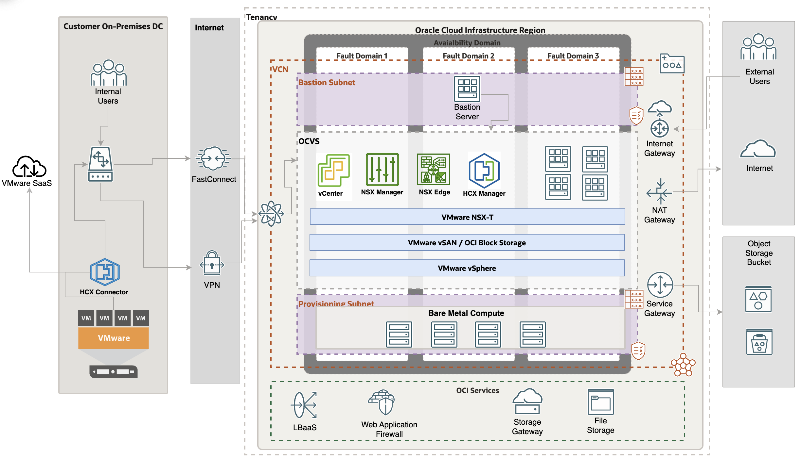
High Level OCVS architecture
The architecture has the following components:
OCVS
The VMware SDDC comes in with vSphere 7.0 version. The OCVS SDDC consists of vSphere (ESXi + vCenter), NSX-T, vSAN & HCX. The SDDC deployment can be on OCI DenseIO shapes that offer vSAN Storage or it can be on OCI Standard Shape with OCI Block Storage as a primary storage option.
- VMware HCX - Application mobility platform designed for simplifying application migration, workload re-balancing, and business continuity across data centers and clouds. This will allow the seamless migration of VMware workloads to OCVS.
- HCX Manager – HCX manager is an appliance deployed in Oracle Cloud VMware Solution. HCX manager will be paired with an on-premises vCenter through HCX Connector.
- HCX Connector – HCX connector is an appliance deployed at an on-premises vCenter server which will be then paired with the HCX manager in the cloud for the base configuration necessary for workload migration.
- VMware NSX-T - This is NSX-T Data Center implementation as part of the SDDC stack used for Software Defined Networking. The migrated workloads can use NSX network segments for networking usage. NSX-T offers full perimeter services configuration in OCVS environments such as Load Balancer, Routing, Switching, firewall, and micro-segmentation.
- VMware vSAN - VMware vSAN is a software-defined storage solution offered as part of the OCVS SDDC solution. The vSAN has been configured by leveraging locally attached NVMe all-flash disks from each OCI Bare Metal server to offer common storage for workloads.
- OCI Block Storage - The OCI Block storage can be leveraged as an additional storage option with DenseIO compute SDDC along with vSAN. The Standard Shape OCVS environment consists of OCI block storage as the only primary storage option.
- VMware vSphere - Includes ESXi and vCenter servers
- FastConnect - OCI FastConnect is a dedicated private high-speed network link connected to the Customer Data Center and OCI region. The FastConnect will be leveraged for migrating the workloads over the network.

Solution Considerations

High Availability and Disaster Recovery

OCVS Resilience and Recovery
Oracle Cloud VMware Solution is deployed at Availability Domain (AD) within the OCI region. Each Availability domain consists of Fault Domains to maintain a fault-tolerant and highly resilient environment. For more details about OCI Availability domains and Fault Domains refer to the OCI documentation.
The details of the Oracle Cloud Infrastructure SLAs are found in the link below. OCI Service SLA.

OCVS High Availability
This section describes the VMware SDDC High Availability.
OCI BM Compute (ESXi): The OCI native services such as compute bare metal and VCN resources are highly resilient cloud service offerings from Oracle Cloud Infrastructure. OCI BM failure can be addressed by replacing the faulty node with a new ESXi host in the cluster.
OCI BM NVMe (vSAN): The OCVS SDDC consist of vSAN for the software-defined storage layer. With vSAN's failure to tolerate (FTT) feature, host failures, and data loss can be effectively managed. Customers can utilize the vSAN SPBM (Storage Policy Based Management) which includes different RAID levels to protect the data.
OCVS Networking (NSX-T): The OCVS SDDC consists of NSX-T implementation to manage software-defined networking. The NSX Edge, Managers/Controllers are deployed in a fully redundant manner to maintain high availability.
OCI Block Storage: The OCI Block Storage offers the highest level of data resiliency by the backend system at the availability domain. The OCI Block storage being the primary storage option with OCVS does not require RAID configuration but rather relies on the resiliency offered by the Oracle Cloud Infrastructure.

OCVS Backup
This section describes a proposed backup architecture for the Customer workloads post-migration to OCVS. We recommend using the VEEAM backup and replication suite which works best with the VMware platform. However, other backup solutions such as Commvault can also be used.
The following diagram illustrates the proposed VEEAM backup architecture for the Customer's" application backup and restores requirement.
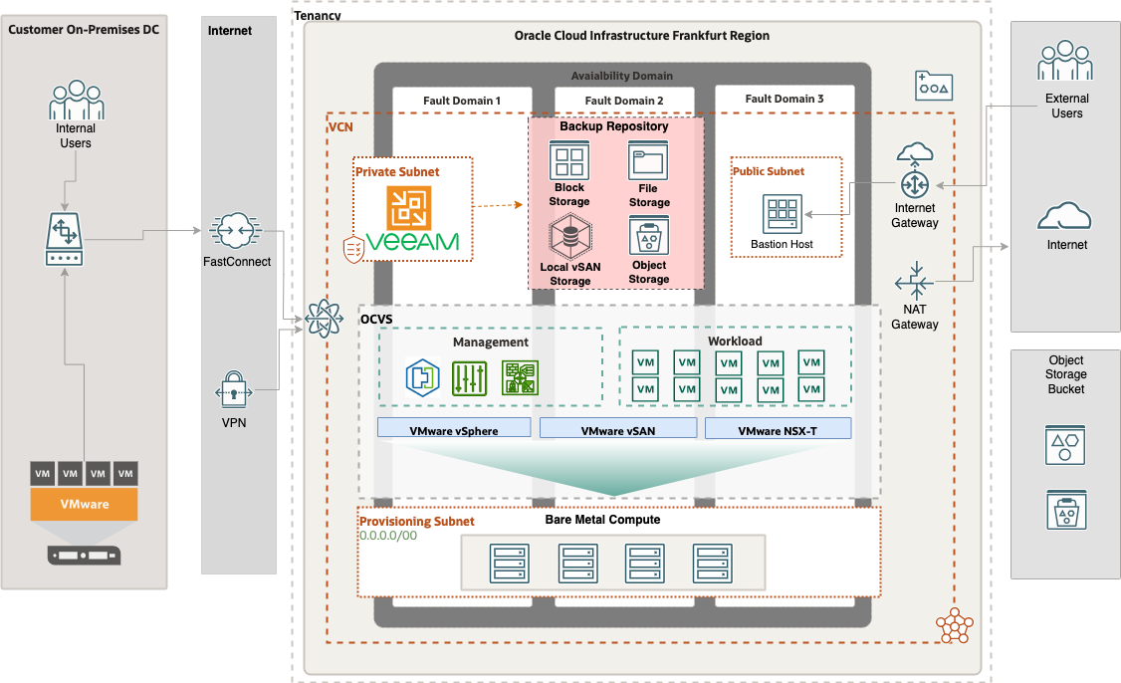
OCVS backup

Architecture Components Overview
The VEEAM backup and restore integrates with the VMware vCenter server and offers backup and restore capabilities to the VMs deployed in SDDC as well as the instances deployed in OCI. Below summarizes the backup components as part of the architecture and a detailed description of each.
- VEEAM Backup Server – VEEAM backup server is a software suite installed on the MS Windows operating system. It is recommended to deploy VEEAM outside of the SDDC Cluster. The VEEAM backup server will be installed on OCI Compute instance with MS Windows 2016 and above Operating System.
- MS SQL Cluster – The Microsoft SQL cluster is required for VEEAM Backup Server Database. The SQL Nodes will be deployed in the same management subnet as that of the VEEAM backup Server and will use OCI native compute instances. The MS SQL will be deployed in High Availability mode using native AlwaysON clustering functionality. This will offer a fully redundant database for VEEAM. The SQL nodes will be spread across Fault Domains.
Note: Depending upon the licensing requirement, we can use an MS SQL marketplace image where the license will be included. This needs to be discussed with the customer during the actual implementation.
- VEEAM Proxy – VEEAM proxy is one of the main components of VEEAM Backup and replication. VEEAM proxy sits between the data source and target and is used to process jobs and deliver backup traffic. It allows to offload of the VEEAM Backup Server and has better performance resulting shorter backup window. There is a default proxy server that can be used if no proxy is deployed but it is recommended to deploy a VEEAM proxy for better backup performance. The proxy can be a Windows or Linux VM inside the OCVS SDDC.
- Backup Repositories – A backup repository is a storage location where VEEAM keeps backup files, VM copies, and metadata for replicated VMs. To configure a backup repository, you can use the following storage types:
- Direct Attached Storage (DAS): You can add virtual and physical servers as backup repositories. The compute Microsoft Windows 2016 and above Instance in OCI with a bunch of block storage can be used as a Direct attached storage. This will be considered as a performance tier and recommended to use for better backup and restore performance. The VM with vSAN local storage disks can also be used as DAS but is not recommended to avoid a single point of failure.
- Network Attached Storage (Optional): OCI File storage service NFS v3 service can be used as a Network Attached Storage.
- Object Storage: You can use cloud storage services as backup repositories. The OCI Object storage is S3 compatible and can be used as a “Scale-out Repository” for the capacity tier or a direct backup repository. The Object storage scale-out repository can be configured to have an immediate copy of the backup, or it can be copied over after a specific schedule. It is recommended to use the OCI Block Storage attached to an instance as a primary storage option for backing up the VMs for better performance and backup operations. Object storage should only be considered as a capacity tier for long-term retention and archival purpose.
Important Notes:
- Sizing requirements & Design considerations should be followed from VEEAM official documentation.
- the Customer will bring their own license for VEEAM. the Customer can discuss different VEEAM license options available with VEEAM directly and choose according to the requirement.
- the Customer can choose their choice of backup tool and Oracle will assist in architecting the necessary backup solution.

Security
Identity federation | ​
Logging and SIEM | ​
Encryption and key management | ​

OCI - Oracle and Customer Shared Security Model
Oracle employs best-in-class, enterprise-grade security technology, and operational processes to secure cloud services. To deploy and operate your workloads securely in Oracle Cloud, you must be aware of your security and compliance responsibilities.
Oracle ensures the security of cloud infrastructure and operations, such as cloud operator access controls and infrastructure security patching. You’re responsible for configuring your cloud resources securely. The following graphic illustrates the shared security responsibility model.
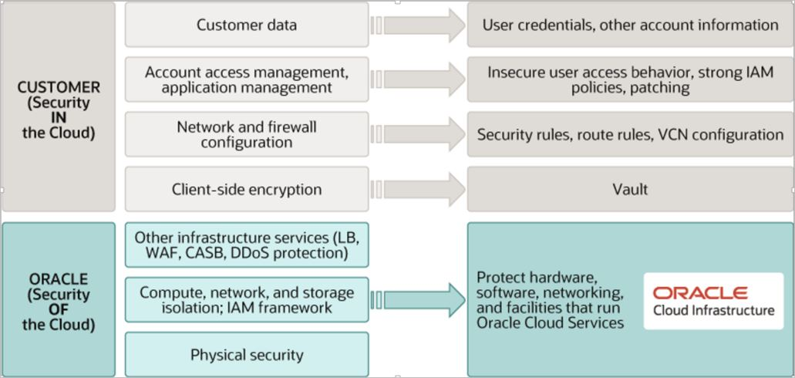
Shared Security Model
OCVS specific Responsibility Matrix
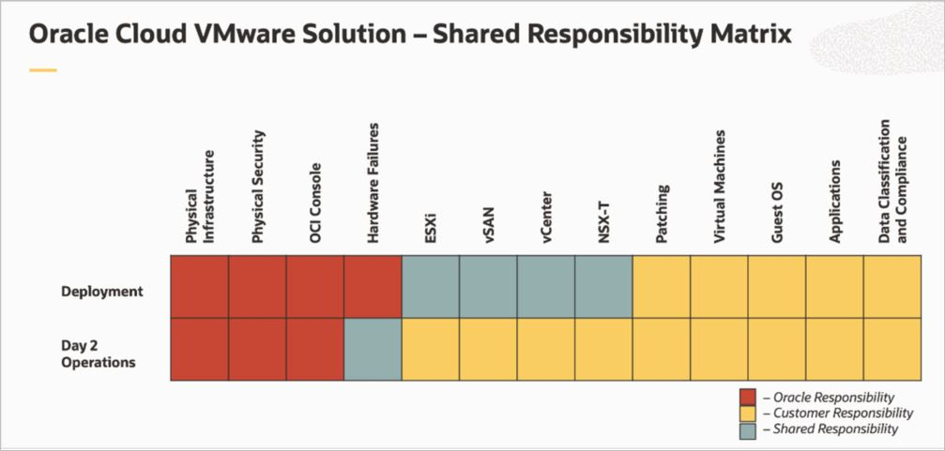
Responsibility Matrix
Oracle is solely responsible for all aspects of the physical security of the Availability Domains and Fault Domains in each region. Both Oracle and you are responsible for the infrastructure security of hardware, software, and the associated logical configurations and controls.
As a customer, your security responsibilities encompass the following:
- The platform you create on top of Oracle Cloud.
- The applications that you deploy.
- The data that you store and use.
- The overall governance, risk, and security of your workloads.
The shared responsibility extends across different domains including identity management, access control, workload security, data classification and compliance, infrastructure security, and network security.

OCVS Security Posture
The section below describes the security posture of Oracle Cloud VMware Solution and Oracle Cloud Infrastructure.
- Access to the Customer's OCI tenancy is restricted and controlled using IAM and IDCS federations. Network sources can be optionally used to restrict access from known IP addresses within VCN or on-premises.
- Security in a subnet can be controlled by Security Lists and/or Network Security Groups. OCI is a zero-trust environment by default, you must explicitly permit traffic for known communication patterns. Additional security can be offered to Customer's external facing applications using OCI Web Application Firewall.
- VLAN resides in VCN and is only provisioned for OCVS service. Each VLAN is attached to the Network Security Group to control traffic. All traffic inside a VLAN is blocked by default.
- An NSX Segment is an overlay network that runs on top of the VMware virtualization stack. This network is independent outside of the VCN network. Any communication from the NSX overlay segment to OCI resources needs to be explicitly allowed through uplink interfaces using routing and controlled using security lists.
- Security in an NSX Segment is managed by the NSX-T control plane, by default all traffic inside a segment is allowed. The NSX Micro-Segmentation enables you to increase the agility and efficiency of your network infrastructure while maintaining the highest level of security posture.
- Users from an on-premises environment can securely connect to Oracle Cloud VMware Solution resources through IPSec and or FastConnect (for more details see Chapter 6.3 OCI networking).
- Bastion host is deployed in a public subnet in Customer's tenancy. Secured access is allowed for Remote Desktop Protocol (RDP) through Internet Gateway and controlled using a security list.
- The OCVS SDDC environment is allowed to access only from the Bastion host.

OCVS Data Security
This section details Data Security for the virtual machines in the OCVS environment. It also provides details about how encryption works in vSAN and possible options for Data at rest and Data at transit. We have not received any data security requirements from the Customer. Therefore, the below section details out-of-the-box data security standards for OCVS.
vSAN Data-At-Rest
Oracle Cloud VMware Solution uses VMware vSAN technology for virtual machine storage management. vSAN comes with its own data-at-rest encryption technique. vSAN can encrypt data at rest in the vSAN datastore. Data at rest encryption within vSAN requires an external Key Management Server (KMS) or a vSphere Native Key Provider. vSAN data at rest encryption is out of the scope of this project. However, customers can enable the data-at-rest encryption anytime at cluster provided it meets the required pre-requisite.
vSAN Data-in-Transit
Oracle Cloud VMware Solution uses VMware vSAN technology for virtual machine storage management. vSAN can encrypt data in transit, as it moves across hosts in your vSAN cluster. vSAN can encrypt data in transit across hosts in the cluster. When you enable data-in-transit encryption, vSAN encrypts all data and metadata traffic between hosts. Traffic between data hosts and witness hosts is encrypted. vSAN data encryption in transit is out of the scope of this project. However, the Customer can enable this functionality at the vSAN cluster in OCVS SDDC.
Block Storage Encryption
OCI Block Storage can be used to scale the storage for DenseIO OCVS deployment and be used as primary storage in the case of Standard Shapes OCVS. OCI Block Volume is presented to the VMware ESXi server as an iSCSI target to store virtual machine files. OCI security features such as KMS, encryption, and vaults apply to VM data stored in OCI Block Volume. OCI Block Volume is mounted as an external Datastore for VMware SDDC by leveraging OCI managed/Customer managed keys for VM data encryption.

Networking
Connectivity type | ​
Target OCI region | ​
The architecture has the following components:
- On-premises Network - This network is the local network used by your organization. It is one of the spokes of the topology.
- Region - An Oracle Cloud Infrastructure region is a localized geographic area that contains one or more data centers, called availability domains. Regions are independent of other regions, and vast distances can separate them (across countries or even continents).
- Virtual Cloud Network (VCN) - A VCN is a customizable, private network that you set up in an Oracle Cloud Infrastructure region. Like traditional data center networks, VCNs give you complete control over your network environment. You can segment VCNs into subnets, which can be scoped to a region or an availability domain. Both regional subnets and availability domain-specific subnets can coexist in the same VCN. A subnet can be public or private.
- Security List - For each subnet, you can create security rules that specify the source, destination, and type of traffic that must be allowed in and out of the subnet.
- Network Security Group (NSG) - NSGs act as virtual firewalls for your cloud resources. With the zero-trust security model of Oracle Cloud Infrastructure, all traffic is denied, and you can control the network traffic inside a VCN. An NSG consists of a set of ingress and egress security rules that apply to only a specified set of VNICs in a single VCN.
- Route Table - Route tables contain rules to route traffic from subnets to destinations outside a VCN, typically through gateways.
- Dynamic Routing Gateway (DRG) - The DRG is a virtual router that provides a path for private network traffic between a VCN and a network outside the region, such as a VCN in another Oracle Cloud Infrastructure region, an on-premises network, or a network in another cloud provider.
- Bastion Host - The bastion host is a compute instance that serves as a secure, controlled entry point to the topology from outside the cloud. The bastion host is provisioned typically in a demilitarized zone (DMZ). It enables you to protect sensitive resources by placing them in private networks that can't be accessed directly from outside the cloud. The topology has a single, known entry point that you can monitor and audit regularly. So, you can avoid exposing the more sensitive components of the topology without compromising access to them.
- VPN Connect - VPN Connect provides site-to-site IPSec VPN connectivity between your on-premises network and VCNs in Oracle Cloud Infrastructure. The IPSec protocol suite encrypts IP traffic before the packets are transferred from the source to the destination and decrypts the traffic when it arrives.
- FastConnect - Oracle Cloud Infrastructure FastConnect provides an easy way to create a dedicated, private connection between your data center and Oracle Cloud Infrastructure. FastConnect provides higher-bandwidth options and a more reliable networking experience when compared with internet-based connections.

Network connectivity options (on-premises to OCI)

IPSec VPN
The following diagram of a reference architecture shows how to set up a Virtual Private Network (VPN) to connect to a customer's on-premises network and VCN.
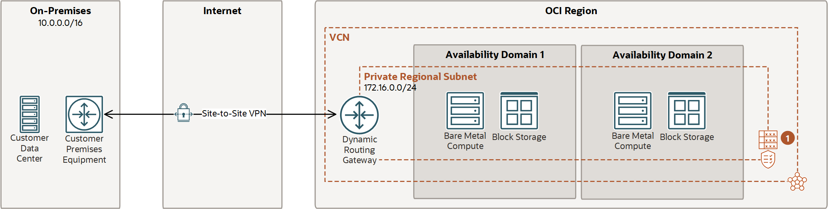
IPSec VPN
IPSec VPN architecture has the following components:
- VPN Connect - Function that manages IPSec VPN connections to your tenancy.
- Customer-Premises Equipment (CPE) - An object that represents the network asset that lives in the on-premises network and establishes the VPN connection. Most border firewalls act as the CPE, but a separate device (like an appliance or a server) can be a CPE.
- Internet Protocol Security (IPSec) - A protocol suite that encrypts IP traffic before packets are transferred from the source to the destination.
- Tunnel - Each connection between the CPE and Oracle Cloud Infrastructure.
- Border Gateway Protocol (BGP) routing - Allows routes to be learned dynamically. The DRG dynamically learns the routes from your on-premises network. On the Oracle side, the DRG advertises the VCN's subnets.
- Static Routing - When you create the VPN connection, you inform the existing networks on each side. Changes are not learned dynamically.
IPSec VPN will be used to provide for the connection between the Customer's data center and Oracle OCI Public cloud region for standard day-to-day operational purposes. Based on the current information IPSec connection is already established.

Fast Connect
The following reference architecture diagram shows how to set up a FastConnect connection between your on-premises network and Virtual Cloud Network (VCN).
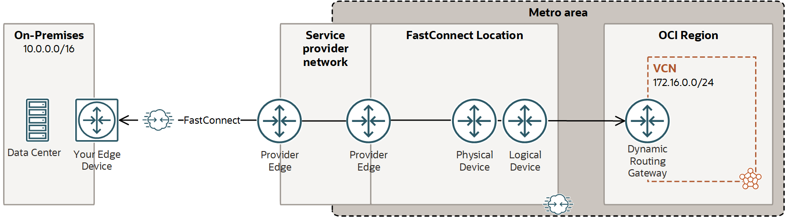
Fast Connect
- Border Gateway Protocol (BGP) routing - Allows routes to be learned dynamically. The DRG dynamically learns the routes from your on-premises network. On the Oracle side, the DRG advertises the VCN's subnets.
- Private Peering - Extends existing infrastructure by using private IP addresses.
- Public Peering - Allows public Oracle Cloud Infrastructure services to be accessed using a private connection instead of the internet.
- Virtual Circuit - The private path used to connect on-premises and Oracle Cloud Infrastructure. It can include multiple lines, physical or logical, depending on the requirements and capabilities of the line provider.
Fast Connect will be used to provide for the connection between the Customer's data center and the selected OCI region for the period migrations of VMs from on-premise to Oracle cloud. It is a requirement to use Fast Connect at least for the period of workload migration.

OCVS Specific Networking Configuration Within OCI
Network segment | CIDR | Purpose
​ | ​ | ​
The Oracle Cloud VMware Solution networking categorizes into Virtual Cloud Networks, Subnets, and VLANs. Each VLAN within VCN is attached to the Network Security Group for network communication and Route Table for routing functionality. Similarly, the subnet created as an outcome of the SDDC provisioning operation is attached to Security List and Route Table.
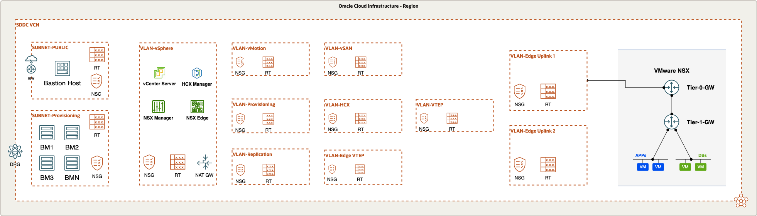
OCVS detailed networking overview and components

OCI Virtual Cloud Network (VCN) for OCVS
VCN CIDR | ​
SDDC CIDR | ​
Workload CIDRs | ​
All the resources in OCVS/SDDC architecture are in a single VCN. For VMware SDDC we need at least /24 network CIDR but recommended is to have a dedicated /16 VCN CIDR block that can accommodate future scaling of the networks.
The OCVS networking resources such as Subnet, VLANs, Network Security Groups (NSG), Route Tables, and Gateways are the result of OCVS SDDC provisioning operation. The network CIDR ranges for the management VLANs are solely dependent on the size of the SDDC CIDR. The network design considerations should be carefully assessed before provisioning the OCVS environment.

Operating Model, Monitoring, and Management
Operating model | ​
Monitoring model | ​
Backup architecture | ​
This section describes the details of management and monitoring capabilities available out of the box from Oracle Cloud VMware Solution. Oracle Cloud VMware Solution offers VMware vRealize Operations (vROPS) manager as a monitoring tool integrated with OCVS vCenter server. VMware vROPS is pre-integrated with the vCenter server and offers a dashboard for monitoring the entire VMware SDDC farm. The vROPS has a predefined matrix for availability, performance, and capacity which will help customers for their day-to-day operations. Below are some of the benefits of vROPS.
- Application-aware monitoring across SDDC and multiple clouds.
- Cloud Planning, capacity optimization, and compliance.
- Automated and proactive workloads management.
Customer can also leverage their existing on-premises vROPS implementation to extend the monitoring capabilities to OCVS. In addition, customers can also leverage their existing tooling and automation with OCVS SDDC. For example, products such as VMware vRealize Log Insight, VMware vRealize automation, and others.
Important note: Customers will need to bring their own license to use vRealize Operations Manager. The vROPS is also available as a SaaS subscription from VMware which can be used to monitor the OCVS environment in VMware Cloud.

OCVS Support
- Oracle will provide tier one and tier two support for Oracle provided versions of VMware components (vSphere, vCenter, vSAN, NSX) on Oracle Cloud Infrastructure. Tier three support cases will be routed to VMware via a warm hand-off from Oracle.
- Support does not extend to other VMware products, nor does it extend to on-premises instances of VMware or configurations that are not listed in the VMware SCL as being supported by combinations of operating systems, VMware hypervisor versions, and VMware agent configurations.

OCVS Migration
HCX required | ​
Migration method | ​
Migration window | ​
Downtime tolerance | ​
Validation and rollback | ​
This section describes the Migration options and tools used for the migration of mission-critical workloads to OCVS.
VMware HCX is an application mobility platform that allows you to migrate VMs from an on-premises VMware environment to the OCVS SDDC. The HCX comes with two different types of license, HCX Advanced offered for free and the HCX Enterprise as an additional SKU which can be enabled from the OCI console on a monthly subscription basis.
According to the feature requirements, the HCX license type should be carefully evaluated. For more details about the HCX licensing comparison, refer to the document link below.
VMware HCX Licensing
Please note: If you are using OCVS with Standard Shapes, then the HCX enterprise is included in the subscription and no additional cost is required.
VMware HCX is a preferred way of migrating VMWare Workloads to OCVS. However, in some cases, you should consider using other third-party tools.
The HCX offers different key features along with various migration options.
Please Note: Please check the VMware interoperability matrix for version compatibility of VMware HCX with the source vSphere environment.

Migration Architecture with OCVS
The architecture diagram shows the overall HCX architecture.
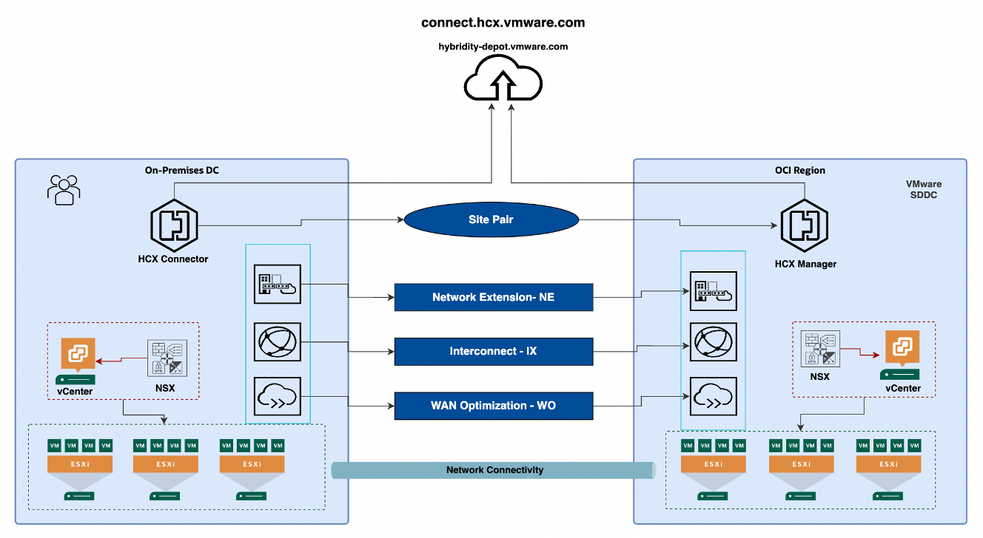
OCVS Migration Architecture using HCX

HCX Features and Migration Options
The below list of features is included with the default HCX advanced license offered with an OCVS subscription without any additional cost.
- Migration
- Disaster Recovery
- Network Extension

Migration Options with VMware HCX
vMotion - Allow live migration of the VM from source to target (OCVS). It is a serial migration and does not allow parallel live migration of more than 1 VM with an HCX advanced license. Use HCX Enterprise, if you would like to migrate VMs live and in parallel.
Bulk Migration - Parallel migration of multiple VMs. The VMs incur downtime equivalent to the restart of the VM at OCVS. The source VM will be preserved and powered off at the source. When there are no changes at the source, the HCX will power on the target VM and shut down the source. The failover operation is not controlled by the end user. The HCX bulk migration can be used with the HCX advanced license.
Disaster Recovery - Works on the same technology as bulk migration but allows you to replicate on different RPO with controlled failover, re-protect, and fallback operations.

Network Extension
This is a feature that allows you to perform L2 VLAN extension from on-premises to OCVS. The network extension is used for preserving the same IP address for the migrated VMs. The requirement of network extension should be carefully evaluated.

Sizing and Bill of Materials
Part number | Product | Metric | Quantity | Commitment | Storage | Pricing
​ | ​ | ​ | ​ | ​ | ​ | ​

Commercial Summary
Currency | ​
IaaS discount | ​
Commitment term | ​
Monthly cost | ​
Annual cost | ​
Pricing availability | ​

Target OCVS Architecture Sizing
Target OCI region | ​
Tenancy | ​
Compartment | ​
Topology | ​
SDDCs | ​
Target clusters | ​
Total OCVS nodes | ​
Selected shape | ​
Sizing driver | ​
Workload nodes | ​
Spare nodes | ​
Storage architecture | ​
Workload storage requirement TB | ​
Cluster | Role | Assigned sources | VMs | Shape | Nodes | Storage and architecture | Monthly cost
​ | ​ | ​ | ​ | ​ | ​  ​  ​  ​ | ​  ​ | ​

Consolidated single-cluster sizing
​ | ​ | ​ | ​ | ​

DenseIO and vSAN sizing
Shape | Nodes | Storage requirement TB | Storage headroom | Usable vSAN
​ | ​ | ​ | ​ | ​

Standard or Optimized and OCI Block Volume sizing
Shape | Nodes | Storage requirement TB | Storage headroom | VPU per GB
​ | ​ | ​ | ​ | ​
The sizing modules below are populated from the approved OCVS sizing result.
OR

Summary Of Target Architecture Sizing
​

BoQ Notes:
- Bring Your Own License (BYOL) of existing On-Premises VMware licenses to OCVS is not supported.
- VMware HCX Advanced is offered free with OCVS. However, the HCX enterprise license is a separate SKU and can be enabled/disabled from the OCI console based on the extended functionality requirements for migration.
- If you are using OCVS with Standard Shape and then the HCX enterprise license is included in the subscription and no additional cost is required.

Implementation Approach
Implementation provider | ​
Transition plan summary | ​

Annex

Oracle Security, Identity, and Compliance
Oracle Cloud Infrastructure (OCI) is designed to protect customer workloads with a security-first approach across compute, network, and storage – down to the hardware. It’s complemented by essential security services to provide the required levels of security for your most business-critical workloads.
- Security Strategy – To create a successful security strategy and architecture for your deployments on OCI, it's helpful to understand Oracle's security principles and the OCI security services landscape.
- The security pillar capabilities reflect fundamental security principles for architecture, deployment, and maintenance. The best practices in the security pillar, help your organization to define a secure cloud architecture, identify and implement the right security controls, and monitor and prevent issues such as configuration drift.

References
- The Best Practices Framework for OCI provides architectural guidance about how to build OCI services in a secure fashion, based on recommendations in the Best practices framework for Oracle Cloud Infrastructure.
- Learn more about Oracle Cloud Security Practices.
- For detailed information about security responsibilities in Oracle Cloud Infrastructure, see the Oracle Cloud Infrastructure Security Guide.

Compliance and Regulations
Cloud computing is fundamentally different from traditional on-premises computing. In the traditional model, organizations are typically in full control of their technology infrastructure located on-premises (e.g., physical control of the hardware, and full control over the technology stack in production). In the cloud, organizations leverage resources and practices that are under the control of the cloud service provider, while still retaining some control and responsibility over other components of their IT solution. As a result, managing security and privacy in the cloud is often a shared responsibility between the cloud customer and the cloud service provider. The distribution of responsibilities between the cloud service provider and the customer also varies based on the nature of the cloud service (IaaS, PaaS, SaaS).

Additional Resources
- Oracle Cloud Compliance – Oracle is committed to helping customers operate globally in a fast-changing business environment and address the challenges of an evermore complex regulatory environment. This site is a primary reference for customers on the Shared Management Model with Attestations and Advisories.
- Oracle Security Practices – Oracle’s security practices are multidimensional, encompassing how the company develops and manages enterprise systems, and cloud and on-premises products and services.
- Oracle Cloud Security Practices documents.
- Contract Documents for Oracle Cloud Services.
- OCI Shared Security Model
- OCI Cloud Adoption Framework Security Strategy
- OCI Security Guide
- OCI Cloud Adoption Framework Security chapter

