# Zadanie –

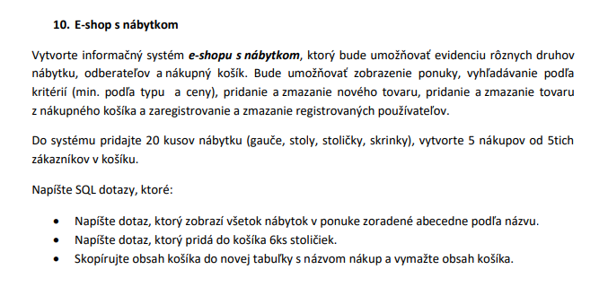

# Schéma riešenia (Vytvorenie Entitno – Relačného modelu)

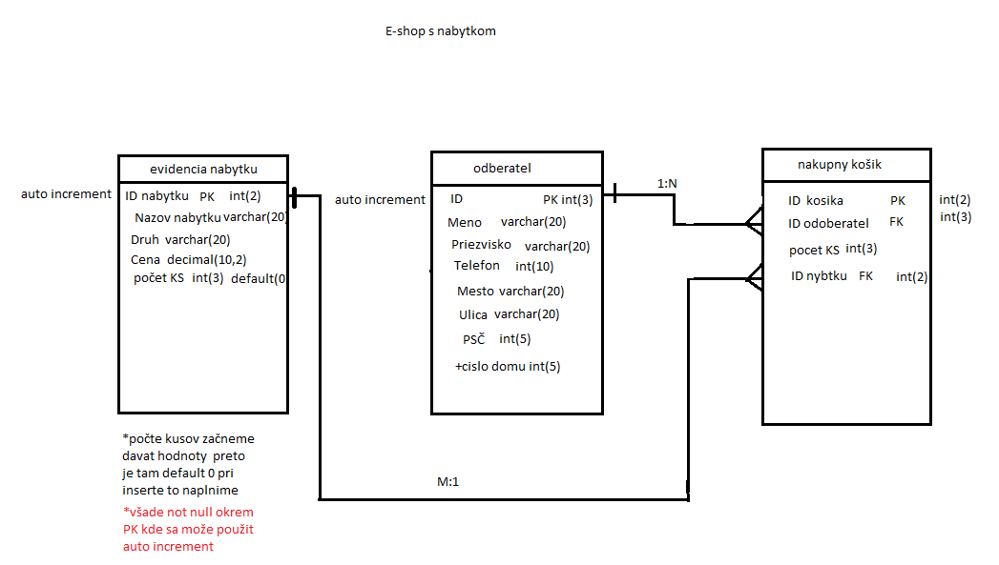

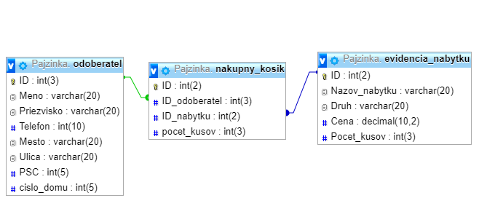

* Vytvorenie databázy -

*v našom prípade toto nedávame keďže na to nemáme pravá a robíme v databáze so svojim menom

create database e-nabytok;

use database e-nabytok;

## Vytvorenie tabuliek –

create table evidencia_nabytku(

ID int(2)auto_increment primary key,

Nazov_nabytku varchar(20) not null,

Druh varchar(20) not null,

Cena decimal(10,2) not null,

Pocet_kusov int(3) not null default"0"

);

create table odoberatel(

ID int(3) auto_increment primary key,

Meno varchar(20) not null,

Priezvisko varchar(20) not null,

Telefon int(10) not null,

Mesto varchar(20) not null,

Ulica varchar(20) not null,

PSC int(5) not null

);

*Pri vyplňovaní mi došlo že by bolo ešte asi fajn dát aj číslo domu tak som to tam pridal –

alter table odoberatel

add cislo_domu int(5);

create table nakupny_kosik(

ID int(2) auto_increment primary key,

ID_odoberatel int(3) not null,

ID_nabytku int(2) not null,

pocet_kusov int(3) not null,

foreign key(ID_odoberatel)references odoberatel(ID),

foreign key(ID_nabytku)references evidencia_nabytku(ID)

);

## Naplnenie tabuliek -

insert into evidencia_nabytku (ID,Nazov_nabytku,Druh,Cena,Pocet_kusov) values ("1","stol","stoly a stoliky","15","5");

insert into evidencia_nabytku (ID,Nazov_nabytku,Druh,Cena,Pocet_kusov) values ("2","gauc","sedacie supravy","99","10");

insert into evidencia_nabytku (ID,Nazov_nabytku,Druh,Cena,Pocet_kusov) values ("3","postel","postele","200","20");

insert into evidencia_nabytku (ID,Nazov_nabytku,Druh,Cena,Pocet_kusov) values ("4","stolicka","stolicky","9","100");

insert into evidencia_nabytku (ID,Nazov_nabytku,Druh,Cena,Pocet_kusov) values ("5","skrina","skrine a komody","50","80");

insert into evidencia_nabytku (ID,Nazov_nabytku,Druh,Cena,Pocet_kusov) values ("6","komoda","skrine a komody","500","3");

insert into evidencia_nabytku (ID,Nazov_nabytku,Druh,Cena,Pocet_kusov) values ("7","obuvnik","nabytok do predsiene","450","6");

insert into evidencia_nabytku (ID,Nazov_nabytku,Druh,Cena,Pocet_kusov) values ("8","linka","nabytok do kuchyne","450.99","5");

insert into evidencia_nabytku (ID,Nazov_nabytku,Druh,Cena,Pocet_kusov) values ("9","zahradny stol","zahradny nabytok","20.99","99");

insert into evidencia_nabytku (ID,Nazov_nabytku,Druh,Cena,Pocet_kusov) values ("10","detska skrina","detsky nabytok","99.99","50");

insert into evidencia_nabytku (ID,Nazov_nabytku,Druh,Cena,Pocet_kusov) values ("11","pracovny stolik","nabytok do pracovne","400.99","10");

insert into evidencia_nabytku (ID,Nazov_nabytku,Druh,Cena,Pocet_kusov) values ("12","vesiak","vesiaky a stojany","9.99","15");

insert into evidencia_nabytku (ID,Nazov_nabytku,Druh,Cena,Pocet_kusov) values ("13","stojan","vesiaky a stojany","5.89","20");

insert into evidencia_nabytku (ID,Nazov_nabytku,Druh,Cena,Pocet_kusov) values ("14","vozik","nabytok do kupelne","9.89","25");

insert into evidencia_nabytku (ID,Nazov_nabytku,Druh,Cena,Pocet_kusov) values ("15","zahradna kovova zostava","zahradny nabytok","520","3");

insert into evidencia_nabytku (ID,Nazov_nabytku,Druh,Cena,Pocet_kusov) values ("16","jedalenska lavica","nabytok do kuchynek","120.89","50");

insert into evidencia_nabytku (ID,Nazov_nabytku,Druh,Cena,Pocet_kusov) values ("17","kancelarske stolicky","nabytok do pracovne","152.29","48");

insert into evidencia_nabytku (ID,Nazov_nabytku,Druh,Cena,Pocet_kusov) values ("18","regal","uložne pristory","192.29","59");

insert into evidencia_nabytku (ID,Nazov_nabytku,Druh,Cena,Pocet_kusov) values ("19","vitrina","uložne pristory","189.29","78");

insert into evidencia_nabytku (ID,Nazov_nabytku,Druh,Cena,Pocet_kusov) values ("20","truhlice","uložne pristory","888.29","40");

insert into odoberatel(ID,Meno,Priezvisko,Telefon,Mesto,Ulica,PSC,cislo_domu)values("1","Richard","Pajzinka","0905890441","Rozhanovce","Duhova","04442","89");

insert into odoberatel(ID,Meno,Priezvisko,Telefon,Mesto,Ulica,PSC,cislo_domu)values("2","Erik","Halas","0905970555","Kosice","Duhova","04018","121");

insert into odoberatel(ID,Meno,Priezvisko,Telefon,Mesto,Ulica,PSC,cislo_domu)values("3","Martin","Varga","0904132456","Trebisov","Blatna","07501","1");

insert into odoberatel(ID,Meno,Priezvisko,Telefon,Mesto,Ulica,PSC,cislo_domu)values("4","Patrik","Rusnak","0901789456","Kosice","alsavska","04001","9");

insert into odoberatel(ID,Meno,Priezvisko,Telefon,Mesto,Ulica,PSC,cislo_domu)values("5","Peter","Rusnak","0901789753","Kosice","alsavska","04001","10");

insert into nakupny_kosik(ID,ID_odoberatel,ID_nabytku,pocet_kusov)values("1","1","4","6");

insert into nakupny_kosik(ID,ID_odoberatel,ID_nabytku,pocet_kusov)values("2","2","15","3");

insert into nakupny_kosik(ID,ID_odoberatel,ID_nabytku,pocet_kusov)values("3","3","10","1");

insert into nakupny_kosik(ID,ID_odoberatel,ID_nabytku,pocet_kusov)values("4","4","4","4");

insert into nakupny_kosik(ID,ID_odoberatel,ID_nabytku,pocet_kusov)values("5","5","19","1");

# Ulohy –

1. Napíšte dotaz, ktorý zobrazí všetok nábytok v ponuke zoradené abecedne podľa názvu -

SELECT Nazov_nabytku FROM evidencia_nabytku

ORDER BY Nazov_nabytku;

2. Napíšte dotaz, ktorý pridá do košíka 6ks stoličiek -

insert into nakupny_kosik(ID,ID_odoberatel,ID_nabytku,pocet_kusov)values("1","1","4","6");

3. Skopírujte obsah košíka do novej tabuľky s názvom nákup a vymažte obsah košíka -

create table nakup as(select * from nakupny_kosik);

delete from nakupny_kosik;