SATIATED

Richard Pilbery

2019-02-15

# Soiled Airway Tracheal Intubation and the Effectiveness of Decontamination by Paramedics (SATIATED): A randomised controlled manikin study

## Author information

**Richard Pilbery**  
Research paramedic  
Yorkshire Ambulance Service NHS Trust  
Springhill, Brindley Way  
Wakefield 41 Business Park  
Wakefield  
WF2 0XQ

ORCID: <https://orcid.org/0000-0002-5797-9788>

email: [r.pilbery@nhs.net](mailto:r.pilbery@nhs.net)  
tel:

**Dr. M. Dawn Teare**  
Reader in Epidemiology and Biostatistics  
University of Sheffield

**Word count:** 2598

**Keywords:** Keyword 1, keyword 2, keyword 3

## Abstract

### Introduction

Intro

### Methods

Methods

### Results

Results

### Conclusion

Conclusion

# Introduction

Vomiting and regurgitation are commonly encountered in out-hospital-cardiac arrest with a reported incidence of 20–30% (Voss et al. 2014; Simons et al. 2007). This is of concern since patients who have suffered an OHCA, are already in extremis. If standard suctioning techniques are not sufficient to maintain a clear airway and provide ventilation, then these patients will die, irrespective of the quality of chest compressions and the timeliness of defibrillation. Arguably, tracheal intubation is the preferred airway management technique in patients with ongoing airway contamination, but there is evidence that this is difficult to achieve when the airway is soiled (Sakles et al. 2017). Even if patients survive to the hospital, it is possible that aspiration pneumonias may adversely affect survival outcome, although this has yet to be proved empirically (Christ et al. 2016).

Traditional suctioning techniques have been criticised, and training in the management of contaminated airways, limited. This has led to the development of a combined suction/laryngoscopy technique to facilitate intubation, known as Suction Assisted Laryngoscopy and Airway Decontamination (SALAD), and the creation of modified airway manikins to allow for practice in these techniques (DuCanto, Serrano, and Thompson 2017).

However, to date there has only been one study specifically looking at the SALAD technique and the outcomes limited to self-reported confidence measures of trainees in using the technique. Other techniques have been described to manage significant airway contamination, including the use of a meconium aspirator (Kei and Mebust 2017), although this technique is not practical in the out-of-hospital environment (and requires a device that is not typically carried by UK ambulance services), and deliberate intubation of the oesophagus (the oesophageal diversion manoeuvre), of which the sum total of evidence in support of the procedure is a single case report (Kornhall et al. 2015).

This study aims to determine whether a short teaching session of the SALAD technique to paramedics, improves their ability to intubate a contaminated airway.The primary objective is to determine the difference between paramedic first-pass intubation success, before and after SALAD training, in a simulated soiled airway. Secondary objectives are to determine the difference in time taken to achieve first-pass intubation success, before and after SALAD training in a simulated soiled airway, and the effect of multiple intubation attempts on success rates following SALAD training.

# Methods

## Study design and participants

This randomised controlled trial was conducted in Yorkshire Ambulance Service NHS Trust (YAS). Participants were NHS staff employed by YAS, who were Health and Care Professions Council (HCPC) registered paramedics at the time of enrolment in the study, authorised to intubate and who had received no SALAD training in the previous 3 months. Potential participants were excluded if they did not meet the inclusion criteria, were allergic to the ‘vomit’ ingredients or unwilling to provide consent to participate.

## Randomisation

In order to adjust for changes in participant performance that might arise from repeated attempts at intubation, paramedics were randomised into either: making two pre-training intubation attempts and one post-training attempt (group AAB); or making one pre-training intubation attempt and two post-training attempts (ABB). Groups were evenly allocated (i.e. 1:1) using a block randomisation sequence provided by RANDOM.ORG. To distinguish between the training pathways and number of the assessed attempts, group AAB’s attempts were denoted A01A02B01 and group ABBs, A11B11B12. It was not possible to blind participants or the researcher from the group allocation.

## Intervention

### SALAD manikin

A modified TruCorp AirSim Advance airway manikin was used for the study as it has realistic airway anatomy and can be used for tracheal intubation training. The oesophagus of this manikin has been connected, via a hosepipe, to a bilge pump that is sited within a reservoir of simulated vomit (Figure 1). The vomit is water, coloured with food-grade colouring, and thickened with xanthan gum (a food additive). Once the bilge pump is switched on, it can generate a constant flow of liquid into the oropharynx, obscuring any view of the laryngeal inlet. The flow rate is controlled by a tap, which was calibrated to provide 1 L/min of vomit to the oropharynx of the manikin during intubation attempts. To keep vomit within the oropharynx, the left and right bronchi on the manikin have been occluded.

Standard intubation equipment, including personal protective equipment (PPE) and motorised suction, that is routinely used within YAS was provided for participants, and the study researcher acted as a competent assistant for the intubation attempts.

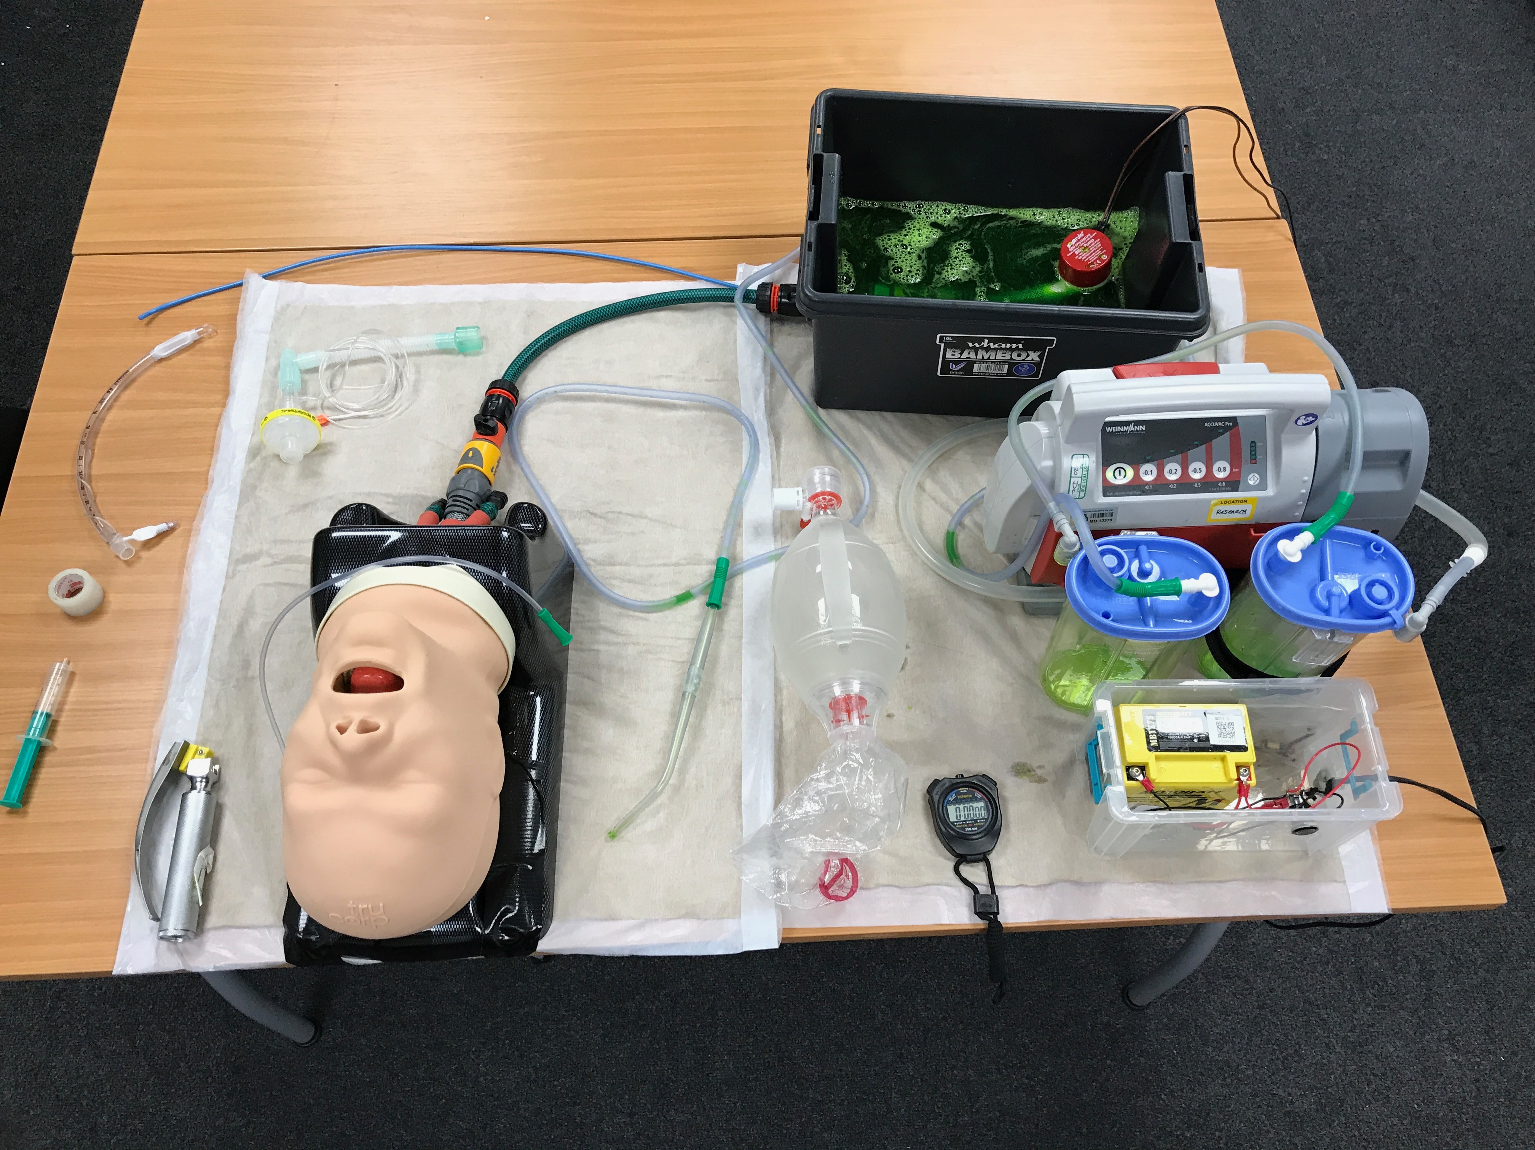

Figure 1 SALAD manikin setup used for the study

### Procedure

Once informed consent was obtained, paramedics were randomised into either group AAB or ABB. All attempts utilised direct laryngoscopy, which is the standard intubation technique within YAS. Prior to each intubation attempt, the manikin was primed with vomit to ensure the same level of oropharyngeal obstruction. All attempts were video recorded for timing accuracy.

Participants were deemed to have begun their attempt once the bilge pump was turned on. The attempt was considered to be over when either: the paramedic intubated the manikin and verbally confirmed with the researcher that the attempt had been completed or; 90 seconds had elapsed or; the tracheal tube was placed into the oesophagus and the cuff inflated while the pump was still running.

If the tracheal tube was not in the trachea, with the cuff inflated and connected to a bag-valve device within 90 seconds, the attempt was considered a failure.

Participants randomised into the two pre-training attempts group (AAB) made their second intubation attempt immediately following the first, and prior to the group training session. Once all participants completed their pre-training intubation attempt(s), the training session was delivered. The training intervention adopted the Advanced Life Support Group/Resuscitation Council 4-stage approach of skills teaching, comprising (Bullock et al. 2008):

1. A real-time demonstration of the SALAD technique by the researcher
2. A repeated demonstration with an explanation of the rationale of the steps taken when performing SALAD (not real-time)
3. Another demonstration of the SALAD technique conducted by the researcher, but guided by one of the participants
4. An attempt by the same participant who guided the researcher in the previous step, followed by a practice attempt by the other participants.

Following the training session, participants made their post-training intubation attempt(s) conducted using the same method as for the pre-training intubation attempt(s). Participants randomised into the two post-training attempts (ABB), made their second attempt immediately following the first post-training attempt.

## Outcomes

The primary outcome was the difference in proportions of paramedic first-pass intubation success, before and after SALAD training The secondary outcomes were:

* Mean of the differences in intubation attempt times, between first and second intubation attempts, and between pre- and post-training attempts
* Difference in success rates between participants who have two post-training intubation attempts versus participants who only have one post-training intubation attempt.

## Statistical analysis

## Sample size

A sample size of 154 participants was calculated to be required to determine a change in the proportion of intubation success, from 0.25 in the pre-training group, to 0.50 in post-training group, with a power (1-) of 90% and a significance level () of 5%. Given that there is no literature to guide expected performance, a conservative estimate was made in consultation with an internationally recognised SALAD expert, Dr. James DuCanto (J.DuCanto, personal communication, April 26, 2018).

### Primary outcome analysis

To determine if the training had an effect and increased the success rate of intubation, the proportions of success in the groups who received no training before their 2nd intubation attempt (A02) was compared to those who did receive training before their 2nd intubation attempt (B11). Comparing the rates at these time points, controlled for any learning effect due to participants making more than one attempt at intubation. The difference in the two proportions was analysed using a two independent samples proportion z-test, assuming a two-sided type 1 error rate of 5%.

### Secondary outcome analysis

Intubation times were truncated at 90 seconds. The mean of the differences (A01 – A02) were compared with the mean of differences (A11 – B11). The mean of the differences seen at the final measurements, (A01 – B01) were compared to (A11 – B12), to see if there were any differences between the two pathways, which might suggest that practice following the training, further improved the time to successful intubation. In addition, success rates between B01 and B12 attempts were compared to see whether practice following training improved the intubation success rate. A Student’s t-test was utilised to test for the differences between mean pre- and post-training intubation attempt times, and a two independent samples proportion z-test to test the difference in success rates.

# Results

164 participants took part in SATIATED, with an equal number in groups AAB and ABB. The groups were similar with respect to intubation attempts (successful or not) undertaken in the previous 12 months. The median number of years as a paramedic was 1.5 years less in group ABB, although the interquartile range was similar. 36 participants had heard of the SALAD technique prior to the study, with a slightly higher number in group ABB (Table 1).

Table 1 Summary details of participants

|  |  |  |  |
| --- | --- | --- | --- |
| Measure | AAB | ABB | Total |
| n | 82 | 82 | 164 |
| Median intubation attempts in past 12 months (IQR) | 2.5 (0-6) | 3.0 (1-7) | 3.0 (1-6.5) |
| Median number of successful intubation attempts in past 12 months (IQR) | 2 (0-5) | 2 (0-6) | 2 (0-6) |
| Median years as paramedic (IQR) | 5.0 (1-10) | 3.5 (0-10) | 4.0 (1-10) |
| Familiar with SALAD technique | 15 | 21 | 36 |

First-pass intubation success with and without SALAD on the second attempt, was 53.7% vs 90.2% respectively, a significant difference of 36.6% (95%CI 24–49.1%, p<0.0001).

Figure 2 summarises the intubation attempt times by participants in each randomisation group. For successful intubation attempts, group ABB was generally faster, except on attempt 2, where AAB intubated sooner (Table 2.)

Table 2 Summary data of successful intubation attempts

|  |  |  |  |  |  |  |
| --- | --- | --- | --- | --- | --- | --- |
|  | Attempt 1 | | Attempt 2 | | Attempt 3 | |
| Measure | AAB | ABB | AAB | ABB | AAB | ABB |
| Successful attempts n (%) | 29 (35.4) | 31 (37.8) | 44 (53.7) | 74 (90.2) | 71 (86.6) | 73 (89) |
| Median elapsed time to intubation attempt secs (IQR) | 7 (4–13) | 6 (3–11) | 4 (2–8.5) | 4 (2–6) | 4 (2–5.5) | 3 (2–5) |
| Median intubation attempt time secs (IQR) | 54 (46–61) | 50 (40.5–58.5) | 40.5 (32.5–57.5) | 44 (39–53) | 47 (40–54) | 41 (35–50) |
| Median total attempt time secs (IQR) | 63 (52–74) | 59 (48.5–70.5) | 49 (37.5–61.5) | 47.5 (43–58) | 51 (43.5–58) | 44 (38–52) |

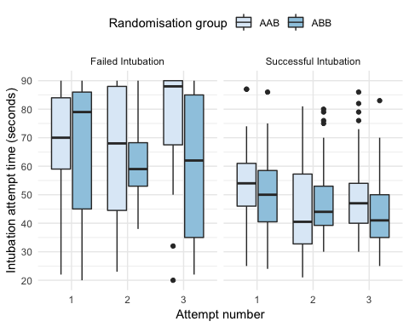

Figure 2 Intubation attempt times, stratified by randomisation sequence and intubation success

## Mean difference in successful intubation attempts

Table 3 Summary data of successful intubation attempts

|  |  |  |  |  |  |
| --- | --- | --- | --- | --- | --- |
| group | n | mean difference (secs) | standard deviation (secs) | standard error (secs) | 95% CI |
| **Attempts 1 and 2** | | | | | |
| AAB | 23 | 15.4 | 16.7 | 3.5 | 8.2–22.6 |
| ABB | 28 | 3.7 | 17.9 | 3.4 | -3.3–10.6 |
| **Attempts 1 and 3** | | | | | |
| AAB | 27 | 6.0 | 20.4 | 3.9 | -2.1–14.1 |
| ABB | 27 | 8.5 | 11.5 | 2.2 | 4–13.1 |

There was a significant difference between groups AAB (n=23) and ABB (n=28) with respect to the mean difference in time taken to perform a successful intubation on attempts 1 and 2 (mean difference 11.71 seconds, 95% CI 1.95–21.47 seconds, p=0.02). There was no significant difference between groups AAB (n=27) and ABB (n=27) with respect to mean difference in time taken to perform a successful intubation on attempts 1 and 3 (mean difference -2.52 seconds, 95% CI -11.64–6.61 seconds, p=0.58)). Summary values for the mean differences are shown in Table 3. Finally, there was no significant difference in success rates on the third attempt between AAB and ABB 89% vs 86.6% respectively, a difference of 2.4% (95%CI 7.6–12.4%, p=0.63).

## Technique

A number of techniques were utilised by participants to facillitate intubation (Figure 3). This included asking the assistant to hold the suction catheter in the mouth (n=35), and leaving with the suction in the mouth (although without occluding the suction vent hole, n=20). In addition, there were also instances where participants did not use a bougie (n=48) and forgot to occlude the suction vent hole on the catheter when attempting to clear the airway themselves (n=35).

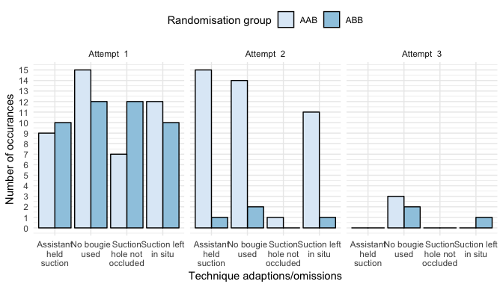

Figure 3 Bar chart showing techniques and omissions during intubation attempts, stratified by randomisation group and attempt number

# Discussion

In this manikin study, following a brief training session, paramedics were able to intubate a soiled airway on their first attempt, significantly more often when using the SALAD technique (90.2% vs 53.7%, difference of 36.6%, 95%CI 24–49.1%, p<0.001). In addition, the mean difference in time taken to perform a successful intubation between groups was signficant for on attempts 1 and 2 (mean difference 11.71 seconds, 95% CI 1.95– 21.47 seconds, p=0.02), but not attempts 1 and 3 (mean difference -2.52 seconds, 95% CI -11.64–6.61 seconds, p=0.58)). There was no significant difference in success rates on the third attempt between AAB and ABB (89.0% vs 86.6%, difference 2.4%, 95%CI 7.6–12.4%, p=0.63).

## SALAD

While some variation in the SALAD technqiue has arisen, the essential principles as described by Jim DuCanto remain the same [REF]:

1. Correct positioning of the patient for intubation success (e.g. external auditory meatus level with sternal notch)
2. Holding the suction catheter (wide-bore, rigid) in a clenched-fisted right hand, with the distal end of the catheter pointing caudad and posterior, to enable manipulation of the tongue and mandible as required
3. Leading with suction to enable identifcation of relevant anatomical structure (posterior portion of tongue, epiglottis, vallecular and laryngeal outlet) and following with the laryngoscope (particularly important with video laryngoscopes to avoid contaminating the optics)
4. Once the laryngoscope is in the vallecular and a view of the laryngeal inlet has been obtained, the suction catheter is ‘parked’ in the top of the oesophagus to provide continuous suction during the remainder of the intubation attempt
5. In order to facillitate placement of the tracheal tube, the suction catheter is moved across to the left-side of the mouth, which remaining in the oesophagus. This can be achieved by either sliding the catheter under the laryngoscope blade, or by briefly removing the catheter and inserting it to the left of the laryngoscope blade
6. Intubate as normal, with or without a bougie
7. Inflate the cuff on the tracheal tube to prevent further contamination of the lower airway
8. Suction down the tracheal tube with a flexible suction catheter prior to ventilation.

The last step in this process typically takes 7–10 seconds to complete, a fact that was overlooked during the design of this study as has likely confounded the mean timing differences aimed at identification learning that occured from multiple attempts. None of the pre-training attempts finished with post-intubation suction, whereas 100% of the post-training attempts did. Successful intubations in group AAB did show timinig improvements between attempts 1 and 2, but the delay in intubation completion in the latter attempts, might explain why there appears to be no significant difference between attempts 1 and 3.

## Suction catheters

The suction catheters used by YAS (Penine healthcare Link Yankauer 22ch with 6mm internal diameter tubing) have an internal diameter of approximately 6mm and include a vent hole. For this study, the vent hole was occluded by tape for the training and post-training attempts. Failure to occlude the vent hole did occur on occasion during some attempts, and this has been reported elsewhere. Cox et al. (2017) conducted a simulated soiled airway study with 37 emergency medicine residents, and found that 76% did not occlude the vent hole immediately on suctioning, with 60% having to be prompted to do so after 20 seconds. Catheters are available which do not contain a vent hole, which may make them more suitable for emergency situations.

Occluding the vent hole also presented a challenge for participants who left the suction in situ while continiuing with an intubation attempt. While this strategy did make it easier to recommence suction when the vent hole was re-occluded by the participant, for the remainder of the attempt, the suction catheter restricted the view of the oropharynx. One alternative strategy that some participants did use, was to utilise the assistant to hold the suction in the oropharynx, thus maintaining continuous suction.

## Limitations

This was a manikin study and as such, does not reflect clinical practice. For paramedics, most intubations they attempt will be at floor level and occur during a cardiac arrest, which is likely to result in some head and neck movement. The intubation attempts in the study by contrast were conducted on a static manikin at table height. In addition, the manikin could not be moved, so alternatrive positioning such as lateral head movement, or placing the patient in a Tredelenburg position, was not possible.

While the study did use a thickened and opaque liquid as the vomit, it did not contain any solid material, and was not as odorous as real vomit.

Finally, it was not possible to blind participants from their allocation, although they did not know that the second attempt was to be used to calculate the primary outcome. However, the researcher, acting as competent assistant did, and this may have inadvertently lead to bias. In addition, for the post-training intubation attempts, it is also possible that the researcher was too proactive in assisting with suctioning down the tube at the end of the attempt, resulting in 100% of post-training attemtps receiving tracheal suction.

# Conclusion

In this manikin study, following a brief training session, paramedics were able to intubate a soiled airway on their first attempt, significantly more often when using the SALAD technique.

# References

Bullock, Ian, Mike Davis, Andrew Lockey, and Kevin Mackway-Jones. 2008. *Pocket Guide to Teaching for Medical Instructors*. 2nd ed. Malden: BMJ Books.

Christ, Martin, Katharina Isabel von Auenmueller, Scharbanu Amirie, Benjamin Michel Sasko, Michael Brand, and Hans-Joachim Trappe. 2016. “Early-Onset Pneumonia in Non-Traumatic Out-of-Hospital Cardiac Arrest Patients with Special Focus on Prehospital Airway Management.” *Medical Science Monitor : International Medical Journal of Experimental and Clinical Research* 22 (June): 2013–20. <https://doi.org/10.12659/MSM.896867>.

Cox, Robert, Mark Andreae, Bradley Shy, James DuCanto, and Reuben Strayer. 2017. “Yankauer Suction Catheters with ‘Safety’ Vent Holes May Impair Safety in Emergent Airway Management.” *The American Journal of Emergency Medicine* 35 (11): 1762–3. <https://doi.org/10.1016/j.ajem.2017.04.009>.

DuCanto, James, Karen Serrano, and Ryan Thompson. 2017. “Novel Airway Training Tool That Simulates Vomiting: Suction-Assisted Laryngoscopy Assisted Decontamination (SALAD) System.” *Western Journal of Emergency Medicine* 18 (1): 117–20. <https://doi.org/10.5811/westjem.2016.9.30891>.

Kei, Jonathan, and Donald P. Mebust. 2017. “Comparing the Effectiveness of a Novel Suction Set-up Using an Adult Endotracheal Tube Connected to a Meconium Aspirator Vs. A Traditional Yankauer Suction Instrument.” *Journal of Emergency Medicine* 52 (4): 433–37. <https://doi.org/10.1016/j.jemermed.2016.09.006>.

Kornhall, D. K., S. Almqvist, T. Dolven, and L. M. Ytrebø. 2015. “Intentional Oesophageal Intubation for Managing Regurgitation During Endotracheal Intubation.” *Anaesthesia and Intensive Care* 43 (3): 412–14.

Sakles, John C., G. Judson Corn, Patrick Hollinger, Brittany Arcaris, Asad E. Patanwala, and Jarrod M. Mosier. 2017. “The Impact of a Soiled Airway on Intubation Success in the Emergency Department When Using the GlideScope or the Direct Laryngoscope.” Edited by Rob Reardon. *Academic Emergency Medicine* 24 (5): 628–36. <https://doi.org/10.1111/acem.13160>.

Simons, Reed W., Thomas D. Rea, Linda J. Becker, and Mickey S. Eisenberg. 2007. “The Incidence and Significance of Emesis Associated with Out-of-Hospital Cardiac Arrest.” *Resuscitation* 74 (3): 427–31. <https://doi.org/10.1016/j.resuscitation.2007.01.038>.

Voss, Sarah, Megan Rhys, David Coates, Rosemary Greenwood, Jerry P. Nolan, Matthew Thomas, and Jonathan Benger. 2014. “How Do Paramedics Manage the Airway During Out of Hospital Cardiac Arrest?” *Resuscitation*, September. <https://doi.org/10.1016/j.resuscitation.2014.09.008>.