Romario Porteous (2305778)
romarioporteous@gmail.com
Web Programming || CIT2011
Lab/Tutorial: Wednesday 6:00PM - 7:50PM
Occurrence: UE1
Individual Assignment #2 (IA#2)

WIREFRAME

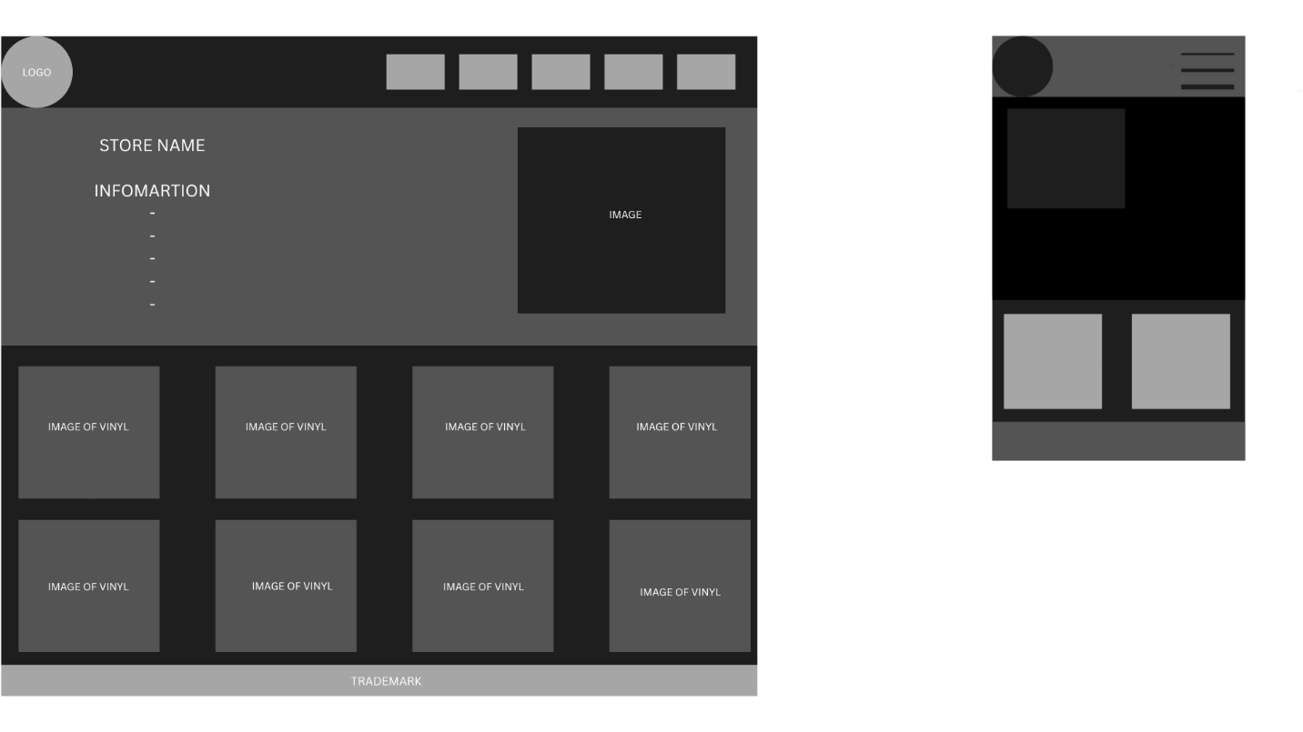

BUSINESS DESCRIPTION

Spin Culture Vinyl’s is a genre-focused vinyl store that celebrates the rhythm, emotion, and global influence of Rap, Pop, K-Pop, and R&B. We offer curated collections of iconic albums, limited-edition pressings, and fan-favorite reissues—bringing the pulse of modern music to analog lovers worldwide.

Slogan: “Drop the needle, Feel the Culture”

Mission Statement: To connect fans with the music they love through high-quality vinyl experiences that honor sound, style, and storytelling.

Vision Statement: To become the go-to vinyl destination for genre-driven collectors, blending global pop culture with the tactile joy of analog music.

INTENDED AUDIENCE

SpinCulture VInyls is designed for:
- K-Pop stans looking for exclusive pressings and idol-themed releases.
- Rap and R&B fans who value lyrical depth and classic beats on vinyl.
- Pop lovers who want to own iconic albums in a collectible format.
- Young creatives and collectors drawn to music as lifestyle and identity.

USER - DEFINED FUNCTIONS

Function Name | Purpose
loadCart() | Loads cart items from localStorage and displays them in the cart table.
updateQty(index, change) | Increases or decreases the quantity of a cart item and updates localStorage.
loadOrderSummary() | Calculates the order total (including tax) for the checkout page.
AddToCartBtn click event | Adds selected product to cart (or increases quantity if it already exists).
Clear Cart button click event | Empties the entire cart from localStorage.
Checkout button click event | Redirects user from cart to checkout page.
validateForm() | Validates checkout fields (name, email, card number, address).

GIT-HUB REPOSITORY LINK
https://github.com/romxrio/IA2-WebProgramming-2305778.git

FREE HOSTING LINK
https://691f9dfaa6501258160d1808--ephemeral-taiyaki-d6f6cb.netlify.app/

