If you are receiving the following error message, this means that your CSV file is not in the right format.

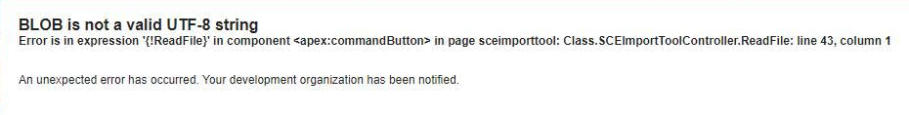

To ensure your file is in the right format follow the steps below:

1. Using the program Notepad++ find your import file and right click and choose option “edit with Notepad++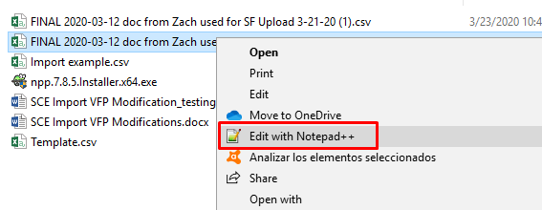
2. Once the file opens go to the Encoding tab and select “convert to UTF-8”

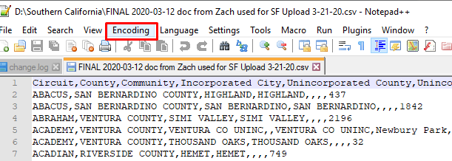

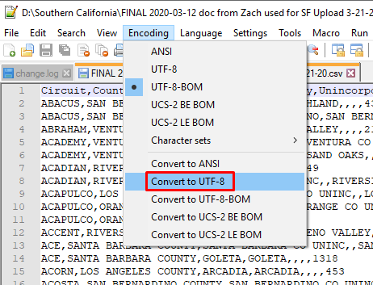

1. Save the file:

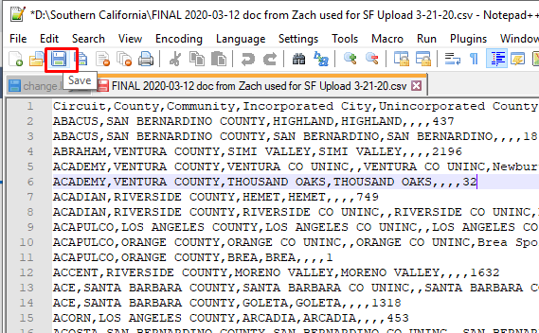

1. Now, you can import with the file converted:

