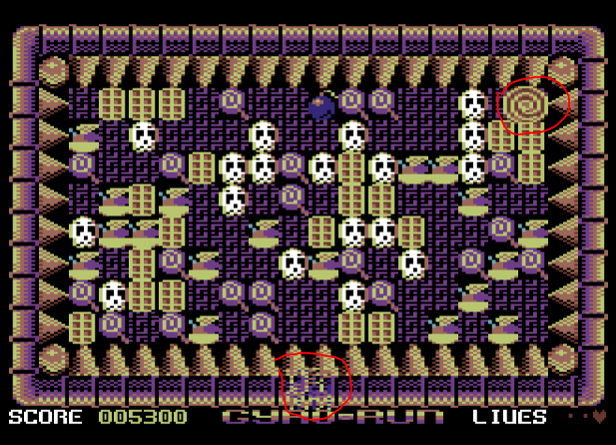

The vanishing weathervane bug happens when the spinning is on the top border. If I insist on putting the joystick on the left, the sprites will glitch and the spinning will get stuck if I press on fire. If I put the joystick to the right for a while the arrow reappears.

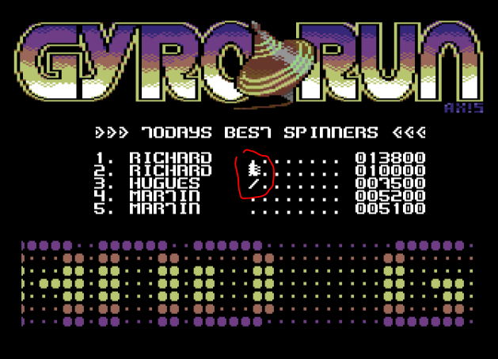

I do “enter” without entering a name. I have characters that appear.

In the second part the game crashes as it passes over the screen to enter the names.