**Project Topic:**

**An extension to, and the implementation of an intelligent charging station (software/hardware) for electric vehicles (based on embedded Linux and Ethernet) following ISO 15118 AC/DC charging with CAN bus.**

**Idea**

HHN, automotive systems engineering has developed a charging station that is capable to run the ISO15118 protocol. There is a board inside running Linux, that has a stack installed (<http://openv2g.sourceforge.net/> ) and is able to detect a car by the old CP/PP (SAEJ1772) protocol or by ISO15118

-          Task 1: get a bit familiar with 15118 (a bit only, it is HUGE)

**In English first reading:**

<http://schaufenster-elektromobilitaet.org/media/media/documents/dokumente_steckbriefe_oder_news/ISO_15118_Workshop_20151001_Stephan_Voit.pdf>

**The board is described here:**

<http://download.i2se.com/EVAchargeSE/evacharge_se_datasheet_r6.pdf>

The description is cryptic and confusing…. We are now through it and understand what is happening.

We have also the openv2g Stack running, so what is left?

**Car:**

-          Detect that a cable is plugged and lock it. Send lock status message to LED driver (CAN message). Retry if not locked, develop a retry strategy and a LED signaling scheme.

-          Do the appropriate Pre- and Post- insertion measures according to ISO 61851 (CP-PP) : <https://en.wikipedia.org/wiki/Type_2_connector> resp. <https://en.wikipedia.org/wiki/SAE_J1772> SAEJ1172

-          Start the protool, sending according messages

-          After a while, act as if the battery was full and do the according signalization (LED and/or ISO protocol and CAN message)

**Station**

-          First: Start the station via an Ethernet or via car plugged detection

-          if not: Detect, that a car is plugged

-          start the protocol

-          Lock the cable, retry if not locket etc as in the car

-          Send according messages to the Raspberry PI which is not yet programmed at all, we have a nice touch screen on the PI so we can also visualize the charging process

-          Do the visualization including communication between the board I2SE and Raspberry PI

-           If the car turns out not to run the ISO protocol, develop an according strategy to run the Type 2

**How to prepare for it:**

-          Get roughly familiar with the norms

-          Get familiar with the idea of the operation of a charging station

-          Get familiar how to run CAN on a raspberry PI including socket programming in C++

**Paper being used as reference:**

[1] Electric Vehicle Charging Infrastructure – Security Considerations and Approaches, Rainer Falk, Steffen Fries Corporate Technology, Siemens AG Munich, Germany.

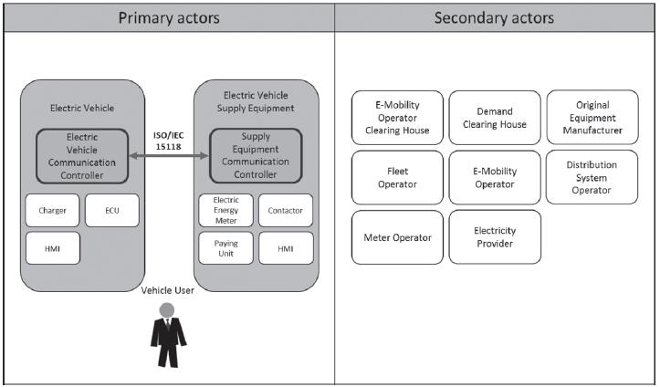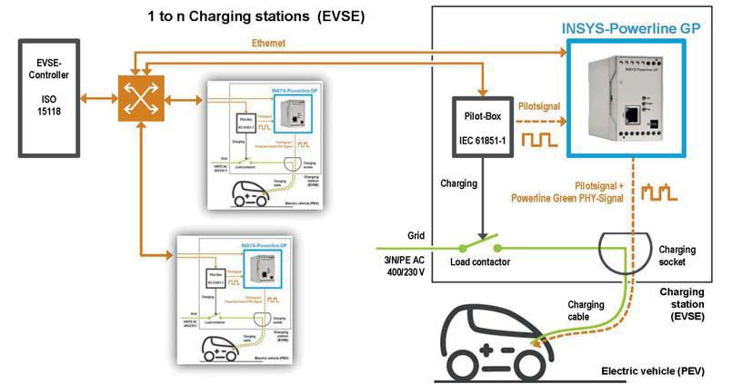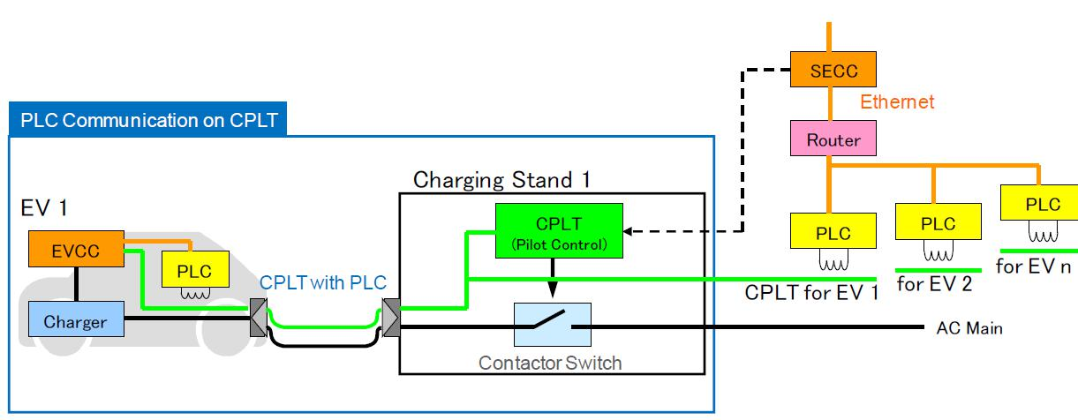**flowcharts:**

**Figure 1 ISO/IEC 15118 actors**

**Figure 2 The INSYS Power line GP as a commercial solution**

**Figure 3PLC communication on Control Pilot Line (CPLT)**

**Abstract: ISO/IEC 15118-1:2013**

ISO 15118 specifies the communication between Electric Vehicles (EV), including Battery Electric Vehicles and Plug-In Hybrid Electric Vehicles, and the Electric Vehicle Supply Equipment (EVSE). As the communication parts of this generic equipment are the Electric Vehicle Communication Controller (EVCC) and the Supply Equipment Communication Controller (SECC), ISO 15118 describes the communication between these components. Although ISO 15118 is oriented to the charging of electric road vehicles, it is open for other vehicles as well.

ISO 15118-1:2013 specifies terms and definitions, general requirements and use cases as the basis for the other parts of ISO 15118. It provides a general overview and a common understanding of aspects influencing the charge process, payment and load levelling.

ISO 15118 does not specify the vehicle internal communication between battery and charging equipment and the communication of the SECC to other actors and equipment (beside some dedicated message elements related to the charging). All connections beyond the SECC, and the method of message exchanging are considered to be out of the scope as specific use cases.

### **Abstract – IEC 61851-1: 2010 :**

IEC 61851-1:2010 applies to on-board and off-board equipment for charging electric road vehicles at standard a.c. supply voltages (as per IEC 60038) up to 1 000 V and at d.c. voltages up to 1 500 V, and for providing electrical power for any additional services on the vehicle if required when connected to the supply network. It includes characteristics and operating conditions of the supply device and the connection to the vehicle; operators and third party electrical safety, and the characteristics to be complied with by the vehicle with respect to the a.c./d.c. EVSE, only when the EV is earthed. This second edition cancels and replaces the first edition published in 2001. It constitutes a technical revision. The main changes with respect to the first edition of this standard are:  
- revision of connector definitions and current levels (Clause 8);  
- modification definition of pilot wire to pilot function;  
- division of Clause 9 to create Clauses 9 and 11;  
- Clause 9: specific requirements for inlet, plug and socket-outlet;  
- Clause 11: EVSE requirements: the basic generic requirements for charging stations;  
- renumbering of annexes;  
- deletion of previous Annex A and integration of charging cable requirements into new Clause 10;  
- Annex B becomes Annex A and is normative for all systems using a PWM pilot function with a pilot wire; Annex C becomes Annex B;  
- replacement of previous Annex D (coding tables for power indicator) with B.4 in Annex B using new values;  
- new informative Annex C describing an alternative pilot function system.   
  
This publication is of high relevance for Smart Grid.

**CAN Bus Protocol: ISO 11898**

A Controller Area Network (**CAN bus**) is a vehicle **bus**standard designed to allow microcontrollers and devices to communicate with each other in applications without a host computer.

CAN is a multi-master serial bus standard for connecting Electronic Control Units [ECUs] also known as nodes. Two or more nodes are required on the CAN network to communicate. The complexity of the node can range from a simple I/O device up to an embedded computer with a CAN interface and sophisticated software. The node may also be a gateway allowing a standard computer to communicate over a USB or Ethernet port to the devices on a CAN network.

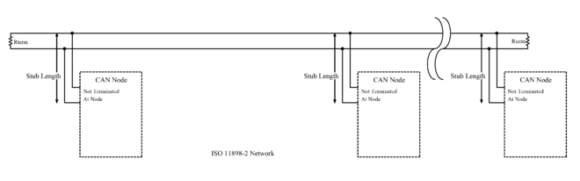

Figure 4 ISO 11898-2

All nodes are connected to each other through a two wire bus. The wires are 120 Ω nominal twisted pair.

**ISO 11898-2**, also called high speed CAN, uses a linear bus terminated at each end with 120 Ω resistors.

**ISO 11898-3**, also called low speed or fault tolerant CAN, uses a linear bus, star bus or multiple star buses connected by a linear bus and is terminated at each node by a fraction of the overall termination resistance. The overall termination resistance should be about 100 Ω, but not less than 100 Ω.

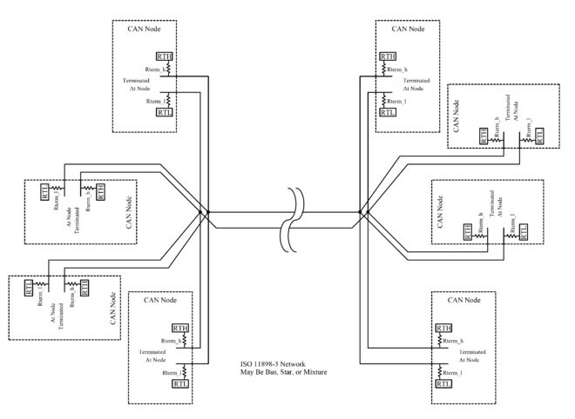

Figure 5 ISO 11898-3