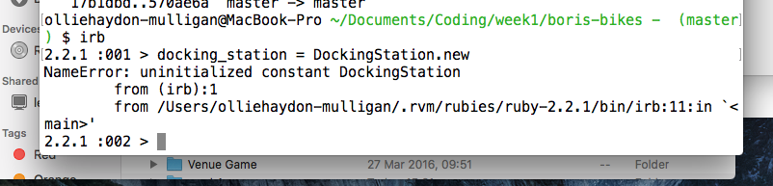

error type is NameError

the error happened in irb: /Users/olliehaydon-mulligan/.rvm/rubies/ruby-2.2.1/bin/irb:11:in `<main>

the error means DockingStation does not exist as a class of which instances can be initialized (with the ‘.new’ method)

suggested solution:

