Instructions for Using the MODFLOW-2000 Model Archive and DiffInterface
By Richard B. Winston
July 31, 2007
rbwinst@usgs.gov

MODFLOW-2000 Model Archive
The models in the MODFLOW-2000 model archive are intended to be used for comparing the results of different versions of MODFLOW-2000. Significant differences between the model results with one version of MODFLOW-2000 as compared to another may mean that a bug has been introduced into MODFLOW. (It could also mean that a bug has been fixed.)
To make the comparison, the user should place a revised copy of MODFLOW-2000 in the “bin” directory and then run each of the batch files in either the “run” directory. All the archived files in the run directory were created with MODFLOW 2000 version 1.17.03. The name of the revised version of MODFLOW must be “mf2k.exe”. The models in the archive are modified versions of the models distributed with version 1.16 of MODFLOW-2000 plus one additional model (testsfr2 from MODFLOW-2000 version 1.17.02) The input files of the models have been modified to direct the output of the models to the “binary” and “test” subdirectories of the “run” directory. The batch files have been modified to create the correct directories if they do not exist and in one case to move some output files to the correct directory. In addition, the printout intervals for the solvers were changed so as to minimize the printing of solution information. No other changes have been made to the models. In the future, additional models may be placed in the archive.
The program DiffInterface can be used to compare the new and archived model results to determine if significant differences exist between them. DiffInterface has not been documented in a USGS report so it is not appropriate to place it on a public web page at this time.

DiffInterface

Introduction
When numerical modeling programs are changed, it is important to test whether the changes have introduced new bugs into the program. Such bugs typically result in the program generating incorrect results. DiffInterface is tool to compare model results generated from two different versions of the same numerical modeling program. If significant differences are found, there must have been a significant change to the modeling program. The change might be the introduction of a bug or correction of a bug.
DiffInterface makes use of the open source program “diff” (http://gnuwin32.sourceforge.net/packages/diffutils.htm) to compare lines of text output generated by two different versions of a modeling program. Diff, however, will report all differences between a pair of files. DiffInterface allows the user to filter those differences so that the some of the insignificant differences are ignored.
DiffInterface runs on Windows computers.

Installation
To install DiffInterface, first get the installer for “diff” from http://gnuwin32.sourceforge.net/packages/diffutils.htm and run it. Then place DiffInterface.exe in any convenient folder.

Running DiffInterface
To run DiffInterface, double click on its icon in Windows Explorer. When the program starts, it will appear as in figure 1.

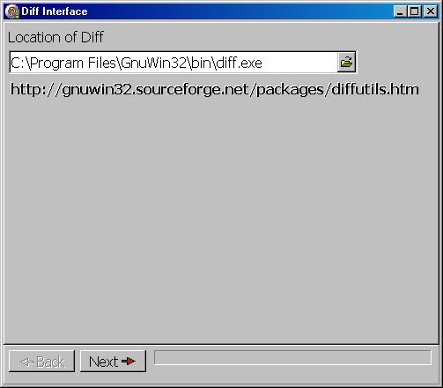
Figure 1. Initial appearance of DiffInterface
If “diff” is present at the location in the edit box (the default installation location), the “Next” button will be enabled. Otherwise, enter the correct location or click the open file button next to the program location to browse to its location. If “diff” is not installed, the user can click on the link in the program to go to the web site for “diff”. When the location for “diff” is correct, the user clicks the “Next” button and the lists of files to compare will appear (figure 2).

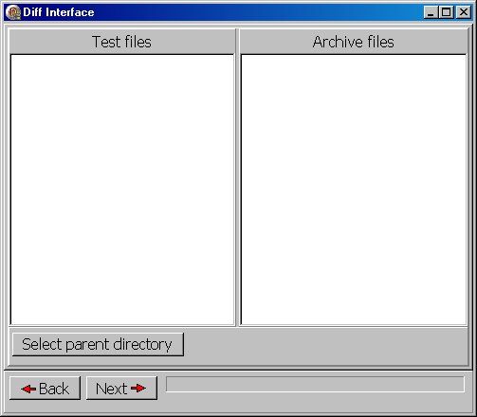
Figure 2. Selecting files to test.
In Diff Interface, it is assumed that all the files that are to be compared have the same file names. However, they are placed in different directories. One of the directories must be named “archive” and the other must be named “test”. (The files may also be in subdirectories of the “archive” and “test” directories.) The “archive” and “test” directories must both be subdirectories of the same directory. When the user clicks the “Select parent directory” button, DiffInterface will search for all the files in each directory and place their names in the “Test files” or “Archive files” lists respectively (figure 3). (If desired, the user can resize each list or the window as a whole to see the full file names.) To use Diff Interface with the MODFLOW-2000 model archives, the user should select the “run” directory.

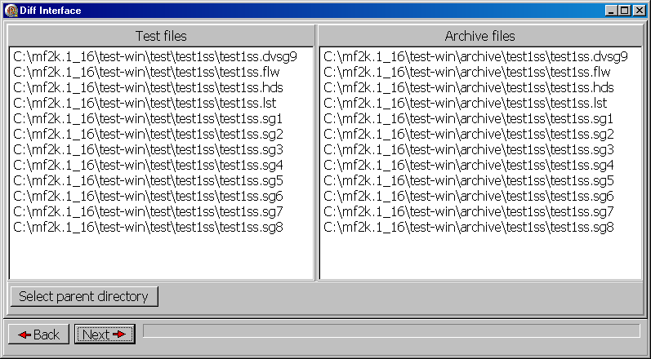
Figure 3. Files to be compared are listed.
If any file in the test or archive directories does not have a corresponding file in the other directory, the names of the missing files will be displayed (figure 4). All such files will be skipped when performing the comparisons. When ready, the user presses the Next button to proceed.
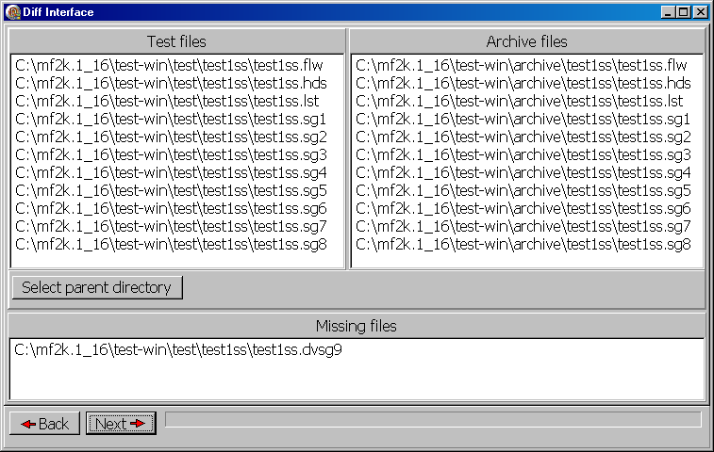
Figure 4. Missing files.
At this point, the user defines the criteria for deciding whether or not a difference is significant. Any line that contains one of the lines in the text field near the top will be skipped (figure 5). In addition, numeric values can be skipped, if either the relative or the absolute difference is less than the value displayed in the corresponding edit box (figure 5). For example, if the program was set up as in figure 6, any lines containing
“IN - OUT =” would be skipped because “IN - OUT =” is include in the text field.
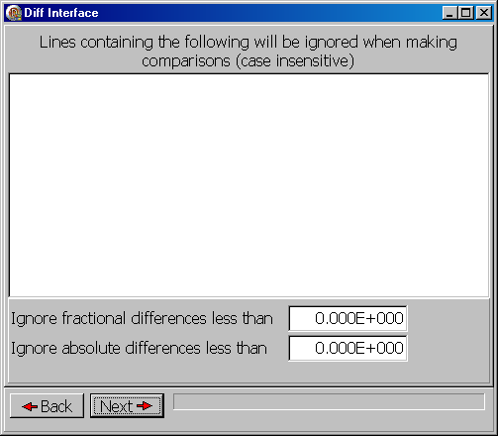
Figure 5. Fields for identifying significant differences
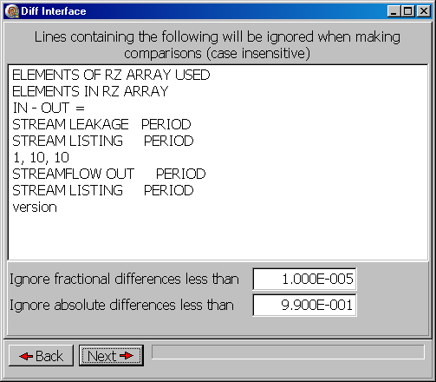
Figure 6. Examples of criteria for ignoring differences

To begin with, it is probably a good idea to show all differences so the text field would be empty and both the fractional and absolute differences would be set to zero.
When ready, the user presses the Next button to perform the comparison. The progress bar will advance as each file is processed. When all have been processed, the user can then display the differences. The files containing the differences will be displayed in a tree control in the top half of the window. (If no significant differences are found in any of the files, the tree control will be empty.) Below each file is a list of the groups of lines that contain the differences. When the user clicks on one of these groups of lines, the differences are displayed in the lower half of the window (figure 7). If desired, the user can resize either the program as a whole or the relative size of the tree control and difference display.
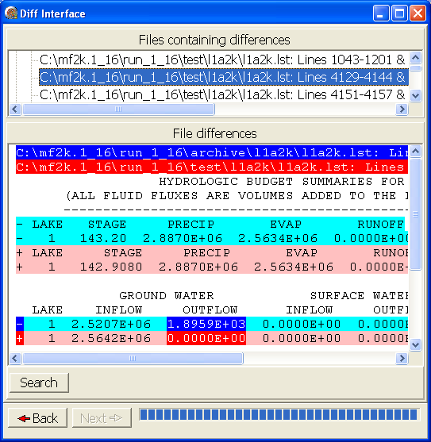
Figure 7. Significant differences are highlighted.
In the difference display, the first two lines show the names of the files that are being compared and the lines that are being compared. (The line numbers may or may not be identical.) Each file name is highlighted in a different color. In the rest of the text field, significant changes are highlighted with those same colors. Lines that contain other differences that are not considered significant are also highlighted but in less intense versions of the colors used to highlight the significant differences. Each line that differs between the two files being compared will have a “+” or a “-“ in front of it. If the differences are significant, the “+” or “-‘ will be a bright color. Otherwise, it will be a less intense color.
The user can examine the differences identified as significant. If the user considers the differences to be insignificant, the user can click the back button to return to defining the significant differences (figure 6) and then rerun the analysis by clicking the Next button.
It is often helpful to look at where significant differences occur before deciding to ignore them. Doing so can help prevent the user for inadvertently ignoring lines that should not be ignored. The “Search” button in the difference display can be used for this purpose.

Results of Model Comparisons
When comparing the model output generated by MODFLOW-2000 version 1.16 to those generated by MODFLOW-2000 version 1.17.01, a number of differences were noticed. For example, with version 1.16 in l1a2k.lst, line 185 was
SPACE ALLOCATION FOR 1445 GRID CELL FACES ADJACENT TO LAKES
Whereas with version 1.17.01, the corresponding line was
SPACE ALLOCATION FOR 722 GRID CELL FACES ADJACENT TO LAKES
This difference turned out not to be a bug. Nevertheless, the difference was worth investigating and highlighting it was a good response.
Diff Interface was not able to filter out all non-significant differences. For example, changes in the SFR and Lake package algorithms resulted in small differences in the output especially in the solver information such as the maximum head change per iteration and location of the maximum head change. Thus, Diff Interface is helpful but not perfect in testing for significant differences between different versions of a model.

