**Interactive Image Segmentation**

About Project

This program will implement an interactive clustering routine for image segmentation on a mobile device. It will begin by automatically clustering the image and then by using user defined foreground and background pixels the segmentation of the image will occur.

Usage

Double-Tap -> Clear changes and change image

Long-Press -> Clear changes, reloads same image

Swipe (Up/Down) -> Perform clustering initially

Swipe (Left/Right) -> Remove background from image and only show foreground

Tap *after initial clustering* -> Choose foreground and background respectively

Tap *after selecting 2 points* -> rerun clustering algorithm

NOTE: all other functionality such as zoom, rotate and multi clustering have been disabled in this project although they are written

Program Flow

1. The user will first select an image from the predefined library. This will cause the next image to be loaded and the previous clustering to be cleared.
2. The user will then swipe the screen in any direction (Up/Down) to perform the initial clustering (Note: clustered image will not show until user selects foreground and background respectively)
3. The user will select foreground and background pixels respectively *they will be marked with gray and black circles*
4. The user will tap the screen again to rerun clustering algorithm based on their input
5. The user can continue testing different pixel assignments for the same image or choose new image
6. The user can swipe (Left/Right) AFTER initial segmentation to show original pictures foreground.

Screenshots of application:

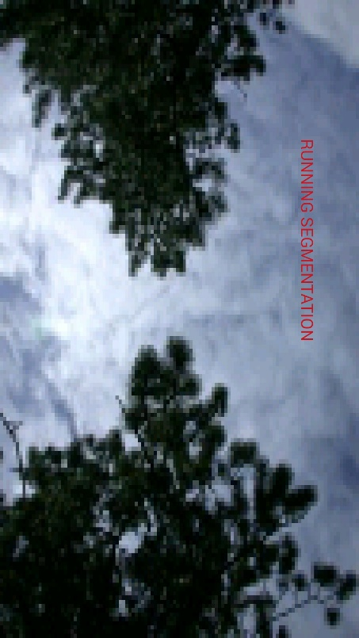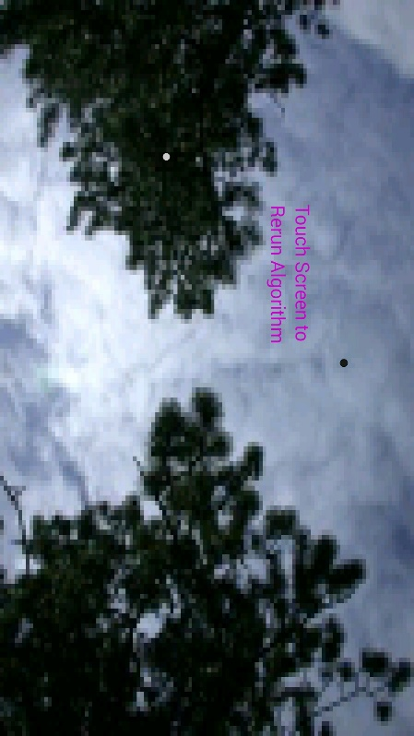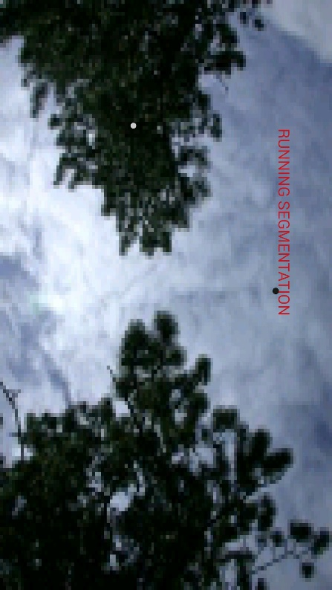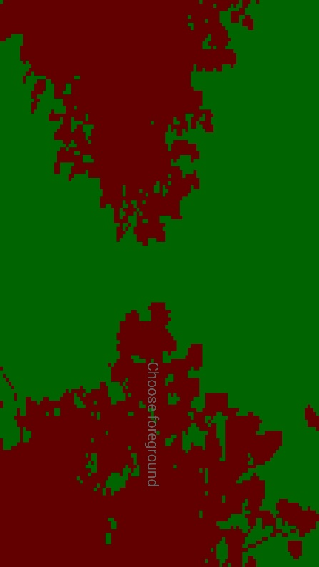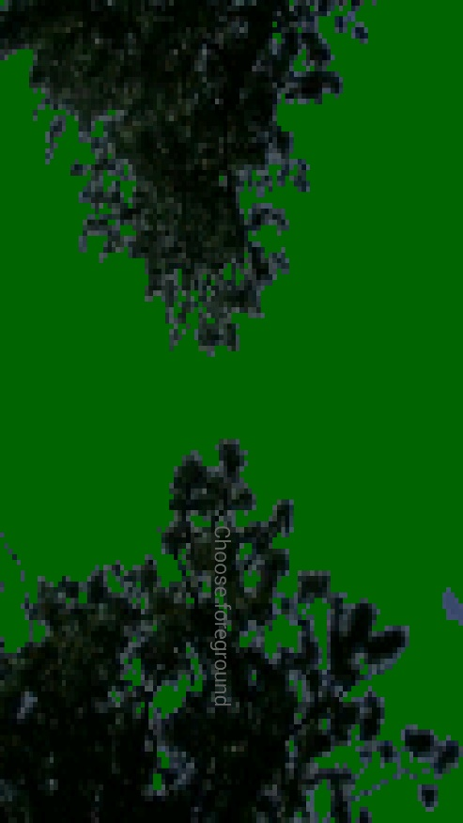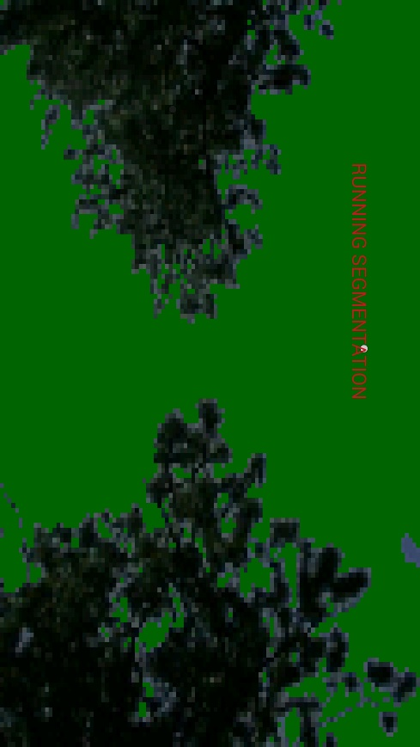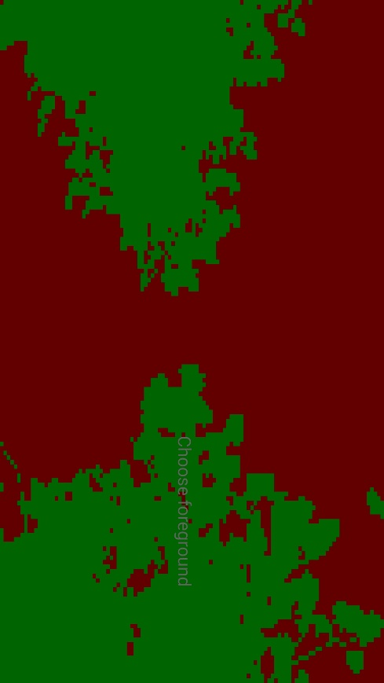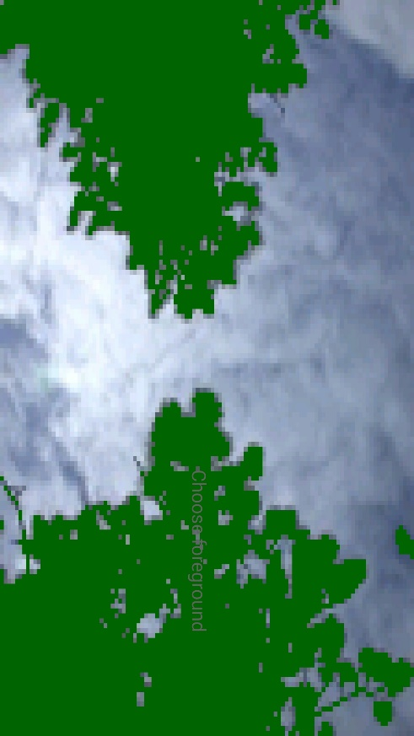

Developer Notes and issues

* There are times where a thread would randomly end causing task to end prematurely
* There is a half written implementation of graph-cut within the code
* To add image
  + Place image in data folder
  + Add image name to “picDatabase” array
* The algorithm works best on images with high contrast (i.e. the tree image works a lot better with the application than the cheetah image)