**Report**

**Computer Science**

**Quiz**



**Task1**

A primary school teacher wants a computer program to test the basic arithmetic skills of her students. The program should generate a quiz consisting of a series of random questions, using in each case any two numbers and addition, substraction and multiplication. These system should ask the students name, then ask 10 questios, output if the answer to each question is correct or not and producea final score out of 10.

When i just read the above stated task i gain the information that i will have to create random numbers, a score and 10 randomly generated questions.

First of all i need libraries to perform the planes:

:Bildschirmfoto 2015-04-29 um 18.42.54.png stdio is the standart library(input and output). time is needed to generate random numbers

math is used to perform mathematical equations.

stdlib is the standart library. [1]

My next Stepp is to declare variables which i will need later on:

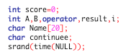Score=0 means that at the beginning the score is =.

A and B will get a radom number and result is needed to store my result. I appears only i for loops. Name[20] tells the program that the name can only consists of 20 characters. At least i declared the random number operator.

The next part basically asks the user for his name and wether i want to continue:

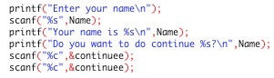 Prints the text in t terminall as well as the next line.

The answer of the question is stored as continuee.

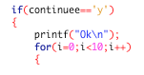 When my answer , saved as continuee was y the program would print Ok to say that it succeeded and will start to perform for lloop with all its content. The for loop states that all t the informations are only done 10 times.

The following code will create a question with a specific operator and randomly numbers in it.

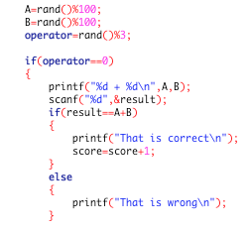First of all the program selects random numbers for A and b. Than it also chooses a number between 0 and 3 for the operator. It depends on the operator which opertor, type of question, is performd. In this case the operator is 0 and consequently a plus operation becomes set up. The program prints the equation into terminal and will save an expected result as result. Afterwards it checks if the result is corret, when yes that the Output is a printed text „That is

Correct“ or „That is wrong“. It also adds a point to your result when your result is correct. The same procedure occurs when operator is 1 (plus), 2 (x) and 3 (:) . [2]

After successfully creating of mathematical tasks i want a finsl score:

:Bildschirmfoto 2015-04-29 um 18.57.17.png

The code adds a final score to terminal.

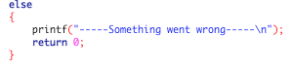

At the beginning i could say y, i want to continue or n, i dont want. If continuee is n, than the program prints „Something is wrong“ and ends.

The following figure represents a flow chart for my code:

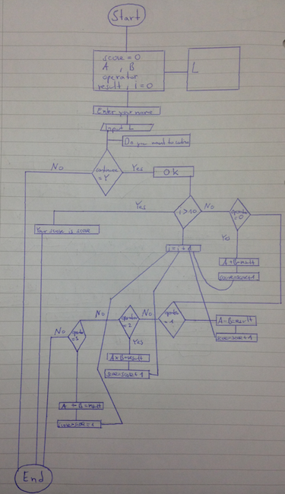

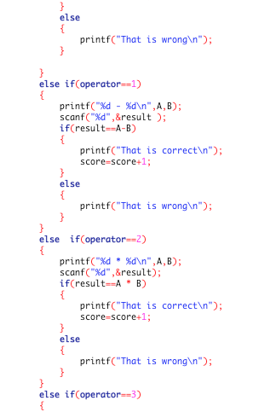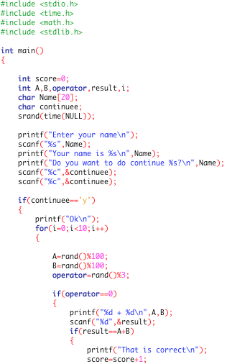

**2**

**1**

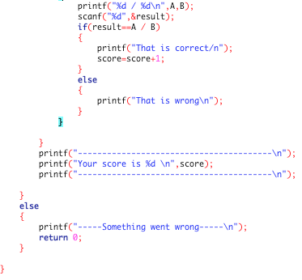

**3**

**Task2**

The teacher wants to keep track of the scores each member of the class obtains in the quiz. There are three class in the school and the data should be kept separately for each class. Analyse the requirements in detail fort his program and design, code, test and evaluate a program that will record and store the data for three separate classes of students using the arethmetic quiz.

By reading the task i immediately recognized that i will need to store the datas into a file. So my task is to find out how to include a file into my code and the program should ask the user for his class:

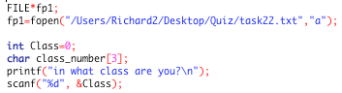

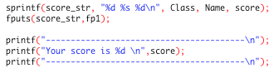In this part two things happen. First of all i declared importend variables for my file. FILE*fp1 means that i declared a pionter of type file for communication between file and program. The next line opens a file with help of the library function command fopen and it is also stated where the file is. A is used to tell the program to create a file if one does not exist.

The next two lines potter at the topic class. Class is declared and gets the value 0 for the beginning and only 3 classes exist. After that the program will ask the user for his class and savest he respond as Class. [3]

To the normal result which is printed into terminal i added two lines which are responsible that The username, class and score is added to a file.

The first line, sprintf sends outputs (in this case Class, Name and score to a pointer which refers to a file. Fputs is used to print the already created pointer into a file. [4]

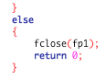

At the end i not only want to end terminal but also to close the file. [5]

The flow chart shows only the party that i added to solve task 2:

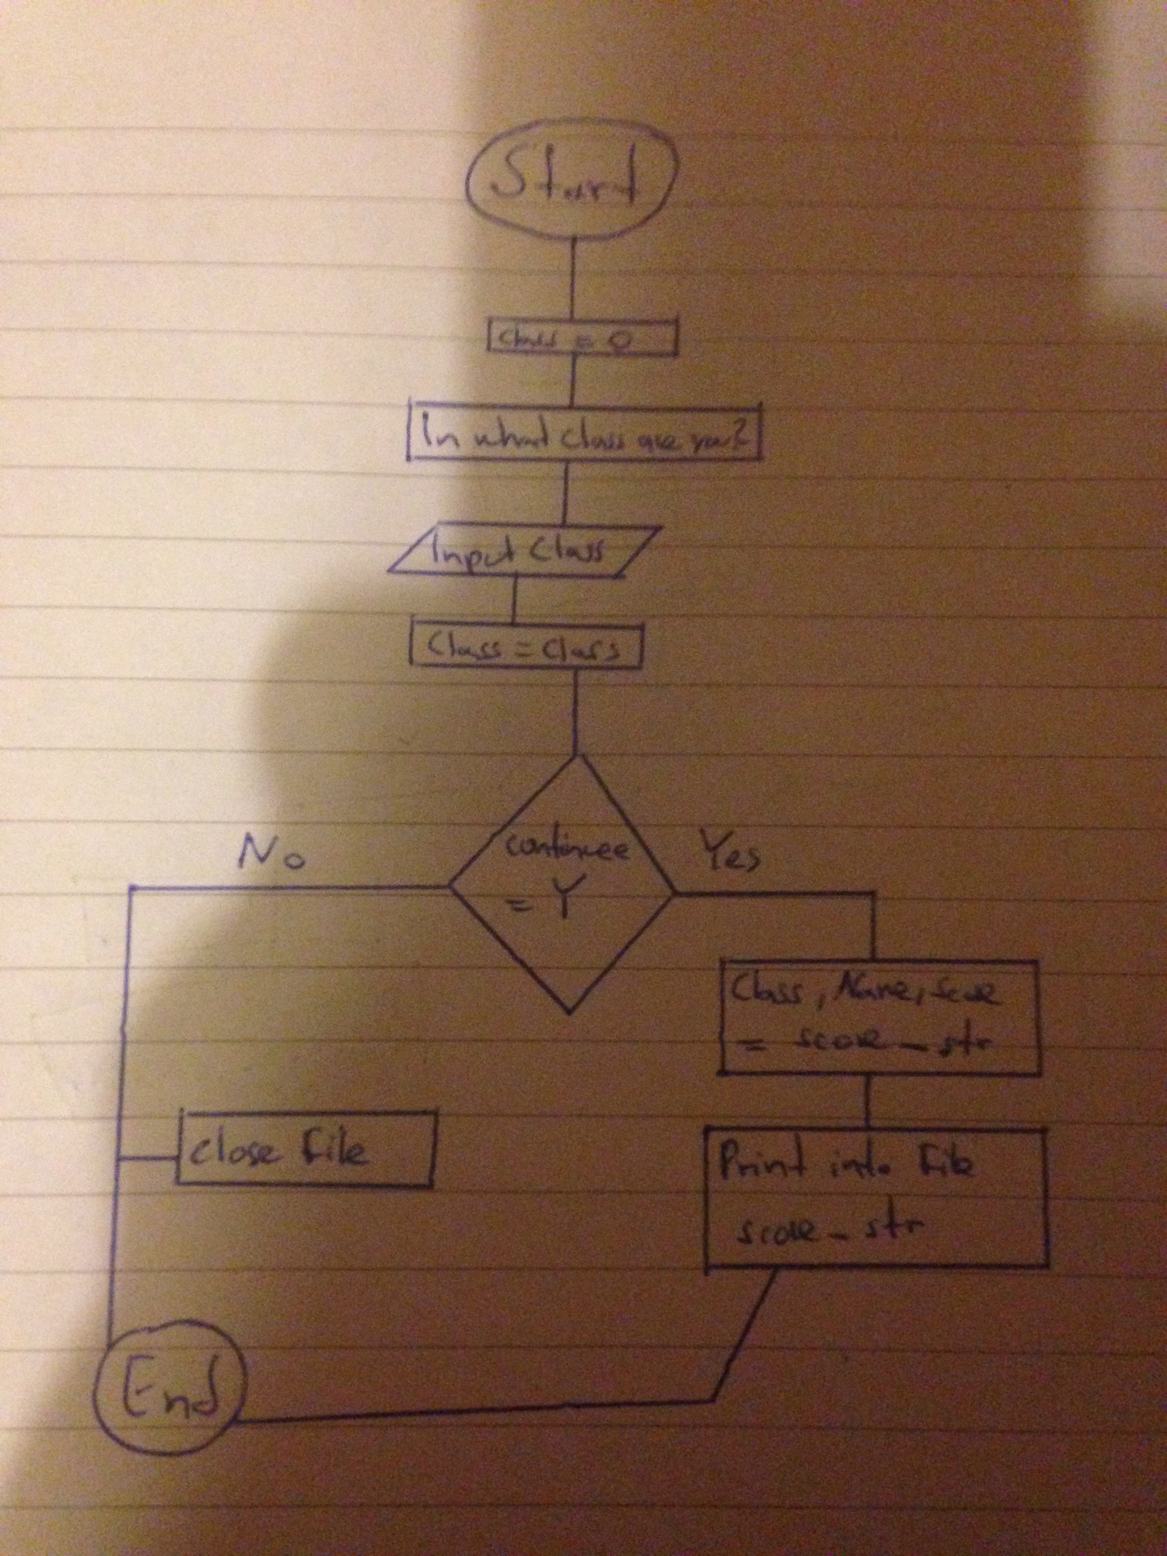

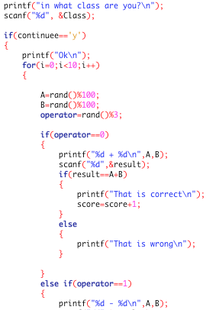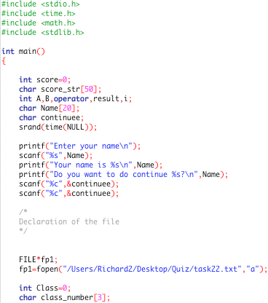

**2**

**1**

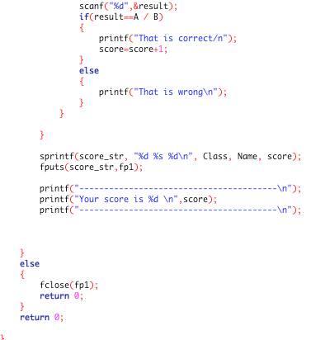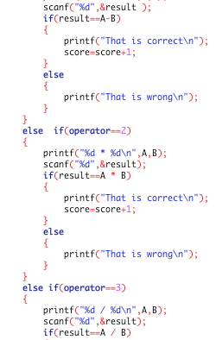

**4**

**3**

**Task2**

The task description tells that i have to do a couple of various things such as change the order or store only the last three scores. To be able to perform any of those task i must be able to manipulate the file content which would involve the separating of the file content in Class, Name and score. To be able to do that i developed the following code:

The teacher wants to use the results from students taking these quizzes to log their performance. The system should store the last three scores for each student. The teacher would like to be able to output the results of the quiz for a particular class, sorted: in alphabetical order with each student’s highest score fort he tests, by the highest score, highest to lowest and by the average score, highest to lowest.

Anylyse the requorements in detail fort his program and design, code and evaluate a program that will allow the teacher to select which class group to look at and shich field to use when sorting the output data.

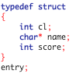 typedef is used to create a new data type for a structure ( struct). Struct is a structure-object. We use this combination to create and declare new data types. The name of this group is entry. With use of the structure name(entry) you can get access to those informations. [6]

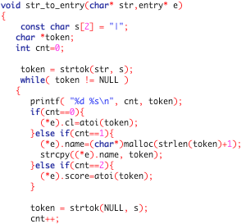

Void is commonly used to say that there is no data transfer or that the data type is unknown. In our case it marks the start of a function. A function is a group of statements which together perform a task to decrease the size of a program and to divide the tasks into separately party. Voids meansthat there is no data transfer ort hat the type of data is and to divide the tasks into separately party. Voids meansthat there is no data transfer ort hat the type of data is nunknown. Inn the same line i give the letter e to the above created entry. Const char secures that the figure | can not be changed during the program. The next few lines are separating the content of e into three different parts (Class, Name and score). [7] [8]

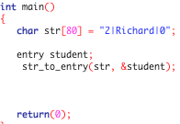

This is the main part of our program. Into that party i declared what text has to be seperated and how long the text can be.

The following code is above described steps:

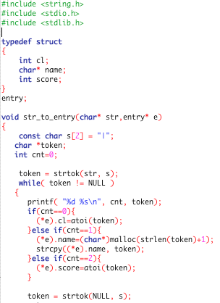

**1**

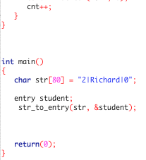

**2**

**Evaluation**

I did the evaluation to show that my program is working and can handle with problems.

**Task1**

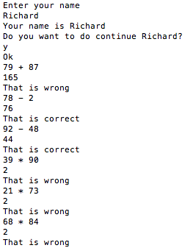

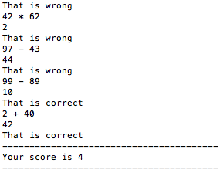

A correct score was printed.

I could successfully enter my name and continued. Equations became generated.

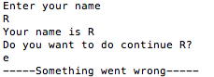

If i press input another letter then y or n, then the program will recognize that something is wrong.

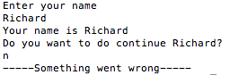

The program ends as expected.

**Task2**

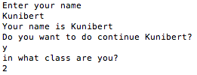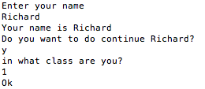

I proved that i there are three classes to choose. However it is possible to enter class 4 or 12.

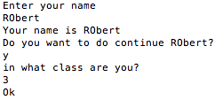

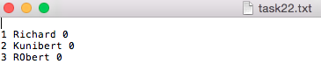

I checked that Class, Name and score are stored into a file.

**Task3**

**:Task3:Evaluation:Bildschirmfoto 2015-04-29 um 22.13.19.png**

The programm separated a text „2|Richard|0“ into three separate parts subdivided over three lines, each marked with a referring line number.

**Success criteria**

|  |  |
| --- | --- |
| Did i understand the basics? | Yes, through out the taks i was able to understandt commands and their practical use. |
| Adding of own ideas. | Yes, to enlarge my posibilities i added a particular coding which asks the user wether he want to continue or not. |
| Was there logical thinking during the project. | Yes, without logical thinking in the project i would not be able to use and compare already known informations from privious tasks. |
| Does everything work? | Yes, everything which i program worked as expected. |
| Did i finished everything? | No, i did task3 only party since i have not understand the concept. |
| Did i followed the task strictly. | No, on some specific parts i changed the task slightly to add own ideas. |

**Conclusion**

Overall i can say that the project was a success for me since i was or am able to include files in my code which can be felpful for future use or personal tasks. Through out the report i showed a clearly order which can be very useful and crucial when i need to lokk back during other tasks. I generated these program to be able to store datas into a file and to train basic programming skills.

I learnd the declaration of files and a couple of other things such as separating of a text or arrays.

I hope that i will be able in the future to do task3 without problems because it seems to be a good source of additional knowledge.

Previous projects have been very helpful since they trained my ability to perform c language and they teached me as well how to do a project.

I think that this course work was successful and a good source of tasks which refreshed my knowings about c language.

**Sources**

**Task1**

1. <http://de.wikipedia.org/wiki/C-Standard-Bibliothek>

2. <http://en.wikipedia.org/wiki/Operators_in_C_and_C%2B%2B>

3. <http://www.programiz.com/c-programming/c-file-input-output>

**Task2**

4. <http://www.tutorialspoint.com/c_standard_library/c_function_sprintf.htm>

5. <http://www.codingunit.com/c-tutorial-file-io-using-text-files>

**Task3**

6. <http://www.c-howto.de/tutorial-strukturierte-datentypen-strukturen-struct-synonyme-typedef.html>

7. <http://de.wikipedia.org/wiki/Void_(Schlüsselwort>)

8. <http://www.tutorialspoint.com/cprogramming/c_functions.htm>

1. 30.4.15/ I used that source to find out something about libraries.

2. 30.4.15/ Explanation and to see what kind of operator i will need.

3. 30.4.15/ To explain FILE*fp1 and fclose.

4. 30.4.15/ Defenition for sprintf.

5. 30.4.15/ General exolanation how include a file.

6. 30.4.15/ How to use typedef struct.

7. 30.4.15/ Defenition of void.

8. 30.4.15/ What is a function.