# Tableau Lab Answer Sheet – Independent Activity Part 1

Use this answer sheet to answer the questions with the **red squares ⬜** from the Tableau Lab (see lab handout for the entire set of instructions). You can include partial screenshots of displays/visualizations if the entire display is too big. We just want to know that you were able to generate the answer/transformation.

**Question 6: Which movies were about dragons?**



**Question 9: Are there directors who have never directed a profitable movie? Who are they?**

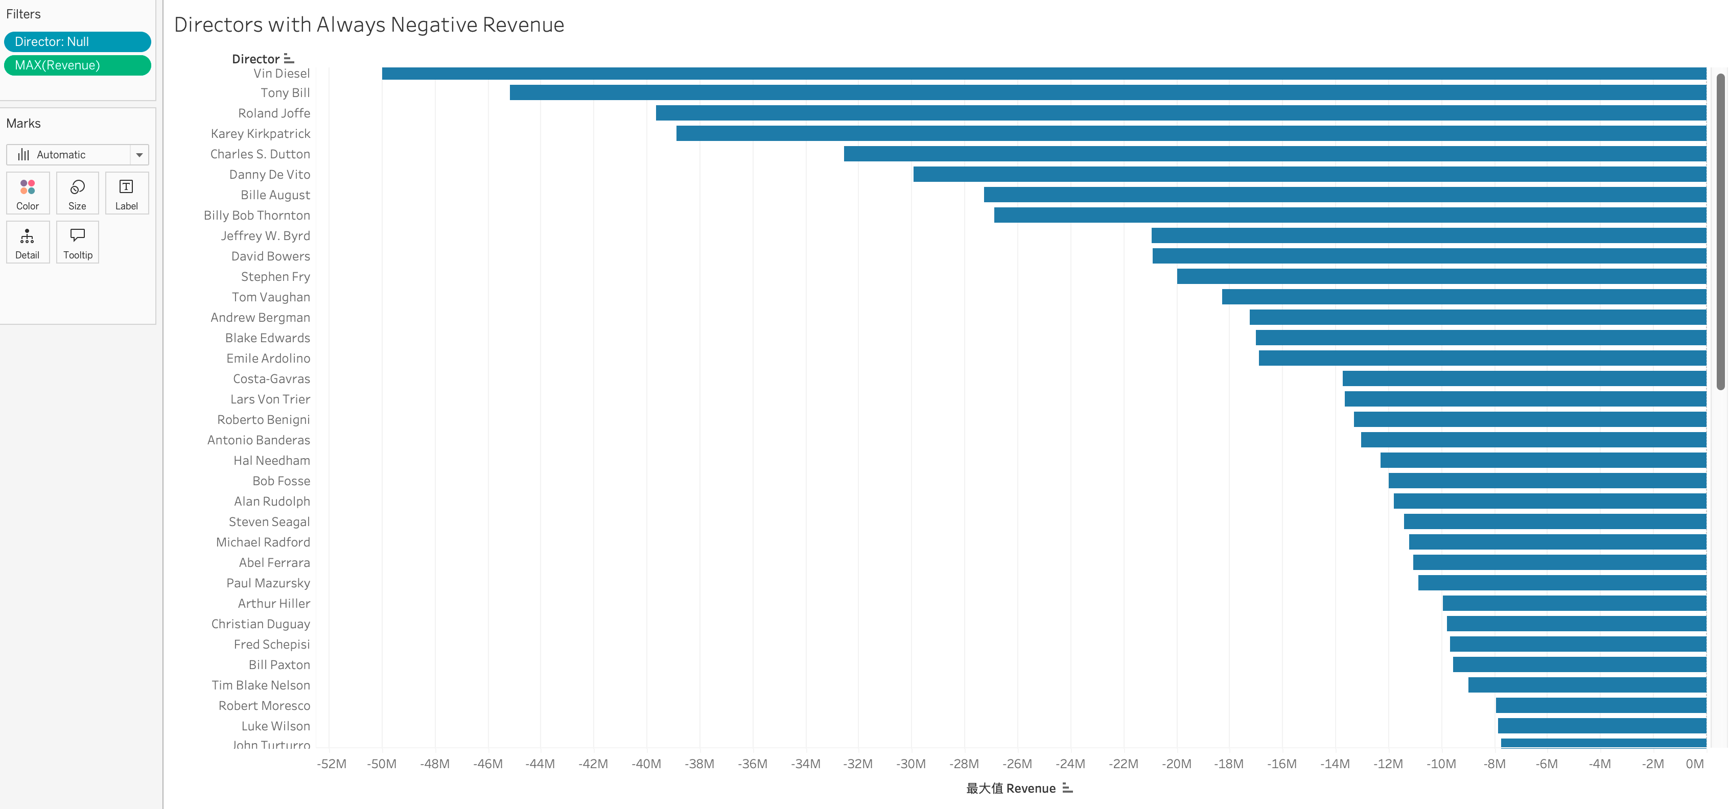

I added the filter that filters directors whose maximum revenue is less than 0, and arranged them by the order of the maximum revenue.

The names are shown in the left column (not the full list).

**Question 11: Which director has directed the most profitable Comedy movie?**

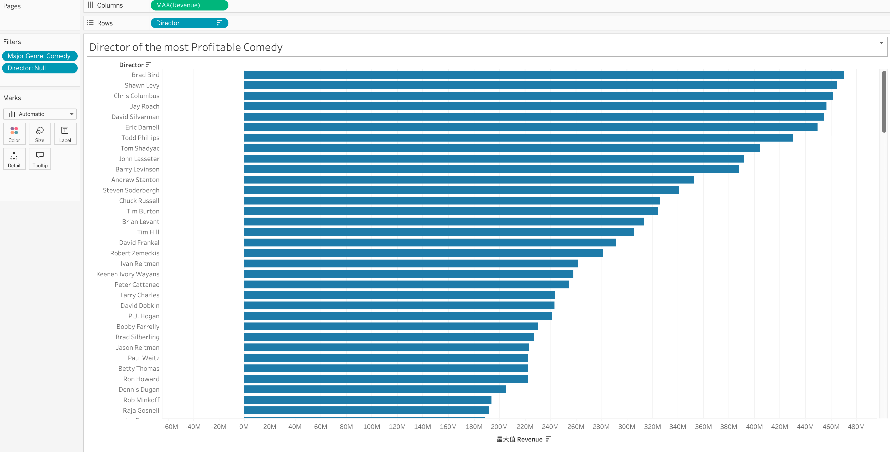

The director who has directed the most profitable Comedy movie is Brad Bird.

**Question 12: (bonus question): Do movies that contain the word “star” have higher average revenue than movies with “dragon” in the title?**

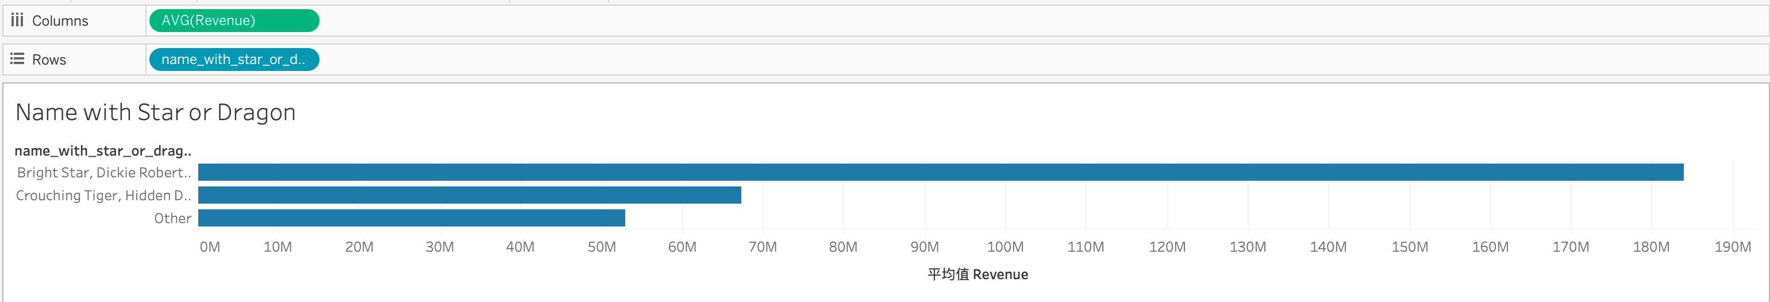

Movies that contain the word “star” do have higher average revenue than movies with “dragon” in the title.

**Question 15: Is it better to invest in action movies or comedies? Which director would you invest in?**

I created a chart showing the relationship between average revenue and major genre. We can see from the char that action movies have higher average revenue than comedies. So it is better to invest in action movies if the goal is to seek for maximum average revenue.

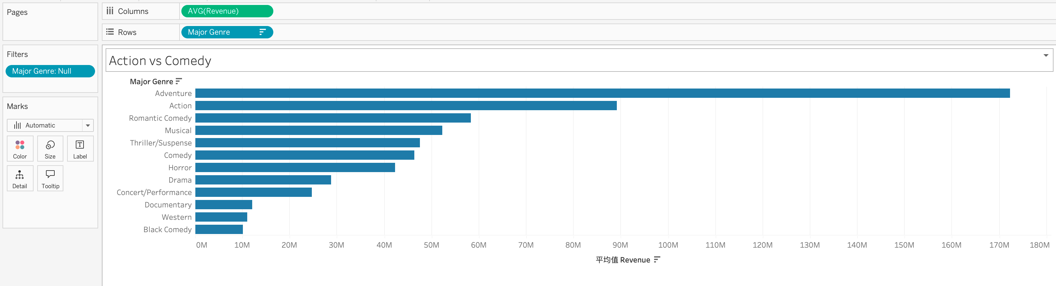

Then I created a chart showing the average revenue of a director in action movies.

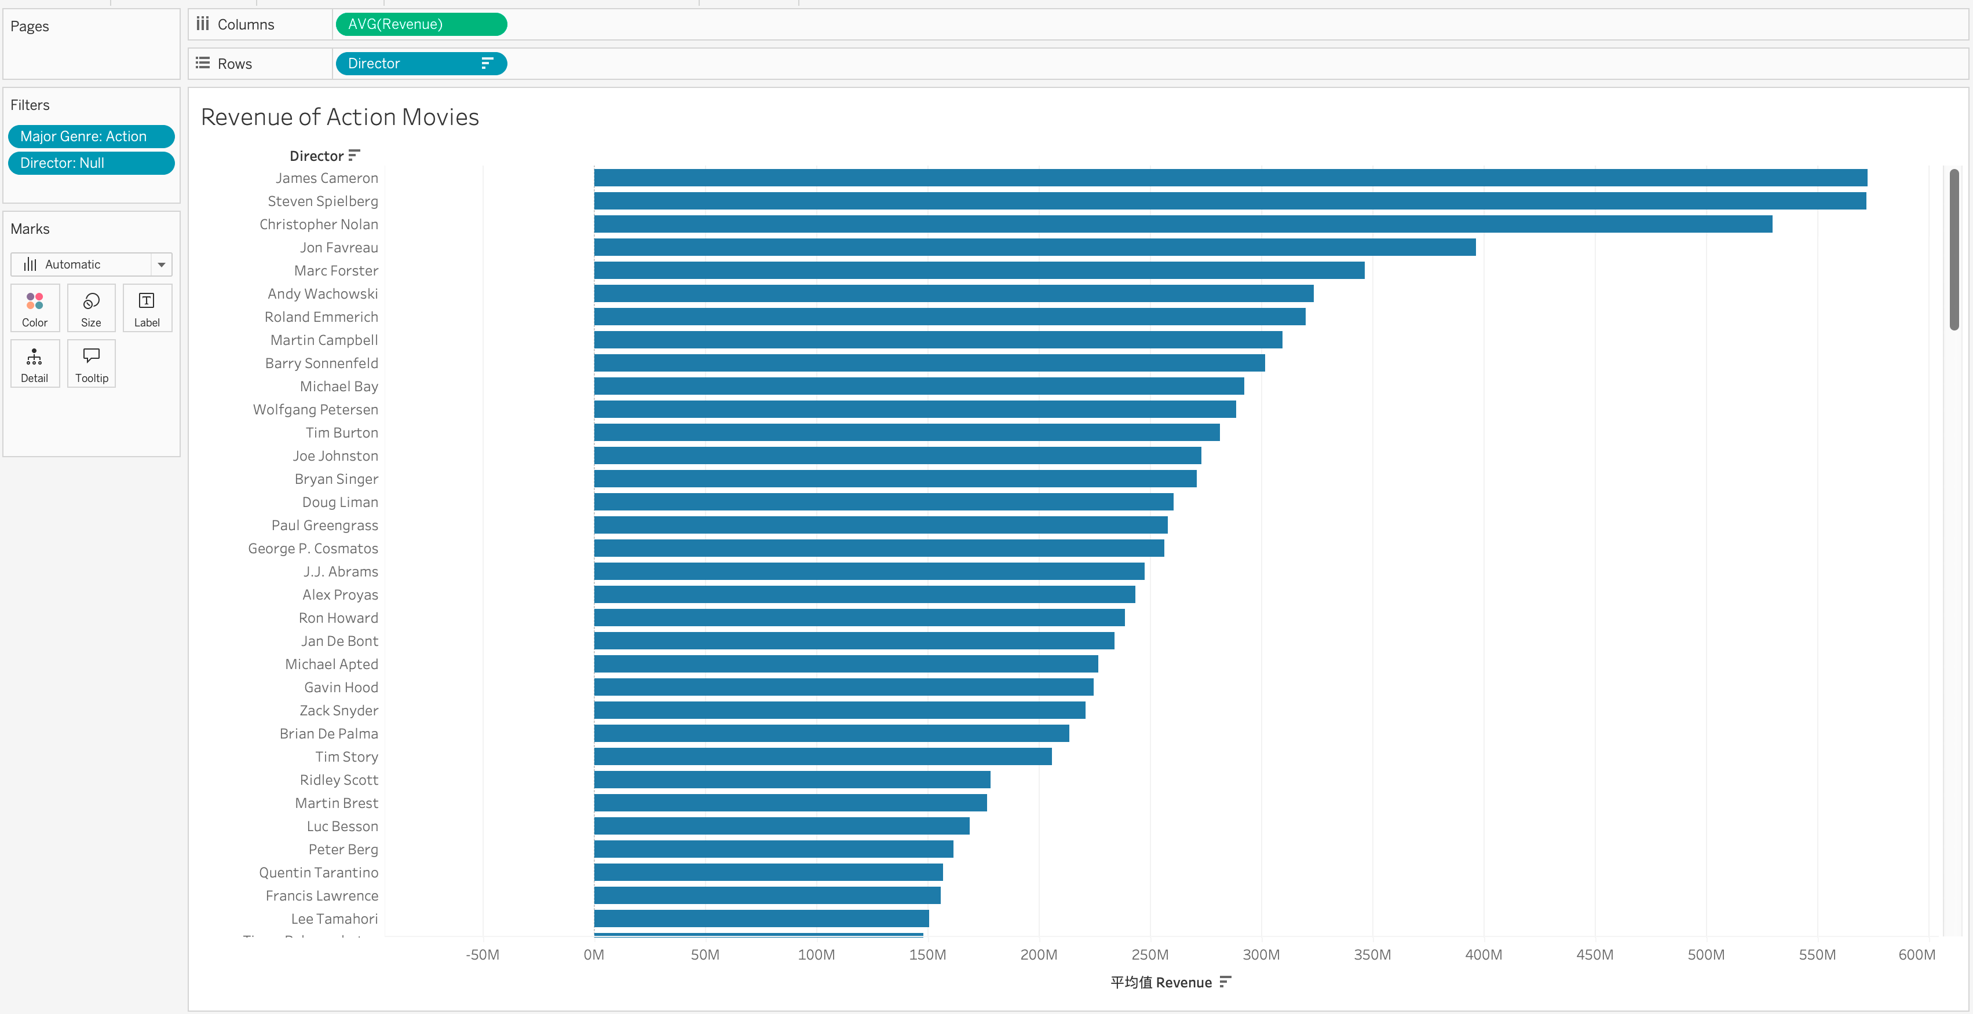

We can see that James Cameron has the highest average revenue. So it is best to invest in him if the goal is for maximum average revenue.

**Question 16: What’s the relationship between IMDB ratings and revenue? Are highly-rated movies more profitable?**

I created a chart showing the IMDB ratings and revenue, and added a linear trend line. The trend line does shows a significant positive correlation between the IMDB ratings and revenue of the movie. Hence highly-rated movies are more profitable.

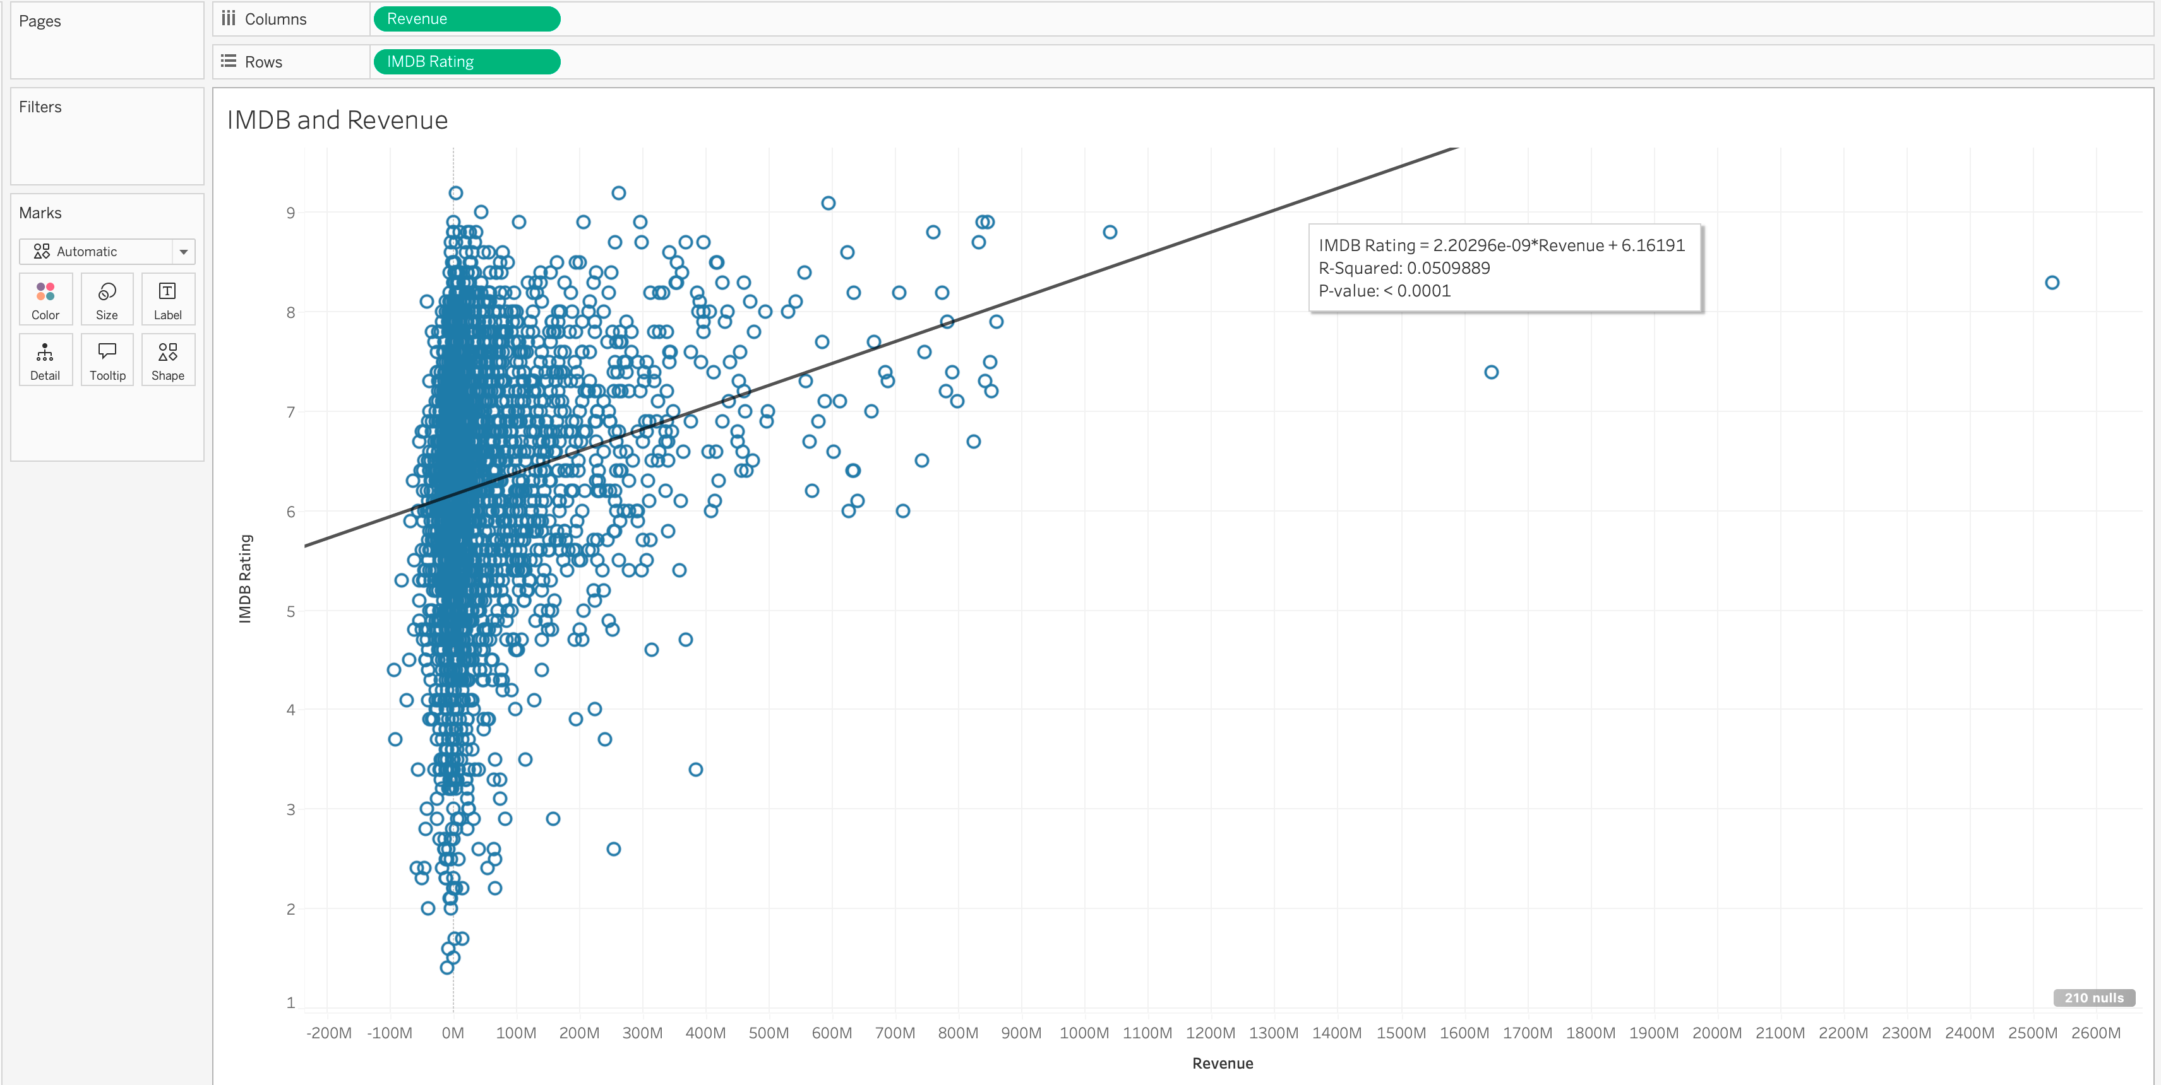

**Question 18: Who would you invest in?**

I created a chart showing the minimum revenue of directors.

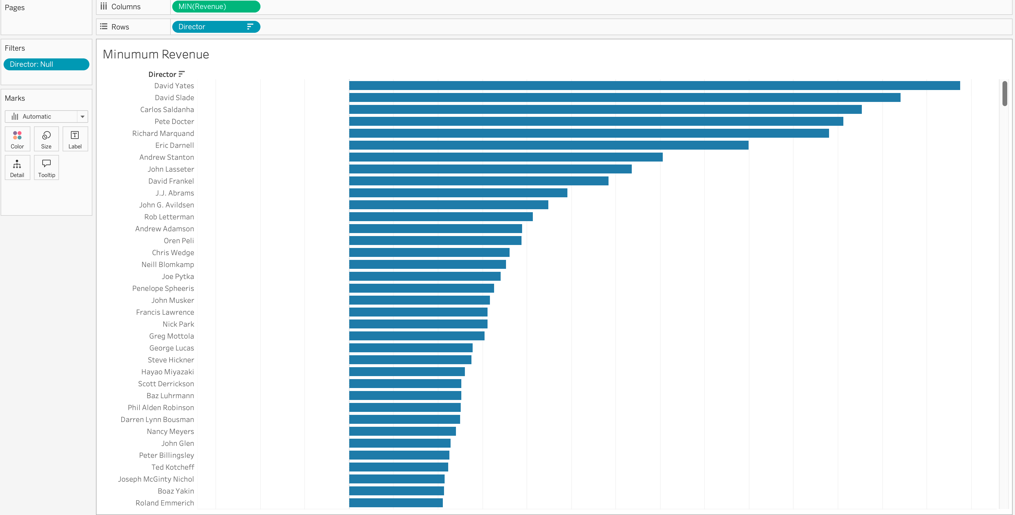

The result shows that David Yates has the highest minimum revenue. I would invest in him to prevent losing money in the investment and seek conservative returns.