Lab3 Answer Sheet

Part 1 Data Models

**Question 1:** Create a data model based on the tables included on MI_Store file. This model will be used to create visualization that will help to respond the questions from 2 until 10. (3 pts)

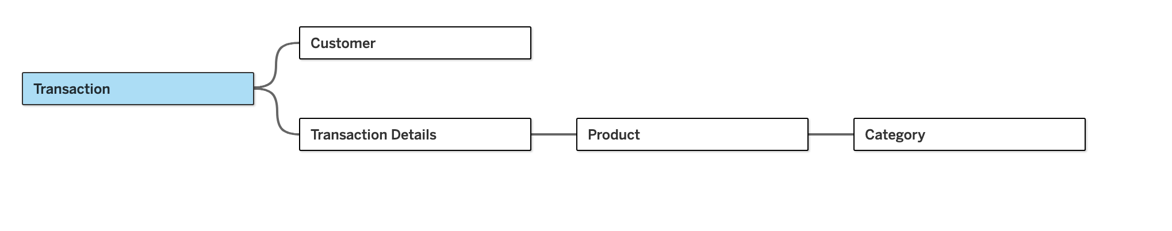

The data model is built based on the relationship:

Transaction.Customer ID = Customer. Customer ID

Transaction.Transaction ID = Transaction Details.Transaction ID

Transaction Details.Product ID = Product.Product ID

Product.Category ID = Category.Category ID

**Question 2:** What are the best-selling products? What are the worst? (0.5 pts)

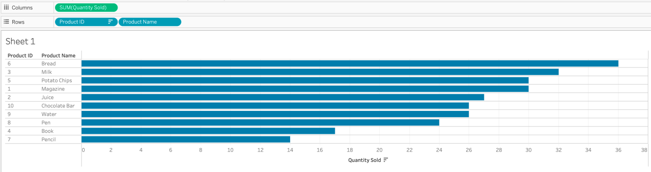

The best-selling products are bread, milk, and potato chips. The worst-selling ones are pencil, book, and pen.

**Question 3:** What are the products with less Contribution Margin? (0.5 pts)

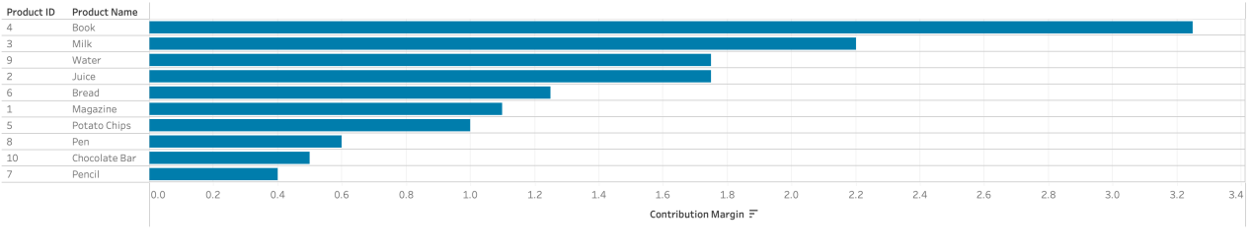

Pencil, chocolate bar, and pen have less contribution margin.

**Question 4:** What are the products with the best and worst Sales Revenue? (0.5 pts)

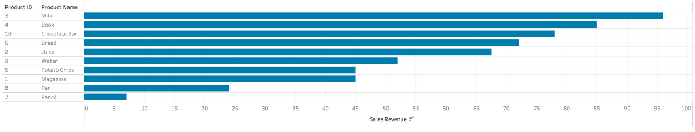

Milk, book, and chocolate bar have the best sales revenue, while pencil, pen, and magazine have the worst sales revenue.

**Question 5:** What are the products with the best Profit? (0.5 pts)

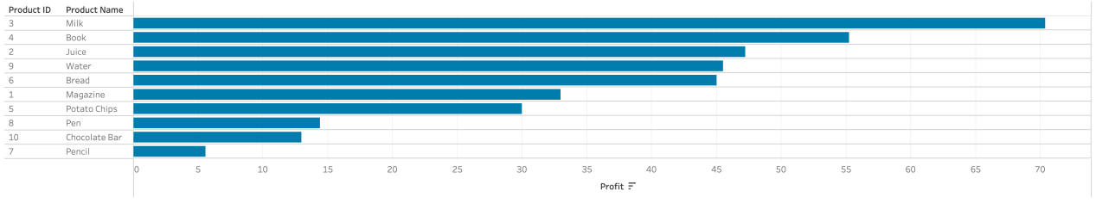

Milk, book, and juice have the best profit.

**Question 6:** Who was the most frequent customer? (0.5 pts)

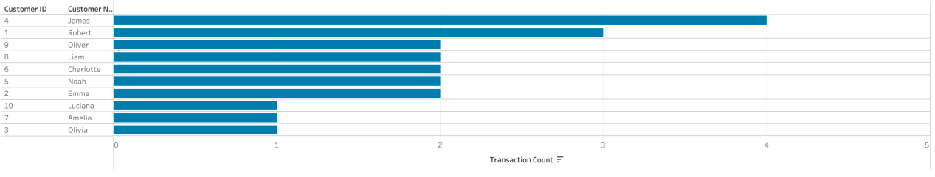Customer James was the most frequent customer.

**Question 7:** Who was the customer that gave us more Profit Margin? (0.5 pts)

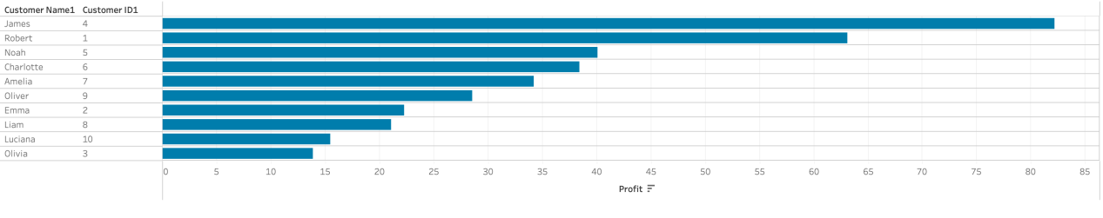

James gave us most profits.

Part 2: Tableau Interactions

**Question 8:** Combine views and apply at least two actions to create a fully interactive

dashboard using some interesting visualizations that you define from data on

2016_presidential_candidate_expenditures.cvs file.(4 pts)

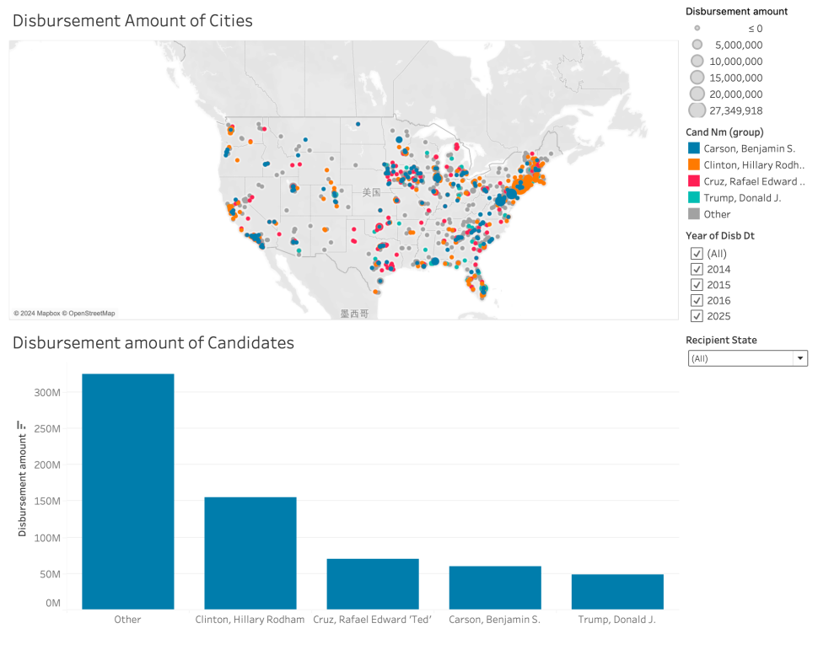

Link: https://public.tableau.com/app/profile/jiayu.chen4612/viz/Book2_17276639223790/Dashboard1?publish=yes