ENTERPRISE NETWORK SECURITY
Design, Implementation and Verification Report
Cisco Packet Tracer | Professional project portfolio | 29 October 2026
Student: Richard Sebopela
Evidence basis: Actual Cisco Packet Tracer screenshots captured during network configuration and testing. This is a simulated lab, not a production deployment.

1. Executive Summary
This project implements a segmented enterprise network for IT, Human Resources (HR), and Finance. A Cisco 2960 switch provides VLAN separation, a Cisco 2911 router routes between VLANs, and an ASA 5505 firewall provides perimeter routing, NAT/PAT, and HTTP/ICMP inspection. An extended access control list (ACL) blocks HR-initiated traffic to the Finance network. Port security on user-facing switch ports restricts each port to one learned MAC address.
Screenshots demonstrate successful internal routing and internet access from IT, an HR-to-Finance block, active 802.1Q trunking, sticky MAC learning, and firewall NAT counters. Some further tests are recommended before claiming full security validation.

2. Project Objectives and Scope
Objectives: (1) isolate departments with VLANs; (2) enable controlled inter-VLAN routing; (3) restrict HR-to-Finance access; (4) secure access switch ports; (5) translate internal addresses for internet access; (6) verify connectivity and document evidence.
Scope: Packet Tracer simulation. The project does not establish real-world production security, comprehensive firewall policy hardening, intrusion detection, or high availability.

3. Network Topology and IP Addressing
Final topology: IT-PC / HR-PC / FIN-PC → SW1 → R1 → FW1 → ISP-R1 → Internet-Server. The unused Internet Cloud icon was removed from the final design.
Observed PC addresses: IT-PC 192.168.10.21, HR-PC 192.168.20.21, FIN-PC 192.168.30.21.
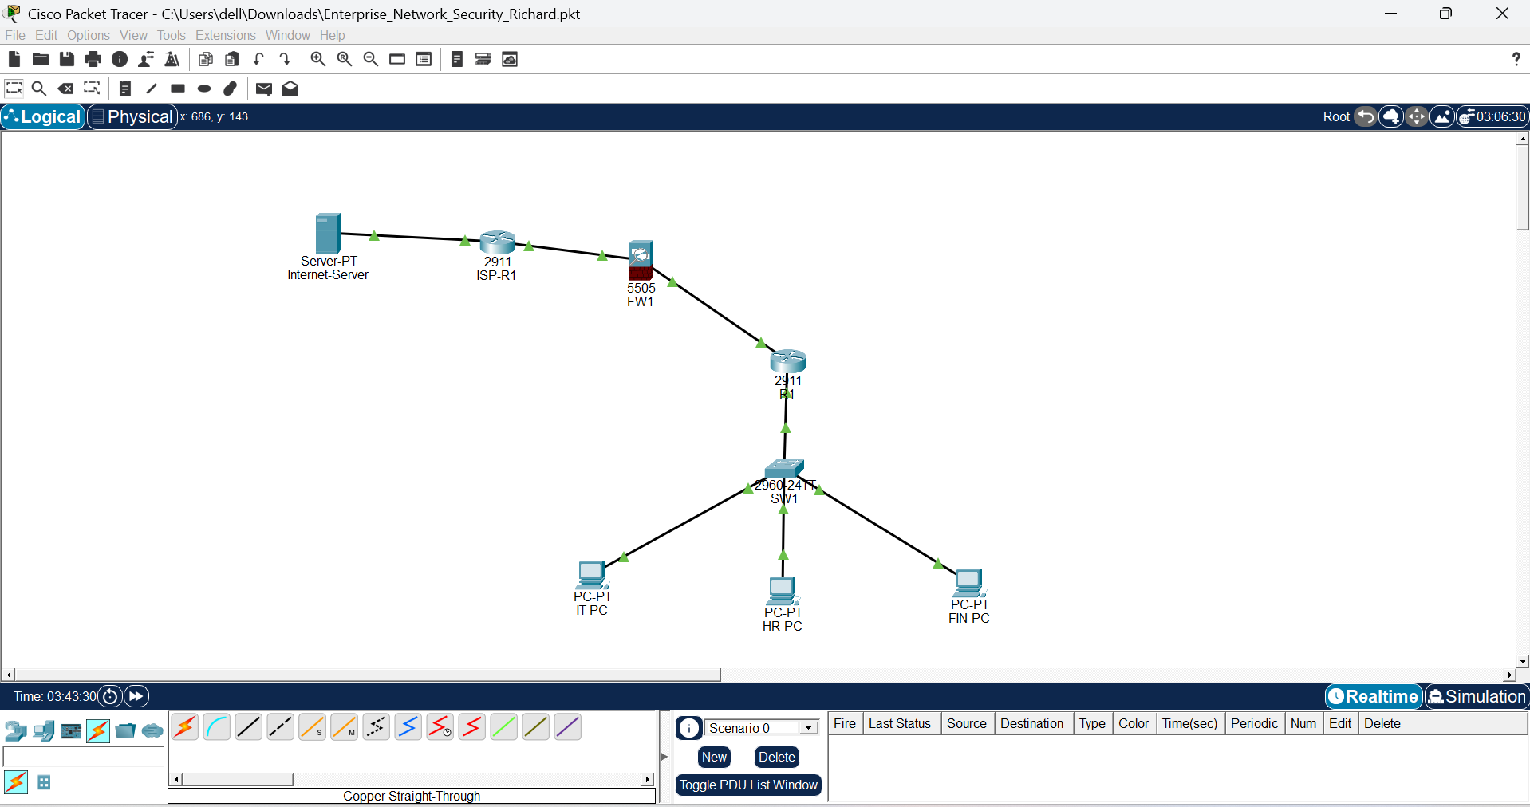
Figure 1. Final logical network topology with active links and three departmental PCs.

4. VLAN Segmentation and 802.1Q Trunk
SW1 uses VLAN 10 (IT) on Fa0/1, VLAN 20 (HR) on Fa0/2, and VLAN 30 (FINANCE) on Fa0/3. Gi0/1 is an active 802.1Q trunk allowing VLANs 10, 20, and 30; the observed native VLAN is 1.
SW1# show vlan brief
SW1# show interfaces trunk
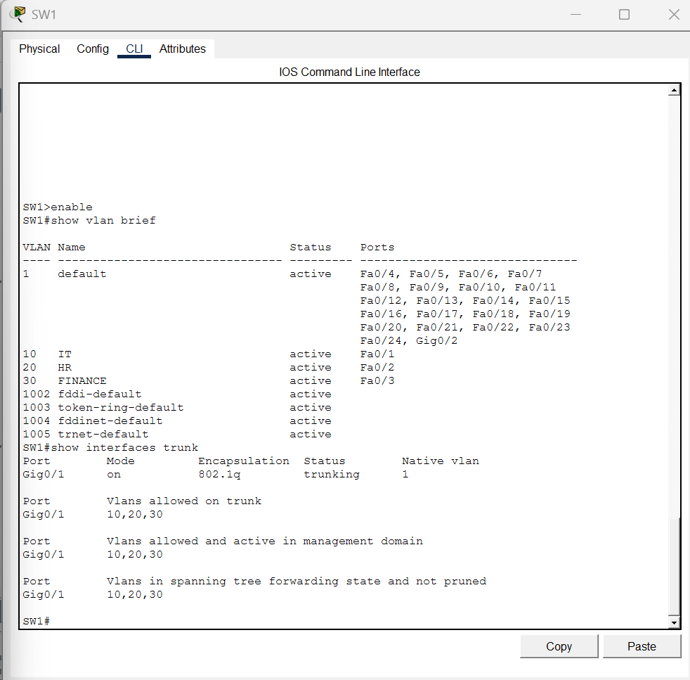
Figure 2. Switch VLAN assignments for IT, HR and Finance.
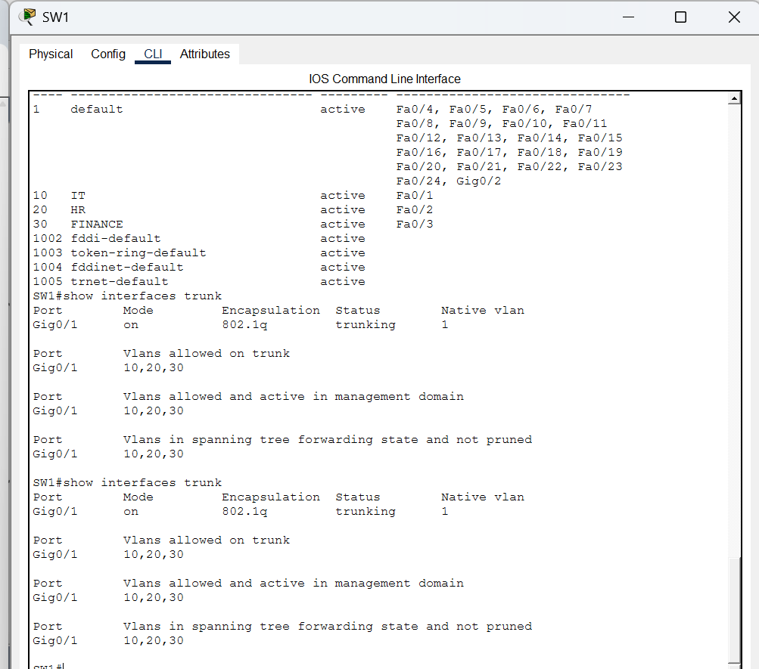
Figure 3. Active 802.1Q trunk and allowed VLANs.

5. Router-on-a-Stick and Routing
R1 uses subinterfaces Gi0/0.10, Gi0/0.20 and Gi0/0.30, tagged with dot1Q 10, 20 and 30. Their gateway IPs are .1 in each VLAN. Gi0/1 connects to FW1 at 10.0.0.1/30. R1 default route points to FW1 at 10.0.0.2.
interface GigabitEthernet0/0.10
encapsulation dot1Q 10
ip address 192.168.10.1 255.255.255.0
interface GigabitEthernet0/0.20
encapsulation dot1Q 20
ip address 192.168.20.1 255.255.255.0
ip access-group BLOCK_HR_FINANCE in
interface GigabitEthernet0/0.30
encapsulation dot1Q 30
ip address 192.168.30.1 255.255.255.0
ip route 0.0.0.0 0.0.0.0 10.0.0.2
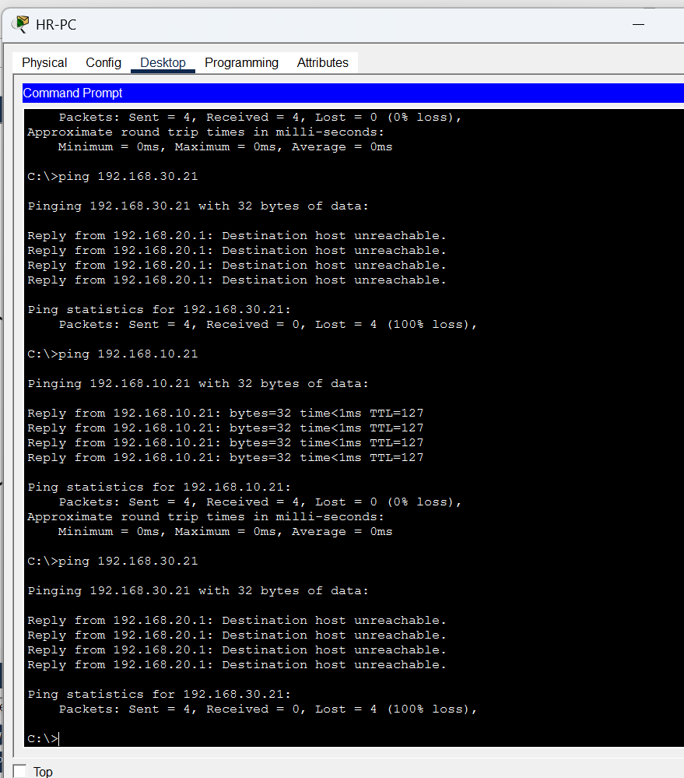
Figure 4. Router interface and subinterface addressing evidence.

6. Departmental Access Control
An extended ACL named BLOCK_HR_FINANCE denies packets sourced from HR (192.168.20.0/24) destined for Finance (192.168.30.0/24), and permits other IP traffic. It is applied inbound on R1 Gi0/0.20.
ip access-list extended BLOCK_HR_FINANCE
deny ip 192.168.20.0 0.0.0.255 192.168.30.0 0.0.0.255
permit ip any any
Evidence: show access-lists displayed deny-rule match counts increasing from 8 to 20; HR-PC pinging 192.168.30.21 failed with “Destination host unreachable” from 192.168.20.1. IT-PC successfully pinged both HR and Finance. A Finance-to-HR ping also timed out in the supplied screenshot, but this is not a general bidirectional deny rule: return traffic to HR is affected by the inbound ACL on HR, while initiating traffic from Finance is not directly denied by the shown ACL. More protocol-specific tests are required to characterize all flows.
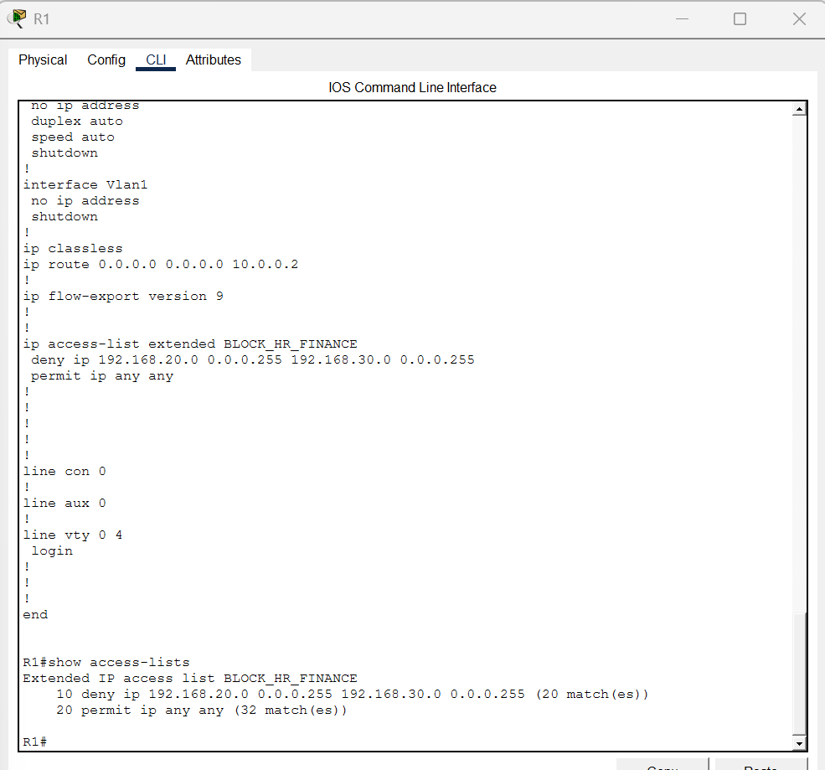
Figure 5. Extended ACL configured on R1.
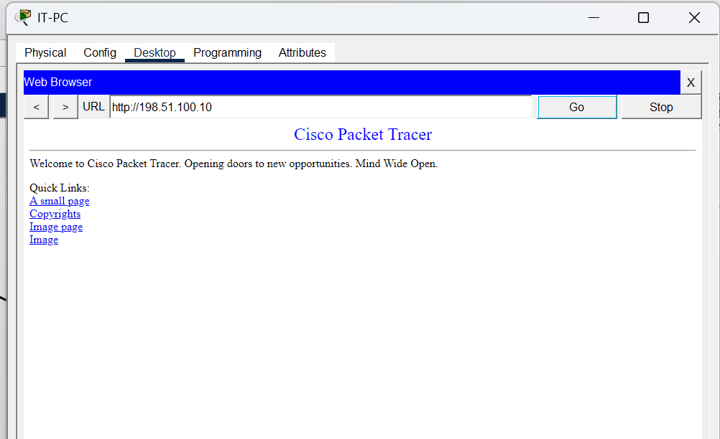
Figure 6. HR-to-Finance ping blocked by the configured ACL.
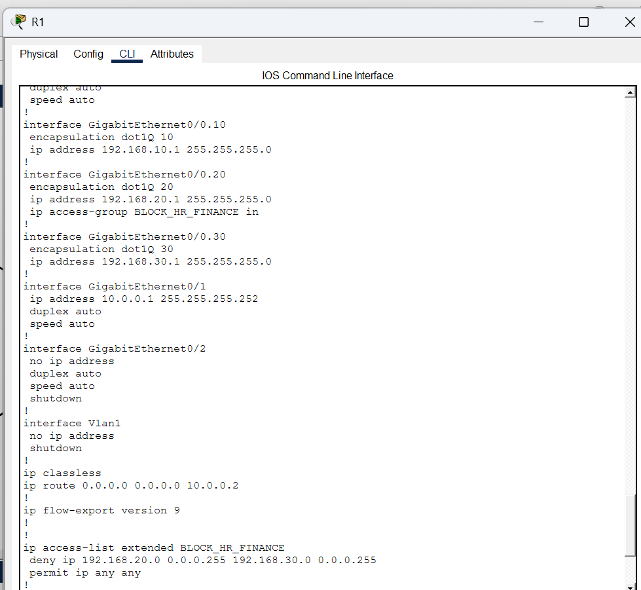
Figure 7. IT-PC connectivity verification to permitted destinations.

7. Switch Port Security
Fa0/1–Fa0/3 have port security enabled, maximum one MAC address per port, sticky MAC learning, and violation mode restrict. The final secure address table displayed one sticky MAC for each VLAN/port: VLAN 10 Fa0/1 0060.4730.ACBA; VLAN 20 Fa0/2 0001.4351.1D25; VLAN 30 Fa0/3 0060.5C85.BCA1. The screenshots showed secure-up status and zero violations.
SW1# show port-security interface fastEthernet 0/1
SW1# show port-security address
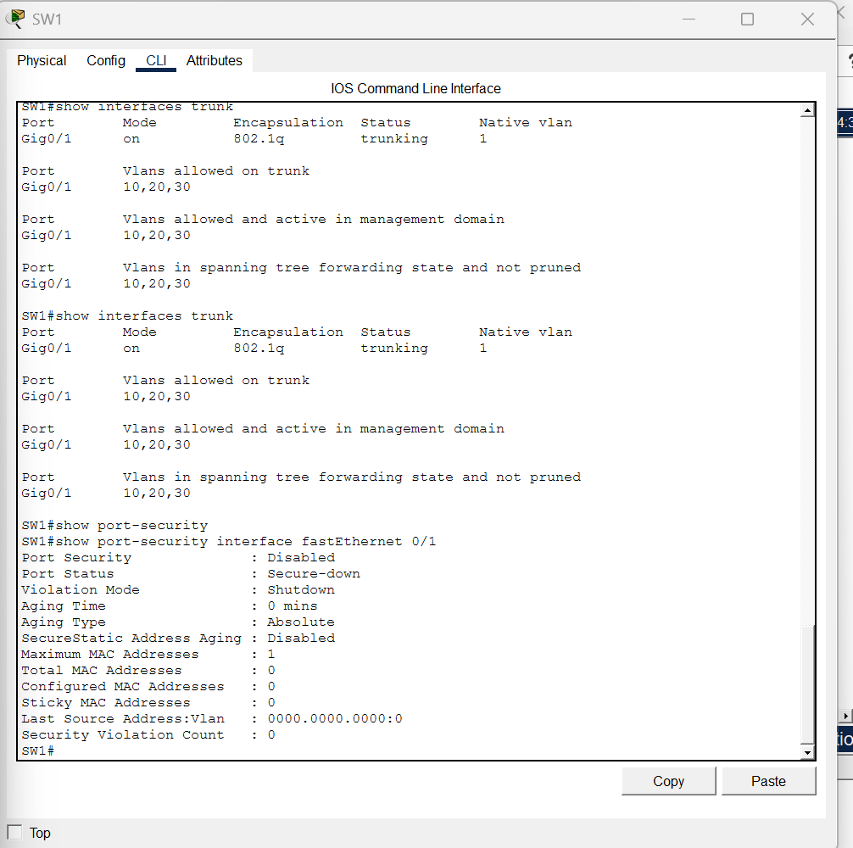
Figure 8. Switch access-port security verification.
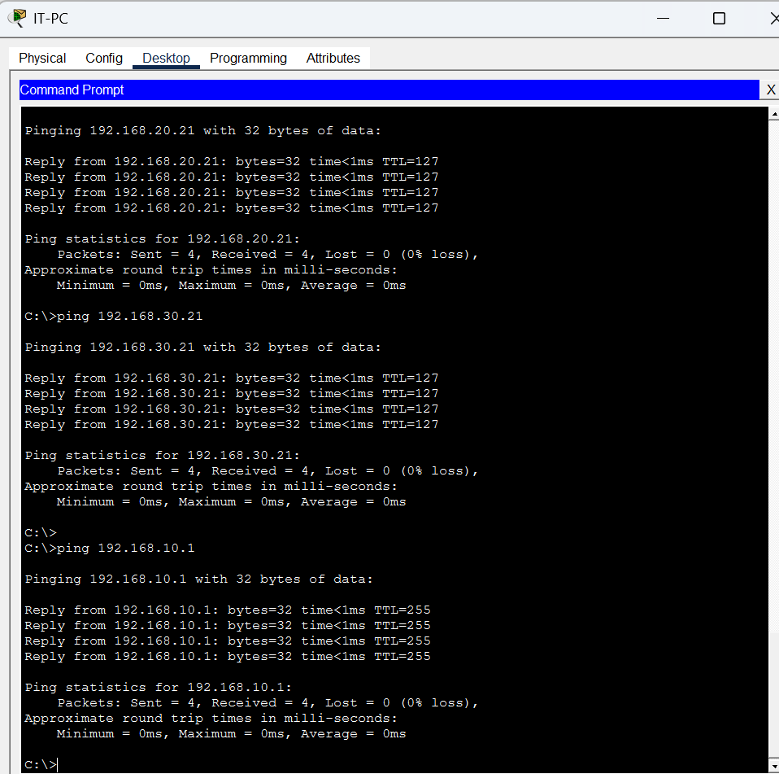
Figure 9. Sticky MAC address table for the departmental ports.

8. ASA Firewall, NAT and Inspection
FW1 inside VLAN1 is 10.0.0.2/30 with security level 100. Outside VLAN2 is 203.0.113.2/30 with security level 0. Static routes point to VLANs 10, 20, 30 via 10.0.0.1; default route points to ISP-R1 203.0.113.1.
object network INTERNAL_LAN
subnet 192.168.0.0 255.255.0.0
nat (inside,outside) dynamic interface
policy-map global_policy
class inspection_default
inspect http
inspect icmp
service-policy global_policy global
FW1 show nat displayed translate_hits=170 and untranslate_hits=218, demonstrating NAT activity. show running-config confirmed HTTP and ICMP inspection are configured and the policy is applied globally. The Packet Tracer ASA rejected show service-policy; this command limitation is not itself evidence of a failed policy.
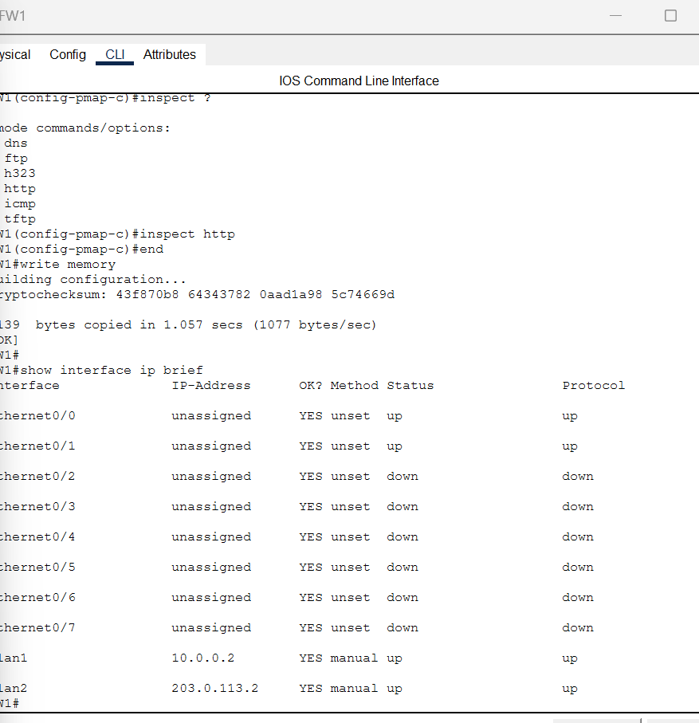
Figure 10. ASA inside and outside interface status.
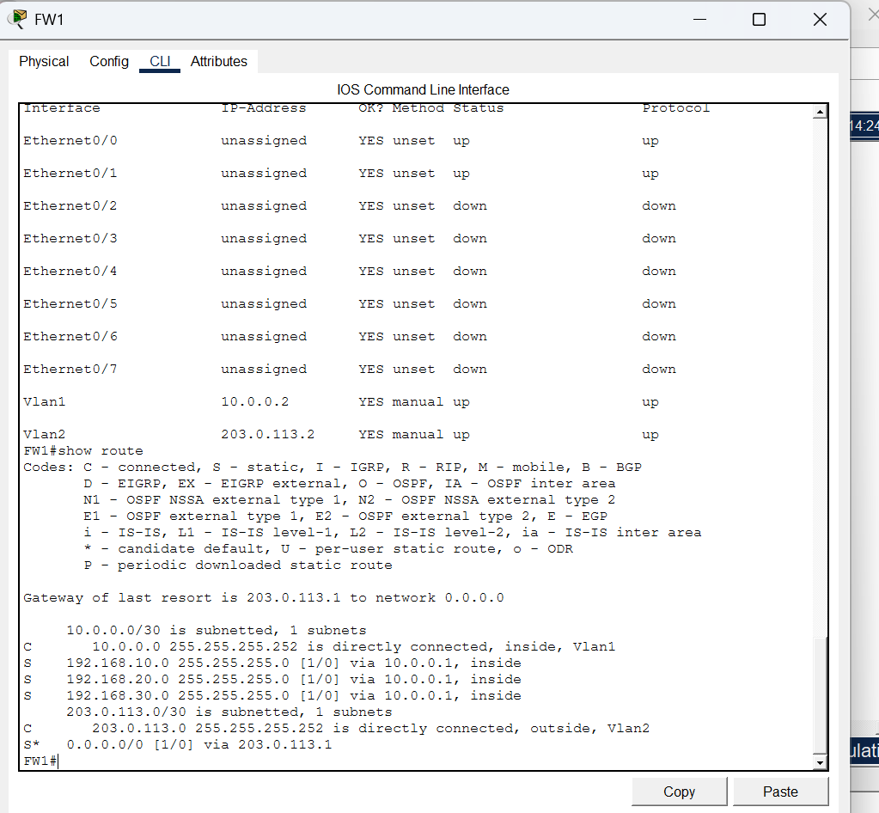
Figure 11. ASA routing table and internal network routes.
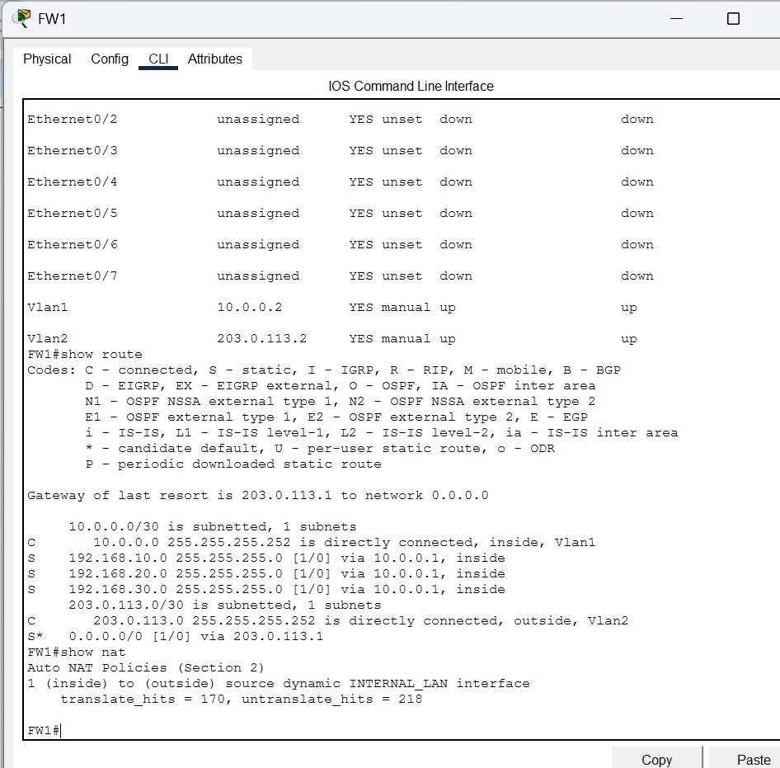
Figure 12. ASA NAT/PAT configuration and translation counters.
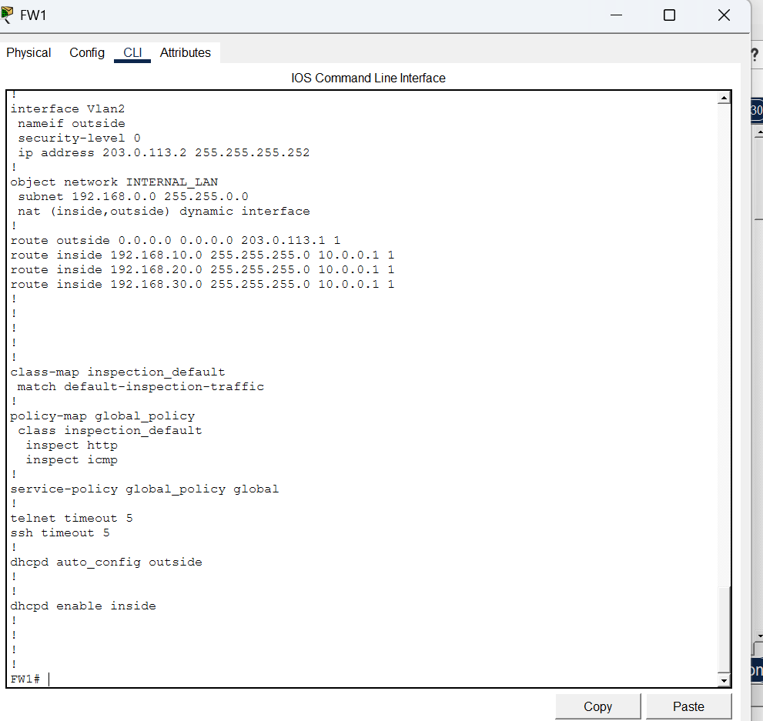
Figure 13. ASA inspection policy verification.

9. Verification Results
Verification | Observed result
IT → HR | Successful ping
IT → Finance | Successful ping
HR → Finance | Blocked as intended
IT → simulated Internet Server | Successful ping
SW1 port security | Secure-up and sticky MAC addresses observed
ASA NAT/PAT | Translation counters observed
The screenshots above provide evidence of the tested configurations. The ACL specifically blocks HR-initiated traffic to Finance; it is not evidence of a complete bidirectional isolation policy.

10. Security Evaluation and Limitations
Strengths: VLAN segmentation reduces broadcast domains; an ACL enforces a specific HR-to-Finance restriction; sticky MAC port security limits new devices on access ports; NAT/PAT hides internal addresses from the simulated outside network; firewall inspection is configured for HTTP and ICMP.
Limitations: The ACL shown does not constitute a complete least-privilege departmental policy. The native trunk VLAN remains VLAN 1. No evidence was supplied for disabling unused ports, SSH-only management, administrative authentication hardening, logging, DHCP snooping, DAI, or a port-security violation test. The inside-to-outside default firewall policy and application-level access controls require additional review for production use.

11. Recommended Follow-up Checks
Before reusing this lab, save all device configurations, reopen the .pkt file, and repeat the ping tests. For a stronger security demonstration, document Finance-to-HR policy behavior separately and test least-privilege access rules.

12. Conclusion
The Cisco Packet Tracer enterprise network demonstrates working VLAN segmentation, router-on-a-stick inter-VLAN routing, HR-to-Finance ACL enforcement, sticky MAC port security, firewall routing, dynamic NAT/PAT, and configured HTTP/ICMP inspection. Available tests show IT access to both departments and to the simulated internet server. The project meets the main demonstrated implementation goals, while the outstanding validation and hardening tasks should be completed before presenting it as production-ready.
This report includes thirteen actual screenshots within their relevant technical sections. No figure placeholders remain.

