**B00239486**

There are three text files included with the project the first being the original dictionary words file the other two being one for constantans and one for vowels the project starts of by reading the three files, first it reads the dictionary file into a string array and names it wordlist for ease it then goes on to read the vowels and constantans files separately this time loading them into char arrays and calling them Vowels and Constantant.

The program then explains to the user what is going to happen and what input is needed from them, It then loads an empty char array with 8 partitions of name Combiword representing the combined random letters when they are loaded in. A loop is then entered where it will continue until it has gone round 8 times to fill the array the user is asked for a constantan or a vowel represented by a 1 or 2 the choice is read and a switch statement is entered if 1 is chosen case 1 is entered where math.random is used and times against the amount of letters in the constanats file to give a random number the random number used to pick a letter and that letter is added to the array, displayed to the user and the array is moved along one point and the loop counter is moved along one and a break statement renters the loop the same process happens for if a vowel is picked and if any character except 1 or 2 is entered the user will be asked to try choosing again. This continues until the loop is finished then the 8 random letter combination is displayed to the user.

The program then enters a series of loops and checks the first loop moves through the dictionary file until it reaches at the end of the file at 70548 words, the loop within that loop moves through the randomly generated word and the loop within that loops through the letters in the word from the dictionary and in that loop the two characters are checked against each other, each correct comparison adds to the correct counter and if that reaches over 5 comparisons the word is printed to the screen

**Critical Appraisal:**

The program worked well up until the point of it recognising multiples in one word for instants it would compare two words correctly and match letters together and move all the way through the words in the dictionary file but if there where two a’s or two o’s or any other letters it would count it twice when it should only count it once meaning words would appear in the correct section when they where actually not quite correct, only close.

All other parts of the program worked well and I had no problem making them work and making it look and work better the bit that got me stuck was the multiple letters it took a long time to get it to work and even now still I don’t quite feel like its done as well as it can be.

Proof of correct word finding: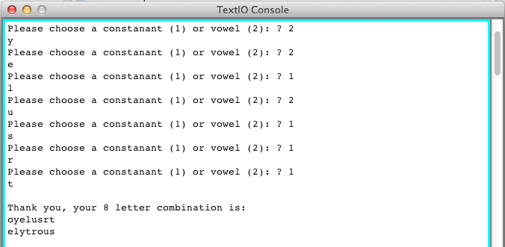

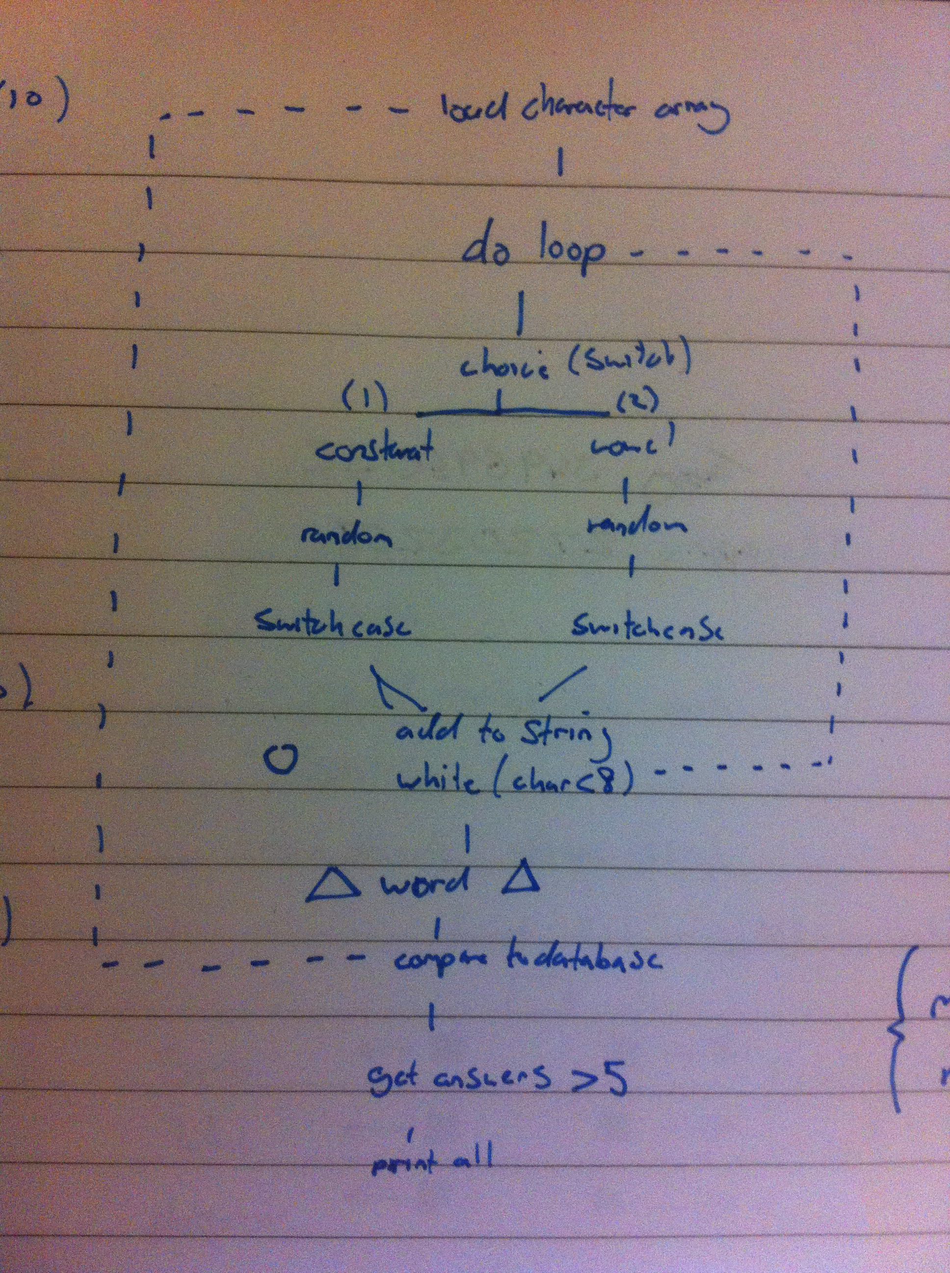

Original plan for the program:

**Tests:**

Checking that the dictionary file is properly loaded and can be displayed:

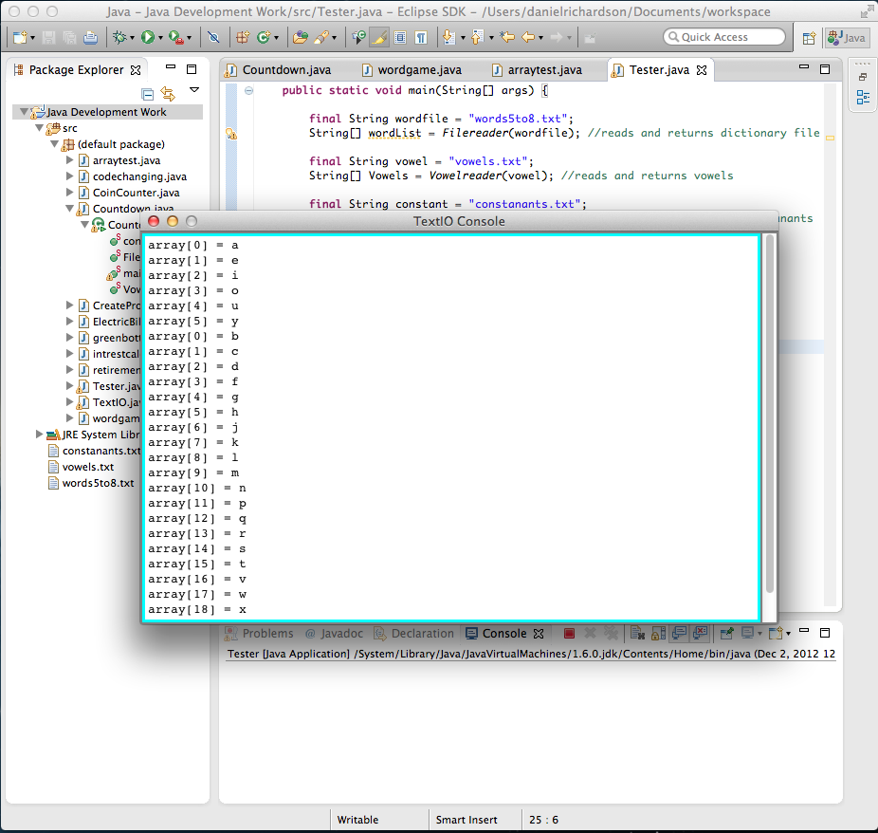

Checking that all 70548 words load and vowel and constanants can be loaded:

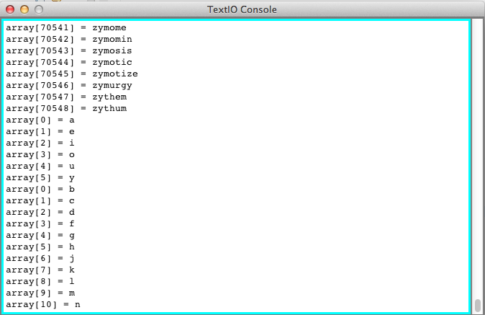

Checks that the program asks for 8 characters and that they are displayed at the end:

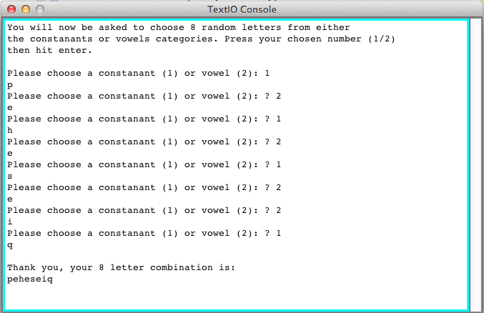

Checking that a character other than 1 or 2 can be entered and wont break the program:

