Cancer Image Diagnosis System
Architecture and User Guide
For non-commercial use

Contents
1 Overview 3
1.1 Features 3
2 Scenario 1: Train a model 4
3 Scenario 2: Serve on a server (Docker) 4
4 Scenario 3: Offline local network (no internet) 5
5 Scenario 4: Diagnose with a phone or computer 6
6 Project structure and files per computer 7
7 Reference 7
7.1 Supported cancer types 7
7.2 Training options 7
7.3 Service settings, API and privacy 8
8 Troubleshooting 8
9 Licence and acknowledgements 8

1 Overview
Describe a cancer type in any language. The system picks a public dataset and the best deep-learning models, trains a voting ensemble, and serves it to phone and computer browsers, either on a server or on an offline local network.
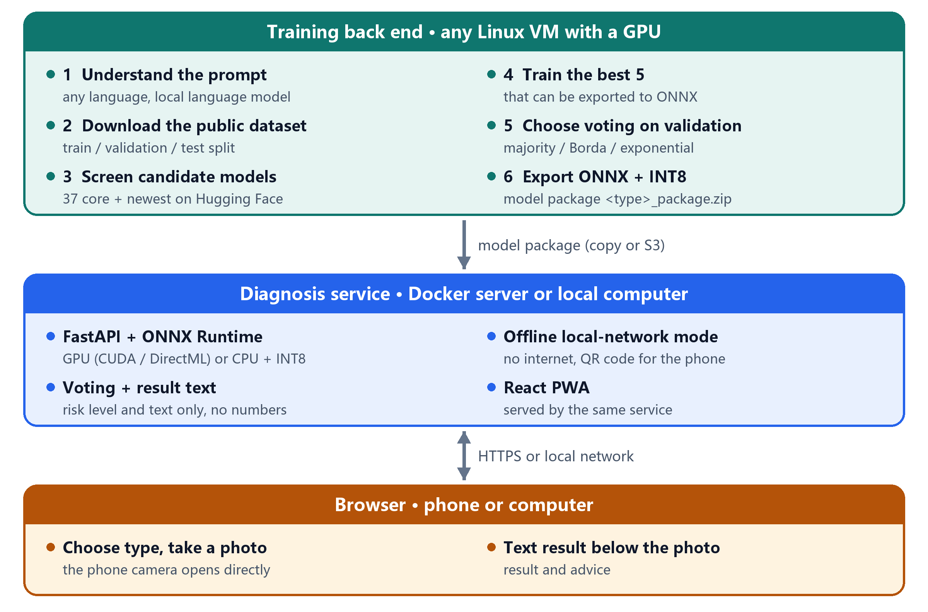
Figure 1 System architecture
For non-commercial use under the PolyForm Noncommercial License 1.0.0.

1.1 Features
- Any-language prompt: a local language model maps the request to a supported cancer type, or rejects it.
- Automatic dataset and model choice: 6 public datasets; 37 core models plus the newest on Hugging Face, or any model you add.
- Voting ensemble: majority, Borda or exponential voting chosen on validation data, with a referral threshold at 95% malignant sensitivity.
- Browser app: phones and computers; the camera opens directly; the result is plain text below the photo, with no numbers.
- Offline mode: a local computer serves phones over Wi-Fi or a hotspot with no internet; scan a QR code to connect.
- Fast: GPU when available, otherwise INT8 on the CPU; 0.13-0.5 s per photo measured.

2 Scenario 1: Train a model
Where: any Linux VM with an NVIDIA GPU (16 GB+), about 50 GB of disk, internet access.
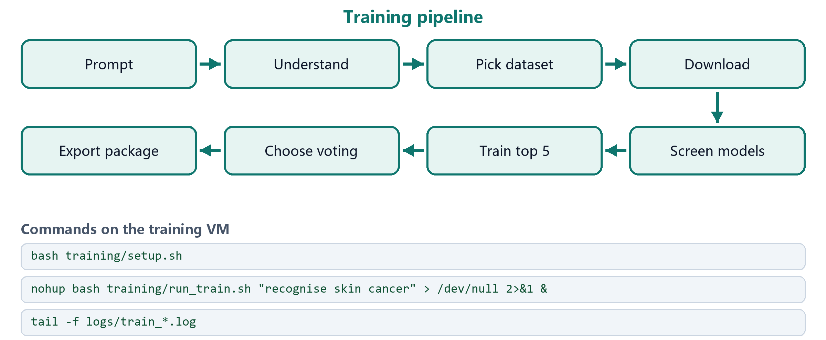
Figure 2 Training pipeline and commands
Step | What happens
Understand | a local language model (Qwen3-4B) reads the prompt; if it cannot load, the prompt is translated and matched by keywords; unsupported types are rejected
Download | the matching public dataset, split into train / validation / test (by patient or lesion where available)
Screen | 37 core models (incl. DINOv2/v3, SigLIP 2, ConvNeXt V2, MedSigLIP) plus optional newest models; each trained briefly
Train | the best 5 that can be exported to ONNX; class-weighted loss; automatic batch reduction on out-of-memory
Choose voting | majority / Borda / exponential voting and a referral threshold, picked on the validation set; never shown in the app
Export | ONNX (current PyTorch exporter), verified against PyTorch; INT8 kept only where faster → artifacts/<type>_package.zip

Examples: run_train.sh "Quiero reconocer el cáncer de piel" · --pool latest · --add_model hf:facebook/dinov2-base · --task lung --epochs 5. Re-running the same command resumes an interrupted run.

3 Scenario 2: Serve on a server (Docker)
Where: any Docker host; CPU is enough, about 2 GB RAM per model package.
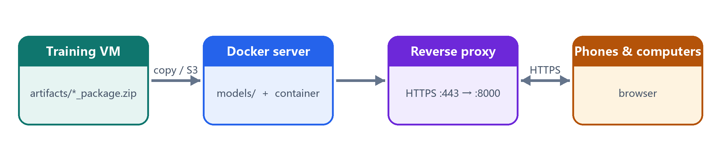
Figure 3 Server deployment
cp .env.example .env # set ACCESS_TOKEN
mkdir -p models # copy *_package.zip here
docker compose up -d --build
docker compose exec diagnosis python benchmark.py # check diagnosis time

Public addresses need HTTPS: put a reverse proxy or load balancer (Nginx, Caddy, AWS ALB, Azure Application Gateway, ...) in front of port 8000. New model: copy the package into models/, then run docker compose restart.

4 Scenario 3: Offline local network (no internet)
Where: a Windows / macOS / Linux computer that holds the model packages; phones on the same network.
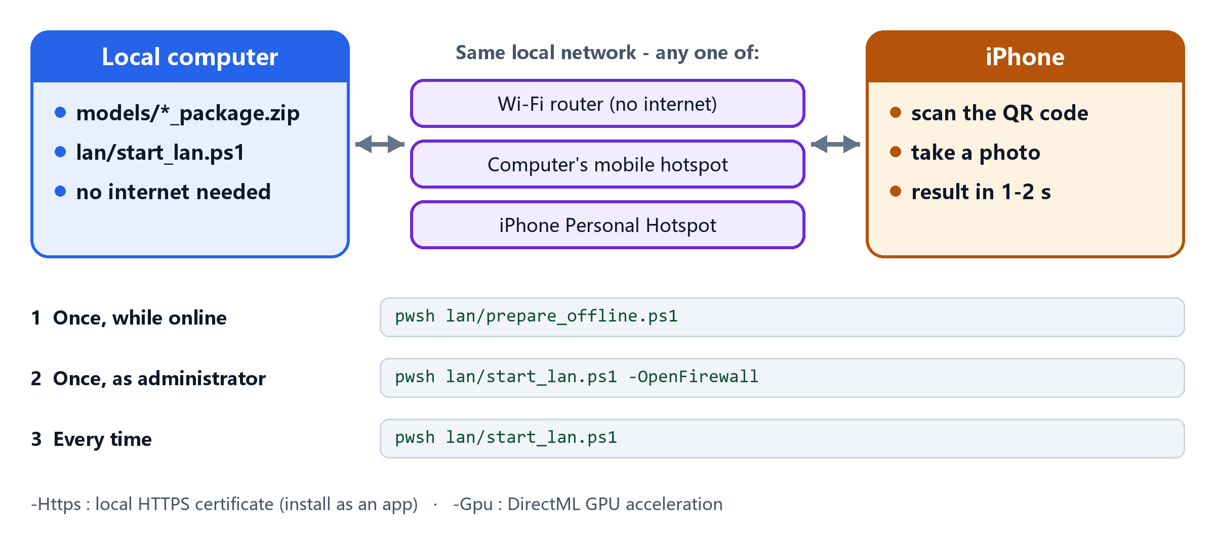
Figure 4 Offline local-network mode
- Never-online computer: run prepare_offline.ps1 -Wheelhouse on an online computer, copy the project folder, then run prepare_offline.ps1 -FromWheelhouse. macOS / Linux: bash lan/start_lan.sh --prepare, then bash lan/start_lan.sh.
- Install as an app (optional): start with -Https; on each iPhone once, open https://<address>/lan/ca.crt, install the profile, then enable it in Settings › General › About › Certificate Trust Settings.
- GPU: prepare_offline.ps1 -Gpu uses DirectML (any DirectX 12 GPU); NVIDIA CUDA is picked up automatically.
- Speed: 0.13 s per photo (22 CPU threads), 0.5 s (4 cores), 0.17 s phone upload over local HTTPS.

5 Scenario 4: Diagnose with a phone or computer
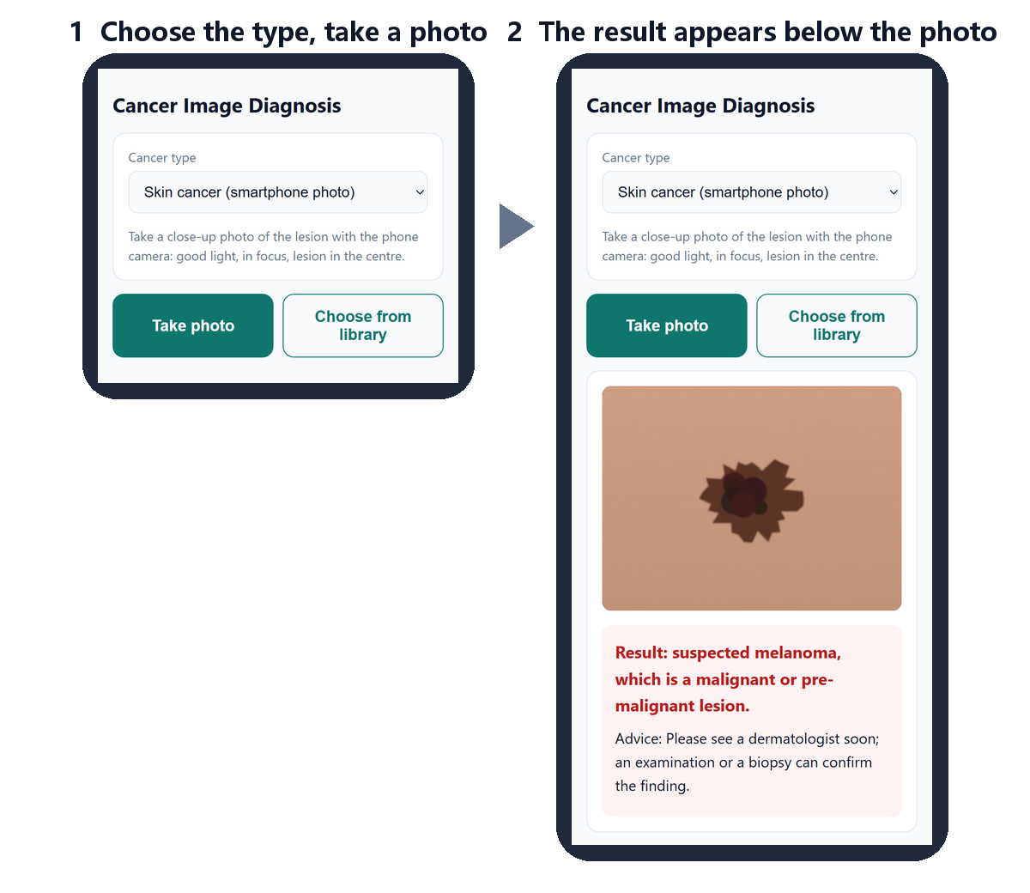
Figure 5 The web app (real screenshots)
Open the address (or scan the QR code) in Safari / Chrome / Edge / Firefox → choose the cancer type → Take photo or Choose from library. The result appears below the photo, with no numbers.
Colour | Meaning
Red | suspected malignant (or cannot be ruled out); see a doctor
Green | most likely benign
Yellow | uncertain; retake the photo or see a doctor

Tips: good light, in focus, lesion in the centre. For skin photos choose Skin cancer (smartphone photo). Upload original ultrasound / histology / MRI images, not photos of a screen.

6 Project structure and files per computer
training/ prompt → dataset → screening → training → voting → ONNX package
common/ voting and image preprocessing shared by training and serving
server/ FastAPI + ONNX Runtime service; lan.py (offline mode); benchmark.py
web/ React + TypeScript browser app (PWA)
lan/ setup / start scripts for an offline local computer
docs/ diagrams, screenshots and this guide
Dockerfile, docker-compose.yml, .env.example

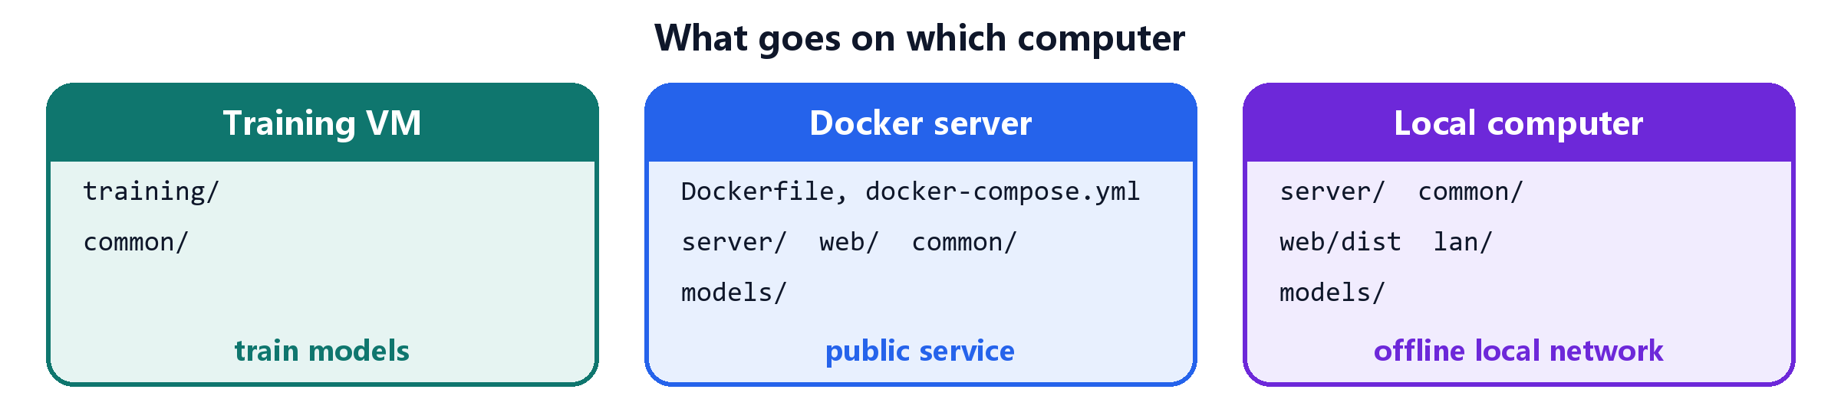
Figure 6 What goes on which computer

7 Reference

7.1 Supported cancer types
Task | Dataset (licence) | Images
skin_phone (default for skin) | PAD-UFES-20 (CC BY 4.0) | smartphone photos
skin (prompt mentions dermoscopy) | HAM10000 (CC BY-NC 4.0) | dermoscopy
breast | BreastMNIST (CC BY 4.0) | ultrasound
colorectal | PathMNIST (CC BY 4.0) | H&E histology
lung | LC25000 lung (CC BY 4.0) | H&E histology
brain | Brain Tumor MRI (CC0) | MRI

7.2 Training options
Option | Default | Meaning
--task | - | task id instead of a prompt
--pool | core | core (37) · quick (10) · latest (core + newest on Hugging Face)
--add_model | - | timm:<id> or hf:<repo>, repeatable
--top_k | 5 | ensemble members (fewer = faster)
--epochs | 10 | use 3 for colorectal (about 90,000 images)
--quantize | auto | INT8 members: auto · int8 · fp32
--prompt_model | llm | llm · translate · keywords
--s3_uri | - | also upload the package to S3

7.3 Service settings, API and privacy
Item | Details
Environment variables | ACCESS_TOKEN (access code) · MODELS_S3_URI (optional S3 sync) · ORT_PROVIDERS (hardware order, default CUDA → DirectML → CPU) · MAX_UPLOAD_MB (15) · CORS_ORIGINS · LOG_LEVEL
API | GET /api/health · GET /api/tasks · POST /api/diagnose (task_id, image → level, verdict, advice) · GET /api/docs
Privacy | photos are processed in memory only, never stored or logged; in local-network mode nothing leaves the network
Stack (pinned) | PyTorch 2.14 · timm 1.0.30 · Transformers 5.17 · ONNX Runtime 1.30 · FastAPI · React 19 · TypeScript 7 · Vite 8 · Docker (Node 24, Python 3.12)

8 Troubleshooting
Problem | Fix
Prompt rejected | name a supported cancer type, or use --task
Language model does not load | falls back to translation automatically; or --prompt_model translate
A candidate model is skipped | normal (gated, unsupported, not exportable); see screening.json / exportable.json
CUDA out of memory | retried automatically with a smaller batch; stop other GPU jobs
Phone cannot open the address | same network? run start_lan.ps1 -OpenFirewall; corporate Wi-Fi may block devices, so use a hotspot
Certificate warning in Safari | trust the local certificate (Scenario 3) or start without -Https
"No models are installed" | put *_package.zip in models/ and restart
Diagnosis slower than 2 s | run benchmark.py; use a GPU (-Gpu) or train with --top_k 3

9 Licence and acknowledgements
For non-commercial use under the PolyForm Noncommercial License 1.0.0. Non-commercially licensed datasets and models (e.g. HAM10000, ConvNeXt V2, EUPE, Hiera) are therefore included; gated models such as MedSigLIP need HF_TOKEN and accepted terms on Hugging Face. Each ensemble member's licence is recorded in its model package.
Datasets: PAD-UFES-20 (Pacheco et al., 2020) · HAM10000 (Tschandl et al., 2018) · MedMNIST+ (Yang et al., 2023) · LC25000 (Borkowski et al., 2019) · Brain Tumor MRI (Nickparvar, 2021). Models via timm and Hugging Face Transformers.

