Gesture Calculator
User Manual: how to use it and how it works
A scientific calculator operated with hand gestures in front of a webcam
Windows · runs entirely offline

Contents
1 Overview 3
2 Getting started 3
2.1 What you need 3
2.2 Start 4
2.3 The window 4
3 Left hand: digits and editing 5
4 Right hand: operators 5
4.1 Entering a code 5
4.2 The codes 6
5 Timing and a worked example 7
6 Settings and keyboard 7
7 Calculator functions 8
8 How it works 9
8.1 From the camera picture to a key 9
8.2 When a gesture is entered 10
8.3 The models 10
9 Files 11
9.1 Running from the source code 11
9.2 Building the exe 11
10 Troubleshooting 12

1 Overview
Gesture Calculator is a scientific calculator with no keys to press. The left hand shows the digits. The right hand, held on a whiteboard in the camera picture, shows two digits that together select an operator or a function.
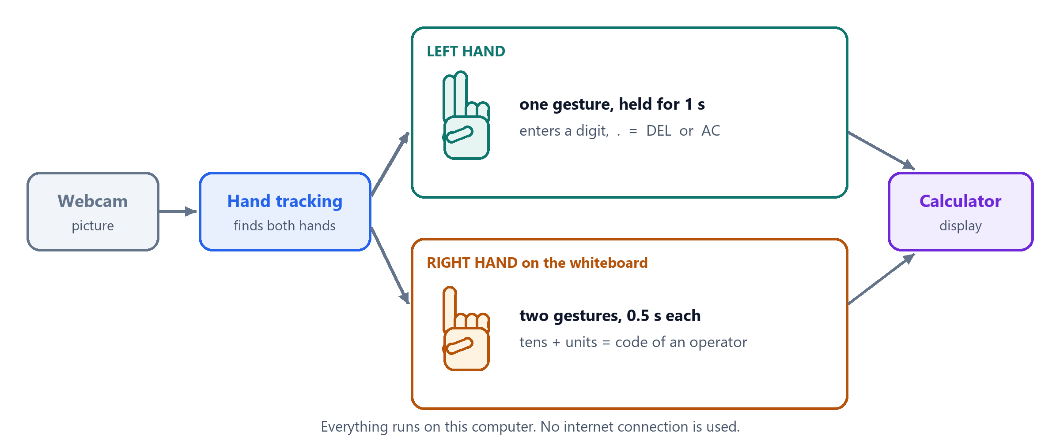
Figure 1 The idea in one picture
Hand | What it shows | What is entered
Left hand | one gesture, held still for 1 second | a digit, ., =, DEL or AC
Right hand, on the whiteboard | two digit gestures, 0.5 second each, tens first | the operator with that two-digit code

The program never uses the internet. Camera pictures are processed on this computer and are not stored.

2 Getting started

2.1 What you need
Item | Requirement
Computer | Windows 10 or 11, 64-bit
Camera | any webcam (the built-in one of a laptop is fine)
Files | GestureCalculator.exe, the folder _internal and the folder models, kept together
Installation | none: no Python, no internet connection

2.2 Start
- Double-click GestureCalculator.exe.
- Wait a few seconds until the camera picture appears.
- Sit 40–80 cm from the camera, in good light, with both hands able to reach into the picture.

2.3 The window
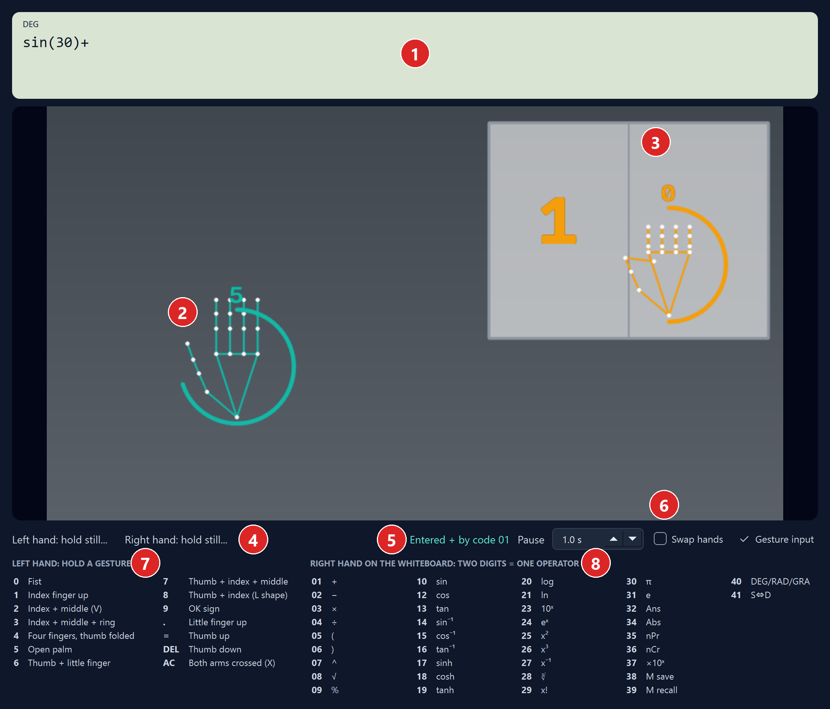
Figure 2 The window (the numbers refer to the table below)
No. | Part | What it does
1 | Display | expression on the first line, result on the right; DEG / RAD / GRA and M (memory in use) at the top left
2 | Left hand | green outline; the ring fills while the gesture is held, the guessed key is shown above it
3 | Whiteboard | two halves: tens digit on the left, units digit on the right; the right hand has an orange outline
4 | Hints | what each hand should do next
5 | Last entry | what was just entered, or why a gesture was not accepted
6 | Settings | Pause, Swap hands, Gesture input (section 6)
7 | Gesture list | the gestures of the left hand
8 | Code list | the two-digit code of every operator

3 Left hand: digits and editing
The left hand enters the digits, the decimal point, =, DEL and AC. Hold a gesture still for 1 second. A green ring fills around the hand; when it is full, the key is entered.
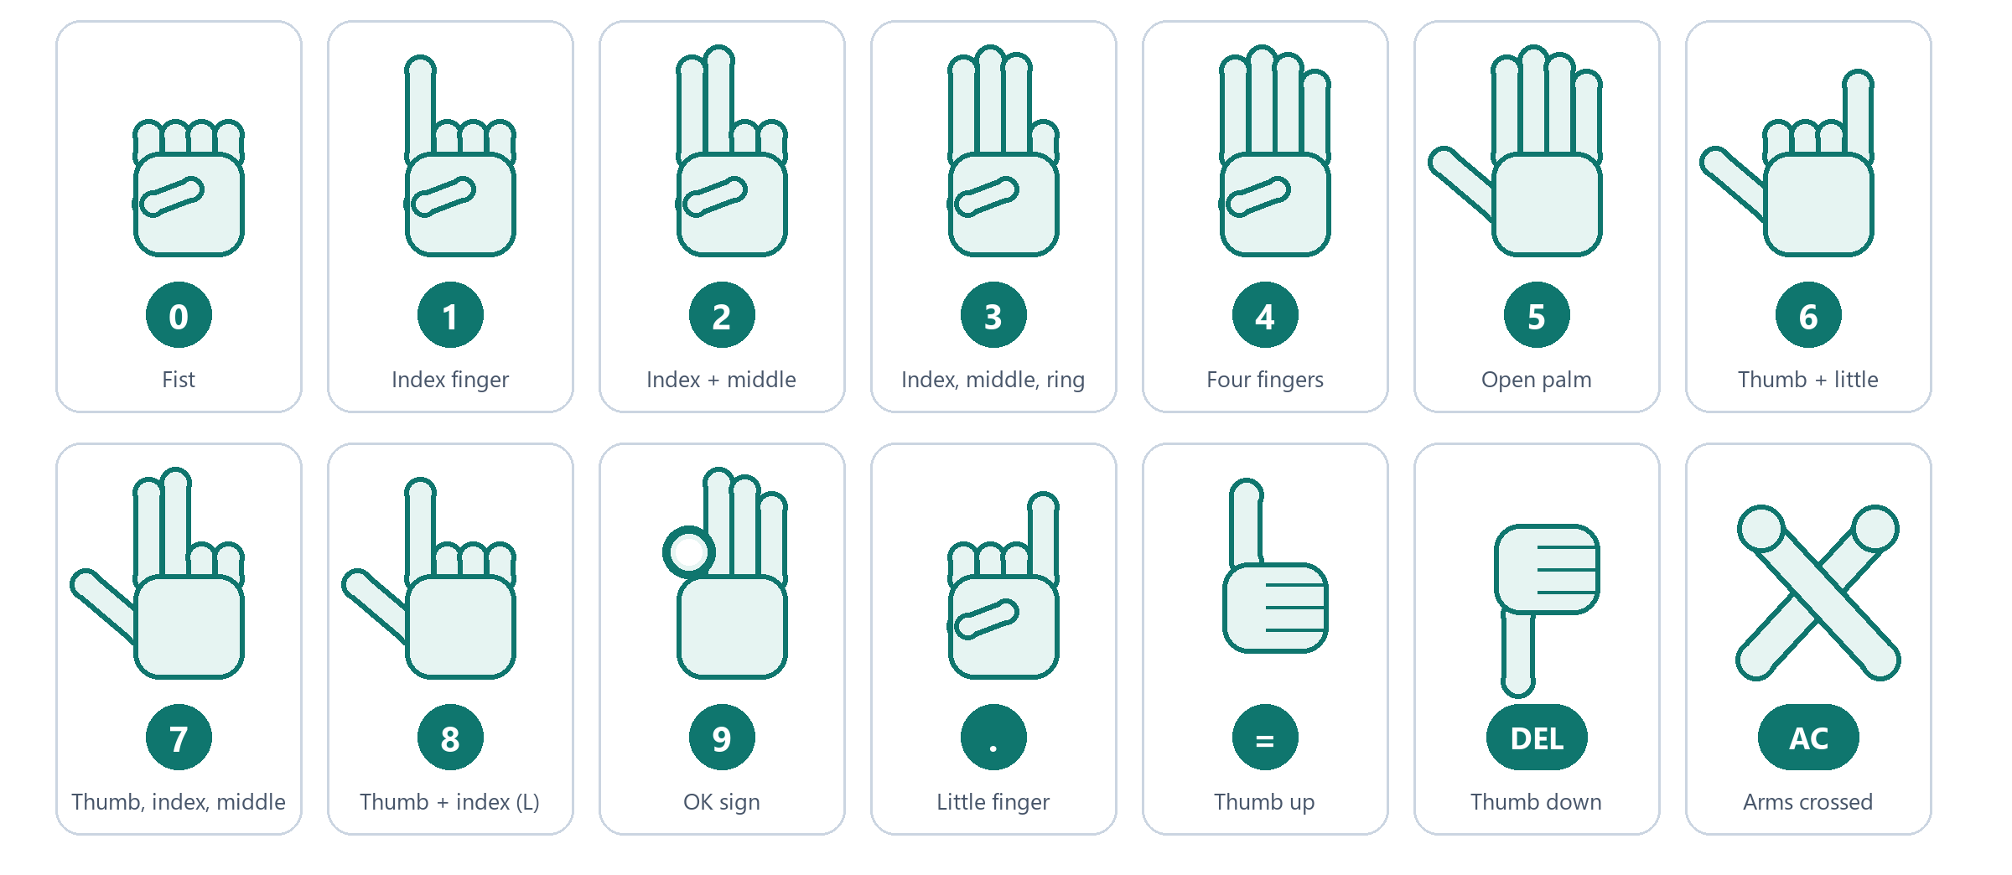
Figure 3 The fourteen gestures of the left hand
To do this | Do this
Enter the next character | change to the next gesture and hold it
Enter the same character twice (55) | after the first one, move the hand aside and back, then hold the gesture again
Delete the last character | thumb down (DEL)
Clear everything | cross both forearms, away from the whiteboard (AC)
Work out the result | thumb up (=)

A held gesture is entered only once. A hand shape shown only in passing, on the way to the next gesture, is ignored.

4 Right hand: operators

4.1 Entering a code
The whiteboard is the light panel in the top right of the camera picture. Put the right hand on it and show two digits, each for 0.5 second: first the tens digit, then the units digit. The digit gestures are the same as for the left hand; an orange ring shows the time running.
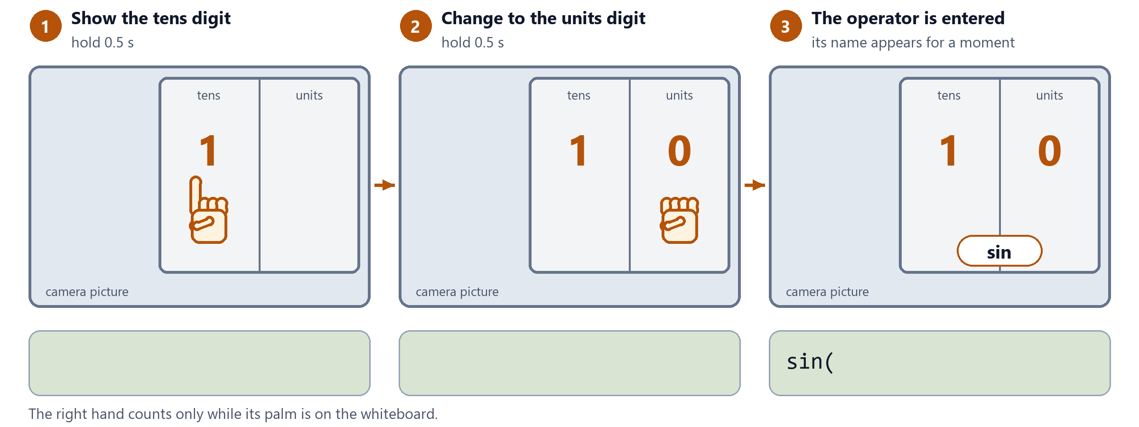
Figure 4 Code 10 enters sin
- The right hand counts only while its palm is on the whiteboard, and it can only enter code digits.
- A code that does not exist enters nothing.
To correct this | Do this
A wrong tens digit | take the hand off the whiteboard; after 6 seconds the digit is dropped
A wrong operator | delete it with the left hand (thumb down, DEL)

4.2 The codes
0x Basic | 1x Trigonometry | 2x Logs, powers | 3x Constants, other | 4x Settings
01 + | 10 sin | 20 log | 30 π | 40 angle unit
02 − | 12 cos | 21 ln | 31 e | 41 decimal ⇔ fraction
03 × | 13 tan | 23 10ˣ | 32 Ans
04 ÷ | 14 sin⁻¹ | 24 eˣ | 34 Abs
05 ( | 15 cos⁻¹ | 25 x² | 35 nPr
06 ) | 16 tan⁻¹ | 26 x³ | 36 nCr
07 ^ | 17 sinh | 27 x⁻¹ | 37 ×10ˣ
08 √ | 18 cosh | 28 ∛ | 38 save to memory
09 % | 19 tanh | 29 x! | 39 recall memory

The tens digit names the group. There are no codes with the same digit twice (11, 22, 33), so the hand never has to show one gesture twice in a row. The same list is printed in the window.

5 Timing and a worked example
The pause starts when the hand is still and its shape no longer changes. Moving the hand or changing the gesture starts it again.
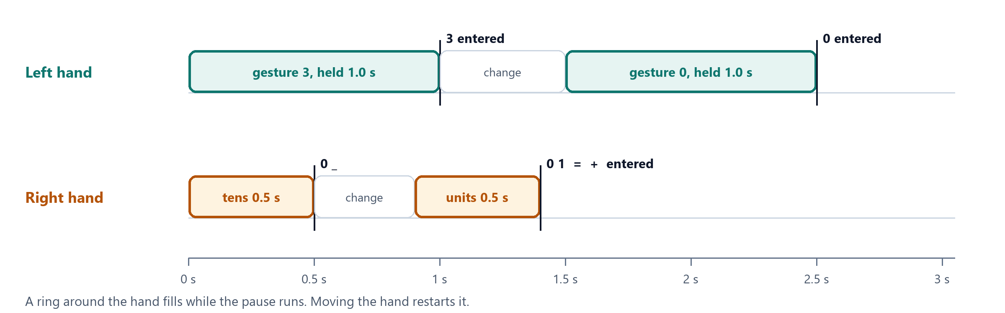
Figure 5 The left hand needs 1 second per character, the right hand 0.5 second per digit
In the example below, orange steps are made by the right hand (a code), green steps by the left hand.
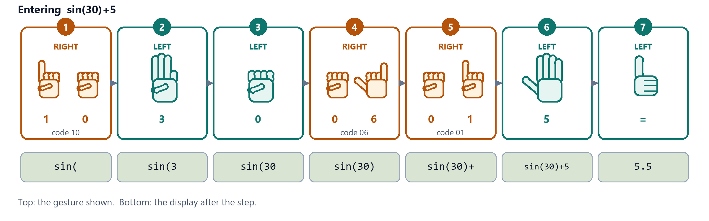
Figure 6 Entering sin(30)+5 in seven steps

6 Settings and keyboard
Setting | Effect
Pause | how long the left hand must be still (1.0 s at the start, 0.4–2.0 s); the right hand always needs half of it
Swap hands | for left-handed use: digits with the right hand, operator codes with the left hand
Gesture input | untick to pause gesture input; the camera picture keeps running

The keyboard always works as well:
Keys | Enter
0–9 . + - * / ( ) ^ ! % | the same characters
Enter or = | the result
Backspace / Esc | DEL / AC
D / F | angle unit / decimal ⇔ fraction

7 Calculator functions
Group | Functions
Arithmetic | + − × ÷, parentheses, %, ×10ˣ
Powers and roots | x², x³, xʸ (^), x⁻¹, √, ∛
Trigonometry | sin, cos, tan, their inverses, sinh, cosh, tanh; angles in DEG, RAD or GRA
Logarithms | log, ln, 10ˣ, eˣ
Counting | x!, nPr, nCr, Abs
Constants, memory | π, e, Ans (the last result), one memory (save, recall)

Rule | Example
A missing × is understood | 2π, 3sin(30)
A missing ) at the end is allowed | sin(30 gives 0.5
After =, an operator continues from the result | 6×7= then +8 shows Ans+8
After =, a digit starts a new calculation | 6×7= then 3 shows 3
Results have 10 significant digits | 1÷3 gives 0.3333333333
What cannot be worked out | Math ERROR (such as 1÷0) or Syntax ERROR (such as 1+); DEL returns to the expression

8 How it works

8.1 From the camera picture to a key
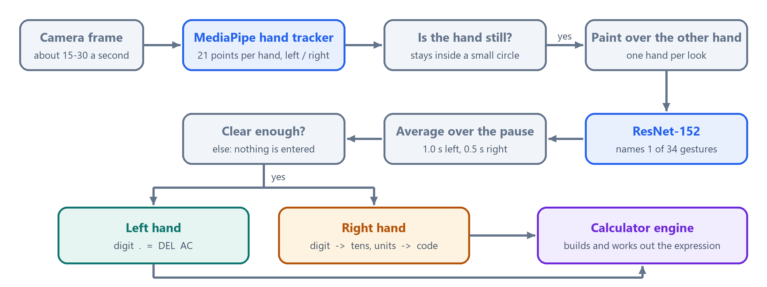
Figure 7 What happens to every camera frame
Step | What it does
Hand tracking | MediaPipe finds up to two hands, 21 points on each, and tells the left hand from the right. The picture is mirrored, so the right hand appears on the right.
Stillness | A hand is still while its palm and index fingertip stay inside a small circle. This tolerates the slight tremor of a raised hand.
One hand per look | The gesture network judges the whole picture and names one gesture. So each hand gets its own look, with the other hand painted over in grey.
Gesture network | ResNet-152, a deep convolutional network pre-trained on the HaGRID gesture data set, gives a probability to each of 34 gestures.
Averaging | The answers for all frames of the pause are averaged, so one bad frame does not decide.
Calculator | The key is added to the expression; = works it out.

8.2 When a gesture is entered
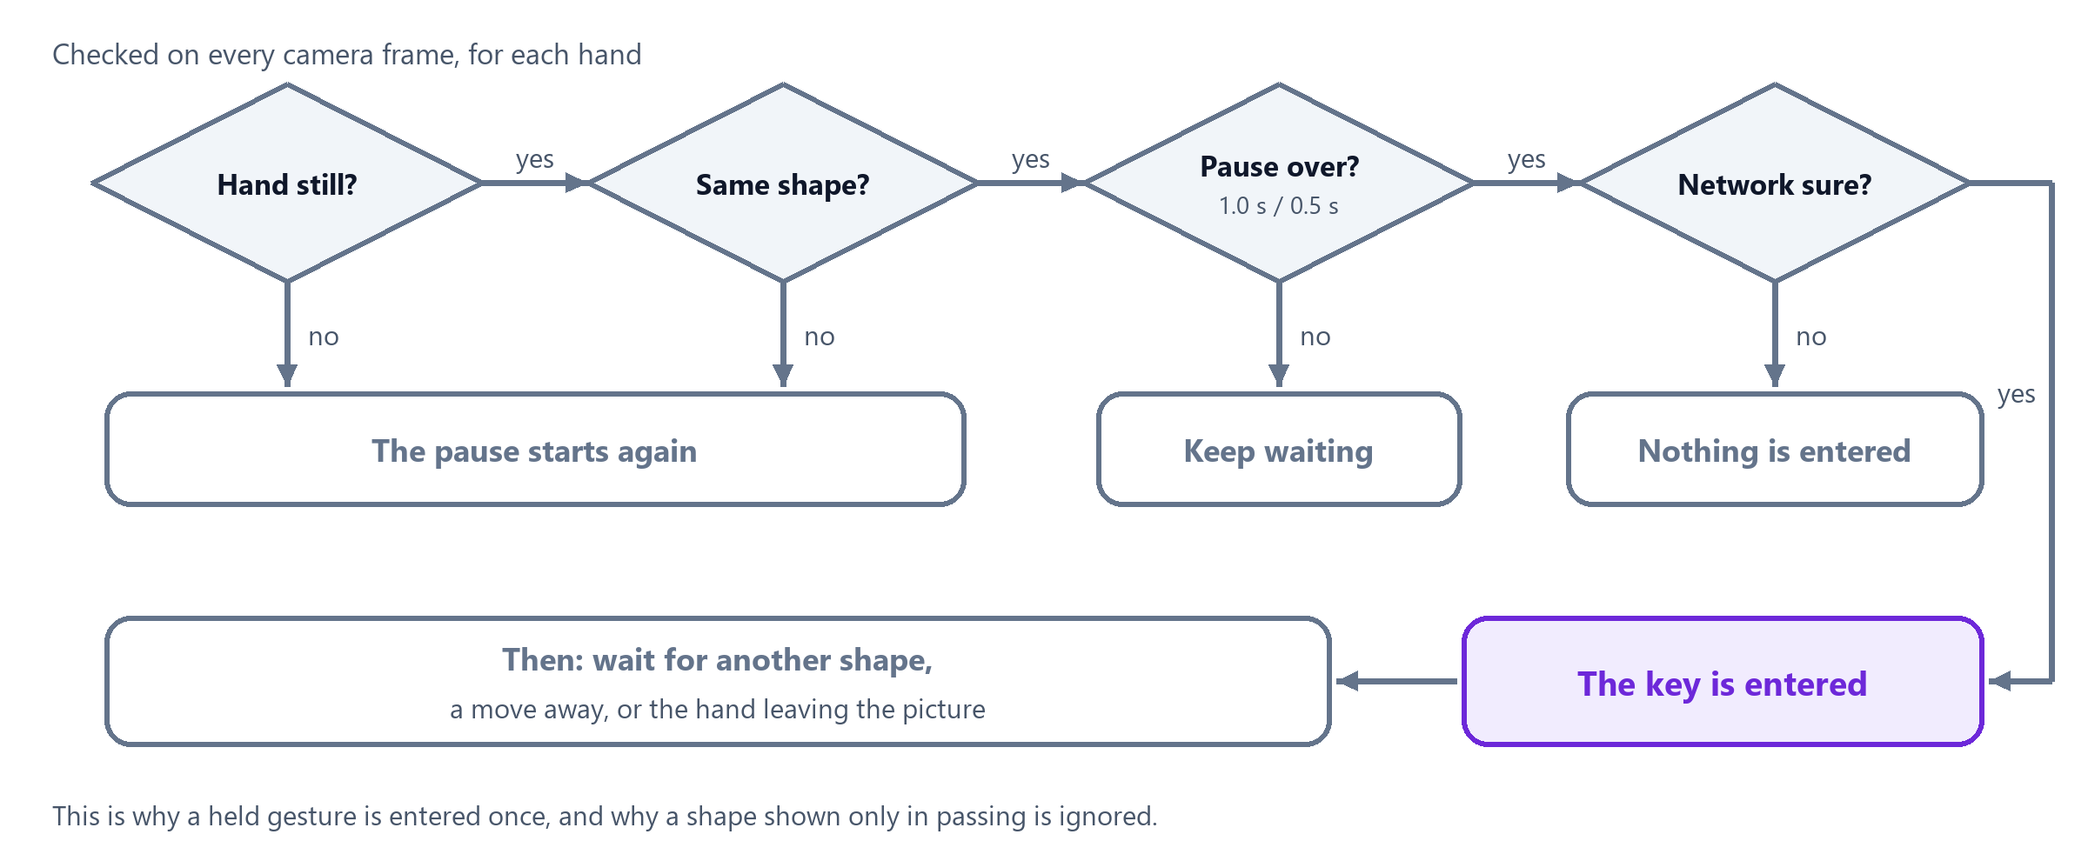
Figure 8 The decision for each hand
"Network sure" means: the calculator's gestures together receive at least 30% of the probability, and the best one at least half of that. Otherwise nothing is entered and the window shows the closest guess.

8.3 The models
File in the models folder | Role
hand_landmarker.task | MediaPipe hand tracker: where the hands are and which one is the left
gesture_resnet152.onnx | ResNet-152 gesture network (used by default)
gesture_vit_b16.onnx | ViT-B/16, a vision transformer trained on the same data; an optional alternative

Both gesture networks are the published HaGRID models, converted to the ONNX format. Nothing is trained on this computer. They run on the processor with ONNX Runtime; no graphics card is needed.

9 Files
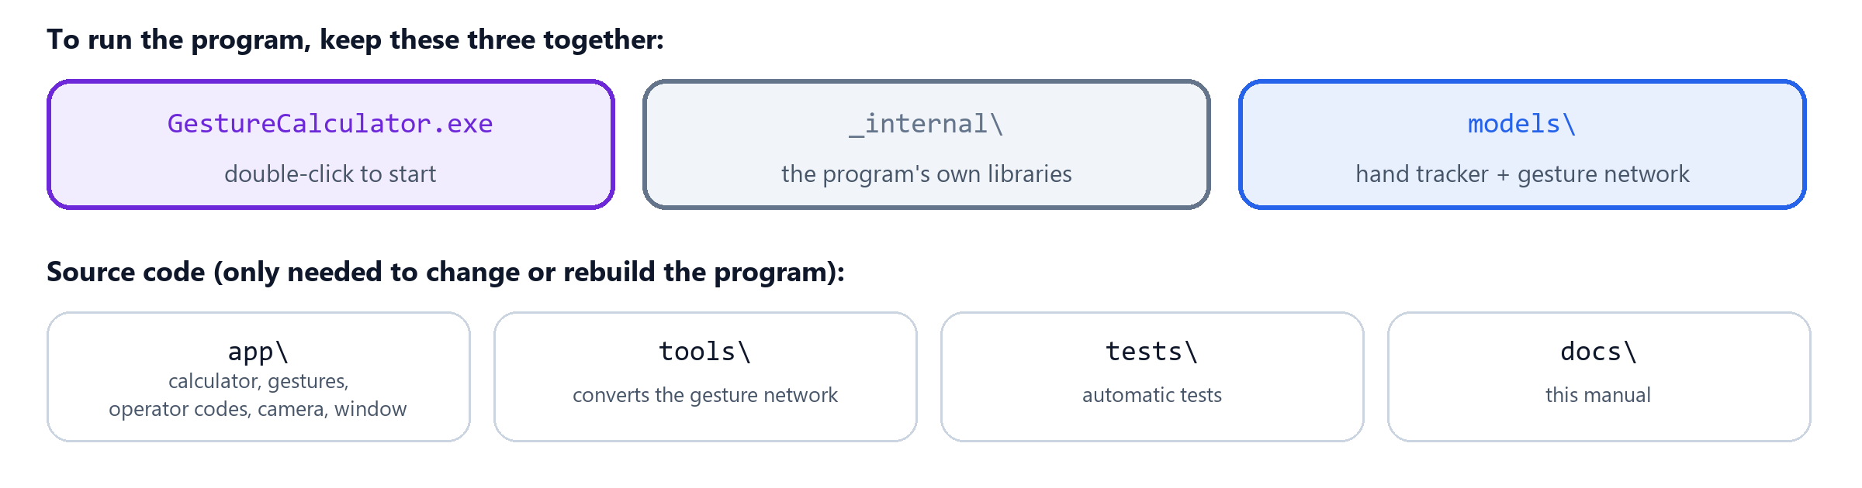
Figure 9 The files of the program
To use the calculator on another computer, copy GestureCalculator.exe, _internal and models together. The program writes no files: nothing is recorded or stored.

9.1 Running from the source code
The source code does not contain the gesture network (it is too large). Step 2 creates it once: the script downloads the published HaGRID model and converts it. This step needs the internet; running the calculator does not.
# 1. environment
py -3.12 -m venv .venv
.venv\Scripts\python -m pip install -r requirements.txt

# 2. the gesture network, once
.venv\Scripts\python -m pip install -r tools\requirements-convert.txt
.venv\Scripts\python tools\convert_hagrid.py --arch resnet152

# 3. start
.venv\Scripts\python app\main.py

Option | Effect
--camera 1 | use another webcam
--no-camera | keyboard only
--gesture-model vit_b16 | use the ViT-B/16 network instead of ResNet-152 (convert it first with --arch vit_b16)

9.2 Building the exe
.venv\Scripts\python -m pip install pyinstaller
pwsh build_exe.ps1

The script writes GestureCalculator.exe and _internal into the project folder.

10 Troubleshooting
Problem | What to do
"No webcam found" | connect a camera, close other programs that use it, start again; or start with --camera 1
"gesture model missing" | put gesture_resnet152.onnx and gesture_resnet152.json into models
No outline on a hand | bring the whole hand into the picture; improve the light
The ring never fills | hold the hand still; rest the elbow on the table
"Gesture not recognised" | face the palm to the camera, spread the fingers clearly, keep the other hand away from it
A digit is entered twice | keep the hand still after an entry until you change the gesture
The right hand enters nothing | its palm must be on the whiteboard
The hands are taken for each other | keep them apart; if it is always wrong, tick Swap hands
"There is no operator with the code …" | check the code list; enter the tens digit first
Entries are too slow or too hasty | change Pause

