**Database Application Programming**

**Project Status and Design Report**

|  |  |  |
| --- | --- | --- |
| **Topic:** | Topic 1: Introduction to PHP and MySQL | |
| **Date:** | 04APR19 | |
| **Revision:** | 1.0 | |
| **Author:** | Richard Boyd | |
| **Team Status:** | |  |  |  |  | | --- | --- | --- | --- | | **Task** | **Team**  **Member** | **Hours**  **Worked** | **Hours Remaining** | | *Build all tables in the database for the project* | *Richard* | *2* | *0* | | *Write the HTML registration form* | *Richard* | *1* | *0* | | *Write the php handler that adds new users to the database* | *Richard* | *1* | *0* | | |
| **GIT URL:** | <https://github.com/RichardvBoyd2/Blog> | |
| **Hosting URL:** | N/A | |
| **Peer Review:** | Y | We acknowledge that our team has reviewed this Report and we agree to the approach we are all taking. |

**Supporting Design Documentation**

**Install Instructions:**

1. Install MAMP (if you don’t already have it)
2. In your web browser, navigate to the MAMP phpMyAdmin page, and click on the import tab
3. Click “Choose File” and select “blog.sql” from the downloaded project files
4. Leave default options and click “Go”
5. In File Explorer, copy the “CST-126_Blog” project folder into “…/MAMP/htdocs”
6. In your web browser, type “<http://localhost/CST-126_Blog/Registration/register.html>”

**General Technical Approach:**

Pretty basic approach for this milestone, with a focus on organization for future additions.

**Key Technical Design Decisions:**

Using HTML and PHP, possible CSS in the future.

*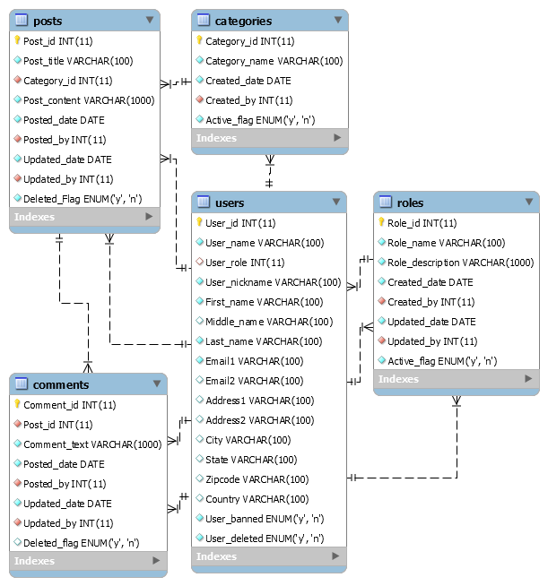***ER Diagram:**

**DDL Scripts:**

Included in the above GitHub link

**Sitemap Diagram:**

N/A

**User Interface Diagrams:**

N/A

**Other Documentation:**

N/A