**Database Application Programming**

**Project Status and Design Report**

|  |  |  |
| --- | --- | --- |
| **Topic:** | Topic 3: PHP Functions | |
| **Date:** | 19APR19 | |
| **Revision:** | 3.1 | |
| **Author:** | Richard Boyd | |
| **Team Status:** | |  |  |  |  | | --- | --- | --- | --- | | **Task** | **Team**  **Member** | **Hours**  **Worked** | **Hours Remaining** | | *Write HTML form and PHP handler for creating a new blog post* | *Richard* | *2* | *0* | | *Refactor program to use external functions for DB connections* | *Richard* | *1* | *0* | |  |  |  |  | | |
| **GIT URL:** | <https://github.com/RichardvBoyd2/Blog> | |
| **Hosting URL:** | N/A | |
| **Peer Review:** | Y | We acknowledge that our team has reviewed this Report and we agree to the approach we are all taking. |

**Supporting Design Documentation**

**Install Instructions:**

1. Install MAMP (if you don’t already have it)
2. In your web browser, navigate to the MAMP phpMyAdmin page, and click on the import tab
3. Click “Choose File” and select “blog.sql” from the downloaded project files
4. Leave default options and click “Go”
5. In File Explorer, copy the “CST-126_Blog” project folder into “…/MAMP/htdocs”
6. In your web browser, type “<http://localhost/CST-126_Blog/Registration/register.html>”

**General Technical Approach:**

Pretty basic approach for this milestone, with a focus on organization for future additions.

**Key Technical Design Decisions:**

Using HTML, PHP, and CSS.

*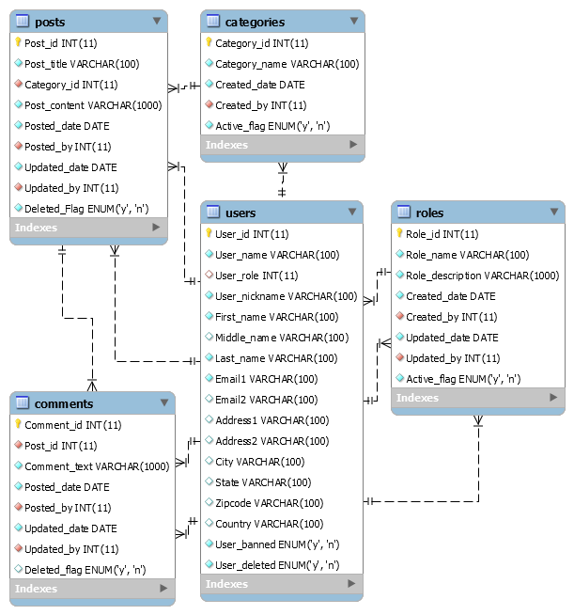***ER Diagram:**

**DDL Scripts:**

Included in the above GitHub link

**Sitemap Diagram:**

N/A

**User Interface Diagrams:**

N/A

**Other Documentation:**

N/A