Lab 6 Assignment

學號 0860077 姓名 王國倫

1. Assignment 1

Expected Result 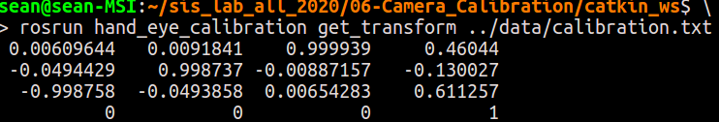

(You can name your node arbitrary)

Your Result

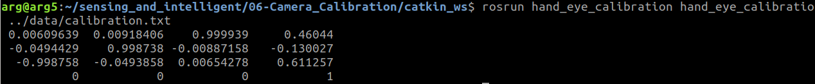

Please also hand in the compressed `hand_eye_calibration` package into .zip format, the directory tree would be liked 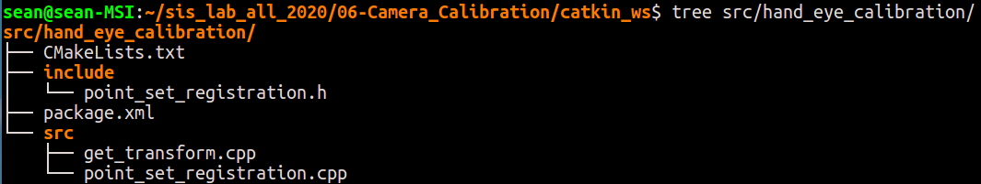

The required files include `CMakeLists.txt`, `package.xml` and corresponding source code. The separated header file and its implementation structure is not forced.

1. 注意事項

* 檔案名稱請改為Lab6_assignment_學號_姓名，上傳格式請用PDF
* 壓縮檔名稱請改為Lab6_assignment_學號_姓名，上傳格式請用ZIP
* 學生只要將作業要求的圖片更改為自己做實驗並截圖下來的圖片即可，無須多做說明。
* 請勿抄襲