Background

The nonprofit foundation Alphabet Soup wants a tool that can help it select the applicants for funding with the best chance of success in their ventures. With your knowledge of machine learning and neural networks, I will use the features in the provided dataset to create a binary classifier that can predict whether applicants will be successful if funded by Alphabet Soup.

Results

Firstly,after removing the 'EIN' and 'Name'colums,the rest of the colums are regarded as features for the model.I split the data into training and testing data. The target variable of the model is called'IS_successful'. It has value 1 for yes and 0 for no.Application and 'Classfification' are counted and replaced.Categorial variables are encoded by get_dummies.

Compiling, training and evaluating the Model:

The research creates three layers for each model by applying neural networks. The number of hidden nodes were determined by the number of features.

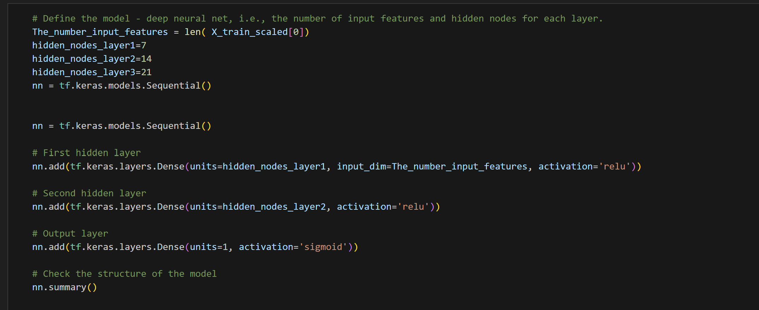

In the trained model, 477 parameters were produced. The first attempt is with 0.7296 accuracy.

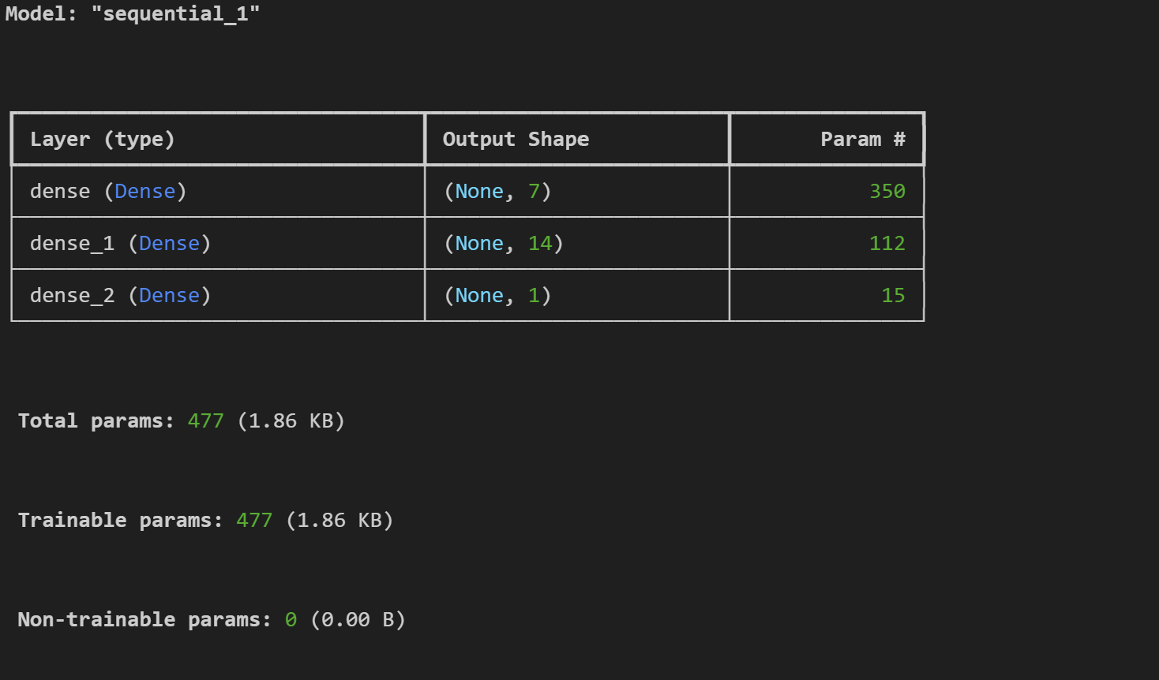

Optimisation

The second attempt lifts the accuracy of the prediction which is 0.75. There are 137,453 parameters.

