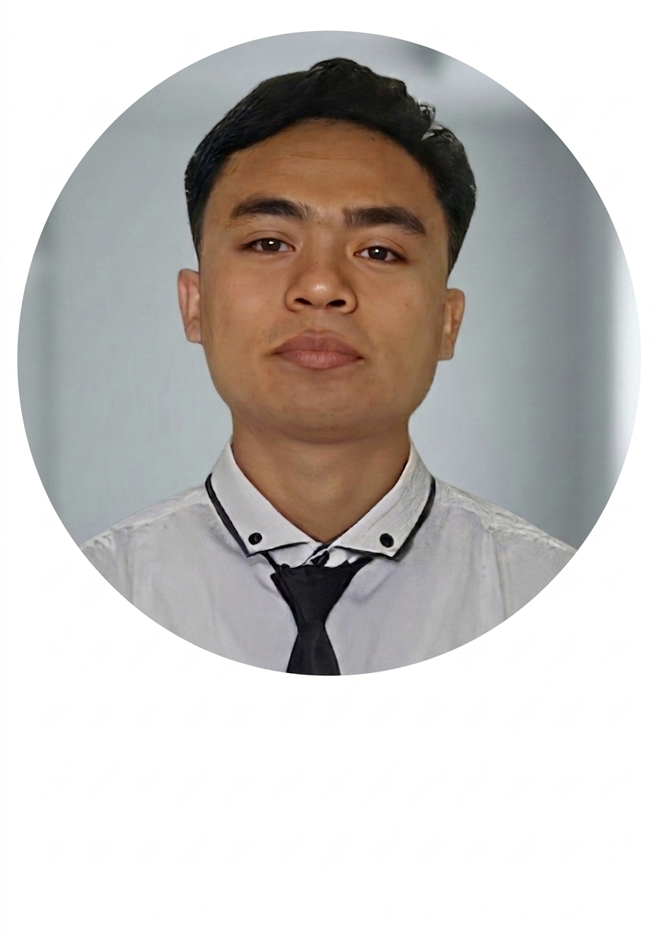
RICHARD ANTONIUS NENAT
Software Engineer | Full Stack Developer
📞 082341411616 | ✉ richardran12@gmail.com | 📍 Kefamenanu, NTT

PROFILE  Computer Science graduate with hands-on experience in PHP, Python, Java, and web technologies. Proven ability to manage information systems and deliver technical solutions in organizational settings. Eager to contribute as a Software Engineer in a dynamic tech environment.  EDUCATION  Bachelor of Computer Science  Universitas Katolik Widya Mandira  Kupang  GPA: 3.31 | Graduated July 2021  TECHNICAL SKILLS  Languages: PHP, Python, Java, C/C++  Web: HTML5, CSS3, JavaScript  Database: MySQL, SQL  Tools: Git, VS Code, NetBeans  Concepts: OOP, REST APIs, MVC  SOFT SKILLS  - Team Collaboration  - Problem Solving  - Fast Learner & Adaptable  - Strong Communication  - Attention to Detail  - Time Management  LANGUAGES  Indonesian: Native  English: Professional Working Proficiency  AREAS OF INTEREST  - Web Application Development  - Backend Systems & APIs  - Database Management  - Software Architecture | WORK EXPERIENCE  Staff Member (IT & Administration)  Dinas Pendidikan Dan Kebudayaan, Malaka – NTT July 2025 – Present  - Managed and maintained digital records and information systems for the department.  - Coordinated cross-departmental projects, facilitating knowledge sharing and data accuracy.  - Developed streamlined workflows that improved team communication and operational efficiency.  - Provided technical assistance and administrative support to improve service delivery.  Administrative Staff Member  SMA Negeri Taekas, Kefamenanu January 2022 – 2024  - Managed comprehensive school administration including student records and scheduling systems.  - Implemented digital filing systems that improved document retrieval efficiency.  - Demonstrated strong self-motivation with consistent delivery of high-quality administrative output.  - Coordinated communication between departments, staff, and external stakeholders.  Intern – Field Work Study  Badan Pusat Statistik (BPS), Kefamenanu 2019  - Completed 1-month field work internship supporting data collection and statistical activities.  - Worked independently and collaboratively to ensure accurate data recording and project completion.  - Gained practical experience in data entry, reporting, and institutional operations.  ACADEMIC PROJECTS  Student Information System (PHP/MySQL)  Designed and developed a web-based information management system for school administration using PHP, MySQL, and HTML/CSS. Implemented CRUD operations and user authentication.  Data Processing Application (Python)  Built a Python-based data processing tool for automating report generation, applying data cleaning techniques and file I/O operations.  Inventory Management App (Java)  Developed a desktop inventory management application in Java with GUI, database integration, and reporting features as part of coursework at Universitas Widya Mandira.

