**Problem Analysis**

**CodeforLife Team   
Choice of System:** Hydraforce Company System (Import, Retail & Accounting Process)

|  |  |  |  |  |
| --- | --- | --- | --- | --- |
| **ID#** | **Description**  **(What’s the problem?)** | **Cause**  **(What causes the problem?)** | **Symptoms**  **(How do we know the problem exists?)** | **Impact**  **(Why is this important? What are the consequences?)** |
| 1.1 | The company lacks notifications when it comes to handling items below stock minimum. | Employees manually checks all the stock cards that causes them sometimes to miss out details or oversee some items going below the stock minimum due to human imperfections/ error. | There are out of stocked items when a customer orders. | It is important to be notified to avoid having “out of stocks” that leads to lost sales/income. |
| 1.2 | It is difficult to know customers that exceeds their terms. (Lack of Collectibles Knowledge) | It is very hard to update and keep track of all collectibles accurately because informations about who has not paid and who has paid is changing regularly. | There are customers who exceeds their terms and does not pay on time. | It is important to be notified to avoid profit loss and financial bankruptcy. |
| 2 | It is difficult to organize the inventory and look at reports. There is no up to date inventory report. | They have separate files for different categories which results to many excel files to be opened. If a person is tasked to make a summary report and uses 3 or more excel files, the report may have errors due to the limited space in a monitor which makes him minimize and maximize excel files while tracking informations. | Mr Jao explained that they need to open multiple excel files for viewing when accomplishing a single task; thus making it hard for them to accomplish tasks and maintain consistencies. | It is important to generate reports so that finding items or reports will be easier and more accurate. With this, results will be more reliable that makes the company’s work/task/goal running perfectly. |
| 3 | The current process lacks security. | Since it is done through papers and stock card, there is a chance of losing the papers. | Because papers and cards are used for the inventory and checking of stocks. | To have data secured and prevent loss. |
| 4 | For new employees, or staff who are unfamiliar with an item it is hard to identify the item causing them in giving the wrong items. | There is no inventory list with pictures to know what the item looks like. | According to Mr. Jao, new employees have a hard time knowing what the customer wants because the customers doesn’t know the model name, and just describes the product that they want causing delays and misconceptions. | This will help employees to gather items quicker. Also, with proper inventory with pictures, the profit and loss can be minimized because the prices can be matched with the actual items needed. |
| 5 | It is hard for the company to decipher the item price to be given to a certain customer. | There are repeat orders and different pricing per customer, thus because previous official receipts are hard to trace if there are many and unorganized, employees tend to be lazy and give out prices base on instincts. | Mr. Jao explained that they have different prices for their customers namely, trading price, end user price and wholesale price. | The correct pricing of items based on customers will allow the company to profit higher because it avoids giving lesser price for customers that can pay higher. Also, the company can avoid loss of customers that orders in other companies due to giving higher prices than what they had expected from the company. |

**Visualize the process**

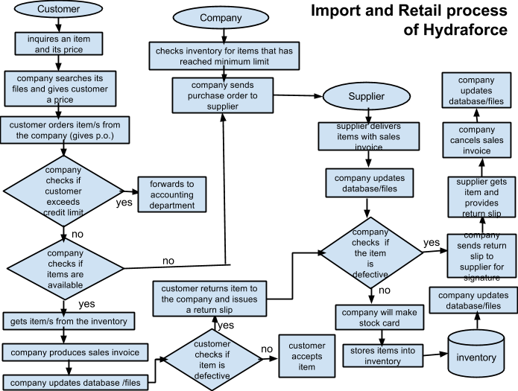

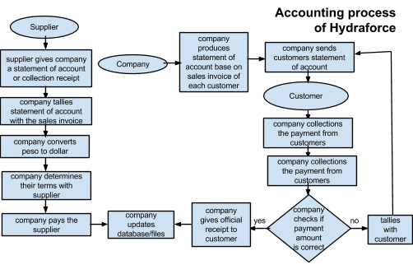

**What’s the business goal? Why do they need software?**

Hydraforce Enterprises is a company who imports and retails a complete line of Oil seals and Seal kits from light to heavy trucks and heavy equipments as well. They handle manufacturing and industrial supplies and services as well as other types of machinery and equipments.   
  
Hydraforce offers services as follows:  
**Primary Categories:** Manufacturing and Industrial Supplies and Services, Machinery, Equipment and Supplies, Industrial Machinery, Hydraulic Equipment And Supplies  
**Other Categories:** Construction, Mobile Plant Equipment, Heavy Equipment

The company needs a software to be easily notified when needed, look over reports and inventory with convenience and attain a connected/unified system. As of now, the company have been using the manual system which causes them to miss out some details such as having items going below the stock minimum and going overdue with their collectibles.

**What characteristics should the software have?**

* **Reliable** and **accurate** informations is produced by the database of the system to lessen profit loss and maximize profit gain.
* **Efficient** process is incorporated in the software to improve current process of the company.
* **Secured** software that will restrict users who are not entitled to access a feature of the program to avoid malicious software inputs and edits.
* **Simplicity** and **user-friendliness** of the software should also be observed to acquire fast data gathering and input.
* **Unified** system that will lessen errors and easen the company process.