CodeforLife Team
System: Hydraforce Company System (Import, Retail and Accounting Process)
Names: Janica Lam(ANA); Angeline Tan(QA); Janine Tan(DEV)
Problem Analysis
Description  (What’s the problem?) | Cause  (What causes the problem?) | Symptoms  (How do we know the problem exists?) | Impact  (Why is this important? What are the consequences?)
Company has an inefficient system | They have separate files for different categories which results to many files to be opened | Because Mr. Joel Jao explained the difficulties of having multiple files opened just for viewing. | It is important to have a more efficient system in regards to handling data
The company lacks notifications when it comes to handling items beyond stock minimum | The manual system causes them to miss out details or oversee some items going below the stock minimum. They check the stock cards individually. | Mr. Joel Jao explained that there are times where employees overlook some datas in regards to this problem. | It is important to be notified to avoid having “out of stocks”
It is difficult to organize the inventory | Since everything is done by hand and by list, you are limited to rearranged or sort out items | Because they told us about the manual system for their inventory. | To be more organized would let employees look for/find items easier.
In regards to the collectibles it would sometimes go overdue | The lack of notifications, since it is in manual system, employees would always need to check, but sometimes misses it. | It was explained how collectibles are set in by months (30,60,90 days or else overdue) and are checked manually. | To minimize the cost of having overdue dates in regards to collectibles.
The manual system lacks security | Since it is done through papers and stock card, there is a chance of losing the papers | Because are papers and cards are used for the inventory and checking stocks | To have data secured and prevent loss.

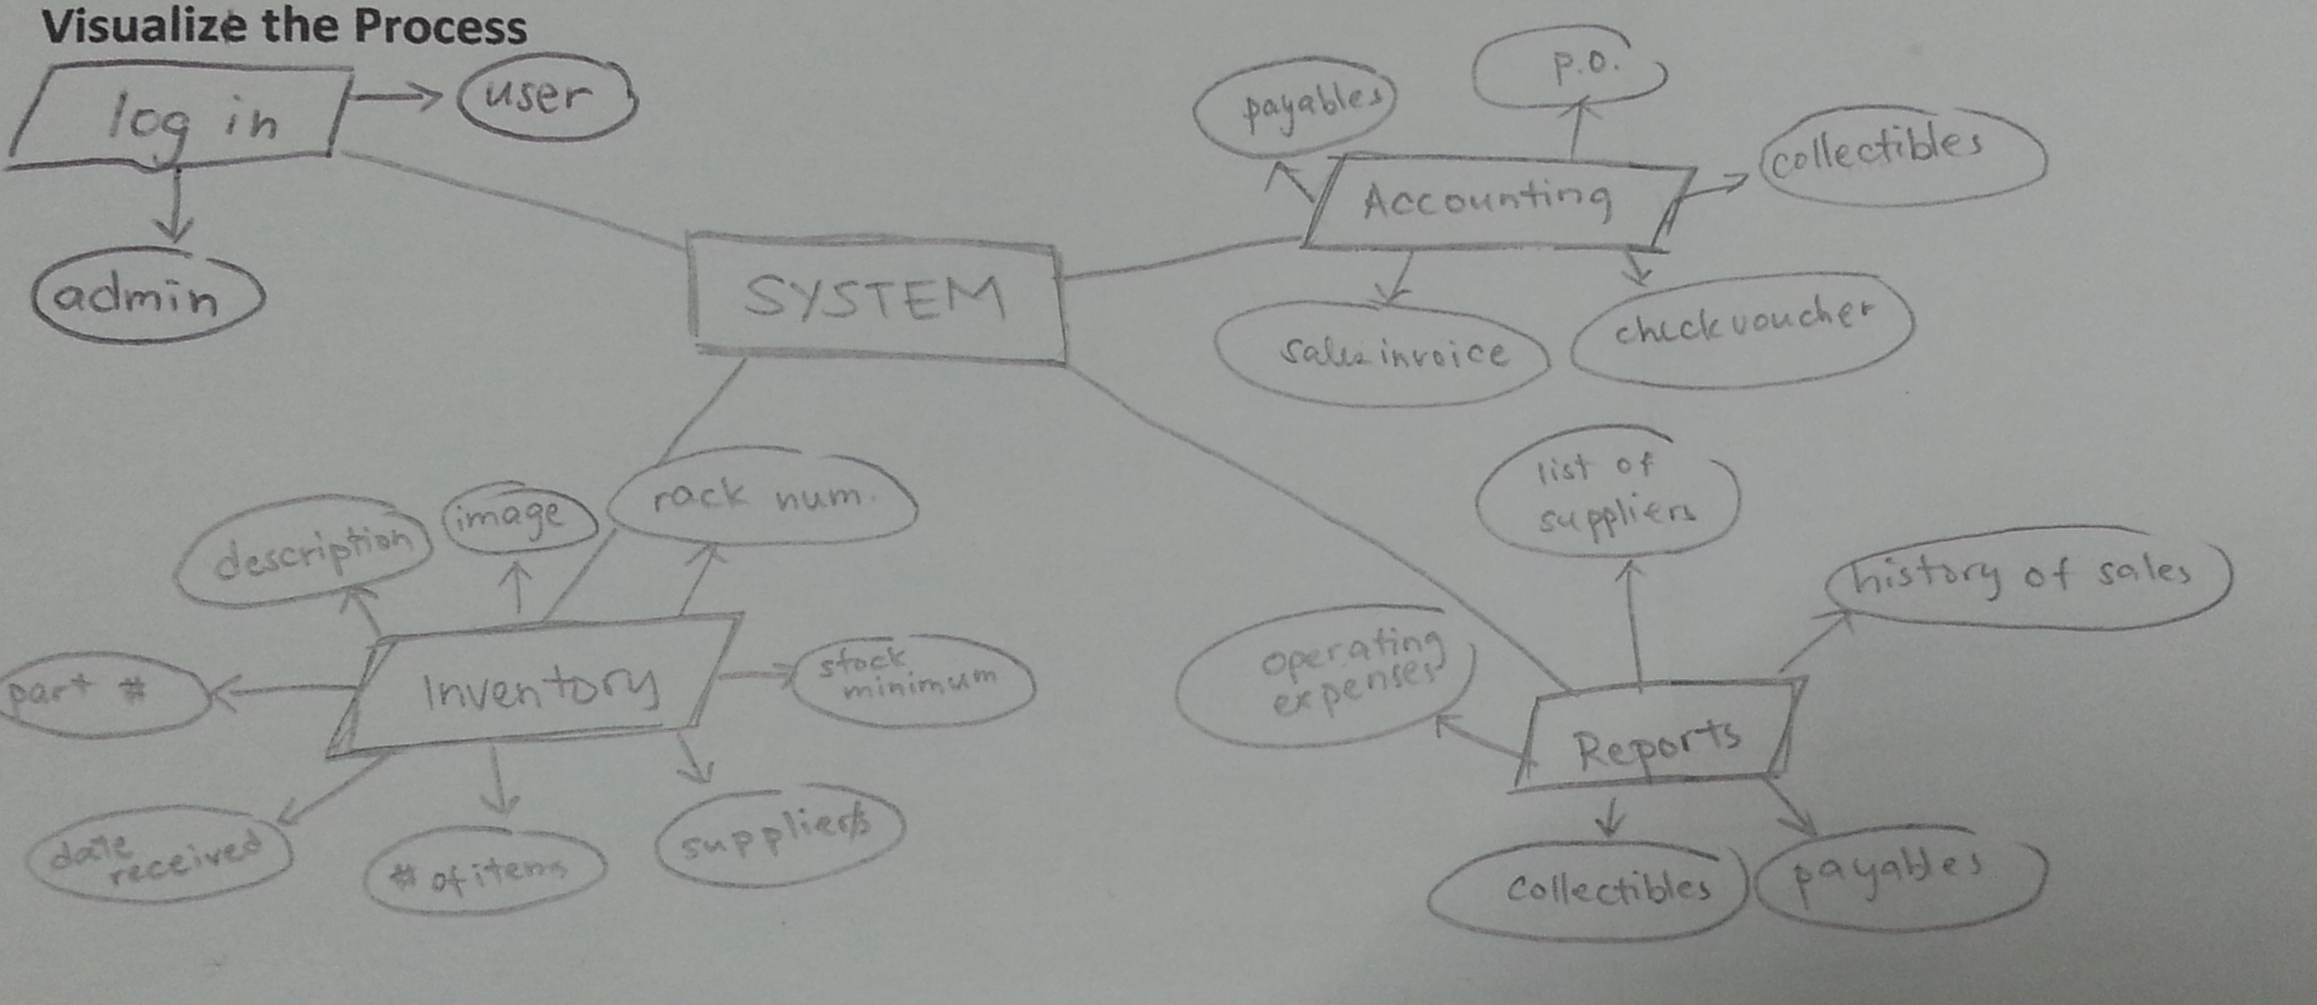

What’s the business goal? Why do they need software?
The company needs a software to be easily notified when needed, look over reports and inventory with convenience and attain a connected/unified system. As of now, the company have been using the manual system which causes them to miss out some details such as having items going below the stock minimum and going overdue with their collectibles.
What characteristics should the software have?
- Efficiency
- Unified System
- Security

