CodeforLife Team
Subteam 2
System: Mangyan Heriatge Center (Inventory System)
Names: Joshua Manto (QA), Jasmin Santillana (ANA), Juan Lorenzo Simeon (DEV)
Problem Analysis
Description  (What’s the problem?) | Cause  (What causes the problem?) | Symptoms  (How do we know the problem exists?) | Impact  (Why is this important? What are the consequences?)
The system (excel file) for the organization’s inventory process is not updated regularly. | Updating is done manually and different products are being sold from their income-generating project. | Some items may be left unaccounted for. There may be lost items. Some items may have already been bought and the staff would not know. | When the system is updated rarely, inaccurate results (financial report) would be generated.
Heavy work load for some employees. (Handling and delivering of products, quality control, and updating of inventory are done by the full-time staff) | There are only 3 full-time staff for the organization. | The inventory is only updated weekly (or only when the staff has time) instead of regularly. The updating process takes longer due to the amount of data needed to be updated. | Having a heavy workload for each staff may result to unfinished tasks. (Especially when updating the inventory).
The report (financial statement) is too general - the report only consists of the amount and the total sales of product. | The staff relies on manually checking the official receipts to know sales. | Other information (Annual sales, number of items sold in a year) are not tracked. | General report isn’t enough to know the company’s business standing.
Inaccurate information is recorded. | There are lost items or products mostly during exhibits. | There are items in the inventory that are not actually available; or there are items being sold that are not listed in the inventory. | Inaccurate information results to incorrect reports.
Additional expenses (shipping cost, manufacturing cost, discounts) are not included in the inventory. | The staff likes to give discounts to their customers in different forms, sometimes the shouldering of the shipping cost, or just a % discount. | It is difficult for the staff to trace which customers do they always give discounts to, as well as the discount they give specifically. | Computation for the gross income (including the additional expenses), which determines if the organization gains or loses money, becomes inaccurate.

Visualize the Process
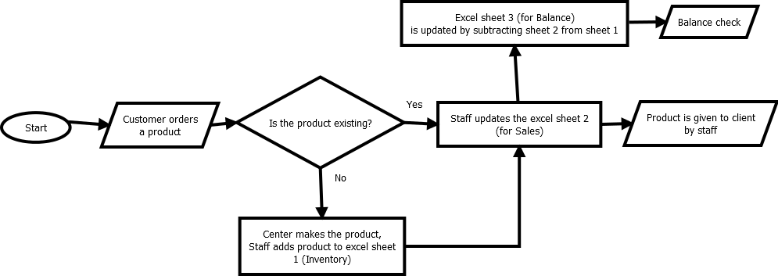

What’s the business goal? Why do they need software?
The Mangyan Heritage Center promotes awareness and culture of the indigenous people of Mindoro by selling handicrafts made by different ethnic groups of Mindoro.
The organization needs a software to help them classify the products or items being sold by the organization and limit the items to be included in their inventory. The software should also be desktop-based so that they could update the data offline or without using the internet (since the internet connection in their place is unreliable).

What characteristics should the software have?
The software should be reliable so that it can generate accurate reports because there are times the final report does not tally with the sales. The software should also be simple so the staff can use it easily.

