**Specification sheet  
(University Reutlingen, department of information technology SS 18)**

**Project: Measurement of shopping time in supermarkets**

**Auftraggeber: Herman Hollerith Zentrum**

**Danzinger Str. 6**

**71034 Böblingen**

**Sebastian Kotstein**

**Auftragnehmer: Alisa Vivian Bunte**

**Rabia Karatas**

**Regina Kehm**

**Isabel Patricia Schorm**

**Richard Luis Wolf**

|  |  |  |
| --- | --- | --- |
| Version | Date | Author(s) |
| 1.0 | SS 2018 | Department of information technology, Alisa Vivian Bunte / Rabia Karatas / Regina Kehm / Isabel Patricia Schorm / Richard Luis Wolf |
|  |  |  |
|  |  |  |
|  |  |  |

**Table of content**

1. Introduction 1

1.1 Initial situation 1

1.2 Objective 1

1.3 Stakeholder 1

2. Use Case 2

2.1 Use Case 1 2

2.1.1 Scenario 2

2.1.2 Business process 2

2.1.3 Value Proposition Canvas 3

2.1.4 Business Model Canvas 4

2.2 Use Case 2 4

2.2.1 Scenario 5

2.2.2 Business process 5

2.2.3 Value Proposition Canvas 5

2.2.4 Business Model Canvas 6

2.3 Use Case 3 7

2.3.1 Scenario 7

2.3.2 Business process 7

2.3.3 Value Proposition Canvas: 8

2.3.4 Business Model Canvas 8

2.4 Central Use Case 9

3. Functional requirements 10

3.1 Essential requirements 10

3.2 Optional requirements 11

4. Non-functional requirements 11

4.1 Usability 11

4.2 Reliability 11

4.3 Performance 11

4.4 Changeability 11

4.5 Maintainability 12

4.6 Security 12

Annex 13

Bibliography 17

1. Introduction

The following work is developed as part of a university project. The beginning of the project was on the 16th of April and was initiated by an introduction date. The project lasts one year and consists of two parts. Both parts will be presented. The first part after a half of year and the other after one year. Both parts build on one another. Students are working in teams and are coached by tutors. Each team works on its own topic and has an own tutor who is also responsible for the evaluation of the work. The teams work self-dependent and meet with the tutor in a two-week rhythm.

* 1. Initial situation

This work deals with the measuring of the shopping time of customers in supermarkets. The project team cooperates with a German retailer. The German retailer is researching how different sensor techniques can be used to achieve a shopping time measurement. With the help of shopping time measurement, the retailer wants to achieve a higher customer satisfaction. The aim of the project is to support this retailer in the research and to exchange the results.

* 1. Objective

The project team has decided to follow the top-down strategy. That means that first a business model is designed on which everything else builds. Requirement criteria are derived from the use case. After that the research phase begins which deals with four sensor technologies. The four technologies are Augmented Reality, Beacons, RFID and different camera system, especially VLC. They are analysed if they are suitable for the implementation of the business model. After the research, the technologies are evaluated. The best technology can be used in the second part of the project for a prototype.

* 1. Typical environment

In this project a typical environment for the usage of the system is in a supermarket of the German retailer. This environment always consists of narrow passages, normal and refrigerated shelves, different areas and defined points such as entrance and cash point. Also, the layout of the various branches can be a little bit different. Therefore, it follows that a system should provide a high accuracy because of the narrow passages. Then a supermarket can be subdivided in areas like the sweets section, refrigerated section or a butcher’s counter. The developed system should have the opportunity to classify the environment as well. It is also important that the system is scalable and customizable because of the different layouts of the supermarket.

* 1. Current state

The German retailer has already tested three sensor technologies: BLC, RFID and Augmented Reality. The next sensor technology the retailer is going to test is VLC.

* 1. Stakeholder

This chapter lists the people who are interested in the results of this work:

* The responsible tutor Sebastian Kotstein
* HHZ
* Customer
* The cooperation partner (German supermarket chain)
  + The administrative IT department (to maintain the system)
  + Employee (they are working with the system)

1. Use Case

The following chapter describes three use cases that arose during brainstorming. They have the goal of generating customer benefit or business benefits and are all concerned with the shopping time measurement. The three use cases should address three different user groups. In the following, the scenario, the associated value proposition canvas (VPC) and the business model canvas (BMC) are presented for each use case.

* 1. Use Case 1

In this scenario the project team focus on the customer type of older consumers. A statistic of the consulting A.T. Kearney in the year 2010 shows that the group of older consumers generated a total turnover of 6 trillion euro in the world. It is assumed that the generated turnover will rise to an amount over 11 trillion euro, which make them an attractive target group. In addition is this target group well known for rarely using smartphones.[1] Indeed, 28% of persons over the age of 65 owned a mobile phone but the majority of this group doesn’t use them.[2]

* + 1. Scenario

In the first scenario the central character is Gertrud, a pensioner. She is a fictional example for the group of customers that don’t use a smartphone. Since her husband died, she lives alone. She goes always shopping in the supermarket close to her apartment. Because of this she is a regular customer in this supermarket and want to be rewarded for this. But the rewards should not be offered via a smartphone. Due to her age she doesn’t want to use such devices. A get-together with friends at the supermarket would be nice as well.

* + 1. Business process

A typical process of this scenario could proceed as follows:

The customer decides whether to go to the store or to the bakery. If the customer goes to the bakery, he/she will be served by the bakery sales assistant. The customer shows the customer card and might be rewarded with a discount depending on the discount points the customer collected. After the bakery sales assistant cashes up, the customer might meet up with friends in the café of the bakery. At last he/she will leave the bakery.

If the customer goes to the supermarket, he/she will get a shopping basket or trolley first. Passing the entrance of the supermarket, the sensor system will notice the sensor in the basket/trolley and will start with the time measurement. Then the customer goes shopping the necessary products and meanwhile the sensor system tracks positions and the corresponding timestamps along the route. If the customer has bought everything, he/she goes to the cash point. The cashier requests the customer card and grants a down rounded discount (only cents) on the base price. It’s possible that the customer gets more discounts depending on his discount points. The discount points will be automatically collected when the customer buys products. The amount of the discount points depends on total purchase price and the frequency the customer goes shopping. This information is saved in the customer card. As soon as the cashier use the cash register system, the sensor system combines the inserted customer card data and purchase price with the tracked data of the used shopping basket / trolley. At last the cashier hands out the bill and the customer leaves the supermarket.

This business process is also modeled in the Business process model notation (BPMN) (evidently in the 1st Annex).

* + 1. Value Proposition Canvas

On the basis of the scenario and the business process the project team modeled a value proposition canvas. It summarizes the needs of the targed group (e.g. no usage of smartphones and a discount that down rounds the total basis price) and a solution that can gain values to that needs. In this case the solution is a customer card that doesn’t need to be operate with and includes a sensor technology to provide the time measurement for the retailer.

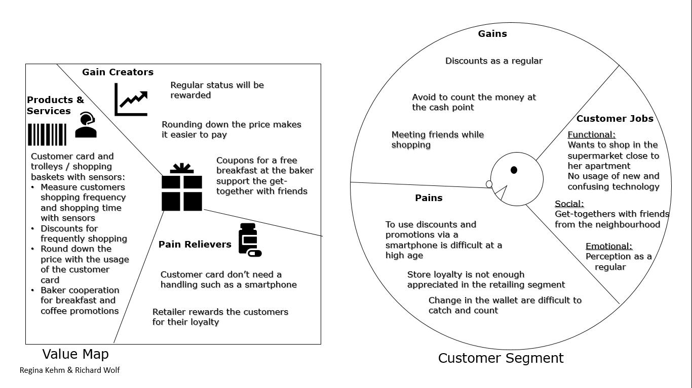

* + 1. Business Model Canvas

The VPC got transferred into a business model canvas. The business model canvas combines the important information of the value proposition canvas with further information. For example, shows this model which factors create cost and which factors create revenue. Furthermore, this model helps to identify the customer segments that can be targeted with the product/service. In this case the targeted customer segments are older customers, customers that doesn’t want to use smartphones and regulars.

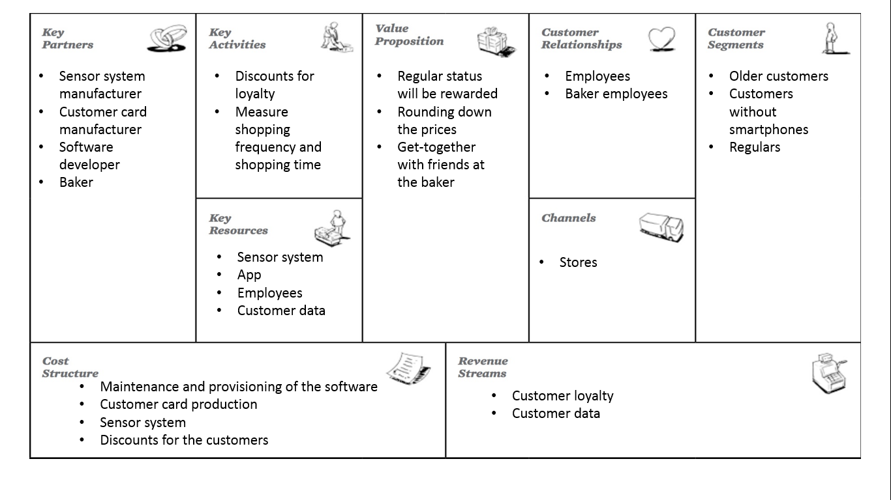

* 1. Use Case 2

According to a study by the global performance management company “Nielsen” in the year 2016, one third of the Germans try to spend as less time as possible on buying food.[3] The reason for that is, that most students and working persons have too less time for activities like that.[4] Also in the “nutrition report 2016” can be seen that every fifth customer uses the smartphone during shopping in a supermarket.[5] Therefore, the next use case depends on the target group of busy and technophilic customers.

* + 1. Scenario

In the second scenario the central character is Sabrina, a medical student. She displays a fictitious role and is new in town and due to her study very busy. For her daily tasks Sabrina has not a lot of time. For every support that helps her saving time she would be very grateful. Shopping food is very time consuming. Nearby is a supermarket where she wants to buy food for her daily needs. It’s very large and some products are difficult to find. A navigation tool which corresponds the products on Sabrina’s shopping list and helps her to find the shortest path to the searched products would be very helpful. In addition, it would be nice if Sabrina can avoid visit the supermarket if the products she is looking for are not available. Sabrina has always her smartphone with her. So, it would be an advantage if the desired features could be used via smartphone.

* + 1. Business process

A typical process of this scenario could proceed as follows:

First the customer creates a shopping list with the retailer app on the smartphone if there is a need to go shopping. After that the customer can check if all the needed products are available in a chosen branch of the retailer. Then the app scans the database of the supermarket inventory and checks if the products on the shopping list are available and informs the user about that. With this information the customer decides if he/she wants to go to the supermarket or another time when the desired products are available again. If the decision is to go shopping, the customer enters the supermarket. It’s possible to activate a shopping list navigation with the app. If the customer uses the navigation, the app informs the sensor system, that the customer enters the shop. The sensor system begins with the time measurement and provides sensor data for the navigation to the app. With this information the app calculates the route and provides the navigation to the customer. So, it’s possible to shop the necessary products with the help of the navigation. At the same time the app tracks positions and the corresponding timestamps of the customer and transfers this data to the sensor system. The sensor system combines the tracked data with the app data and saves it in a database. At last the customer goes to the cash point and pays.

This business process is also modeled in the BPMN (evidently in the 2nd Annex).

* + 1. Value Proposition Canvas

Like in use case one, a modeled VPC summarizes the needs and the solution with there values. An example in this case is, that the solution of a mobile phone app with a product availability scan function can prevent inefficient shopping when the most products are not available at the moment.

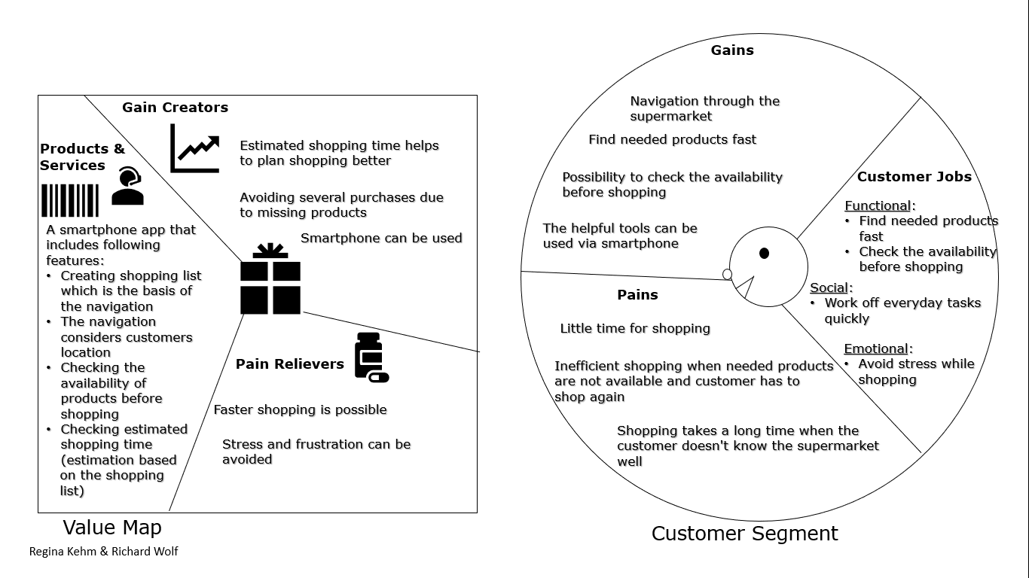

* + 1. Business Model Canvas

This model is very similar to the model of the use case 1. The main differences are the content of the “Value Proposition” which is transferred of the VPC, the key activities and the customer segments. This model focusses on busy customer, technophilic customers, customer who need orientation help.

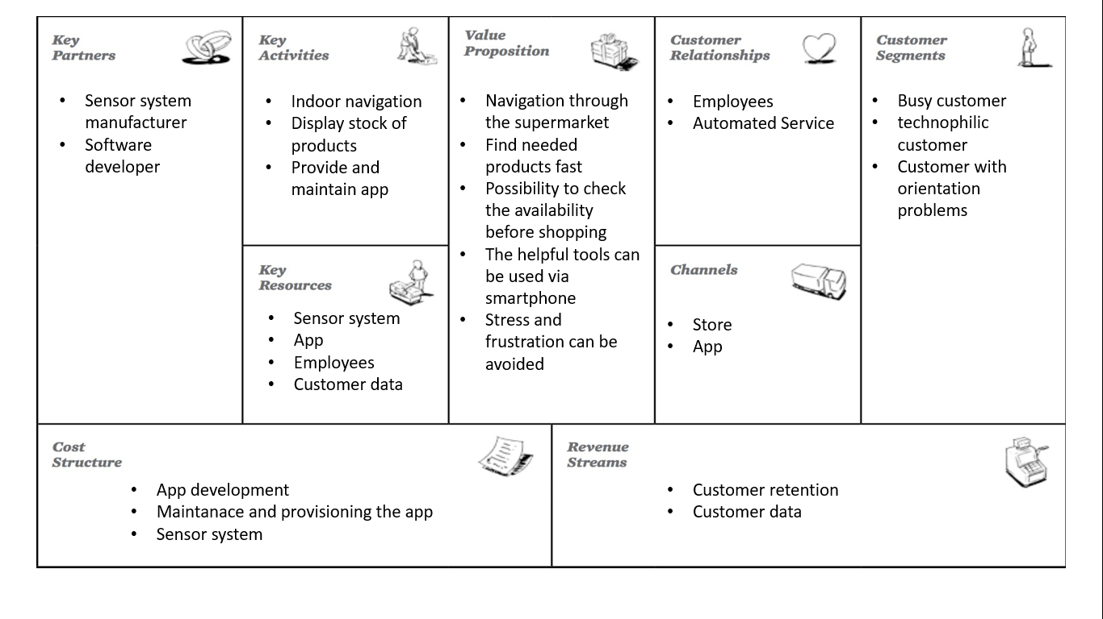

* 1. Use Case 3

A survey by the “Department of public opinion research Allensbach” shows that 50% of the participants are looking for bargains.[6] This buying behaviour can be increased using gamification. Digital natives can be motivated to go to the supermarket that offers a possibility of being rewarded with bargains via gamification features. This approach provides a strong influence on positive feelings and the decision-making of the customers. An effect like this is confirmed by many studies in this setting.[7] This is the basis of the third use case scenario in this specification sheet.

* + 1. Scenario

In the third scenario the central character is Jochen, a 40 years old bargain hunter and he loves games. He likes to go to a supermarket with many discounts. But mostly the supermarkets are too big to find all good discounts. It’s also boring and exhausting to find these discounts and it’s far away of being enjoyable. He would be happy about an app that shows all available discounts and where to find them. It would be perfect if the app shows him the discounts in an enjoyable way in form of a game.

* + 1. Business process

A typical process of this scenario could proceed as follows:

The customer goes shopping in the supermarket. There the customer would like to play a game and find some good discounts. On the smartphone he/she starts a gamification app and begins with the bargain hunter game. The app informs the sensor system that the customer enters the shop and start time measurement. The game provides the first discount puzzle to the user that need to be solved. After the customer solve the puzzle he/she will be rewarded with a discount. This discount can be kept or can be used immediately. During the dissolving process the app tracked positions and the corresponding timestamps of the customer. If the user wants he/she can solve another puzzle. The previous process will be repeated or the game ends, depending on the decision of the customer. If the customer finishes the game and closes the app, the app transfers the tracked data to the sensor system. The sensor system combines the tracked data with the app data and saves it in a database. At last the customer goes to the cash point, pays and leaves the supermarket.

* + 1. Value Proposition Canvas:

This VPC shows the needs of the targeted group like the transparency of discounts that can be satisfied with a smartphone app that shows the available discounts without searching for them in the supermarket or a prospect. The VPC also highlights the interesting and enjoyable way of finding discounts via the gamification features of the app.

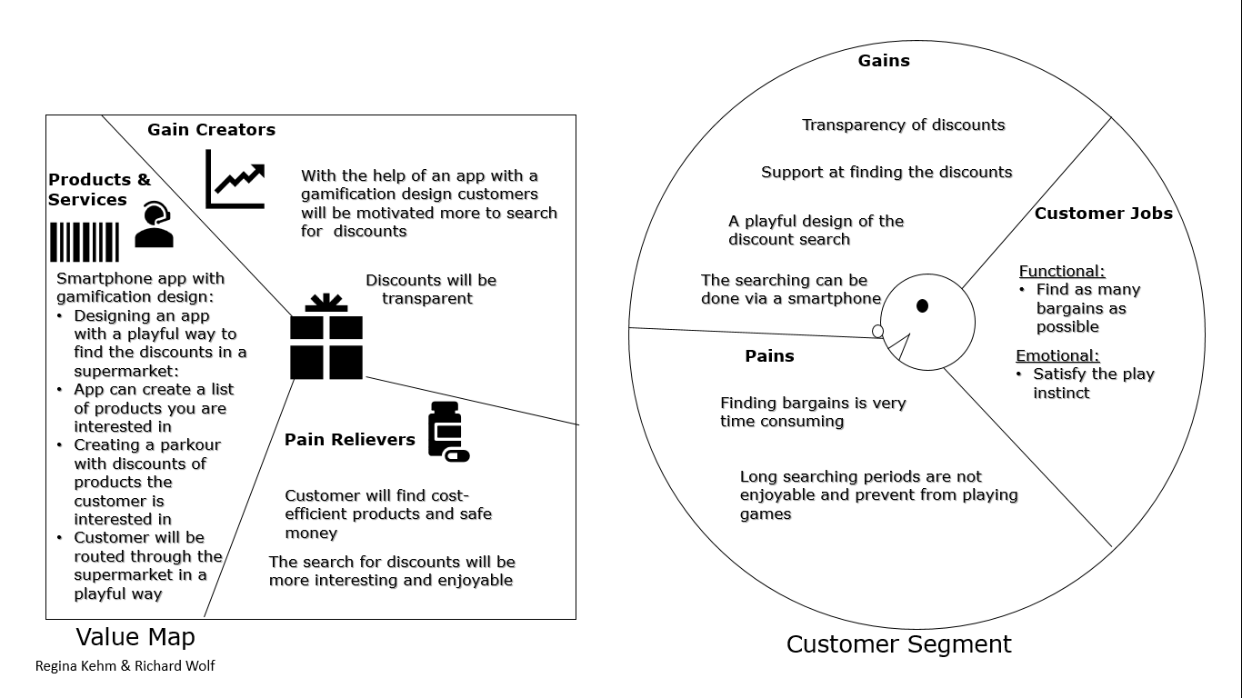

* + 1. Business Model Canvas

This model is also similar to the models of use case 1 and 2. The main differences are the content of the “Value Proposition” which is transferred of the VPC, the key activities and the customer segments. This model focusses on bargain hunter, technophilic customers, customer who love games and children.

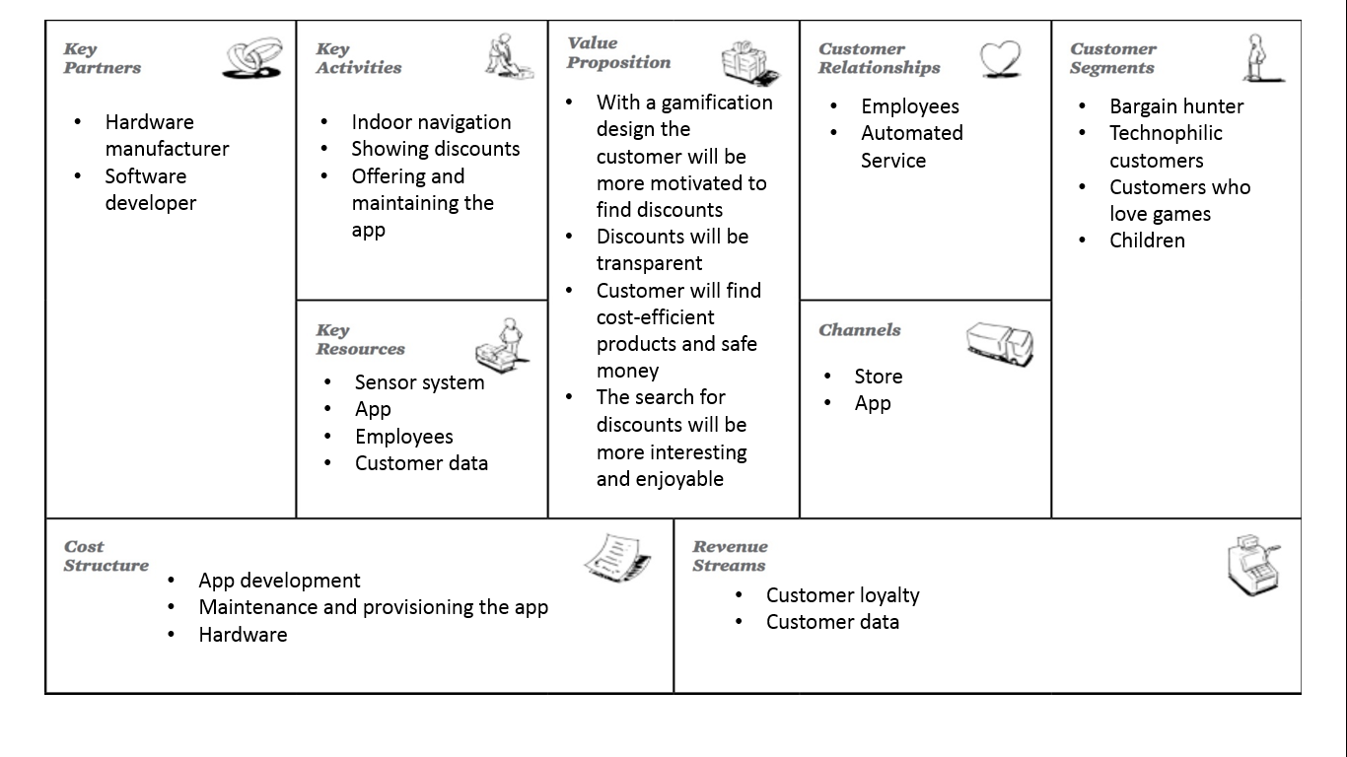

* 1. Central Use Case

For the realization of the solutions in the use cases specific features are necessary. These features are:

* Measure shopping time: Like the title of the project points out, this is the main feature that is needed in all use cases.
* Evaluate collected data automatically: This is needed because the information that time measurement and the navigation provides to the retailer are big data and shouldn’t be evaluated manual.
* Scalability: Due to the different structure of all the branches of the supermarket chain, it is necessary that the system is scalable and customizable.
* Indoor navigation: This feature helps to find the desired products faster and is the main feature of use case 2.
* Calculate estimate shopping time: Is a feature that provides additional information to the customer and can motivate to go shopping on an opportune moment.
* Show availability of products: Is needed because of the same reasons as the feature above.
* Use gamification: Is needed to implement a solution as mentioned in use case 3.
* Show offers: This feature makes the searching for discounts more transparent.

Not all features are needed in the different use cases, so the following table shows the assignment of the identified features to the use cases:

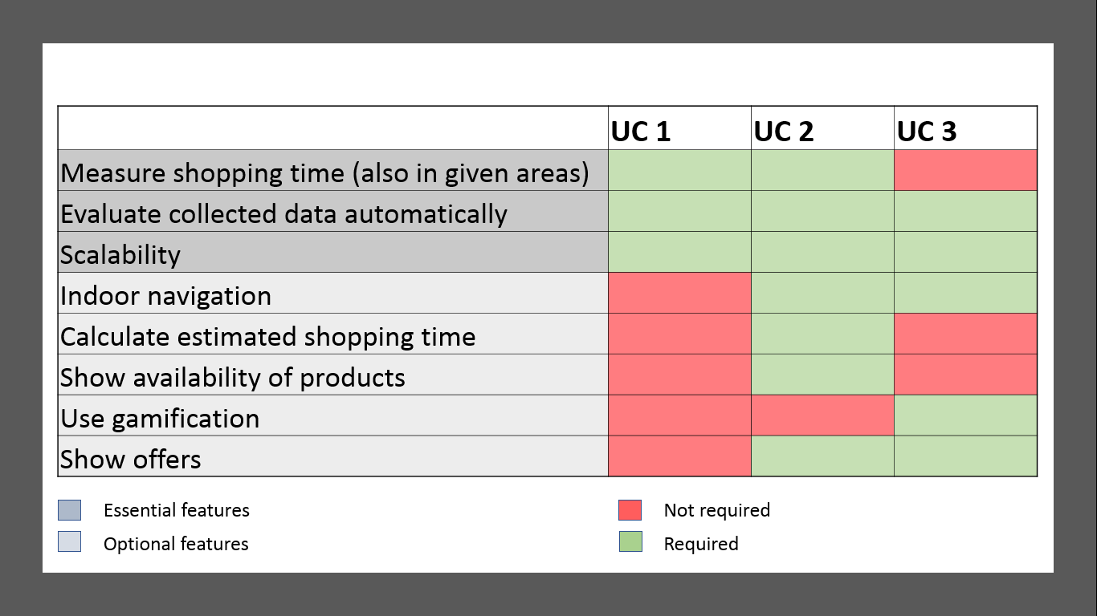

The table shows that the most features will be covered by use case 2. That’s the reason why use case 2 will be the central use case. Further work will build on that use case. The feature that is not required for use case 2 will be anyway considered as an optional feature.

1. Functional requirements

Follows from the foregoing, the project team worked out essential, optional and non-functional requirements. This chapter shows what is needed in general to implement such solutions from the use cases, as well as standard functionalities that consists in present software and systems.

* 1. Essential requirements
* The product should determine the shopping time of the customers. Determining the shopping time means the total shopping time as well as the shopping time within an area.
* It should be possible to evaluate the collected data automatically to generate a business benefit.
* It should be possible to use the solution also in other stores without modifying it.
  1. Optional requirements
* The product should contain a shopping list or should integrate a shopping list from another product or system.
* The product offers an indoor navigation that helps customers to find the desired products faster. The indoor navigation should base on the products on the shopping list.
* An estimated shopping time based on the shopping list can be requested before shopping.
* Availability of products can be requested before shopping.
* To entertain customers the product contains one or more games (e.g. paper chase).
* The product informs the customer about interesting offers.

1. Non-functional requirements
   1. Usability

* The product should be easy to understand
* If necessary, the product should contain an integrated operating instruction.
  1. Reliability
* Localization und duration of stay should be accurate as possible.
* The product/system should have high availability.
* Entered data should be saved to prevent data loss.
  1. Performance
* The requested data should be displayed quickly to the customer.
  1. Changeability
* It should be possible to modify and extend the product easily.
  1. Maintainability
* Errors are recorded centrally and can be evaluated later.
* Monitoring tools are used to detect and eliminate major problems and failures at an early stage.
* Customers can contact a service team if they have technical problems with the product.
  1. Security
* The product evaluates the data anonymously.
* Personal data is encrypted.
* The product should be developed according to the latest security standards.
* The product should protect personal data from unauthorized access (e.g. password).

Annex

1. **Business process model of use case 1 with BPMN**

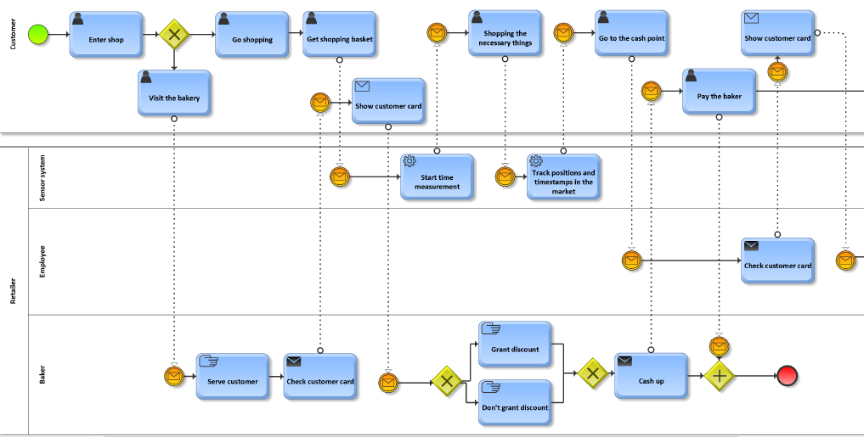

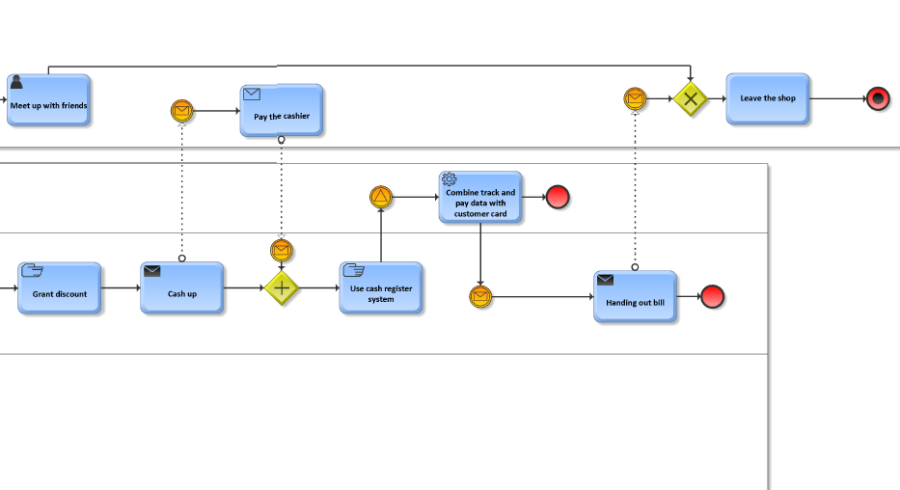

1. **Business process model of use case 2 with BPMN**

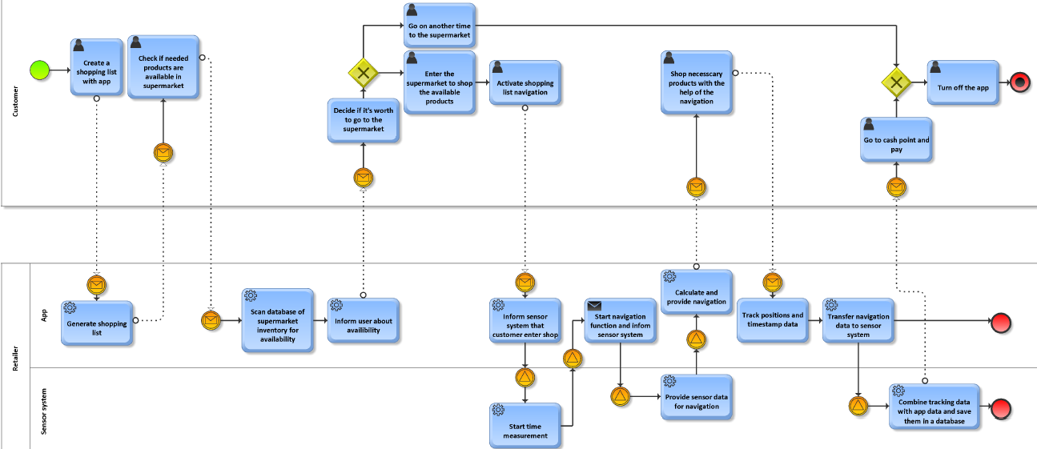

1. **Business process model of use case 3 with BPMN**

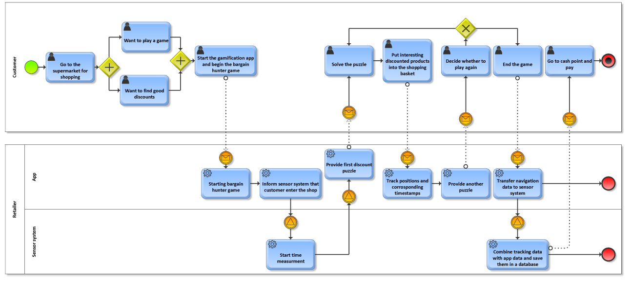

Bibliography

**Internet sources**

|  |  |
| --- | --- |
| dpa (2013): | Lebensmittel-Einkauf: Am Samstag wird es immer voller, https://www.focus.de/finanzen/recht/verbraucher-lebensmittel-einkauf-am-samstag-wird-es-immer-voller_aid_1040891.html, Access Date: 26th August 2018 |
| Ebermann, Carolin (2017): | Wie Gamification Kaufentscheidungen beeinflusst: Studienergebnisse zu Aktivierung, Emotionen und Kaufabsicht, https://www.usabilityblog.de/wie-gamification-kaufentscheidungen-beeinflusst/, Access Date: 27th August 2018 |
| Gerth, Steffen (2011): | Einkaufsverhalten von Senioren: Der Preis zählt wenig, das soziale Erleben viel, https://etailment.de/news/stories/Einkaufsverhalten-von-Senioren-Der-Preis-zaehlt-wenig-das-soziale-Erleben-viel--12849, Access Date: 26th August 2018 |
| Janson, Matthias (2018): | Einkaufsverhalten, Auf Schnäppchenjagd, https://de.statista.com/infografik/13655/sonderangebote-beim-kleidungskauf/, Access Date: 27th August 2018 |
| Kahle, Christian (2016): | Senioren-Handy? - Die Alten sind längst beim Smartphone gelandet, https://winfuture.de/news,92218.html, Access Date: 26th August 2018 |
| mbe (2016): | Immer mehr Kunden nutzen ihr Smartphone beim Lebensmittel-Einkauf, https://www.focus.de/finanzen/videos/preise-vergleichen-immer-mehr-kunden-nutzen-ihr-smartphone-beim-lebensmittel-einkauf_id_5186394.html, Access Date: 27th August 2018 |
| Nielsen (2016): | Studie: So kaufen die Deutschen Lebensmittel ein, https://www.slogans.de/magazine.php?Op=Article&Id=962, Access Date: 26th August 2018 |
|  |  |

1. Gereth 2011
2. Kahle 2016
3. Nielsen 2016
4. dpa 2013
5. mbe 2016
6. Janson 2018
7. Ebermann 2017