**DI 图表题：**

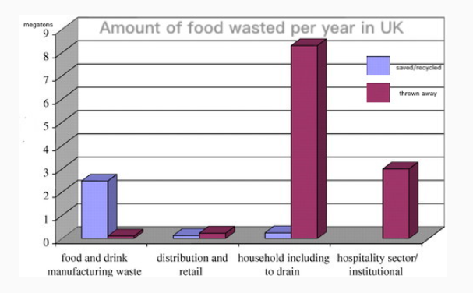

The following graph gives information about (wasted food in UK读题目).

The items include (saved, recycled and thrown away读图例).

According to this graph, the value of （saved food in distribution and retail is one megaton）.

According to this graph, the value of （thrown away in food and drink manufacturing waste） is lower, which is（ 0.5 megaton）.

According to this graph, the highest value of （saved food is in food and drink manufacturing waste） which is around 2.

According to this graph, the lowest value of （thrown away is in household including to drain） which is 8.（具体内容读出名称即可，数字怎么简单怎么说，有小数点或者复杂可以直接取整，但要说出对比词，lower、higher、lowest、highest）

In conclusion, the picture is very informative.

**DI-图片题（地图或者涉及到方位, 图片上有字的话都说出来，没有字会说什么说什么，不会说物品名称可以把颜色说出来）**

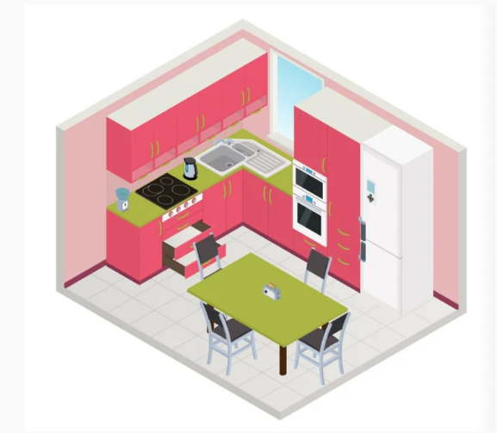

The following graph gives information about (kitchen).

The items include (table, chairs, refrigerator, and etc.).

According to this graph, in the central area, there is a square table with four chairs, the color of it is green.

According to this graph, in the right area, there is a refrigerator; the color of it is white.

According to this graph, in the left area, there is a gas cooker; the color of it is black.

According to this graph, in the background, there are some cupboards, the color of those are pink.

In conclusion, the picture is very informative.

**DI-流程题（图片上有字的话都说出来，没有字会说什么说什么，不会说物品名称可以把颜色说出来）**

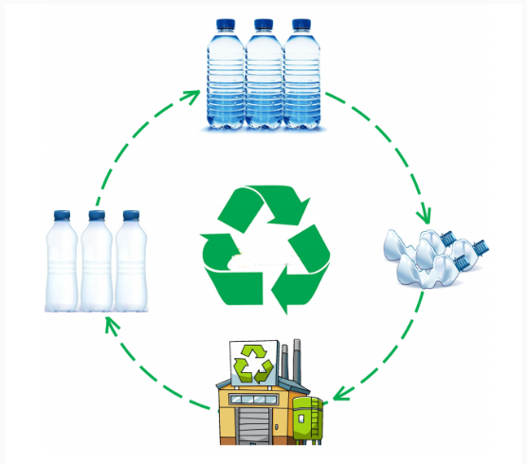

The following graph gives information about (recycle).

The steps include (new bottle, refilling, used bottle, and processing).

According to this graph, the first step is (newly-produced bottles, which are empty).

According to this graph, the second step is (to fill water into the bottles).

According to this graph, the third step is (to open and drink).

According to this graph, the last step is (to process used bottles in the factory).

In conclusion, the picture is very informative.

**RL/SST（50-70字！！少字或超字数都会扣分） 同样的模板：**

1. 听的懂3-4个短句的情况下，可以用这个模板：(RL用这个风险比较小，因为不会去识别语法，但是SST用这个风险比较大，因为自己的内容越多，语法错误扣分的可能性越大)

This lecture mainly talks about ().

Firstly, the speaker mentioned that ().

Also, the speaker mentioned that().

Lastly, the speaker believed that ().

In conclusion, the lecture is very informative.

1. 大部分听不懂的情况下，用这个模板（SST建议直接用这个，可以避免语法错误，而且字数肯定是够用）

The given lecture is about interesting topics based on many different categories. Firstly, we can see the lecture can show a major point which is connected to our society, so it is fair to say that it is very important. Finally, the speaker mentioned that （concept; universal principles; roadmap; moral; boundary; situation; 这里把听到的关键词直接写进去，分号连接，其他内容均为模板）must be followed. In conclusion, the lecture was very interesting.

**SWT（小作文，给一段文字总结成一句话，只能有一个句号！！，挑选原文关键句直接用“，and”链接即可，注意字数50-70，完全不要加入自己的内容容易出现语法错误，考前联系3-5篇找找感觉）**

**WE 大作文（用模板字数肯定够，语法和词语都是复核满分标准的，其他都是模板内容，考前把本周预测的题目都看一遍，想下怎么套用模板）**

题目举例：Television serves many useful functions. It helps people to relax. Besides, it can also be seen as a companion for lonely people. To what extent do you agree with this? Explain it with your own experience.

Nowadays, many headlines hit the newspaper on the topic of （television）. This issue sparked a huge debate on （whether television can be seen as a companion for lonely people基于题目改写一个whether语句）. From my own point of view, I believe that （television serves many useful functions来源于题目）.

On the one hand, there are numerous solid reasons why （television serves many useful functions）. Although potentially negative impacts of （television） should be taken into account, I still reckon that （television） has in many ways enriched people's lives. For instance, a well-known American psychologist once said that television can make our lives more interesting.

On the other hand, those who argue against the use of （television） hold a different opinion. In the first place, it can be claimed that （television serves many useful functions）. In the second place, as far as schools are concerned, the ultimate aim of schools is to shape young people into responsible people in the future. As a result, local governments and international organizations should make a joint effort to reach a consensus to make sure this situation will develop in the right direction.

In a nutshell, while there are many solid reasons on both sides, I still firmly believe that （television serves many useful functions）.