Secret Santa Assignment System
A comprehensive Secret Santa gift exchange automation system built with FastAPI (Backend) and React (Frontend). The system automatically assigns secret children to employees while respecting constraints and previous year assignments.

Table of Contents
- Features
- Architecture
- Requirements
- Installation
- Running the Application
- API Documentation
- Project Structure
- Usage Examples
- Testing
- Error Handling
- Contributing
- License

App Screenshots:
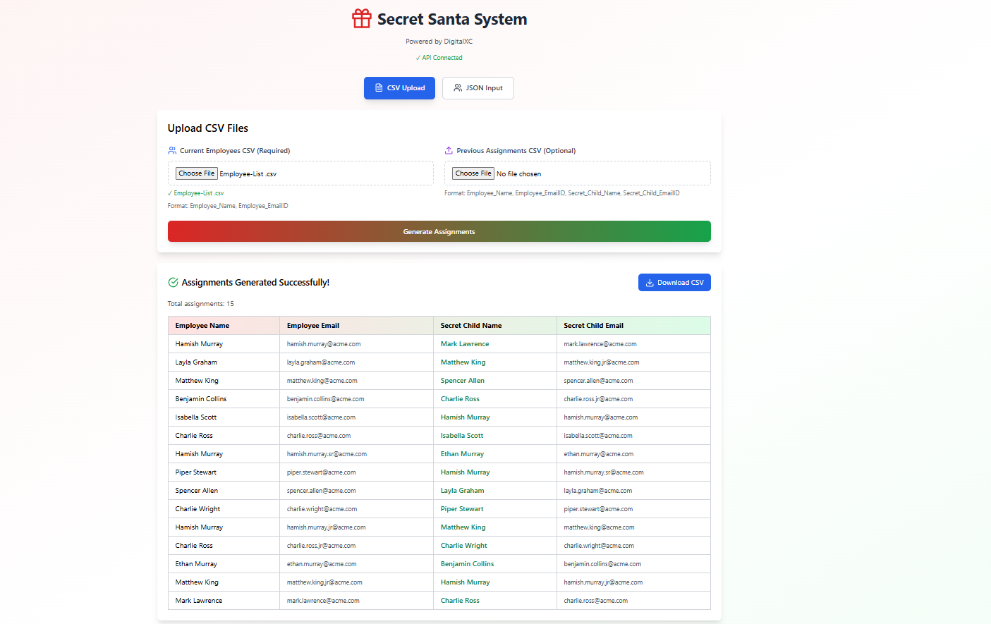

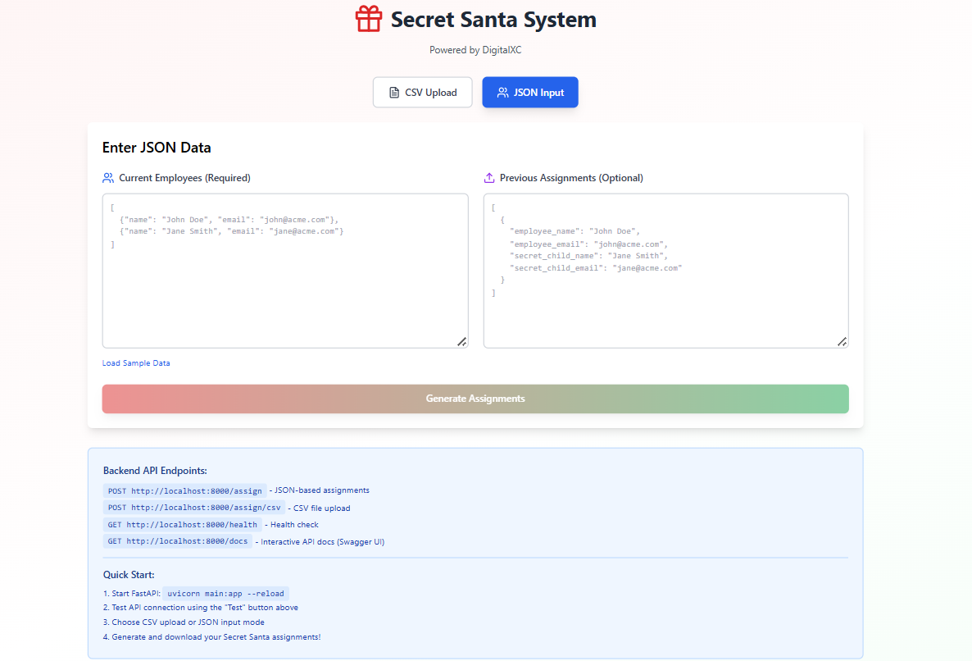
Fastapi swagger UI :
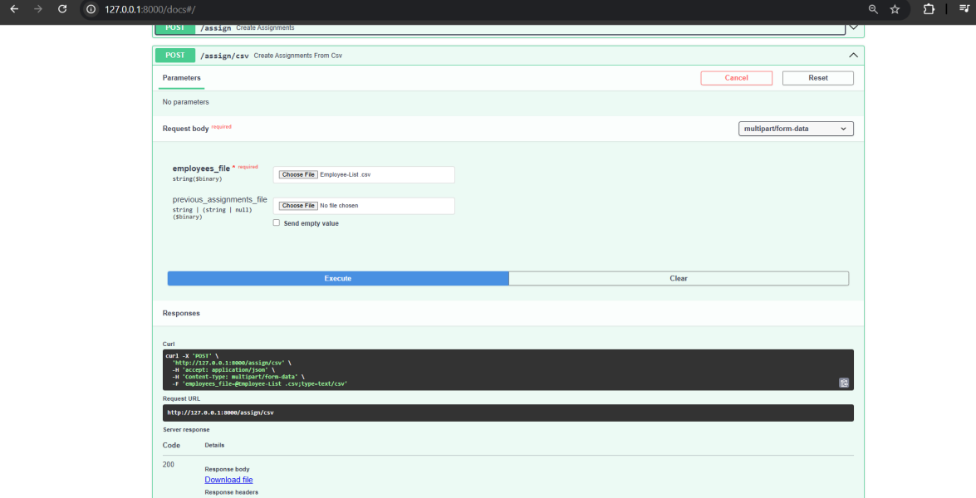

✨ Features

Core Functionality
- ✅ No Self-Assignment: Employees cannot be assigned to themselves
- ✅ No Same-Name Assignment: Prevents assigning to someone with the same name
- ✅ Previous Year Constraint: Avoids duplicate assignments from previous year
- ✅ Unique Assignments: Each employee gets exactly one secret child
- ✅ Fair Distribution: Each person is assigned as a secret child to exactly one person

Technical Features
- Modular OOP Design: Separation of concerns with dedicated classes
- Type Safety: Pydantic models with comprehensive validation
- Dual Input Methods: Support for both CSV files and JSON API
- Interactive UI: Beautiful React frontend with real-time feedback
- Auto-generated API Docs: Swagger UI and ReDoc documentation
- Fast & Efficient: Optimized assignment algorithm
- Comprehensive Tests: Unit tests for all components
- Robust Error Handling: Detailed error messages and validation

Requirements

Backend
- Python 3.8 or higher
- pip (Python package manager)

Frontend
- Node.js 14+ (for local React development)
- Modern web browser (Chrome, Firefox, Safari, Edge)

Architecture

┌─────────────────────────────────────────────────────┐
│ React Frontend │
│ (CSV Upload / JSON Input / Results Display) │
└──────────────────┬──────────────────────────────────┘
│ HTTP/REST API
▼
┌─────────────────────────────────────────────────────┐
│ FastAPI Backend │
├─────────────────────────────────────────────────────┤
│ ┌─────────────────────────────────────────┐ │
│ │ API Layer (main.py) │ │
│ │ - /assign (JSON) │ │
│ │ - /assign/csv (File Upload) │ │
│ │ - /health │ │
│ └──────────────┬──────────────────────────┘ │
│ ▼ │
│ ┌─────────────────────────────────────────┐ │
│ │ Service Layer │ │
│ │ - SecretSantaService │ │
│ └──────────────┬──────────────────────────┘ │
│ ▼ │
│ ┌─────────────────────────────────────────┐ │
│ │ Business Logic Layer │ │
│ │ - SecretSantaAssigner │ │
│ │ - AssignmentValidator │ │
│ │ - AssignmentHistory │ │
│ └──────────────┬──────────────────────────┘ │
│ ▼ │
│ ┌─────────────────────────────────────────┐ │
│ │ Data Layer │ │
│ │ - EmployeeRepository │ │
│ │ - CSVHandler │ │
│ └─────────────────────────────────────────┘ │
└─────────────────────────────────────────────────────┘

Installation

1. Clone the Repository
git clone https://github.com/Richiesam1999/DigitalXC_Secret_Santa.git

2. Backend Setup
# Create virtual environmentpython -m venv venv# Activate virtual environment# On Windows:venv\Scripts\activate# On macOS/Linux:source venv/bin/activate# Install dependenciespip install -r requirements.txt
- Frontend Setup

The React frontend is provided as a standalone component that can run in:
application
Static HTML file
For local development:
cd secret-santa-frontend
npm install, npm run dev

Running the Application
Start the Backend Server
bash# Activate virtual environment (if not already active)
source venv/bin/activate # or venv\Scripts\activate on Windows

# Run the FastAPI server
uvicorn main:app --reload
API Documentation (Swagger UI): http://localhost:8000/docs
Alternative Docs (ReDoc): http://localhost:8000/redoc
Health Check: http://localhost:8000/health

# Run react server
npm run dev
# Server will start at: http://localhost:5173
# Front end Server will start at: http://localhost:8000
Access the Application
Frontend: Open the React component in your browser

API Documentation
Base URL
http://localhost:8000
Endpoints
1. Health Check
httpGET /health
Response:
json{
"status": "healthy"
}

2. Generate Assignments (JSON)
httpPOST /assign
Content-Type: application/json
Request Body:
json{
"current_employees": [
{
"name": "John Doe",
"email": "john.doe@acme.com"
},
{
"name": "Jane Smith",
"email": "jane.smith@acme.com"
}
],
"previous_assignments": [
{
"employee_name": "John Doe",
"employee_email": "john.doe@acme.com",
"secret_child_name": "Jane Smith",
"secret_child_email": "jane.smith@acme.com"
}
]
}
Response:
json{
"success": true,
"message": "Assignments generated successfully",
"assignments": [
{
"employee_name": "John Doe",
"employee_email": "john.doe@acme.com",
"secret_child_name": "Jane Smith",
"secret_child_email": "jane.smith@acme.com"
}
],
"total_assignments": 2
}

3. Generate Assignments (CSV Upload)
httpPOST /assign/csv
Content-Type: multipart/form-data
Form Data:

employees_file: CSV file with current employees (required)
previous_assignments_file: CSV file with previous assignments (optional)

Response:

CSV file download with assignments

CSV Format - Employees:
csvEmployee_Name,Employee_EmailID
John Doe,john.doe@acme.com
Jane Smith,jane.smith@acme.com
CSV Format - Previous Assignments:
csvEmployee_Name,Employee_EmailID,Secret_Child_Name,Secret_Child_EmailID
John Doe,john.doe@acme.com,Jane Smith,jane.smith@acme.com

API Curl requests (Postman)

- For Json input

bashcurl -X POST "http://localhost:8000/assign" \
-H "Content-Type: application/json" \
-d '{
"current_employees": [
{"name": "Alice", "email": "alice@acme.com"},
{"name": "Bob", "email": "bob@acme.com"},
{"name": "Charlie", "email": "charlie@acme.com"}
]
}'

- For cURL (only employees CSV)
curl -X POST "http://localhost:8000/assign/csv" \
-H "accept: text/csv" \
-F "employees_file=@employees.csv"

3.
With previous_assignments_file (optional file)
curl -X POST "http://localhost:8000/assign/csv" \
-H "accept: text/csv" \
-F "employees_file=@employees.csv" \
-F "previous_assignments_file=@previous.csv"

