DementiaGuide AI — Mid-Year Progress Report: Methodology, Results, Discussion, Conclusion (Working Draft)
Author: Richman Tan · Supervisor: Assoc. Prof. Jing Sun · Project Partner: JooHyun Kang
Report: COMPSYS/ELECTENG/SOFTENG 700 Mid-Year Progress Report
Confirmed framing (interpretation B). The mid-year deliverable is a progress report that expects early results, not a proposal. The report should evolve from Introduction → Literature Review → Proposed Solution → Project Plan into: Introduction → Background and Literature Review → Research Objectives → Methodology → Implementation Progress → Results → Discussion → Limitations and Future Work → Conclusion. Existing proposal content is reused; Proposed Solution and Project Plan are updated to reflect actual progress. This document drafts the new empirical sections (Methodology of the evaluation, Implementation Progress, Results, Discussion, Limitations and Future Work, Conclusion). Honesty boundary. The lip-sync evaluation is real, quantitative, and reproducible. It validates one required component — that the avatar can articulate speech accurately enough for the proposed system. It does not assess the accessibility, personalisation, or usability of DementiaGuide AI; those depend on the human evaluation planned for the second half of the project. No data, numbers, or citations are invented. Section numbers below assume the full-report structure above; adjust to your final numbering. Note — one reference to add to your main bibliography: the co-articulation engine follows the Cohen–Massaro dominance model, cited in §7 and listed in the References addendum at the end of this document. Verify the exact editors/pages against your citation style before merging it into the report's reference list.
A. Evidence audit
Research question (§2.1): How can an AI-powered avatar-based interface improve the accessibility, personalisation, and usability of digital resource management systems for dementia care?
Objective (§2.3) | Evidence now | Status
O1 Literature review | Report §3 | Done
O2 Identify gaps | Report §3.9 | Done
O3 Design avatar-based conversational interface | Prototype implemented | Built; not user-evaluated
O4 Develop prototype (AI personalisation + resource management) | RAG chat, voice pipeline, CC4 avatar, UaaL bridge implemented | Built; only articulation sub-system evaluated
O5 Evaluate usability and effectiveness | No human study yet | Outstanding (700B)

Evidence map
Sub-question / aim | Evidence | Main finding | Fig/Table | Confidence / limitation
SQ3 avatar role (articulation-fidelity precondition) | Automated lip-sync loop; baseline vs final; 8 fixtures, 95 checks | Checks 37/85 → 85/85 (hand-authored); 95/95 with G2P | T1, T2, F1, F2 | High for editor; deterministic, no human raters
bilabial closure | V_Explosive + open-shape suppression | 2/7 → 7/7; final 0.93–0.95; leakage ≤ 0.08 | T2, F2 | Editor only
labiodental contact | V_Dental_Lip | 4/7 → 7/7; final ≥ 0.94 | T2 | Editor only
tongue activation | V_Tongue_* | all 27 baseline 0.00 → 0.40–0.72 | T2 | Editor only
silence / segment-end | leakage + decay | leakage ≤ 0.54 → ≤ 0.10; decay 313–324 ms → 30–95 ms | T2 | Editor only
real G2P vs heuristics | g2p fixture 10/10 | passes; no baseline, not isolated | T1 | Partial
motion smoothness | jitter RMS | increased on every fixture | T2 | Negative finding
SQ1/2/4/5 usability, personalisation, decision support, literacy | None | — | — | Outstanding (700B)
SQ3/trust — RAG grounding reliability | Live eval, 42 questions (§6.9) | retrieval 29/32 → 31/32 after source-family cap; 4/4 boundary + 6/6 out-of-scope declined safely; all 32 in-scope answers LLM-judged fully grounded | Table 4 | LLM-judge leniency (human check advisable); deployed retrieval, no user judgement
Voice latency | Instrumented (6 stages); protocol + template defined (§4.2, Table 3); no dataset | — | — | Not measured — ready to run

Still required: (1) human usability study [central]; (2) latency dataset; (3) RAG grounding evaluation; (4) on-device confirmation; (5) the Cohen–Massaro citation above.
B. Confirmed report structure
Introduction → Background and Literature Review → Research Objectives → Methodology → Implementation Progress → Results → Discussion → Limitations and Future Work → Conclusion.
This document drafts the sections in bold below (Methodology is scoped to the evaluation of the component that has results):
- 4. Methodology (evaluation of the avatar articulation component)
- 5. Implementation Progress
- 6. Results — 6.1 setup · 6.2 overall pass rate (T1, F1) · 6.3 bilabial (T2, F2) · 6.4 labiodental · 6.5 tongue · 6.6 silence/end · 6.7 G2P · 6.8 smoothness
- 7. Discussion
- 8. Limitations and Future Work
- 9. Conclusion
C. Draft sections
4. Methodology
The project methodology spans interface design, prototype implementation, and evaluation. Section 4.1 describes the evaluation method for the component that has produced results at the mid-point — the avatar lip-synchronisation pipeline. Sections 4.2 and 4.3 define the evaluation protocols for the streaming voice latency and the retrieval-augmented (RAG) grounding, which are implemented and ready to run but have not yet been executed; no data has been collected for them and none is reported below.
4.1 Avatar articulation evaluation
The avatar's speech articulation was evaluated with an automated test loop inside the Unity Editor. An automated, metric-based approach was chosen over informal visual inspection so that each design iteration could be scored the same way, objectively and reproducibly, and so that the evaluation could serve as a standing regression test as the wider system develops. The loop plays a fixture through the same message entry point the production application uses, records the avatar's blendshape weights each frame, and scores the recording against fixed acceptance criteria.
Fixtures. Eight fixtures were used. Seven were hand-authored ARPAbet utterances chosen to exercise all 14 visemes and the known difficult cases (bilabial /p b m/ closures, labiodental /f v/ contact, dental and other tongue consonants, rounded vowels, sibilants and rhotics, and silence gaps). The eighth (g2p_pipeline) was produced by passing text through the JavaScript grapheme-to-phoneme (G2P) pipeline, exercising the real production text path. Fixtures are deterministic, so each represents one fixed utterance rather than a sample of natural speech.
Metrics. Each fixture embeds timed checks scored by six criteria: bilabial closure (V_Explosive ≥ 0.90 within ±60 ms, with open-mouth shapes suppressed), labiodental contact (V_Dental_Lip ≥ 0.80), tongue activation (mapped tongue shape ≥ 0.30), vowel peak (≥ 0.35), silence (all lip shapes < 0.10), and segment-end decay (all lip shapes < 0.05 within 250 ms). Motion smoothness was additionally reported as the root-mean-square of the second difference of all curves on a 60 Hz grid ("jitter RMS"); jitter was recorded for each run but was not one of the pass/fail criteria.
Design. The same suite was run against the pipeline before the co-articulation redesign (the baseline) and after it (the final pipeline), giving a controlled before-and-after comparison. Weights were baked and recorded at high frame rate (approximately 90 Hz), giving 147 to 202 samples per fixture, and a screenshot was captured at each check time.
4.2 Streaming voice latency evaluation (protocol; not yet executed)
The voice pipeline is instrumented with stage timestamps that print a [LATENCY SUMMARY] record to the console after each spoken response. Six stage durations are recorded: speech-to-text (stt_ms), retrieval (rag_ms), language-model time to first token (llm_to_token_ms), first token to first complete sentence (first_sentence_ms), first text-to-speech request to first audio (tts_first_ms), and the end-to-end time from the end of the user's speech to the first avatar audio (to_first_audio_ms), which is the primary responsiveness measure.
The planned protocol runs a fixed set of representative caregiver queries (for example, 20 questions drawn evenly from the knowledge-base categories) through the deployed application, records the [LATENCY SUMMARY] for each, and reports the median and the minimum-to-maximum range for each stage. Because the pre-optimisation build was not instrumented, the concurrent-playback improvement can be quantified only by re-running the same queries with concurrent playback disabled; if that comparison is not run, the improvement is reported qualitatively (see §8). Sample size, device, and network conditions must be stated with the results. Table 3 is the reporting template.
Table 3. Voice-pipeline latency by stage (reporting template; [TO BE CAPTURED]). Report the median and range in milliseconds over n queries; state n, device, and network.
Stage | Median (ms) | Range (ms)
Speech-to-text (stt_ms) | [TBC] | [TBC]
Retrieval (rag_ms) | [TBC] | [TBC]
LLM time to first token (llm_to_token_ms) | [TBC] | [TBC]
First token → first sentence (first_sentence_ms) | [TBC] | [TBC]
TTS request → first audio (tts_first_ms) | [TBC] | [TBC]
End to end → first avatar audio (`to_first_audio_ms`) | [TBC] | [TBC]

4.3 RAG grounding evaluation (executed 2026-07-13; results in §6.9)
The retrieval-augmented generation path retrieves the top five knowledge-base chunks (TOP_K = 5) above a cosine-similarity floor (MIN_SIMILARITY = 0.25) using text-embedding-3-small, then generates an answer with gpt-4o-mini (temperature 0.4). The planned evaluation uses a fixed question set of representative caregiver queries (drafted in rag_eval_question_set.md: 29 in-scope questions each mapped to an expected chunk, plus near-neighbour, boundary, and out-of-scope sets), split into in-scope questions (answerable from the 70-chunk knowledge base) and out-of-scope questions (outside dementia care), and reports three measures: retrieval hit rate (whether the human-identified relevant chunk appears in the retrieved five), answer groundedness (whether the generated answer is supported by the retrieved chunks, rated by a human or an LLM judge on a fixed rubric), and out-of-scope handling (whether the system appropriately declines or expresses uncertainty rather than fabricating content). Because sample sizes will be below 20 per category, results should be reported as counts rather than percentages. The question set, rater, and rubric must be reported for reproducibility.
5. Implementation Progress
At the mid-point, the prototype implements the core of the proposed pipeline (§4 of the proposal). A retrieval-augmented chat path grounds responses in a dementia-care knowledge base held in Supabase (pgvector), comprising 70 hand-authored chunks across seven categories (caregiving, clinical, communication, best-practices, home-safety, prevention, and wellbeing) plus roughly 380 WHO/NZ iSupport course chunks, 449 in total. Retrieval uses OpenAI text-embedding-3-small with a hybrid vector-plus-keyword match, returning the top five chunks above a 0.25 similarity floor after a source-family cap limits any single bulk source (§6.9), and gpt-4o-mini generates the grounded answer. A streaming voice path performs speech capture, transcription, retrieval, generation, text-to-speech, and avatar playback, with concurrent sentence-level playback so speech begins before the full response is generated, and it is instrumented to record per-stage latency (§4.2). The avatar is a Reallusion Character Creator 4 (CC4) character rendered in Unity and embedded in the React Native application through a Unity-as-a-Library (UaaL) native bridge.
Two components have been formally evaluated so far: the avatar lip-synchronisation sub-system (§6.1–6.8) and the retrieval-augmented generation grounding (§6.9). The streaming voice path's end-to-end latency is instrumented but not yet measured against defined criteria; its evaluation is planned for the second half of the project (§8).
6. Results
The initial evaluation examined whether the avatar could produce sufficiently accurate speech articulation for use in the proposed system. This evaluation did not assess the overall usability or accessibility of DementiaGuide AI, but it provided early evidence that the avatar component could support further prototype development and user evaluation.
6.1 Evaluation setup
Eight fixtures were evaluated, embedding 85 acceptance checks across the seven hand-authored fixtures and 95 checks including the G2P fixture. Recordings contained 147 to 202 samples per fixture.
6.2 Overall acceptance-check pass rate
On the baseline pipeline, 37 of the 85 hand-authored acceptance checks passed. On the final pipeline, all 85 passed, and the g2p_pipeline fixture passed all 10 of its checks, giving 95 of 95 across the full suite (Table 1, Figure 1). Every fixture improved, with the largest absolute gain in the bilabials fixture (6 of 17 to 17 of 17).
Table 1. Acceptance checks passed per fixture, baseline versus final pipeline. The g2p_pipeline fixture was introduced with the final pipeline and has no baseline.
Fixture | Baseline (passed / total) | Final (passed / total)
bilabials | 6 / 17 | 17 / 17
dental | 4 / 13 | 13 / 13
labiodental | 9 / 16 | 16 / 16
sibilant_rhotic | 6 / 13 | 13 / 13
hello | 4 / 11 | 11 / 11
silence_gaps | 4 / 9 | 9 / 9
rounded | 4 / 6 | 6 / 6
Subtotal (hand-authored) | 37 / 85 | 85 / 85
g2p_pipeline | — | 10 / 10
Total | — | 95 / 95

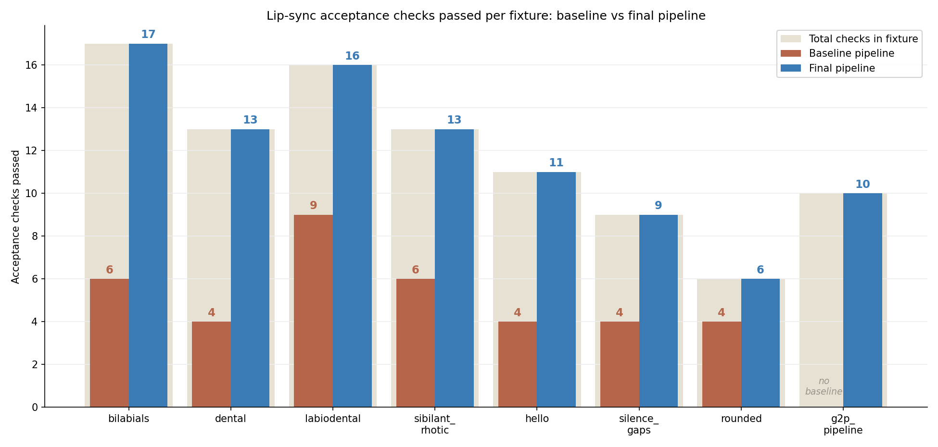
Figure 1. Acceptance checks passed per fixture on the baseline and final pipelines. The light backdrop bar is the total number of checks in each fixture. The g2p_pipeline fixture has no baseline.
6.3 Bilabial closure
Across the seven bilabial checks, two passed on the baseline pipeline and all seven passed on the final pipeline. On the baseline, V_Explosive peaks ranged from 0.58 to 0.94, and open-shape leakage during closure reached 0.15. On the final pipeline, all peaks were between 0.93 and 0.95, open-shape leakage stayed at or below 0.08, and jaw drive at or below 0.14 (Table 2). Figure 2 shows three distinct viseme shapes produced by the final pipeline, including the sealed lips of a bilabial closure.
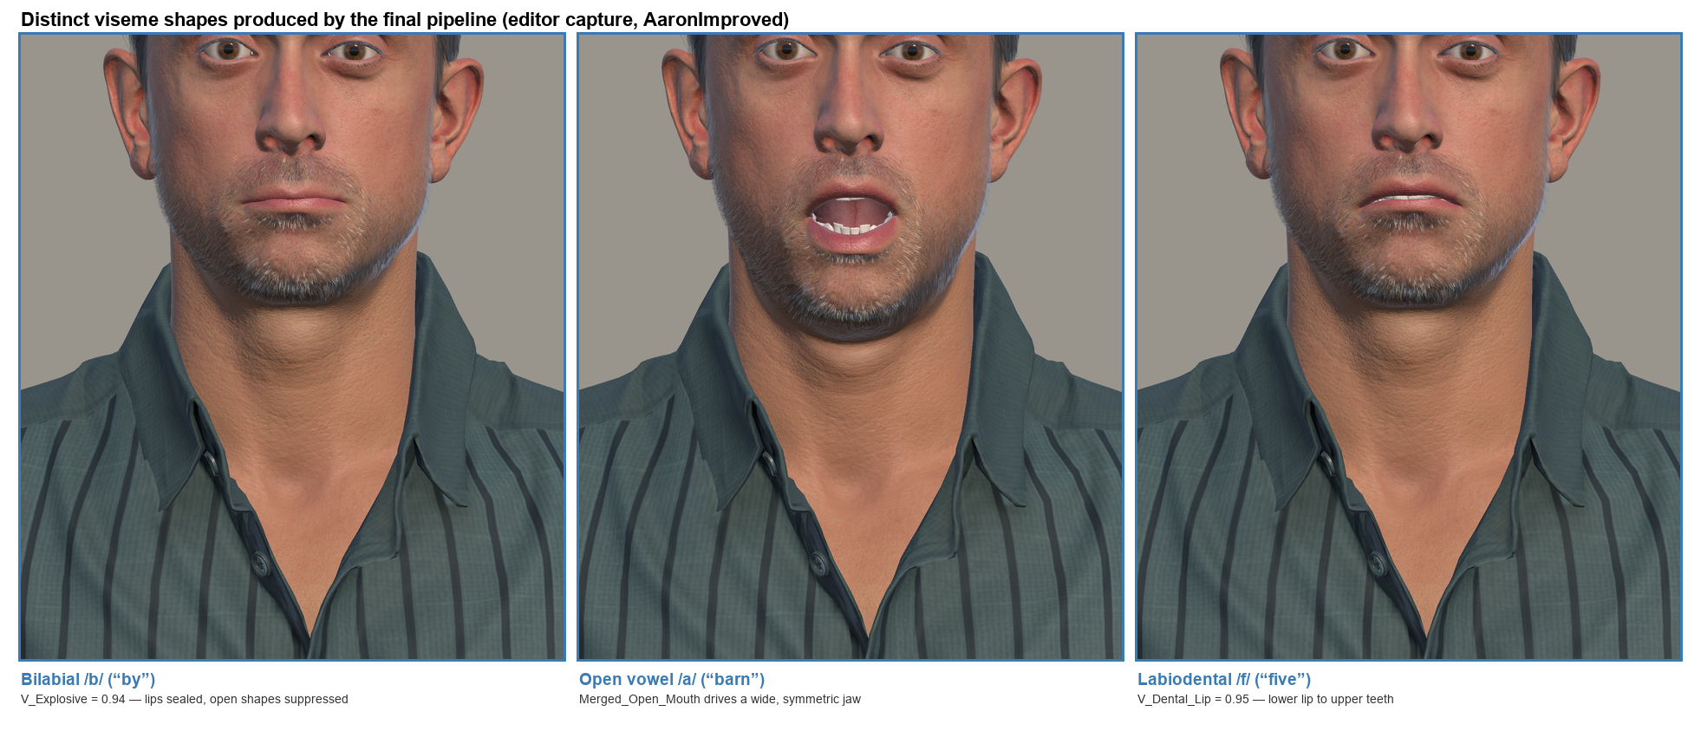
Figure 2. Distinct viseme shapes produced by the final pipeline (Unity Editor capture of the AaronImproved character): a bilabial closure with sealed lips, an open vowel driven by the merged open-mouth morph (with the facial hair following the jaw), and a labiodental lip-to-teeth contact, each annotated with the measured blendshape weight. A like-for-like baseline screenshot is not available because the character and scene camera were revised in the same change set; the before-and-after comparison is carried quantitatively by Figure 1 and Table 2.
Figure 3 traces the closure shape over the whole bilabials utterance. On the final pipeline (solid line), V_Explosive reaches the 0.90 threshold at each /p b m/ instant, and the summed open-mouth shapes (dashed) fall to near zero at those same instants, rising only for the vowels between closures. On the baseline pipeline (faded line), the closure peaks are lower and later at several checks.
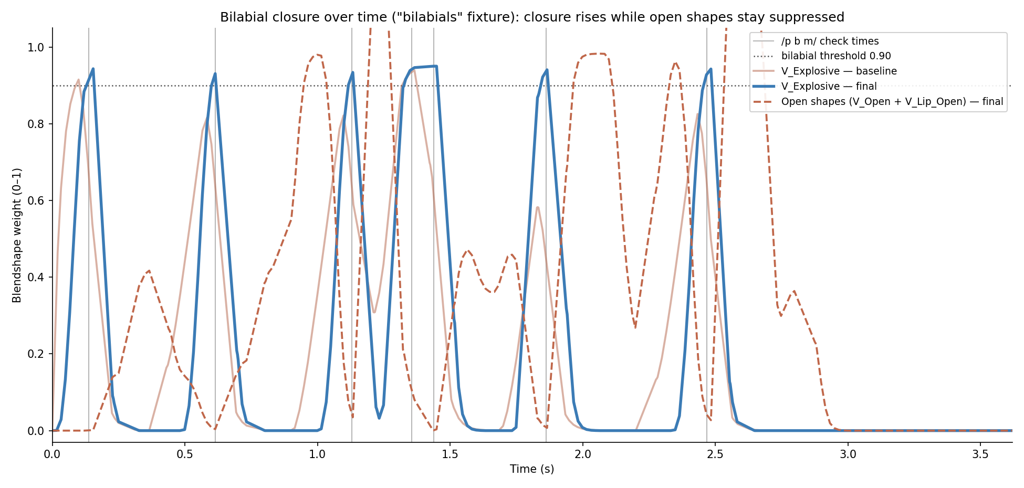
Figure 3. Closure shape V_Explosive over time for the bilabials fixture, baseline versus final, with the summed open-mouth shapes (V_Open + V_Lip_Open) on the final pipeline. The dotted line is the 0.90 acceptance threshold; grey verticals mark the /p b m/ check times. Open shapes rise for vowels between closures, which is expected, but are suppressed at the closure instants.
6.4 Labiodental contact
Across the seven labiodental checks, four passed on the baseline pipeline and all seven passed on the final pipeline. Baseline peaks ranged from 0.525 to 0.90, with the lowest values ("V-of" at 0.525 and "F-fine" at 0.788) below the 0.80 threshold. Final peaks were all between 0.94 and 0.95.
6.5 Tongue activation
On the baseline pipeline, all 27 tongue checks across the fixtures measured exactly 0.00, indicating the tongue shapes were unused. On the final pipeline, every tongue check passed, with measured peaks ranging from 0.40 to 0.72 (for example, V_Tongue_up reached 0.62 at the "N-no" check and 0.72 at the "D-would" check).
6.6 Silence and segment-end behaviour
On the baseline pipeline, the three pause checks measured maximum lip weights of 0.15, 0.17, and 0.54, all above the 0.10 threshold, and every fixture took 313 to 324 ms to decay, above the 250 ms threshold. On the final pipeline, the pause checks measured 0.00, 0.04, and 0.10, and decay times fell to between 30 and 95 ms.
6.7 Grapheme-to-phoneme pipeline fixture
The g2p_pipeline fixture passed all 10 of its checks on the final pipeline, including bilabial peaks of 0.91 to 0.95, labiodental peaks of 0.93 to 0.94, and a tongue reading of 0.40 at the dental check. No baseline was recorded for this fixture because it was introduced with the final pipeline.
6.8 Motion smoothness
Jitter RMS increased on every fixture from baseline to final. Across the hand-authored fixtures it rose from a baseline range of 0.0056 to 0.0125 to a final range of 0.0115 to 0.0191 (for example, bilabials rose from 0.0125 to 0.0191 and dental from 0.0056 to 0.0124); the g2p_pipeline fixture measured 0.0270. No oscillation was observed in the recorded curves.
Table 2. Key articulation metrics by criterion, baseline versus final pipeline. Values are measured blendshape weights at the relevant check (0 to 1 scale) unless stated; decay is in milliseconds. Thresholds are the acceptance criteria.
Criterion (threshold) | Baseline | Final
Bilabial V_Explosive peak (≥ 0.90) | 0.58 to 0.94 | 0.93 to 0.95
Bilabial open-shape leakage (≤ 0.15) | up to 0.15 | ≤ 0.08
Labiodental V_Dental_Lip peak (≥ 0.80) | 0.525 to 0.90 | 0.94 to 0.95
Tongue shape peak (≥ 0.30) | 0.00 (all 27 checks) | 0.40 to 0.72
Silence max lip weight (< 0.10) | 0.15, 0.17, 0.54 | 0.00, 0.04, 0.10
Segment-end decay (< 250 ms) | 313 to 324 ms | 30 to 95 ms
Jitter RMS (reported, not gated; lower = smoother) | 0.0056 to 0.0125 | 0.0115 to 0.0191

6.9 Retrieval-augmented generation: grounding evaluation
The RAG protocol (§4.3) was executed on 2026-07-13 against the live 449-chunk knowledge base using the question set in rag_eval_question_set.md (harness: scripts/rag-eval.mjs; raw output: rag_eval_results.csv).
Retrieval. The evaluation was run twice: once on the initial retrieval path, and once after a source-family diversity cap was added to address the corpus imbalance found in the first run (below). On the initial path, 29 of the 32 in-scope questions retrieved an expected chunk within the top five; the three misses fell in the best-practices (two) and communication (one) categories, where topically related WHO/NZ iSupport course chunks (all stored under the caregiving category) ranked above the hand-authored target. Inspecting the wider candidate list showed the two best-practices targets sitting just outside the top five (ranks 7 and 6), while the communication target was beyond rank 50. Over-fetching candidates and capping the iSupport source family at two before taking the top five (now applied in openaiService.search) recovered both best-practices targets, raising retrieval to 31 of 32; the communication target (A17) remained a miss because it was not competitive in the candidate set, and its answer was grounded in the iSupport validation-therapy content that was retrieved instead. Table 4 gives the post-cap per-category counts. The six caregiving questions retrieved their expected chunk in both runs despite the 387 competing iSupport chunks.
Table 4. In-scope retrieval hits by category after the source-family cap (an expected chunk in the top five). Initial-run total before the cap was 29 of 32.
Category | Hits / questions
caregiving | 6 / 6
clinical | 5 / 5
home-safety | 3 / 3
prevention | 4 / 4
wellbeing | 4 / 4
best-practices | 4 / 4
communication | 2 / 3
Direct (A1–A29) | 28 / 29
Near-neighbour (A30–A32) | 3 / 3
Total in-scope | 31 / 32

Boundary and out-of-scope handling. For the four boundary questions (a specific drug dose, a "cure" claim, a named nursing-home recommendation, and an individual prognosis), the system declined to supply the unsupported specific in all four cases, instead stating it lacked the information or redirecting to an appropriate service. For the six out-of-scope questions, the system declined in all six; five retrieved no chunks above the 0.25 similarity floor, and the sixth (diabetes symptoms) retrieved five weakly matching chunks but still declined rather than answering from them.
Groundedness. All 32 in-scope answers were rated with an LLM judge (gpt-4o-mini, rubric in §4.3), and every one was rated fully grounded (2 of 2), with no material claim unsupported by the retrieved passages. This included the three retrieval misses, whose answers were grounded in the topically related iSupport chunks that were retrieved rather than in the hand-authored target. The boundary and out-of-scope responses were additionally inspected by hand and contained no fabricated specifics. Two caveats attach to the groundedness figure: a same-family LLM judge is known to score leniently, so the uniform full-marks result should be read as indicative rather than definitive, and a human spot-check remains advisable; per-answer judge scores and reasons are in rag_eval_graded.csv.
7. Discussion
Research question and the role of this result. The project asks how an AI-powered avatar-based interface can improve the accessibility, personalisation, and usability of digital resource management for dementia care (§2.1). The literature reviewed in §3.6 argued that avatars may improve engagement and accessibility over text-only agents, but that the dementia-care evidence remains limited to usability and acceptance rather than validated outcomes (Chattopadhyay et al., 2020; Rampioni et al., 2021; Stara et al., 2021). A precondition for any such benefit is that the avatar renders speech convincingly. This evaluation tested that precondition: whether a co-articulation model with explicit closure guarantees, combined with real grapheme-to-phoneme conversion, produces measurably accurate viseme articulation on the CC4 avatar.
Answer. For the automated editor evaluation, this narrow question was answered affirmatively. The final pipeline passed all 95 acceptance checks, against 37 of 85 comparable checks on the baseline, so the co-articulation engine met every articulation target the suite encodes. Accurate articulation is a necessary technical foundation for the proposed avatar interface; it is not, however, evidence of accessibility, personalisation, or usability, which require the human evaluation still to be conducted.
Supporting evidence. The strongest evidence is the bilabial and labiodental results. The closure-suppression pass raised V_Explosive peaks from a range dipping to 0.58 up to a consistent 0.93 to 0.95 while holding open-shape leakage at or below 0.08 (Table 2, Fig 2), the behaviour a viewer reads as the lips actually meeting on /p b m/. Labiodental contact rose from a minimum of 0.525 to at least 0.94. The silence result is similarly clear: pause leakage fell from as high as 0.54 to at most 0.10, and end-of-utterance decay fell from 313–324 ms to 30–95 ms. The tongue result shows previously dormant shapes are now driven, from 0.00 across all 27 baseline checks to a range of 0.40 to 0.72.
Interpretation. The gains match the mechanism that changed. The baseline linearly interpolated raw keyframes with a single smoothing constant, which under-drove short consonant closures and let vowel shapes bleed through; the failing baseline bilabial peaks (0.58 to 0.82) are what that under-articulation looks like numerically. The final engine bakes overlapping dominance envelopes with an explicit suppression pass that forces open shapes down while a closure is dominant, which explains both the higher closure peaks and the low open-shape leakage at the same instants. The jitter increase must be interpreted honestly: the baseline was probably smoother because it was under-articulating — flatter curves produce a smaller second difference — whereas the final pipeline moves the shapes further and faster to reach the targets, raising jitter without introducing oscillation. This is an evidence-based interpretation, not a measured decomposition. The g2p_pipeline result is encouraging but cannot isolate the contribution of G2P from that of the engine, because it has no baseline and was measured together with it.
Comparison with existing literature. The avatar work reviewed in §3.6 evaluates dementia-care avatars almost entirely through usability and acceptance (for example the Anne agent study, Stara et al., 2021; the systematic review by Rampioni et al., 2021), and the broader patient-facing meta-analysis reports engagement benefits without establishing superior hard outcomes (Chattopadhyay et al., 2020). This study is complementary rather than directly comparable: it adds an objective, per-shape articulation-fidelity measure that those human-centred studies do not report, using reproducible thresholds rather than subjective ratings. Technically, the engine follows the dominance-envelope tradition of the Cohen–Massaro model, extended with an explicit closure-suppression pass that guarantees bilabial and labiodental contact (Cohen & Massaro, 1993).
The retrieval-augmented generation component. The RAG evaluation (§6.9) speaks to a different part of the research question — the reliability and trustworthiness that the literature identifies as decisive for conversational agents in health care (Laranjo et al., 2018; §3.5). Two results matter. First, retrieval was accurate on 29 of 32 in-scope questions initially, and 31 of 32 after a source-family diversity cap was added; the misses were not random but a corpus-balance artefact, where 387 bulk-loaded WHO/NZ iSupport chunks (all filed under caregiving) outranked the hand-authored best-practices and communication targets. That this was fixed by a small re-ranking change confirms it was a data-curation and ranking problem, not a failure of the retrieval method; the one remaining miss (validation therapy) reflects a genuinely uncompetitive curated chunk rather than displacement. Second, and more important for a healthcare setting, the system declined appropriately on all four boundary questions and all six out-of-scope questions, including one adjacent medical query (diabetes) for which it retrieved weak chunks but still refused to answer — behaviour consistent with the grounding instruction in its system prompt. An LLM-judge groundedness pass rated all 32 in-scope answers fully grounded, corroborating this, though same-family judges score leniently and a human check remains advisable. Together this provides early evidence that the grounding design resists the fabrication risk that makes general-purpose chatbots unsafe for care contexts.
Strengths. The evaluation drives the production message entry point, so it measures the real playback path; it uses a controlled before-and-after design with the identical suite on both pipelines; and it reports the negative jitter result transparently rather than hiding it. The RAG evaluation additionally exercises the real deployed retrieval path (the live Supabase knowledge base) and deliberately includes boundary and out-of-scope probes rather than only answerable questions.
8. Limitations and Future Work
Limitations.
- No human evaluation (central limitation). The metrics are objective proxies for articulation, not perceptions of realism, engagement, accessibility, or usability. The research question is about human outcomes, none of which have been measured; this is the principal reason the headline question remains open, and it directly motivates Objective 5.
- Deterministic fixtures, one utterance each. Each fixture is a single scripted utterance, so results carry no variance estimate and no statistical test was performed; the word "significant" is used nowhere in this report. This limits generalisation to arbitrary live speech.
- Editor-only. On-device React Native playback was not verified; behaviour may differ because of frame-rate and bridge timing, weakening any claim about the shipped application until re-tested.
- Jitter regressed, and its cause was interpreted rather than isolated.
- G2P not isolated from the co-articulation engine by the current fixtures.
- RAG corpus imbalance (addressed). The 387 bulk-loaded iSupport chunks initially displaced three hand-authored targets (retrieval 29 of 32). A source-family diversity cap recovered two of the three (31 of 32) and is applied in production; the iSupport chunks have since been re-categorised out of caregiving into a dedicated isupport-course category (retrieval verified unchanged at 31 of 32). The one remaining miss (A17) reflects an uncompetitive curated chunk, and its answer was grounded. Groundedness was rated by an LLM judge (all 32 in-scope answers fully grounded), which is indicative but not definitive given same-family judge leniency; a human check is still advisable.
- Latency unevaluated, so no conclusion about responsiveness can yet be drawn.
Future work (specific and actionable). Full protocols for the items below are in 700b_evaluation_plan.md.
- Human usability study (highest priority). Recruit caregivers, and where appropriate healthcare professionals, to complete representative resource-finding tasks with the avatar interface versus a text-only baseline, measuring task success, time on task, and a standard usability instrument. This addresses SQ1, SQ4, SQ5 and Objective 5.
- On-device validation. Re-run the identical fixture suite through the UaaL bridge on a physical iOS device to confirm the editor metrics hold under real timing.
- Perceptual lip-sync study. Have raters blind-score final versus baseline clips to test whether the metric gains correspond to perceived realism.
- Complete and extend the RAG evaluation. Retrieval hit rate, boundary/out-of-scope handling, and LLM-judge groundedness are done (§6.9); a source-family retrieval cap raised retrieval to 31/32; and the iSupport chunks have been re-categorised out of caregiving at the data layer (rag_retrieval_rebalance_plan.md). The remaining step is a human check of the groundedness ratings, since the LLM judge scored leniently (uniform full marks).
- Latency measurement. Execute the protocol defined in §4.2, capturing the six instrumented stage timings across representative queries (Table 3) to quantify responsiveness, ideally with concurrent playback toggled on and off to quantify that optimisation.
- Smoothness isolation and G2P ablation. Sweep the smoothing constants to preserve closures without raising jitter, and compare the character-heuristic and CMUdict paths on identical text.
9. Conclusion
This project asks how an AI-powered avatar-based interface can improve the accessibility, personalisation, and usability of digital resource management for dementia care. At the mid-point, the DementiaGuide AI prototype implements the proposed pipeline — retrieval-grounded conversation, a streaming voice path, and an embodied CC4 avatar delivered to a mobile application through a native bridge — and the first component to be formally evaluated, the avatar's lip-synchronisation, was assessed with an automated, reproducible test loop. The redesigned pipeline passed all 95 articulation checks, compared with 37 of 85 comparable checks on the original pipeline. The strongest supporting evidence was the bilabial and labiodental closures, where measured peak weights rose to a consistent 0.93 to 0.95 while the mouth stayed correctly closed, and the silence behaviour, where end-of-utterance decay fell from over 300 ms to under 100 ms.
The main contribution so far is a reproducible, threshold-based method for producing and verifying accurate viseme articulation on an off-the-shelf CC4 avatar, including a closure-suppression step that guarantees lip contact on plosives. Two qualifications must be kept in view. First, motion smoothness regressed against the baseline, and the evaluation was confined to deterministic fixtures in the Unity Editor with no human raters and no on-device confirmation. Second, and more fundamentally, accurate articulation is only an enabling condition; the accessibility, personalisation, and usability questions at the heart of this project depend on human outcomes not yet measured.
The most important next step is therefore the human usability evaluation planned for the second half of the project: a task-based study with caregivers comparing the avatar interface against a text-only baseline. In short, this work shows that the avatar can be made to speak accurately and that this can be verified objectively; whether that accuracy translates into a more accessible, usable, and personalised experience for the people who provide dementia care is the question the project must answer next.
D. Table and figure recommendations
- Table 1 — checks passed per fixture. Keep. (Duplicates Figure 1; if space is tight keep one as primary.)
- Table 2 — articulation metrics by criterion. Keep. Includes the corrected open-shape leakage row (≤ 0.08) and corrected tongue range (0.40 to 0.72).
- Figure 1 — figures/fig1_checks_passed.png (generated). Grouped bar, baseline vs final, with total-checks backdrop.
- Figure 2 — figures/fig2_viseme_montage.png (generated). Three distinct final-pipeline viseme shapes with measured weights. Caption already notes why a baseline screenshot pair is unavailable.
- Figure 3 — figures/fig3_bilabial_curves.png (generated). V_Explosive over time for the bilabials fixture, baseline vs final, with summed open-shapes on the final pipeline. Shows the closure-and-suppression mechanism and the baseline-to-final improvement in one view. Optional if page budget is tight, since Table 2 and Figures 1–2 already carry the headline.
- Table 3 — latency reporting template (§4.2), to be populated once the latency protocol is run.
E. Claim verification table
Draft claim | Evidence | Source | Support | Note
Final 95/95; baseline 37/85 comparable | summary + per-fixture metrics | both runs | Fully supported | g2p has no baseline — stated
Bilabial peaks 0.93–0.95; leakage ≤ 0.08 | bilabials_metrics.json | both runs | Fully supported | Corrected from earlier 0.14 (that was jaw)
Labiodental ≥ 0.94 (from min 0.525) | labiodental_metrics.json | both runs | Fully supported | —
Tongue 0.00 (all 27) → 0.40–0.72 | tongue checks | both runs | Fully supported | Corrected upper bound 0.62 → 0.72
Silence leakage ≤ 0.54 → ≤ 0.10; decay 313–324 → 30–95 ms | silence/end checks | both runs | Fully supported | Broadened to all fixtures
Jitter increased on every fixture | jitterRms fields | both runs | Fully supported | Reported as regression
Engine follows Cohen–Massaro model | code + plan | CoarticulationEngine.cs | Fully supported | Cited (Cohen & Massaro, 1993); verify bibliographic details
Articulation gain → engagement/accessibility for PwD | — | none | Unsupported | Explicitly not claimed
G2P specifically improves accuracy | g2p fixture, no baseline | T1 | Partly supported | Not isolated from engine
RAG retrieval 29/32 → 31/32 after cap; safe boundary/OOS handling; 32/32 grounded | live eval 42 Qs + LLM judge | rag_eval_results.csv, rag_eval_graded.csv, Table 4 | Fully supported | Groundedness via lenient LLM judge; human check advisable
Latency claim | config only | codebase | Unsupported | Instrumented, not measured
Result holds on device | — | none | Unsupported | Editor-only

F. Final quality checklist
Criterion | Status
Reports findings from collected data | Yes — baseline vs final metrics
Tables, graphs, figures | Yes — T1, T2, F1, F2 (F1/F2 generated)
Interpretation and comparison with published research | Yes — §7 uses the report's own avatar references; Cohen–Massaro flagged
Limitations and validity of the data | Yes — §8, human-evaluation gap central
Recommendations for future research | Yes — §8, six specific items
Separates results from interpretation | Yes — §6 factual, §7 interpretation
Reports negative/inconclusive findings | Yes — jitter, G2P non-isolation, unevaluated components
Avoids invented evidence | Yes
Answers the research question | Honestly bounded — enabling sub-question answered; headline RQ left open
Number-reporting rules | Yes — counts not percentages (n < 20), spaced units, leading zeros, ranges with "to", "significant" avoided
No unsupported claims | Yes — unsupported items flagged

G. Data provenance (reproducibility)
- Baseline run: unity-avatar/UnityAvatarProject/TestResults/lipsync/20260711_231911/
- Final run: unity-avatar/UnityAvatarProject/TestResults/lipsync/20260712_000426/
- Metric definitions / thresholds: Assets/Scripts/Testing/LipSyncMetrics.cs
- Co-articulation engine: Assets/Scripts/LipSync/CoarticulationEngine.cs
- Raw data: <run>/<fixture>.csv, <run>/<fixture>_metrics.json; screenshots: <run>/<fixture>_<label>_<ms>.png
- Figures generated by scripts/make-figures.py (reads the two TestResults runs above) into docs/report/figures/ — fig1_checks_passed.png, fig2_viseme_montage.png, fig3_bilabial_curves.png; Fig 2 viseme face captures in figures/_captures/
- Latency instrumentation (stages / [LATENCY SUMMARY]): src/features/voice/hooks/useAvatarConversation.js
- RAG parameters (TOP_K, MIN_SIMILARITY, source-family cap, models): src/lib/openaiService.js; local knowledge base seed (70 chunks, 7 categories): src/features/library/data/knowledgeBase.js; deployed knowledge base (449 chunks incl. iSupport): Supabase knowledge_chunks
- RAG evaluation: scripts/rag-eval.mjs, scripts/rag-grade.mjs; question set docs/report/rag_eval_question_set.md; results rag_eval_results.csv, rag_eval_graded.csv
H. References addendum (to merge into the report bibliography)
The following source is cited in §7 but is not yet in the report's reference list. Confirm the editors and page range against your citation style before merging.
- Cohen, M. M., & Massaro, D. W. (1993). Modeling coarticulation in synthetic visual speech. In N. Magnenat-Thalmann & D. Thalmann (Eds.), Models and Techniques in Computer Animation (pp. 139–156). Springer-Verlag.
All other in-text citations in §7 (Chattopadhyay et al., 2020; Rampioni et al., 2021; Stara et al., 2021; Laranjo et al., 2018) are already present in the report's existing reference list.

