**KWAME NKRUMAH UNIVERSITY OF SCIENCE AND TECHNOLOGY**

**(KUMASI)**

**COLLEGE OF SCIENCE**

**DEPARTMENT OF COMPUTER SCIENCE**



**SUPERVISOR:** DR. ERIC OSEI

# DESIGN OF AN ONLINE SHIRT SHOPPING WEB APPLICATION.

THIRD YEAR MINI PROJECT

**FULL NAME:** RICHMAN GHARTEY

**INDEX NUMBER:** 4210820

**STUDENT NUMBER:** 20729717

**DATE: 10TH AUGUST 2023**

**EXECUTIVE SUMMARY(ABSTRACT)**

The online shirt purchasing web application is a platform that allows customers to make purchases by selecting colours, shirt fabric type, quantity and design. This enables the consumer to personalise their purchasing order, resulting in a positive user experience.

**PROJECT BACKGROUND AND PROBLEM STATEMENT**

**PROJECT BACKGROUND;**

In an increasingly digitalized world, online shopping has become a cornerstone of convenience and accessibility. However, the specific niche of purchasing customized t-shirts online has shown potential for growth, catering to individual preferences and personal expression. This project aims to tap into this market by developing a web application that facilitates the seamless purchase of customized t-shirts. By integrating user-friendly interfaces and secure authentication mechanisms, the project seeks to create a platform that empowers users to design, order, and receive personalized t-shirts in a hassle-free manner.

**PROBLEM STATEMENT;**

Traditional t-shirt shopping often requires physical visits to stores which may lack user-friendly interfaces and robust security features, leading to user apprehension about sharing personal and financial information.

**PROJECT OBJECTIVES**

**Customization Options:** Implement a range of customization features that enable users to select.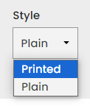  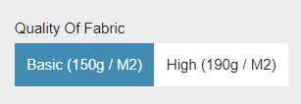

**Secure Authentication:** Incorporate robust authentication mechanisms to ensure user data security and prevent unauthorized access,

**Real-Time Data Management:** Utilize a real-time database, such as Firebase, to store user profiles, design preferences.

**Responsive Design**: Ensure the application's responsiveness across different devices and screen sizes.

**User-Friendly Interface:** Create an aesthetically pleasing user interface that allows users to easily navigate through the application.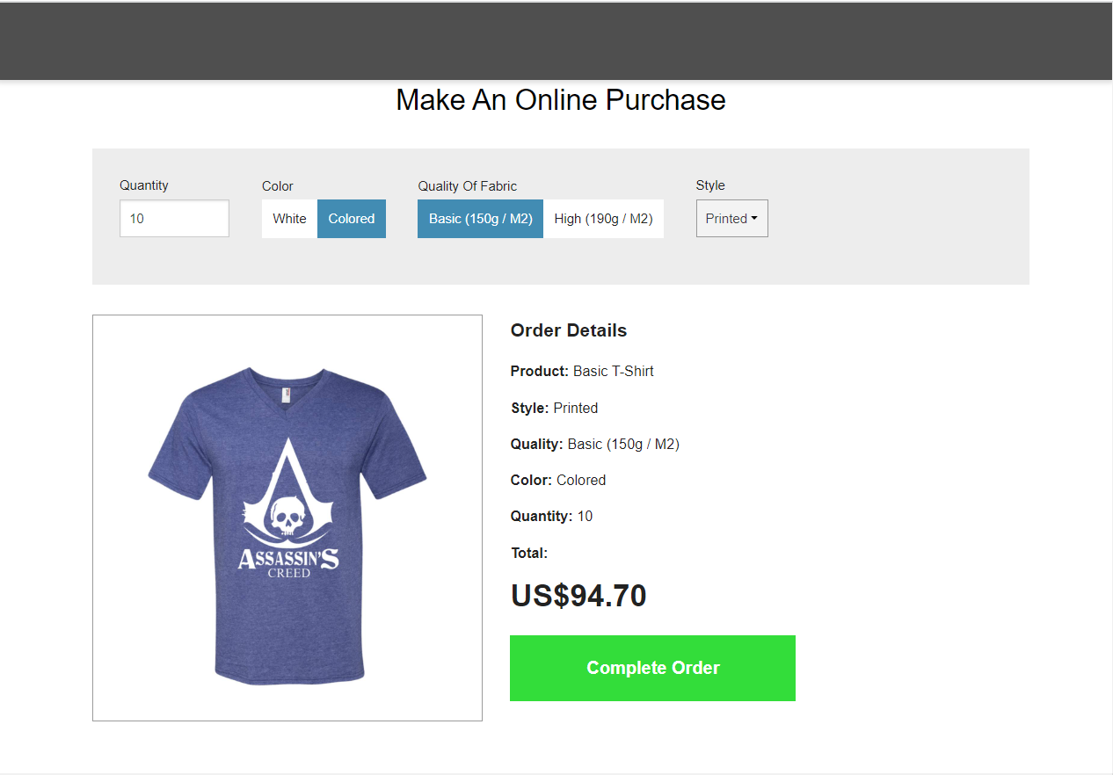

**METHODOLOGY**

**Platform Design & Development:**

* **Frontend Development: HTML**, **CSS**, and **JavaScript** were used to develop the frontend.
* **Backend Integration:** Firebase, a cloud-based NoSQL database was chosen to manage user data and authentication.
* **User Experience (UX):** Form validations (using regex for email format, password length checks) were incorporated to ensure data integrity and guide users in inputting correct data.

**RESULTS**

* On successful login, users will receive an alert stating "user logged in!" and will be redirected to "index.html" or "landingpage2.html".
* For a successful sign-up, users will get an alert that states "user Signed up!" and will then be directed to the login page for authentication.

**CONCLUSION**

In conclusion, this is a comprehensive web application tailored for online t-shirt purchasing. With a clear emphasis on user experience, the application offers intuitive navigation, easy user registration, and secure login functionalities. Leveraging Firebase, a robust cloud-based platform, the app ensures real-time data management, scalability, and secure user authentication. The application is designed with responsiveness in mind, offering a consistent user experience across various devices.

**FUTURE WORKS**

**Potential future works and enhancements that could be considered for the online t-shirt purchasing platform:**

* **Expanded Product Catalogue**: Feature seasonal collections, limited-time offers, or designer collaborations.
* **Advanced Search & Filters:** Implement search capabilities with auto-suggestions.
* **Social Integration:** Implement social login options (e.g., Google, Facebook) for a more seamless login experience
* **Loyalty Programs & Gamification:** Introduce loyalty points, badges, or rewards for frequent shoppers.

**REFERENCES**

**Documentation & Libraries:**

* Firebase Documentation: (https://firebase.google.com/docs)
* Foundation Documentation: (https://foundation.zurb.com/sites/docs/)
* Font Awesome Documentation: (https://fontawesome.com/v5.15/how-to-use/on-the-web/setup/getting-started)
* W3Schools - HTML, CSS, and JavaScript Tutorials: (<https://www.w3schools.com/>)