PRODUCT REQUIREMENTS DOCUMENT
Version 1.0

Design and Implementation of a
Blockchain-Based Academic Certificate Verification System
with Anomaly Detection
Field | Details
Document Type | Product Requirements Document (PRD)
Version | 1.0
Status | Draft — Pending Supervisor Approval
Project Type | Final Year Undergraduate Project — Computer Science
Country / Context | Ghana
Project Duration | 5 Months
Supervisor | [Supervisor Name]
Date | 2025

1. Document Purpose
This PRD defines the complete requirements for a blockchain-based academic certificate verification system. It covers what problem is being solved, what the system will do, who will use it, how each part works, and how success will be measured. It is the single reference document for all design, development, and evaluation work throughout the five-month project.

2. Problem Statement

2.1 Background
In Ghana, academic certificates are the main document used to prove someone's qualifications. Employers use them when hiring. Universities and professional bodies use them for admission. But the systems currently used to issue and verify these certificates are broken in three clear ways.

2.2 Problem 1 — Fake Certificates Are Easy to Make and Hard to Detect
Anyone in Ghana can get a convincing fake academic certificate cheaply. Using basic design software, a fraudster can copy the appearance of a real certificate from any university. When an employer receives it, they have no fast or reliable way to check if it is genuine.

The result is that unqualified people get jobs they should not have. Honest graduates lose opportunities to fraudsters. In critical fields like medicine and engineering, this creates direct public safety risks.

The core issue: There is no fast, accessible way for an employer to check whether a certificate is real.

2.3 Problem 2 — Verification Is Slow and Unreliable
When an employer wants to confirm a certificate is genuine, the only option today is to contact the university directly by phone, letter, or email. This takes seven to fourteen days on average. Many universities do not respond at all. There is no self-service option. Employers are forced to either trust certificates blindly or delay hiring decisions for weeks.

The core issue: There is no instant, independent verification system available to employers in Ghana.

2.4 Problem 3 — Digital Records Can Be Secretly Changed
Some universities now keep records in digital databases. But these databases are centralised — one office, one system, one point of failure. Anyone with admin access can add a fake record, change a grade, or delete an entry. There is no permanent audit trail. If it happens, it is almost impossible to detect.

The core issue: Centralised digital systems can be manipulated from the inside with no audit trail and no detection mechanism.

2.5 The Identity Binding Question
During the initial presentation, the lecturer raised a valid concern: what if someone obtains a real certificate ID and attaches it to a fake document?

The answer is built into the verification design. The system does not verify the certificate ID alone. It verifies the entire certificate content. The SHA-256 hash is computed from all fields combined — name, student ID, institution, qualification, date, and grade. When an employer verifies a certificate, they submit all these details. If a fraudster uses a borrowed ID but has different personal details, the recomputed hash will not match the blockchain record. Verification returns INVALID. The fraud fails.

2.6 Summary
Academic certificates in Ghana can be easily forged, verified too slowly, and digitally manipulated by insiders. This project builds a system that solves all three problems.

3. Project Goals
The following are the clear, simple goals this project must achieve. Every feature, every requirement, and every design decision in this document exists to serve one of these goals.

Goal | What It Means | Why It Matters
Goal 1  Immutable Records | Certificate hashes are stored on a blockchain. Once written, they cannot be changed or deleted by anyone. | Solves Problem 3. Makes insider tampering impossible after issuance.
Goal 2  Instant Verification | Any employer can verify any certificate in under 5 seconds. No account. No fee. No phone call. | Solves Problem 2. Replaces the slow manual process entirely.
Goal 3  Full-Content Hashing | The hash covers every certificate field — not just the ID. Any change to any field makes verification fail. | Solves Problem 1 and the identity binding concern. Fraud cannot pass verification.
Goal 4  Student Visibility | Every student with a certificate can log in and see what was recorded about them. | Students are the subject of every certificate. They must be able to see their own record.
Goal 5  Anomaly Monitoring | The system automatically watches for suspicious patterns and alerts the admin. | Adds an intelligent layer that can catch fraud patterns before they cause harm.
Goal 6  Simple Account Management | The system admin creates university admin accounts. Student accounts are created automatically when a certificate is issued. No open registration. | Keeps the system secure. Only real graduates with real certificates can have a student account.

4. User Roles
The system has four user roles. Each role has a clear job, a clear set of actions, and a clear access level. The design is deliberately simple — no role can do anything that belongs to another role.

Role | Their Job | What They Can Do | How They Get Access
System Admin | Manages the platform and all accounts | Create and deactivate university admin accounts. Reset passwords. View audit logs. Monitor anomaly dashboard. | Pre-configured account. Not publicly accessible.
University Admin | Issues certificates on behalf of their institution | Log in, issue certificates, view issuance history, see anomaly alerts. | Account created by System Admin. Username and password set by System Admin.
Student / Graduate | Views their own certificate record | Log in and view their own certificate details. Read-only. Cannot edit anything. | Account created automatically when their certificate is issued. Credentials given by university admin.
Employer / Verifier | Verifies whether a certificate is genuine | Enter certificate details on the public verification page. Receive VALID or INVALID result. | No account needed. The verification page is public.

4.1 How Student Accounts Work — Explained Simply
Students cannot register themselves. There is no open registration for the student portal. This is a deliberate security decision — if anyone could sign up as a student, they could claim to be a graduate without a real certificate.

Instead, when a university admin issues a certificate, the system automatically creates a student account at the same time. The student ID becomes the username. The system generates a temporary password. The university admin sees these credentials on the confirmation screen and gives them to the student directly.

The student logs in with those credentials. On first login, they are immediately asked to change their password. After that, they can see their certificate record whenever they want.

If a student forgets their password, they contact their university admin. The university admin can request a password reset through their portal. The system admin can also reset any password from the admin panel.

Key design decision: A student account only exists if a real certificate has been issued for that student. This links authentication directly to the blockchain record.

5. System Architecture
The system has four layers. Every layer has one clear job. The layers communicate with each other through REST APIs.

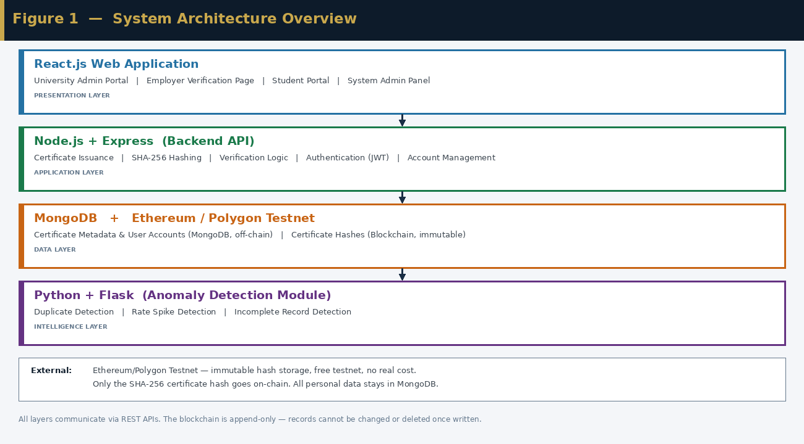
Figure 1 — System Architecture Overview

Layer | Technology | Its One Job
Presentation | React.js | The web interface. Serves four different pages for four different roles.
Application | Node.js + Express | The backend. Handles all logic: hashing, blockchain calls, verification, account management, auth.
Data | MongoDB + Blockchain Testnet | Stores certificate metadata off-chain in MongoDB. Stores certificate hashes on-chain immutably.
Intelligence | Python + Flask | Runs anomaly detection after every issuance. Exposes results to the backend via a REST API.

5.1 Technology Choices
What | Technology | Why
Frontend | React.js | Well-documented, component-based, suitable for multi-role interfaces
Backend | Node.js + Express | Lightweight, JavaScript-native, easy to connect to Ethers.js
Database | MongoDB | Flexible schema, easy to query by student ID or certificate ID
Blockchain | Ethereum / Polygon Testnet | Free testnet — no real cost. Standard platform with Solidity support.
Smart Contracts | Solidity | The standard language for Ethereum. Good tooling via Remix IDE.
Blockchain Client | Ethers.js | Connects Node.js backend to the smart contract
Hashing | SHA-256 | Cryptographically secure, deterministic, industry standard
Anomaly Detection | Python + Scikit-learn | Rule-based checks are simple; Isolation Forest available if time allows
AI Bridge | Flask | Lightweight Python API exposing anomaly detection to the backend
Auth | JWT + bcrypt | Standard token authentication and secure password hashing

6. Account Management Flow
This section answers the question of how accounts are created and managed for each role. The flow below shows the relationship between the System Admin, the University Admin, and the Student — and how accounts move from one level to the next.

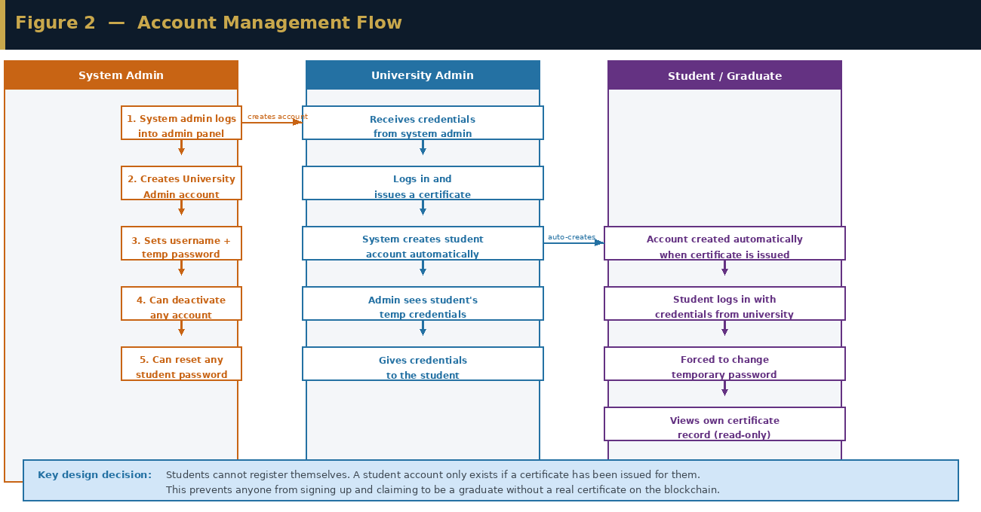
Figure 2 — Account Management Flow

6.1 Creating a University Admin Account — Step by Step
- System Admin logs into the admin panel.
- System Admin clicks 'Add University', enters the university name, and assigns a username and temporary password.
- System Admin submits. The university admin account is created.
- System Admin gives the credentials to the university admin contact.
- University admin logs in. They can now issue certificates.

6.2 How a Student Account Is Created — Step by Step
- University admin issues a certificate by filling in the certificate details form.
- When the certificate is successfully written to the blockchain, the system automatically creates a student account.
- The student ID from the certificate becomes the student's username.
- The system generates a temporary password and displays it to the university admin on the confirmation screen.
- The university admin gives the username and temporary password to the student.
- The student logs in. They are immediately forced to set a new password.
- The student can now view their certificate record in the student portal.

6.3 System Admin Capabilities
- Create university admin accounts — entering university name, username, and temporary password
- Deactivate any university admin account — a deactivated account cannot log in or issue certificates
- Reset any student's password — if a student cannot log in, the admin can generate a new temporary password
- View all registered accounts — university admins and students — in a simple management list
- View the anomaly dashboard — all flagged certificate events

7. Certificate Issuance Flow
This shows what happens when a university admin issues a certificate. Step 6 — the automatic creation of the student account — is new in this version and addresses the student authentication concern directly.

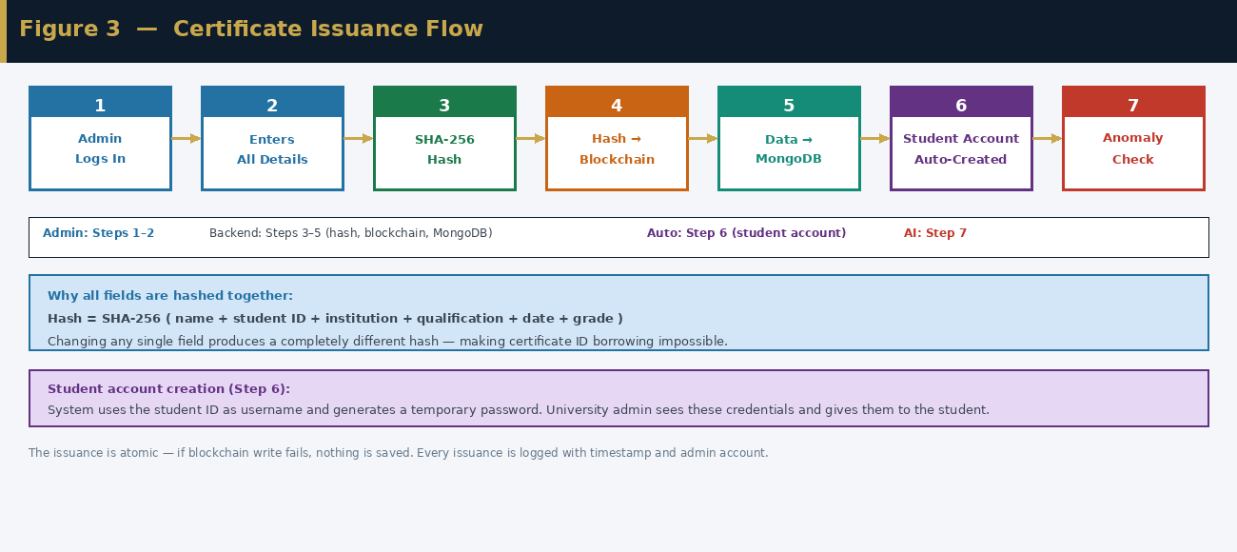
Figure 3 — Certificate Issuance Flow

7.1 Issuance Steps
- University admin logs in using their credentials.
- Admin enters all certificate details: student name, student ID, institution, qualification, date, and grade.
- The backend computes a SHA-256 hash of all fields combined. Every field is included — not just the ID.
- The hash is written to the Solidity smart contract on the blockchain testnet. This record is now permanent.
- Certificate metadata is saved to MongoDB. Personal data stays off-chain.
- The system automatically creates a student account using the student ID as the username and a generated temporary password.
- A confirmation is shown to the admin including the certificate ID, transaction hash, and student credentials.
- The anomaly detection module runs automatically in the background.

The issuance is atomic. If the blockchain write in Step 4 fails, nothing is saved — neither the MongoDB record nor the student account. Both must succeed together.

8. Certificate Verification Flow
The verification page is public. Any employer can use it at any time without an account or a fee.

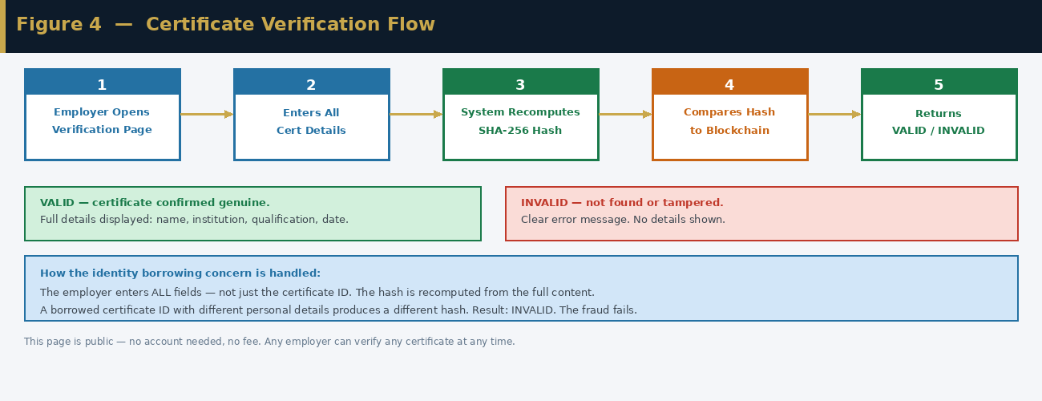
Figure 4 — Certificate Verification Flow

8.1 Verification Steps
- Employer opens the public verification page on any browser.
- Employer enters all certificate details exactly as they appear on the document: name, student ID, institution, qualification, date, and grade.
- The system recomputes the SHA-256 hash from the submitted details.
- The recomputed hash is compared against the hash stored on the blockchain.
- If the hashes match: VALID — full certificate details are displayed. If they do not match: INVALID — a clear error message is shown.

8.2 Why the Identity Concern Is Answered
The employer enters every field — not just the certificate ID. The system recomputes the hash from all those fields. If a fraudster uses a borrowed certificate ID but their name is different, the hash will not match. INVALID is returned. The fraud fails. This is not a workaround — it is the natural result of full-content hashing built into the core design.

9. Student Portal Flow
The student portal is simple. It has one purpose: let a student see what certificate record was issued for them.

9.1 Student Portal Steps
- Student navigates to the student portal and enters their username (student ID) and password.
- The system authenticates the student and retrieves their certificate record from MongoDB.
- The student sees all their certificate details as recorded by their university.
- If anything looks wrong — a misspelled name, an incorrect grade — the student contacts their university to investigate. The student cannot edit their own record.

The student portal is read-only by design. Certificate records are written to the blockchain and cannot be changed after issuance. The student is a viewer of their record, not an editor.

10. Anomaly Detection Flow
The anomaly detection module runs automatically after every certificate issuance. It checks for three specific problems and alerts the System Admin if any are found.

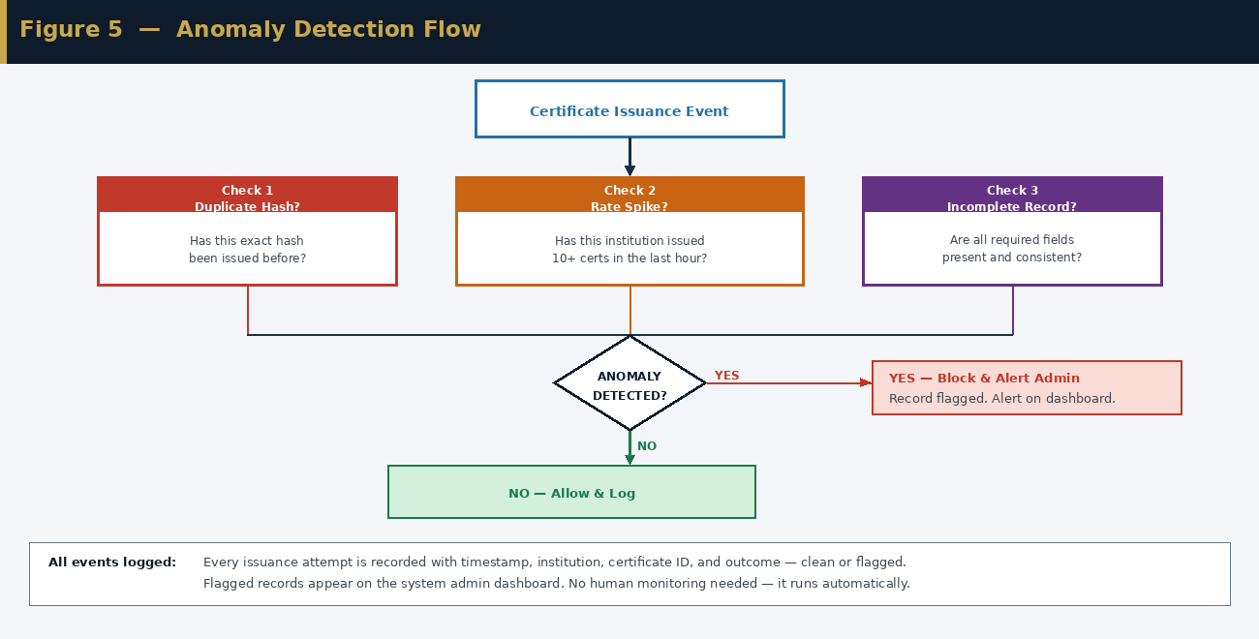
Figure 5 — Anomaly Detection Flow

10.1 Three Checks

Check 1 — Duplicate Hash
After the hash is computed, the module checks whether an identical hash already exists on the blockchain. If it does, this is a duplicate issuance. The module blocks it and raises an alert. This prevents the same certificate being issued more than once.

Check 2 — Rate Spike
The module counts how many certificates one institution has issued in the last hour. If the count exceeds a set threshold — for example ten per hour — it flags the activity as a potential rate spike and alerts the admin. The exact threshold is set during testing using simulated data.

Check 3 — Incomplete Record
The module checks that every required field is present and makes sense. If any field is missing, empty, or logically inconsistent — for example a graduation date that falls before the enrolment date — the record is flagged and the issuance is blocked until the issue is corrected.

All events, clean and flagged, are logged with a timestamp and outcome. Flagged records appear on the System Admin dashboard with a plain-English description of what was detected.

11. Use Case Diagram
The diagram below shows all four user roles and the actions they can perform within the system.

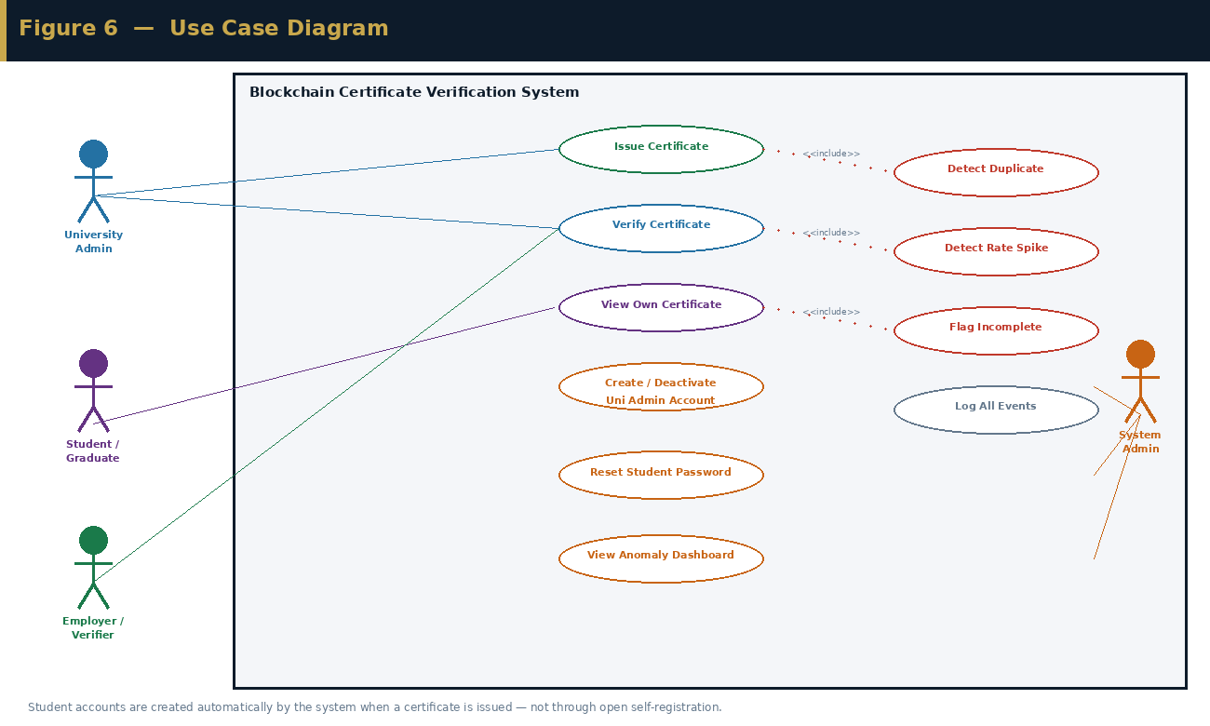
Figure 6 — Use Case Diagram

12. Data Flow Diagram
The context diagram below shows what data flows between the external actors and the central system. Personal data stays in MongoDB. Only the certificate hash goes to the blockchain.

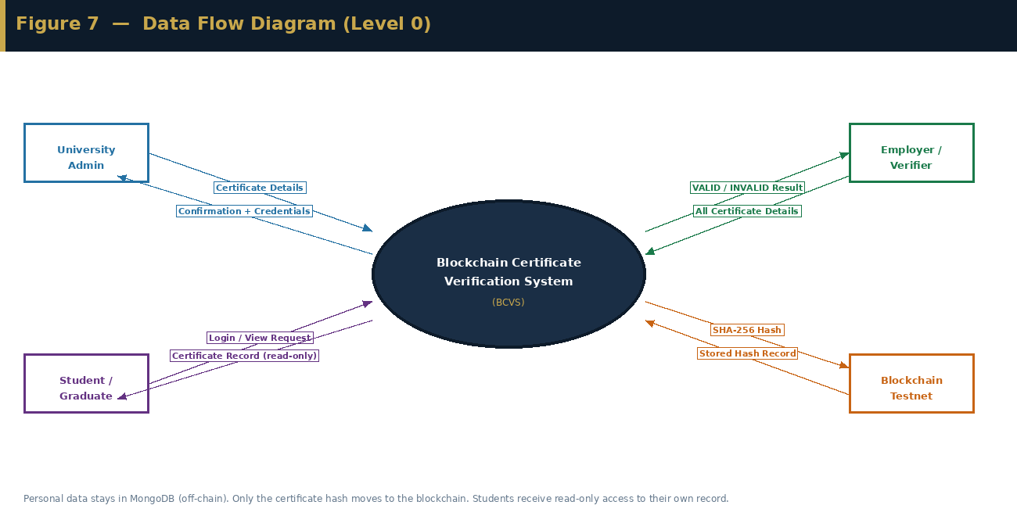
Figure 7 — Data Flow Diagram (Level 0 Context)

13. Functional Requirements
Each requirement has an ID and a priority. Critical means the project is incomplete without it. High means it is an important deliverable. The requirements are kept short and testable — one clear statement each.

13.1 Certificate Issuance
ID | Requirement | Priority
FR-ISS-01 | University admin must authenticate before accessing the issuance form | Critical
FR-ISS-02 | The system must accept: student name, student ID, institution, qualification, date, grade | Critical
FR-ISS-03 | SHA-256 hash must be computed from ALL six fields combined | Critical
FR-ISS-04 | Hash must be stored on blockchain via smart contract | Critical
FR-ISS-05 | Certificate metadata must be stored in MongoDB — no personal data on-chain | Critical
FR-ISS-06 | A student account must be created automatically when a certificate is issued | Critical
FR-ISS-07 | Admin must see certificate ID, transaction hash, and student credentials on the confirmation screen | High
FR-ISS-08 | Issuance must be atomic — blockchain and MongoDB must both succeed or neither is saved | Critical
FR-ISS-09 | Every issuance must be logged with timestamp and admin account ID | High

13.2 Certificate Verification
ID | Requirement | Priority
FR-VER-01 | The verification page must be publicly accessible — no login required | Critical
FR-VER-02 | The employer must enter all six certificate fields to verify — not just the certificate ID | Critical
FR-VER-03 | System must recompute the hash from submitted fields and compare it to the blockchain record | Critical
FR-VER-04 | System must return a clear VALID or INVALID result | Critical
FR-VER-05 | VALID result must display: name, institution, qualification, date, grade | High
FR-VER-06 | INVALID result must display a clear message — no certificate details shown | Critical
FR-VER-07 | Result must be returned in under 5 seconds under normal conditions | High

13.3 Student Portal
ID | Requirement | Priority
FR-STU-01 | Students must authenticate using their student ID as username and their chosen password | Critical
FR-STU-02 | On first login, students must be forced to change their temporary password | Critical
FR-STU-03 | Students must be able to view their own certificate record after login | Critical
FR-STU-04 | The student portal must be read-only — students cannot edit any field | Critical
FR-STU-05 | The system must only show the record belonging to the authenticated student | Critical

13.4 Account Management
ID | Requirement | Priority
FR-ACC-01 | System admin must be able to create a university admin account from the admin panel | Critical
FR-ACC-02 | System admin must be able to deactivate any university admin account | High
FR-ACC-03 | System admin must be able to reset any student's password | High
FR-ACC-04 | System admin must be able to view a list of all university admin accounts and student accounts | High
FR-ACC-05 | No university or student can create their own account — all accounts are system-created or auto-created | Critical

13.5 Anomaly Detection
ID | Requirement | Priority
FR-ANO-01 | System must detect and block duplicate certificate submissions | High
FR-ANO-02 | System must flag and alert when an institution exceeds the issuance rate threshold | High
FR-ANO-03 | System must flag and block certificates with missing or inconsistent fields | High
FR-ANO-04 | Flagged anomalies must appear on the System Admin dashboard with a description | High
FR-ANO-05 | The anomaly module must run automatically — no manual trigger needed | High
FR-ANO-06 | All events — clean and flagged — must be logged with timestamp and outcome | High

14. Non-Functional Requirements
Category | Requirement | Target
Performance | Verification result returned in under 5 seconds | Under 5 seconds
Security | All data in transit encrypted | HTTPS / TLS 1.2+
Security | Passwords stored as salted hashes | bcrypt
Security | SHA-256 hash computed from all certificate fields — enforced by design | 100% — no exceptions
Privacy | No personal data stored on the public blockchain | Hashes only on-chain
Reliability | Blockchain record permanently retrievable once written | 100% — immutable
Usability | Verification page usable by a non-technical employer | Task complete in under 2 minutes
Usability | All error states show a clear, informative message | No silent failures
Maintainability | Codebase commented and structured for readability | All functions documented

15. Constraints and Limitations

15.1 Constraints
Constraint | Description
Time | 5 months, single student. Scope is deliberately kept small.
Budget | No real blockchain costs. Ethereum or Polygon testnet used throughout.
Data | No access to real university records. Simulated data used for all testing.

15.2 What This System Does Not Do
Being honest about limitations makes the project stronger, not weaker.

- It cannot prevent a corrupt university official from issuing a fraudulent but technically valid certificate. The blockchain stops tampering after issuance — it cannot control what is entered in the first place. This is a known limitation of all blockchain credential systems.
- It does not biometrically verify that the person presenting a certificate is the person it was issued to. Full-content hashing is the practical solution used here. Biometric extension is future work.
- It requires internet access. Issuance and verification both need connectivity to reach the blockchain testnet.
- It is a prototype evaluated on simulated data — not deployed at a real university.

16. Evaluation Plan
The evaluation will test five specific things. Every test uses a clear method and has a measurable target.

What Is Tested | How | Target
Verification speed | Time from submitting details to receiving result — measured 20 times | Under 5 seconds on average
Tamper resistance | Manually change a field in MongoDB after issuance, then attempt verification | 100% of tampered records return INVALID
Identity borrowing | Use a valid certificate ID with different personal details and attempt verification | 100% return INVALID
Anomaly detection | Run the module against simulated normal and anomalous data sets | Precision above 80%
Gas cost | Record testnet transaction cost per certificate issuance via Etherscan | Documented and discussed in report

17. Project Timeline
Month | Focus | Key Activities | Deliverables
Month 1 | Learn + Design | Solidity basics via CryptoZombies. Set up tools. Draw all system diagrams. Write and deploy smart contract on testnet. | Architecture diagram, flow diagrams, use case diagram, smart contract on Sepolia testnet
Month 2 | Backend | Node.js setup, MongoDB schema, SHA-256 hashing, Ethers.js blockchain connection, REST API endpoints for issue and verify, account management logic. | Working API with blockchain integration. Tamper test passing.
Month 3 | Frontend | React setup, university admin portal, public verification page, student portal, system admin panel. All connected to the backend. | Four working pages. Full end-to-end flow demonstrated.
Month 4 | Anomaly Detection | Python anomaly module — three checks. Flask API. Admin dashboard showing flags. Integration test. | Anomaly module working. Admin dashboard live. Full system tested.
Month 5 | Evaluation + Report | Run all evaluation tests. Write project report chapters 1–6. | Evaluation results documented. Final report submitted. System ready to demo.

18. Expected Deliverables
# | Deliverable | Description
D1 | Working Web Application | University admin portal, employer verification page, student portal, system admin panel — all connected and working together
D2 | Smart Contract on Testnet | Solidity smart contract deployed on Ethereum or Polygon Sepolia testnet — stores and retrieves certificate hashes
D3 | Anomaly Detection Module | Python-based module with three rule-based checks, exposed via Flask API, results shown on admin dashboard
D4 | System Design Documents | All seven diagrams included in this PRD: architecture, account management, issuance, verification, anomaly, use case, data flow
D5 | Evaluation Report | Verification speed, tamper resistance, identity borrowing test, anomaly accuracy, gas cost — all measured and documented
D6 | Final Project Report | Complete academic report: literature review, methodology, design, implementation, evaluation, conclusion

19. Acceptance Criteria
The project is complete when all of the following can be demonstrated live.

# | Criterion | How to Test
AC-01 | University admin can log in and issue a certificate that is recorded on the blockchain | Live demonstration
AC-02 | System automatically creates a student account when a certificate is issued | Check MongoDB after issuance for student account record
AC-03 | Student can log in with the auto-created credentials and view their certificate | Live demonstration
AC-04 | Student is forced to change temporary password on first login | First login test
AC-05 | Employer can verify a genuine certificate and receive VALID in under 5 seconds | Timed live test
AC-06 | A tampered certificate returns INVALID | Manually alter a field then verify
AC-07 | Using a borrowed certificate ID with different personal details returns INVALID | Identity borrowing test
AC-08 | A duplicate issuance is detected and blocked | Submit same certificate twice
AC-09 | System Admin can create, deactivate, and reset passwords for accounts | Admin panel demonstration
AC-10 | Final project report submitted | Report submission

End of Product Requirements Document — Version 1.0
This document is subject to revision. All changes must be approved by the project supervisor.

