**Inky Ear Tags:** Deterring Sheep Rustlers With Smartphones and Security Ink.

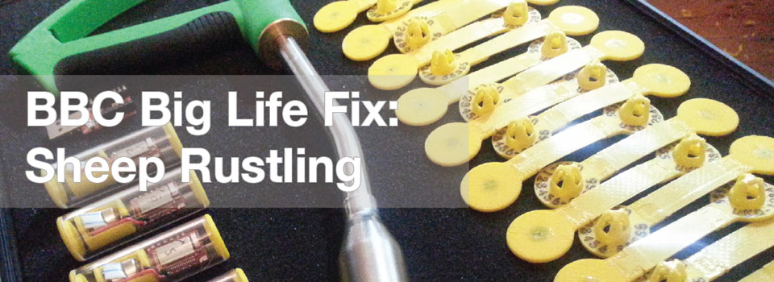

Thousands of sheep are stolen every year in the UK, at a cost of millions to the industry. Trying to prevent theft is seemingly impossible, as an average farm can easily total 600 Acres of pasture (about 500 football pitches), and is services by dozens of roads. The problem only gets more difficult, considering that the unit cost of a sheep is relatively low (£70-£80) compared to cows and horses which are so expensive they actually have passports!

This low price also means that regulatory authorities do not have sufficient impetus to invest in a more advanced ‘closed loop’ database of sheep registration. For example, unlike your car’s numberplate, a new sheep’s ear tag can be acquired, and does not need to be ‘decommissioned’, so a thief can simply cut ear identification (Ear ID) tags off and replace them with his own - and it’d be hard to detect the fraud when the sheep is sold.

The Fix Team had been thinking about how the Tag couldn’t be made impossible to remove, and neither could it realistically house GPS electronics - but it perhaps could be made tamper-evident? If suspicion was raised, somehow it could provide the evidence for an investigation by the police, which might eventually result in a conviction.

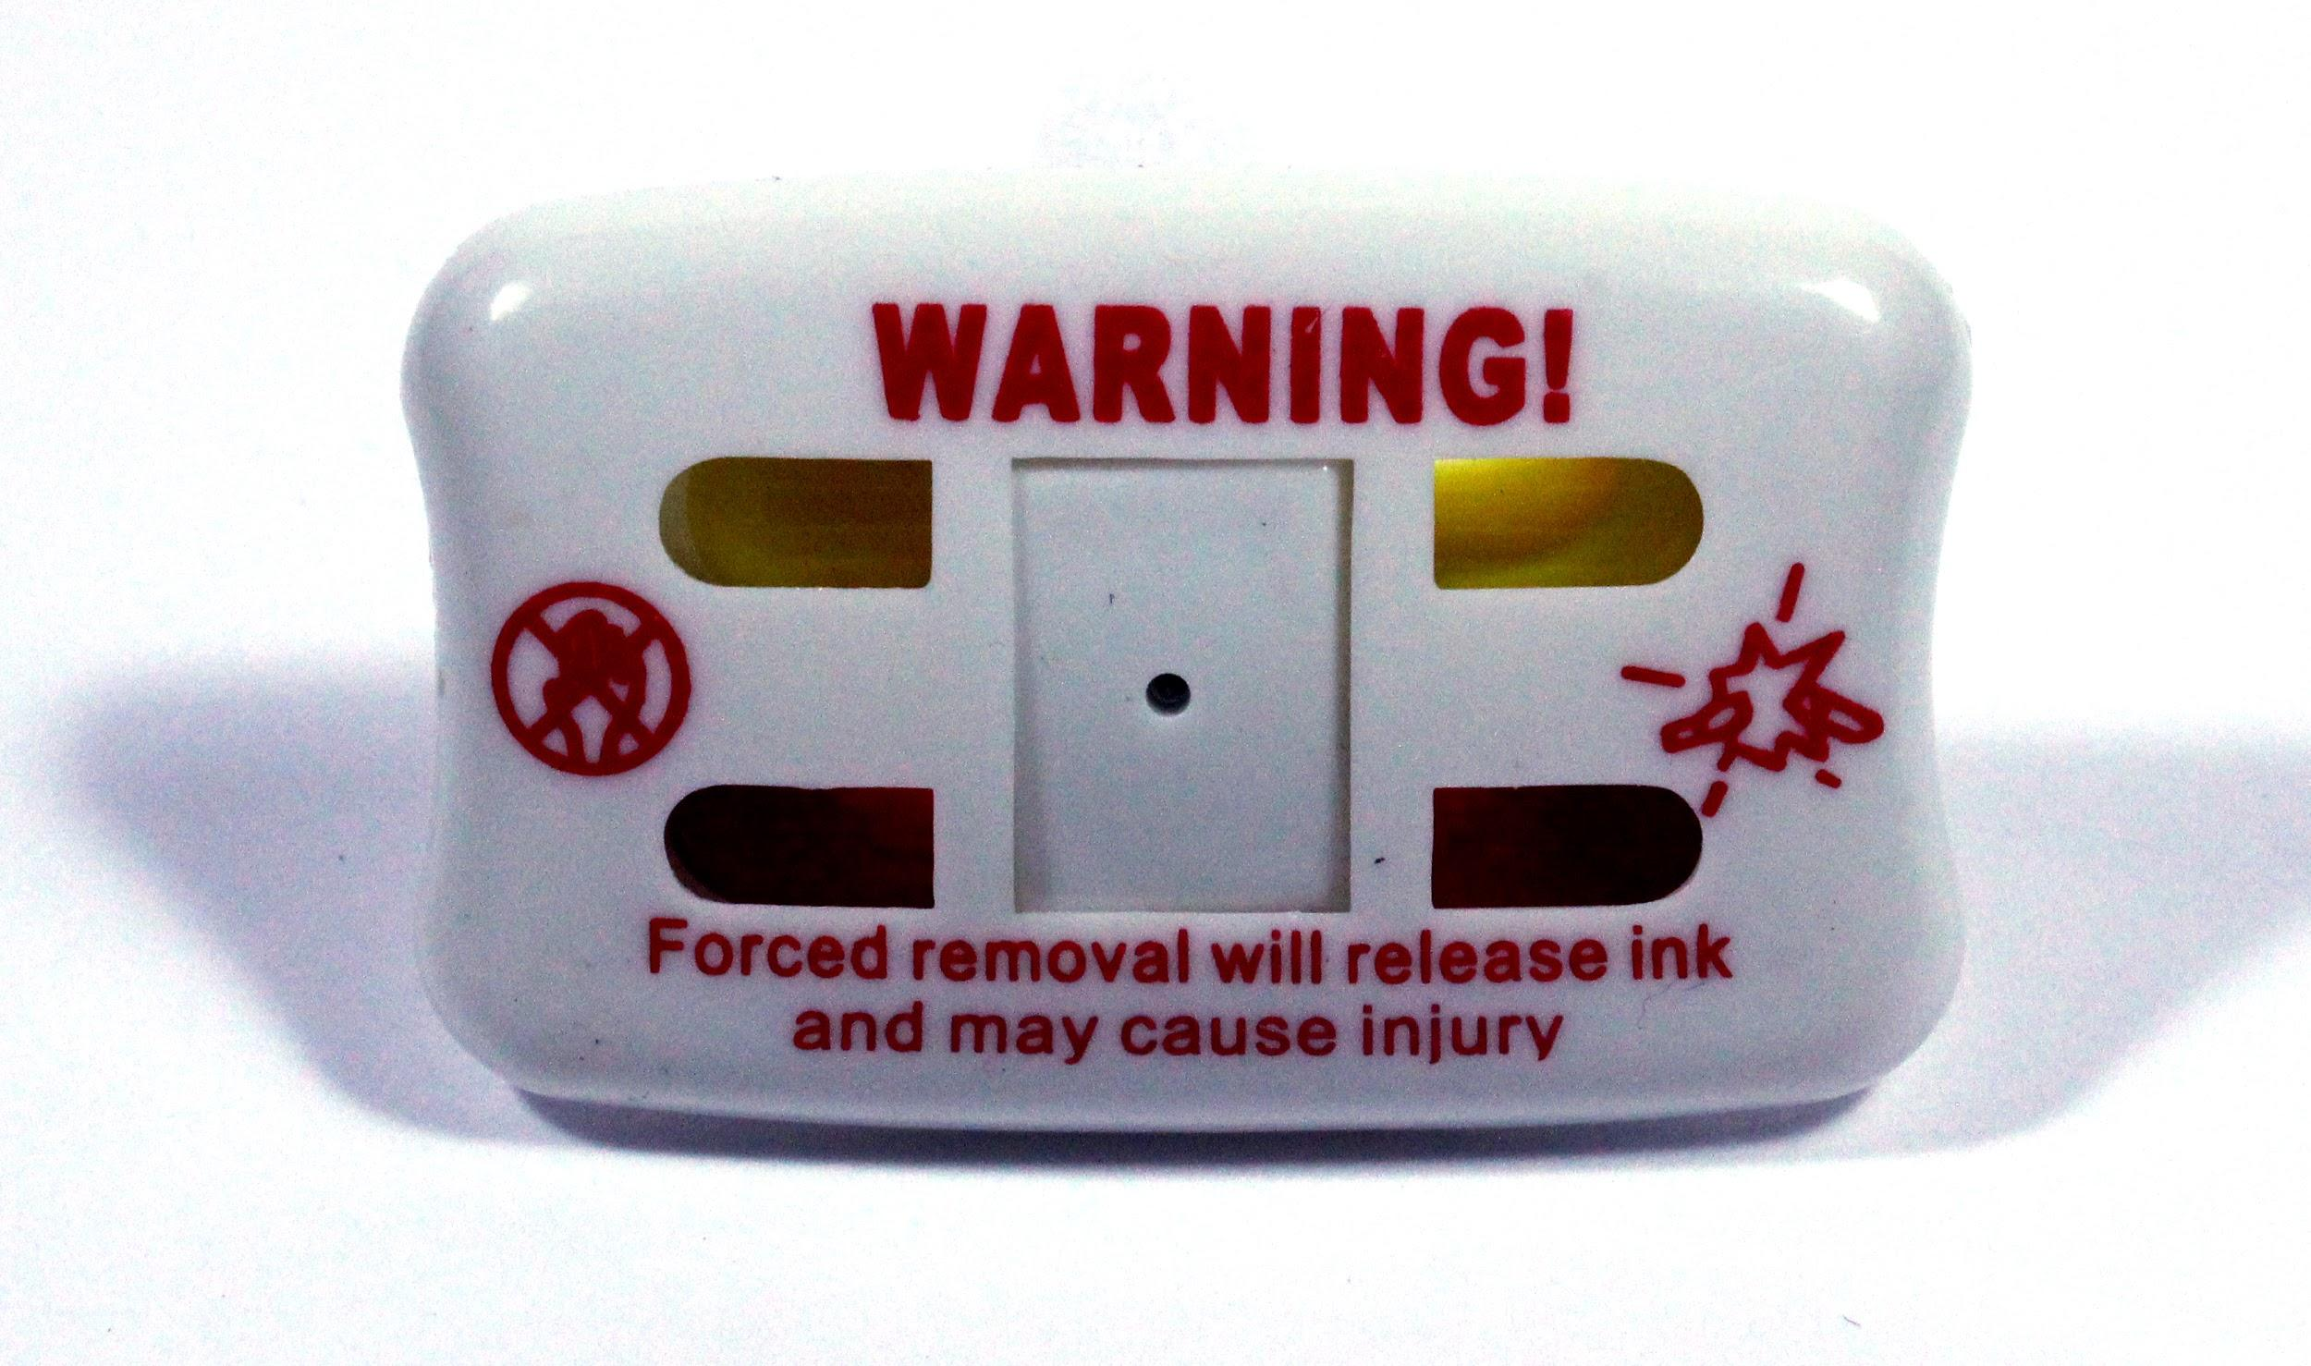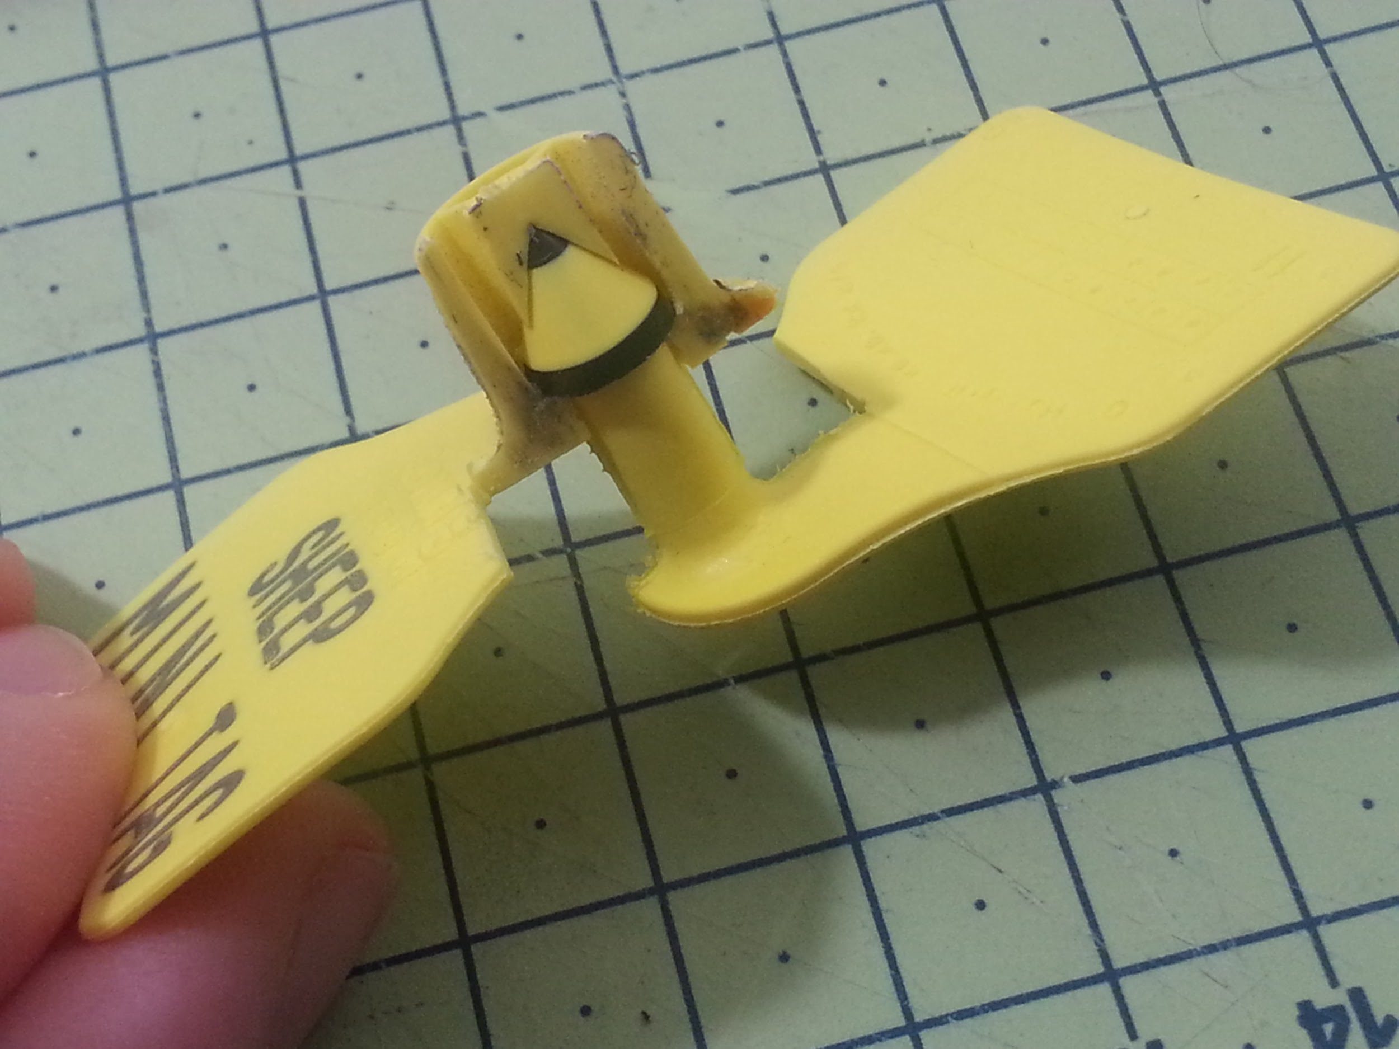

Taking inspiration from the retail industry, which uses ‘tamper-evident’ security tags, which leak dye all over clothing if tampered with, Jude looked at how the Ear Tag could be modified to contain security ink. After examining a large Ear Tag, he realised that the central ‘locking pin’ was quite large - and similar in proportion to the glass vials in the retail tags.

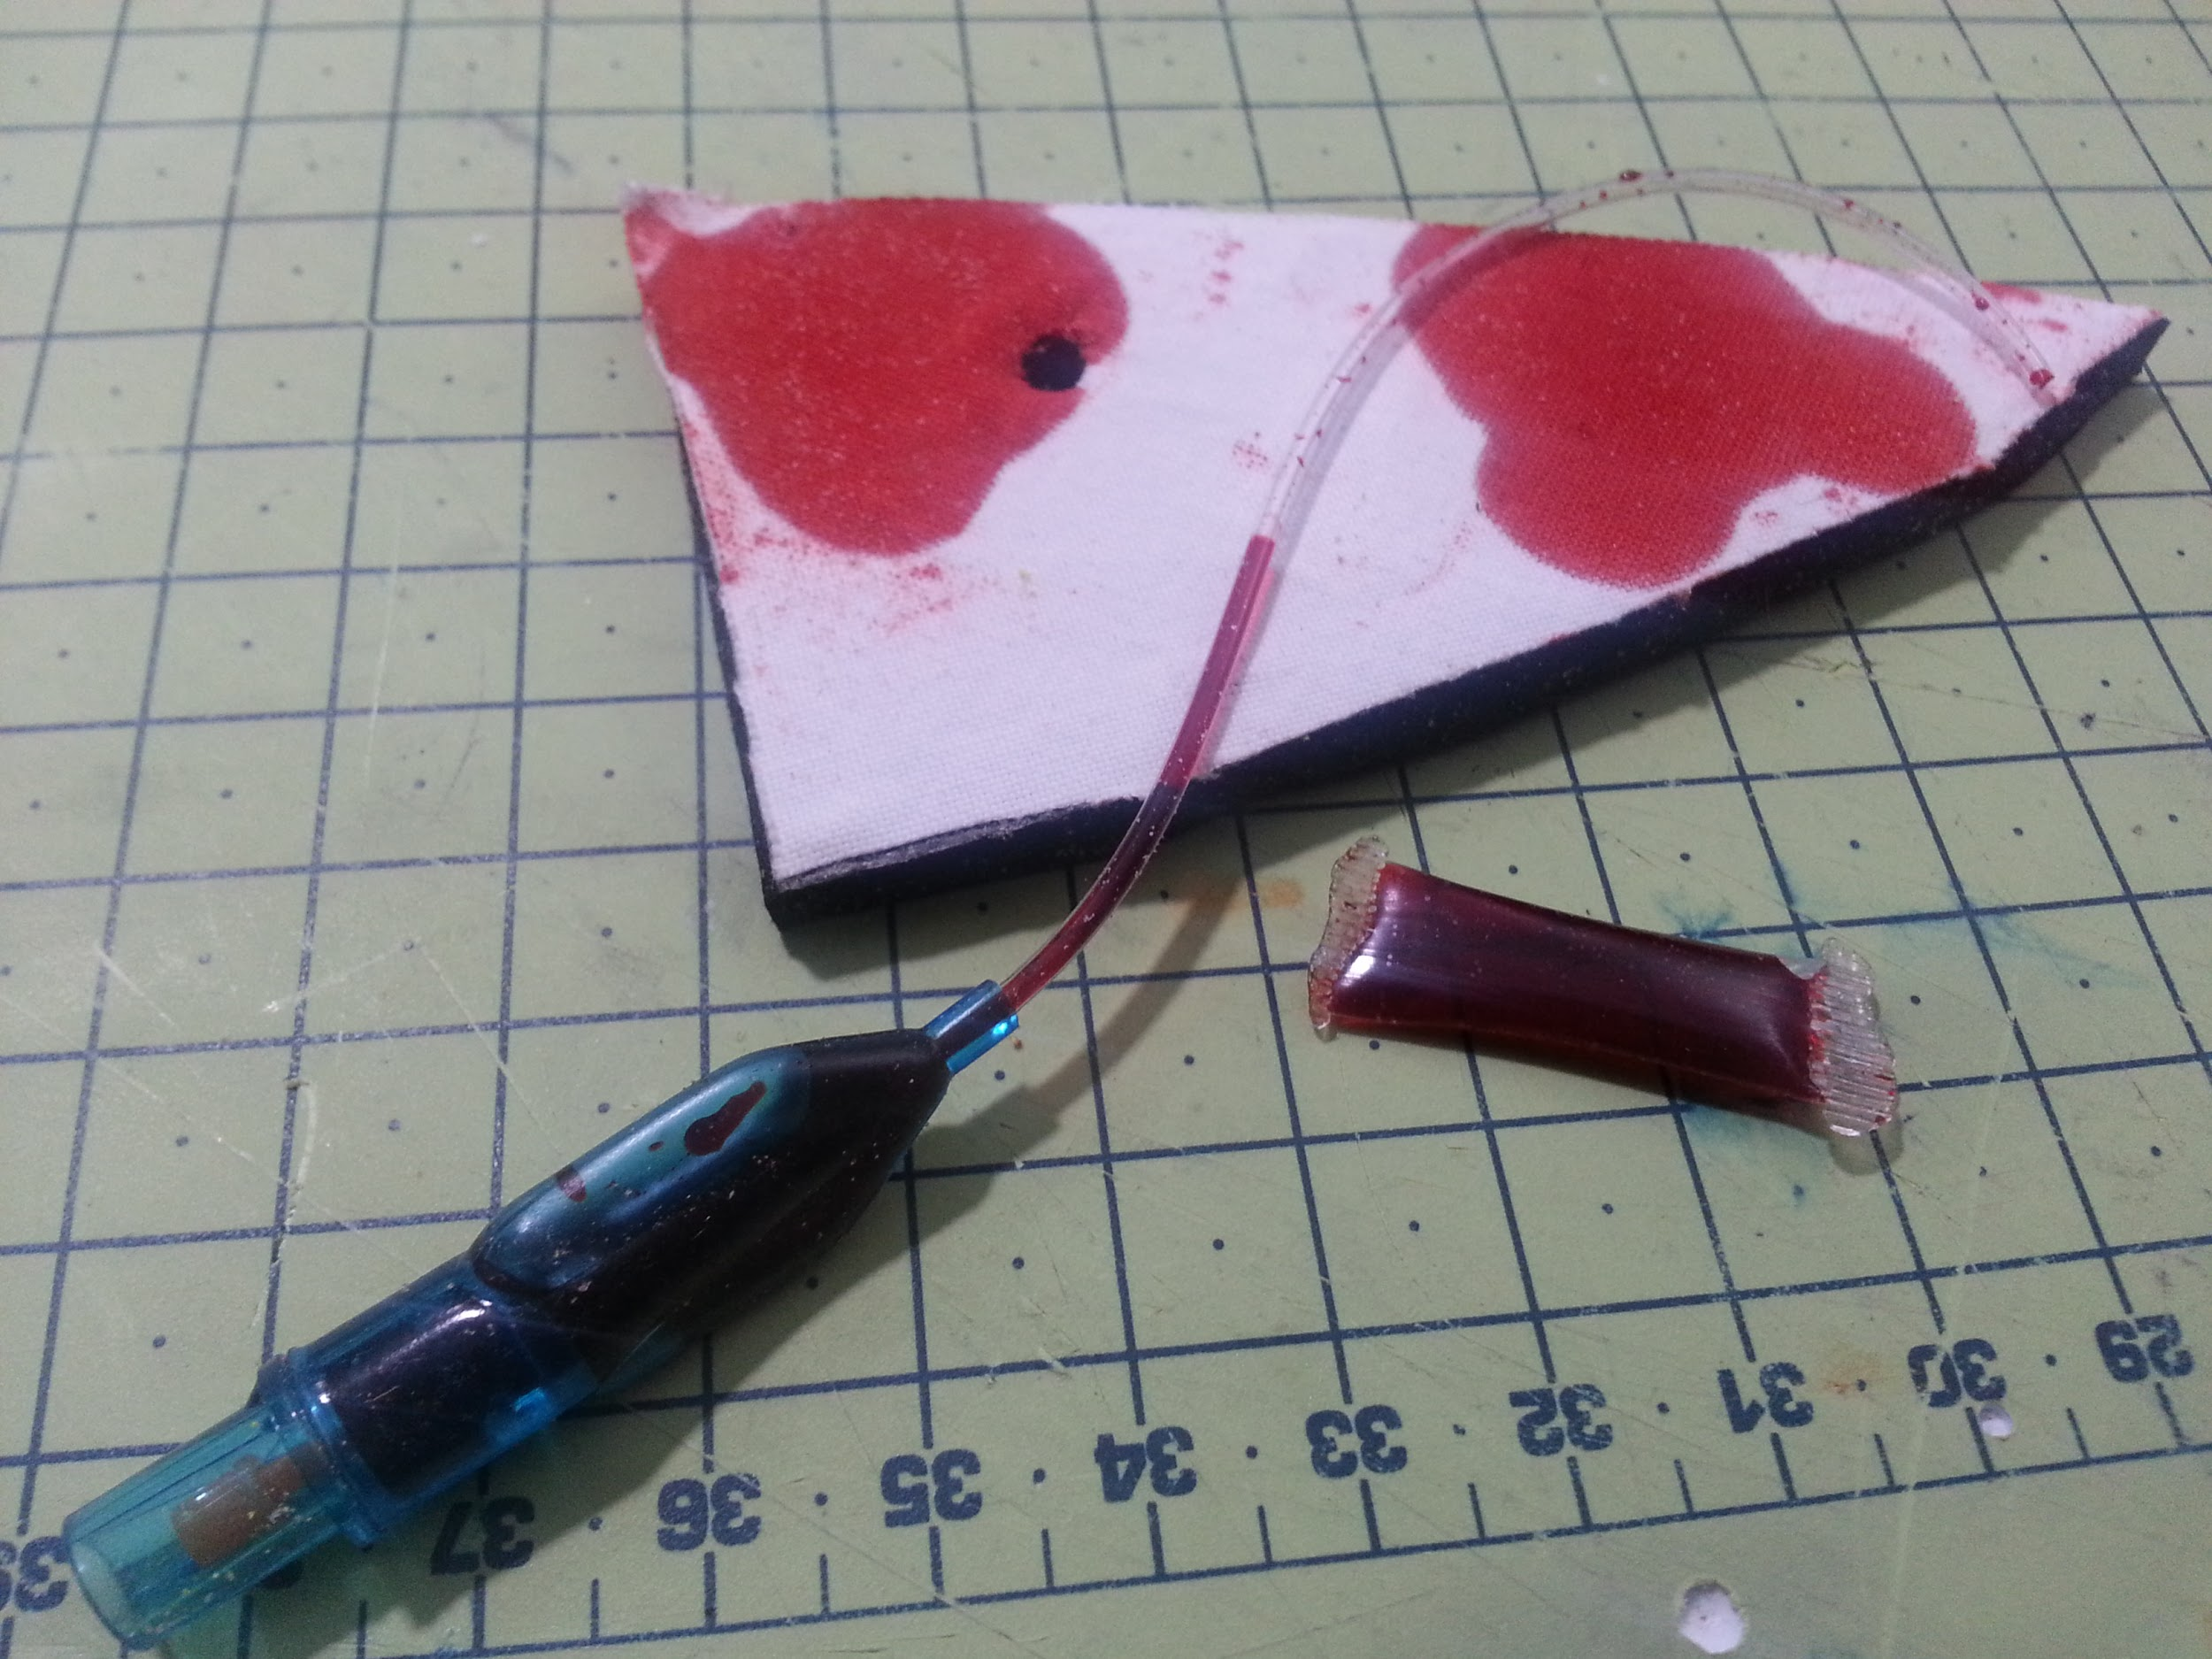

The intention was to use the same ink that is used by banks to ‘spoil’ banknotes in a heist. This ink is very permanent. Zoe also wondered if UV-Smart water could also be used as a secondary trace to catch criminals ‘red handed’ as it were. Jude experimented with numerous ways to house a few milliliters of the dye-cocktail in the central pin. It was clear if one were cut through, this would only leave a relatively small stain, but in the process of cutting off multiple ‘inky ear tags’, the cumulative effect would be noticeable, (as show after only 5 tags were removed in the programme). The ink would accumulate on the tools and hands of the criminals’ hands, as well as the ears and bodies of the sheep. The latter would potentially rouse suspicion if the sheep were trying to be sold at a legitimate auction (for a higher price than black market).

Finally, Jude drew inspiration from the RFID Tags you see stuck on roasting joints in supermarkets, that trigger an alarm at the store exit if not deactivated. He wondered if this could also be incorporated into the Inky Ear Tags as a further means of authentication - and which could be linked to a database, which would know if a flock were registered as stolen.

