*system boundary*

Gas molecules interact with each other and with the walls of their container. (Other forces, such as those of the table holding up the container and the gravitational force, are considered to have a negligible effect on the motions of the molecules and container.

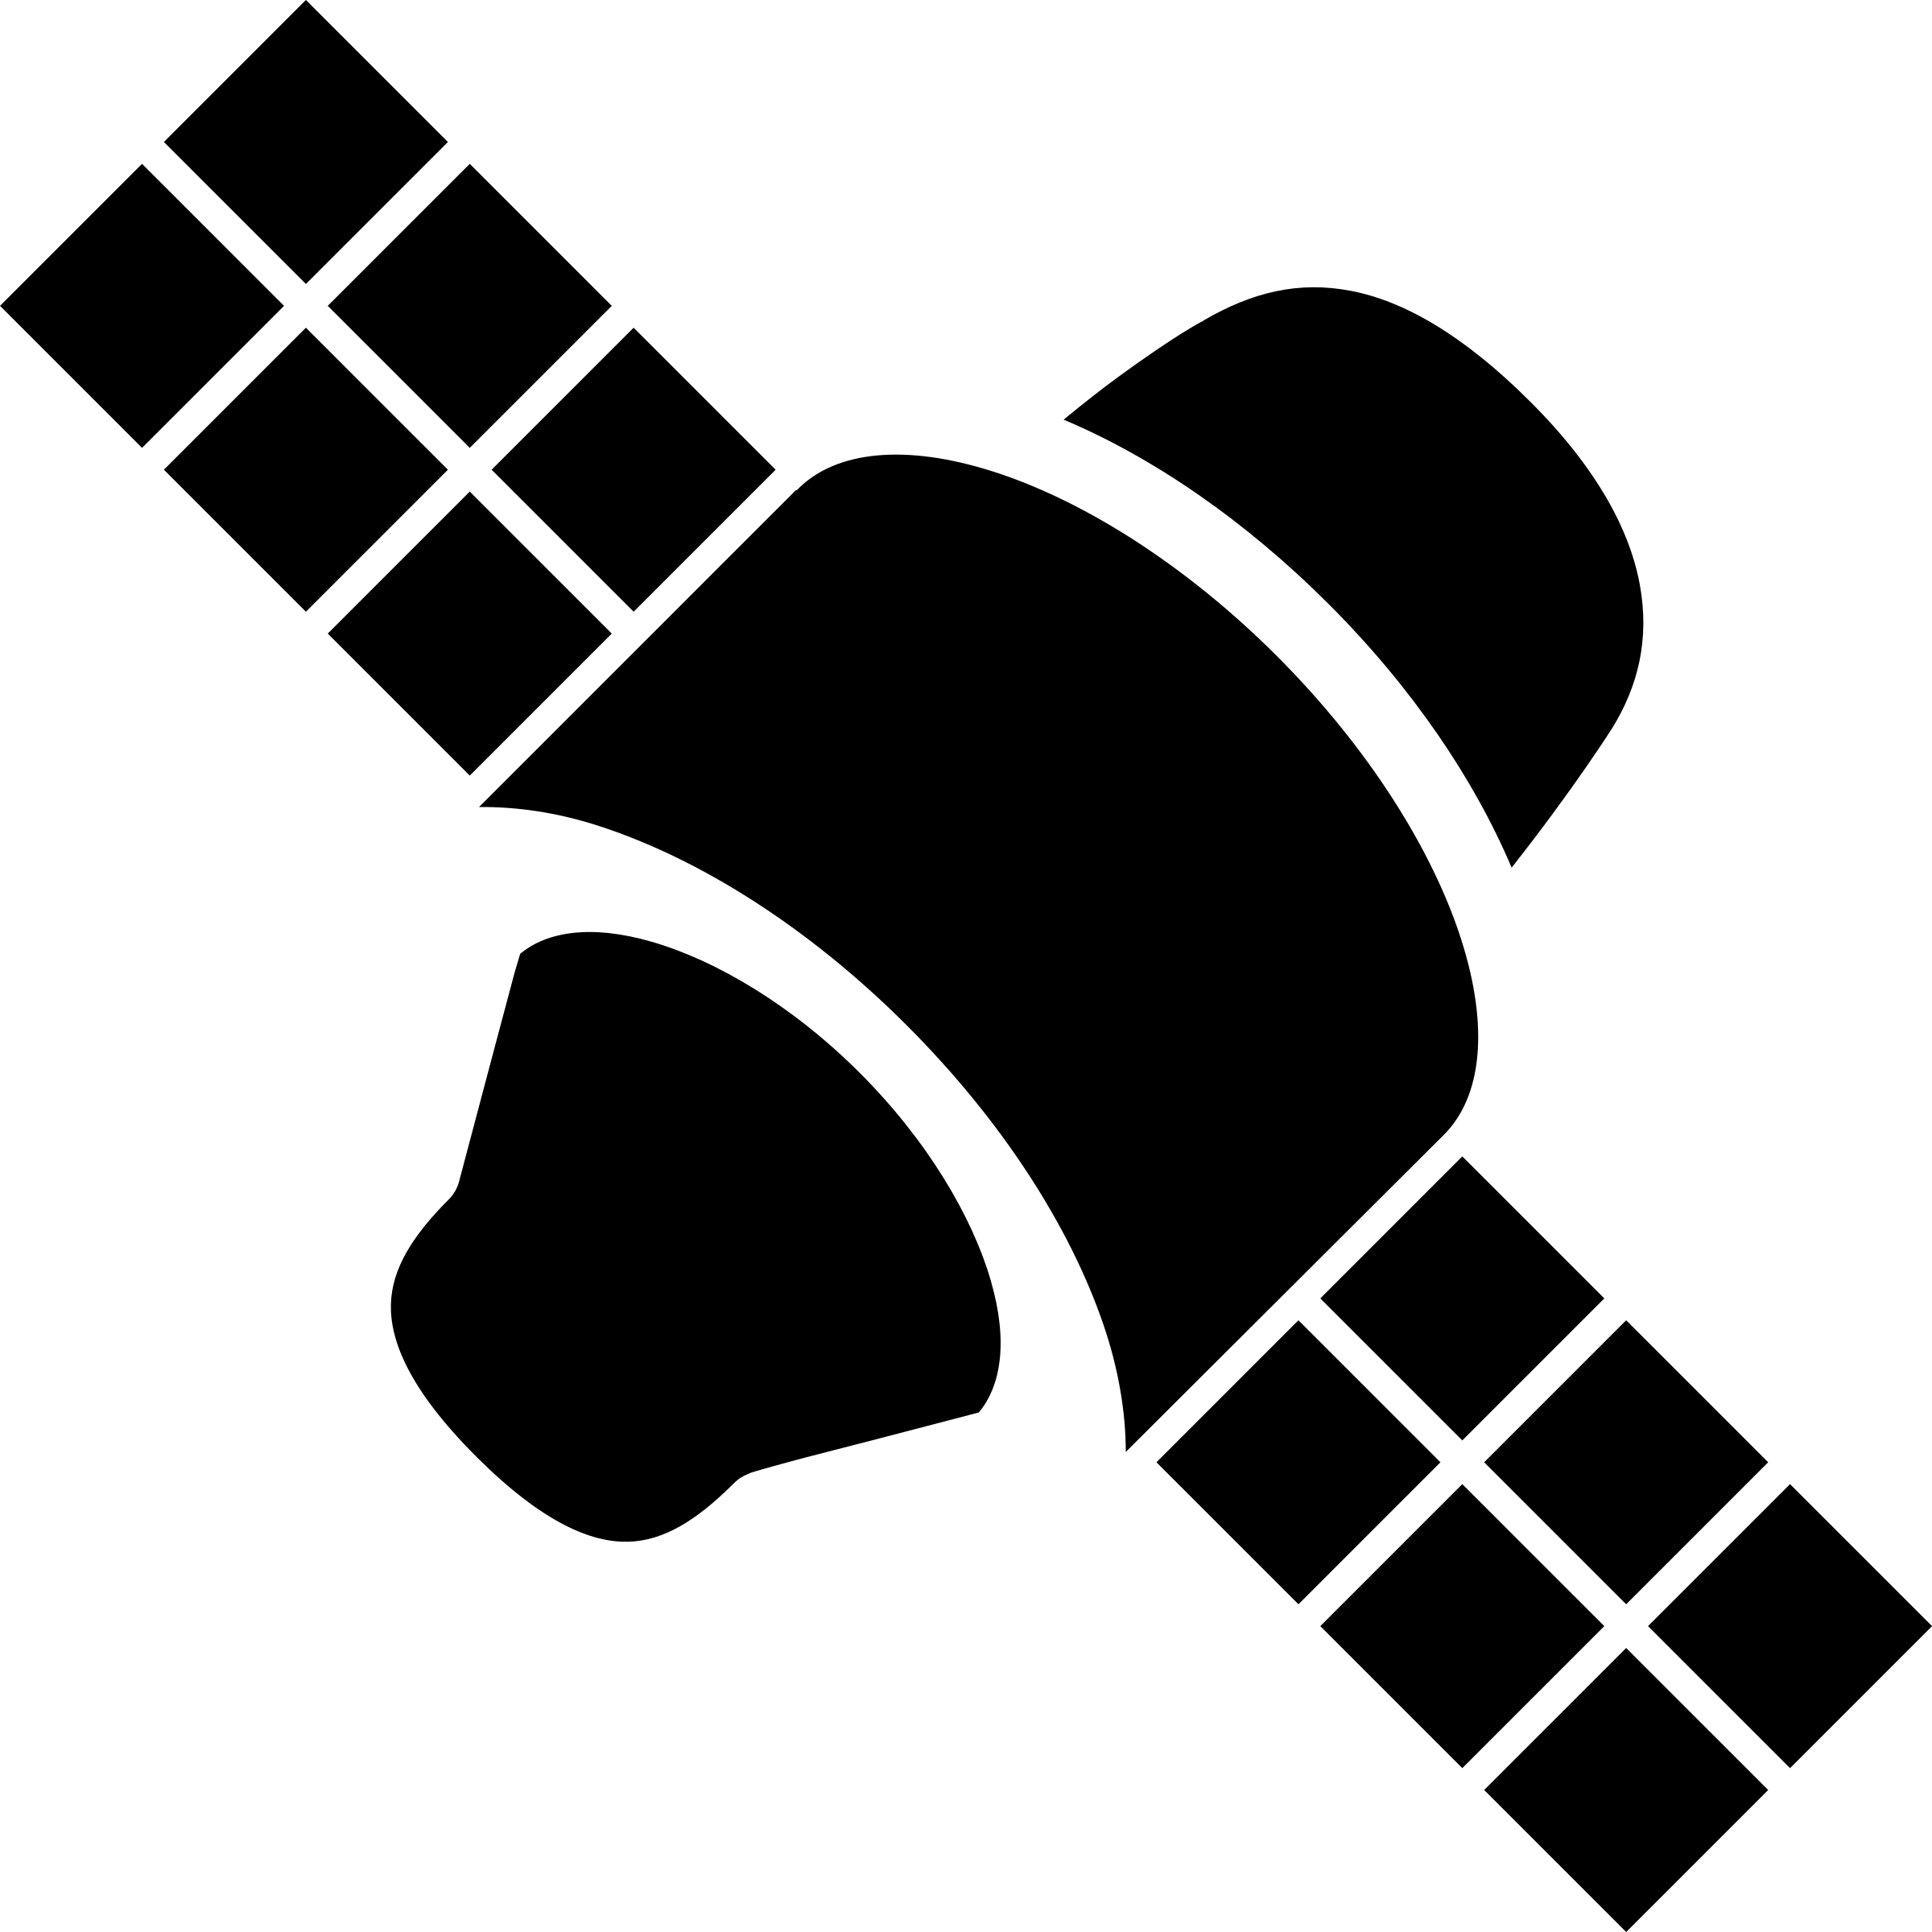

*system boundary*

An orbiting satellite and the Earth interact. (Forces between these objects and others such as the sun and moon are considered to have a negligible effect on their motion.)

*system boundary*

Pucks riding on a cushion of air on an air table interact with each other before hitting the walls of the air table. (Friction forces with the surface of the table are negligible.)

$$\vec{v}$$

$$-\vec{v}$$

Carts with almost frictionless bearings interact but experience only negligible forces from the track

*system boundary*