Experiment 0 – Physics 132 Archimedes’s Principle

Name _______________________ Date _____________

Objective: To determine the densities of three samples using Archimedes’s Principle.

Apparatus

- Three different samples (more dense than water)
- Force probe (with calibration weights) and support
- A plastic beaker
- Pasco 550 interface
- Capstone software (Liquid_Nitrogen_Vapor.cap experiment file)

Introduction

An upward buoyant force is experienced by objects when they are either fully or partially submerged in a fluid. This buoyant force is caused by the decrease in pressure with height in a fluid, and the magnitude of this upward force is equal to the magnitude of the force exerted by gravity on the fluid displaced by the object. This statement is called Archimedes’ principle. Note that there is no reference to the shape, composition, or density of the submerged object: the only factor that comes into play is the volume of the displaced fluid. The volume of displaced fluid is equal to the volume of the submerged portion of the object.

In this lab we will submerge three different objects (made of material more dense than water) in water and measure their apparent weights. Using these values and the weights of the objects in air, the densities of the objects can be calculated from the following formula:
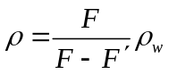 (1)

where F is the of the weight of the object in air, 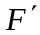is the apparent weight of the object when submerged in water, 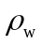 is the density of water, and is the density of the submerged object.

Activity 1: Derivation of the Equation relating to , , and 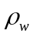

(a) Draw a free-body diagram for an object of volume V, mass m, and density when it is hanging freely from a force probe and is in static equilibrium. Call the force measured by the force probe F and write down an equations that relates F to V, m, and.

(b) Draw a free-body diagram for the same object when it is hanging freely from a force probe and is fully submerged in water and is in static equilibrium. Call the force measured by the force probe and write down an equation that relates to V, m, and.

(c) Use the equation derived in part (a) to rewrite the equation in part (b) in terms of only F, , , and. Note that the volume of the object is related to m and. Then, solve the resulting equation forto get Equation (1).

Activity 2: Measuring the Densities of the Three Objects

(a) Plug the force probe into the input channel A on the Pasco 550 interface. Open the file Liquid_Nitrogen_Vapor.cap in the Phys132 folder.

(b) Calibrate the force probe while it is held vertically (with hook down) by its support with a 200-g weight as outlined in Appendix A. Right after completing the calibration procedure and also before each one of the following weight measurements, check the calibration of the force probe by hanging a 200-g mass from the force probe and recording data for one or two seconds to make sure the force probe measures the weight of a 200-g mass correctly.

(c) Before submerging the objects in water, measure their weights in air by hanging them from the force probe. For each sample record data for a few seconds. Then determine the mean and standard deviations of the values of the recorded data. Using the standard deviations and the uncertainties involved in the calibration of the force probe, estimate the uncertainties in the values of the measured weights. Record the values in the following table.

(d) Now, measure the apparent weight of each sample when they are fully submerged in a beaker of water. Record the mean values of the weights and their estimated uncertainties in the following table.

Sample | 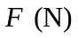 | 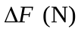 | 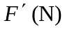 | 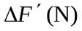
1
2
3

(e) Calculate the densities of the samples from the values of F, , and . For the density of water use 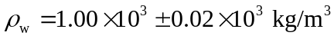. Show the details of one of your calculations.

(f) Calculate the uncertainty of for each sample from the following formula:

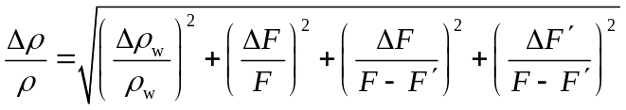 (2)

(g) Summarize your measured values of the densities and their uncertainties in the following table.

Sample | 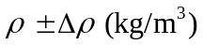
1
2
3

(h) The following table shows the densities of some solid metals at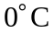. Are your results comparable to these values? Can you identify the samples by comparing their measured densities with those in the table?

Material | Density 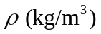
Aluminum | 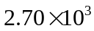
Copper | 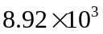
Iron | 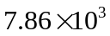
Lead | 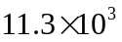
Platinum | 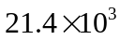
Brass | 