This is for scale

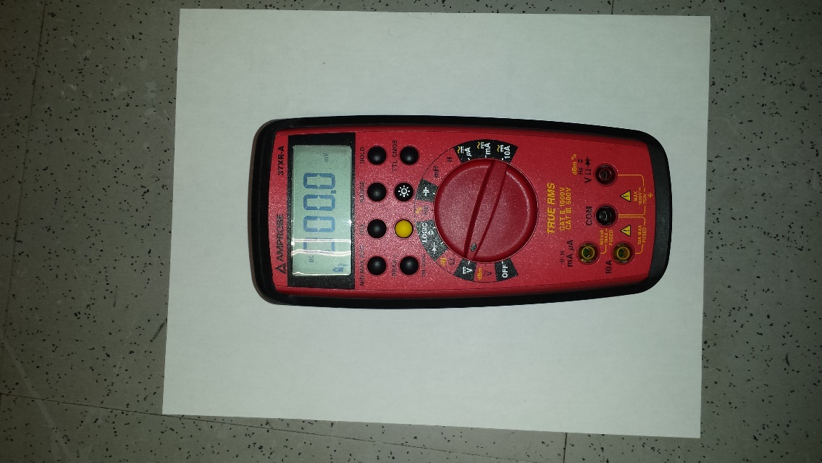

selector: V

leads:

VΩ, COM

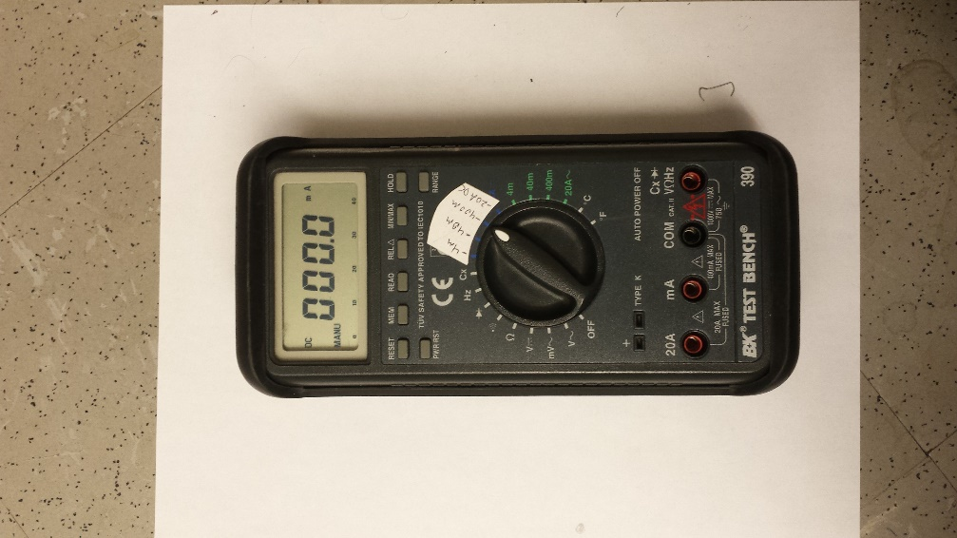

leads:

mA, COM

selector: 400mA

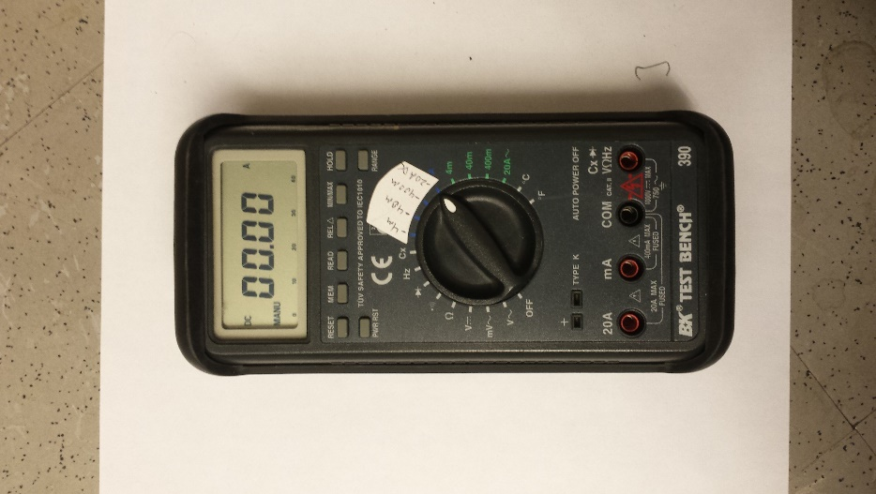

leads:

20A, COM

selector: 20A