This is for scale

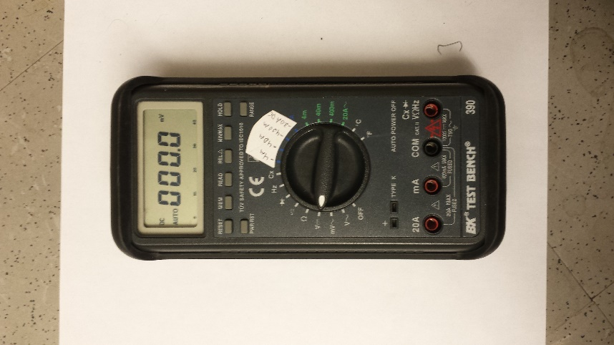

inputs:

VΩHz, COM

selector: V

For voltage measurements:

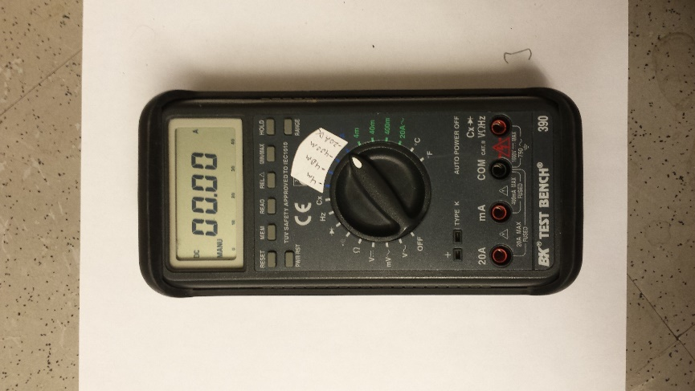

inputs:

20A, COM

selector: 20A

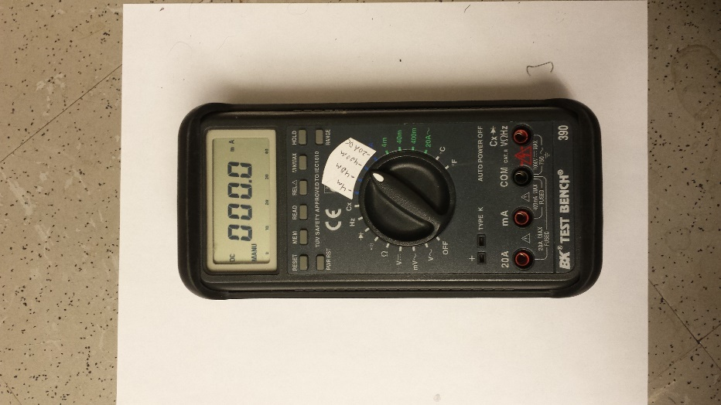

inputs:

mA, COM

selector: 400mA (or 40mA, or 4mA)

For current measurements:

mA

mA