This is for scale

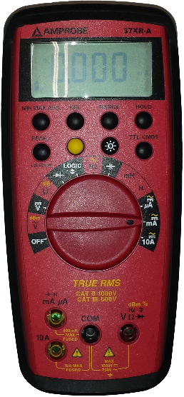

inputs:

mA A, COM

selector: mA (or A)

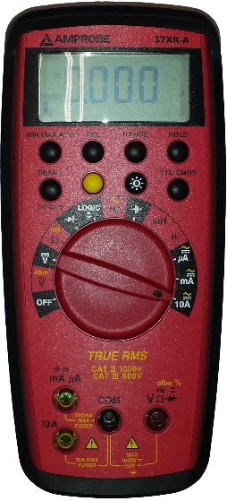

inputs:

10A, COM

selector: 10A

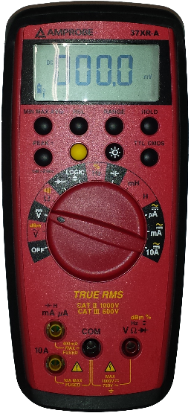

inputs:

VΩ , COM

selector: V

For voltage measurements:

For current measurements:

mA

mA