The colored figures are from a book (probably Serway) and aren't ideal. (Plus color is stupidly expensive.)

*P*

*x*

*L*

Total charge *Q*

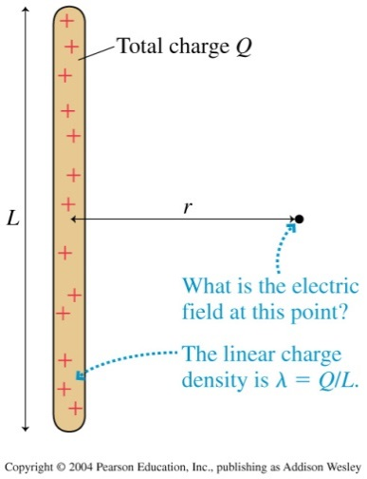

*x*

*L*

*P*