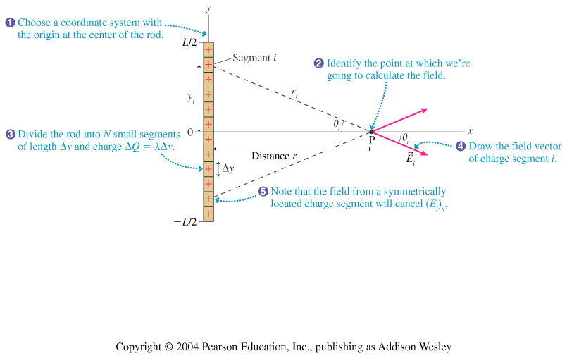

*dQ*

*dy*

*P*

$$0$$

$$-L/2$$

$$L/2$$

*x*

*y*

*dQ*

$$d\vec{E}$$

$$θ$$

$$θ$$

$$dy$$

*y*