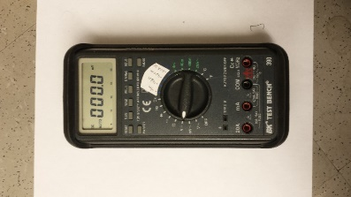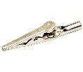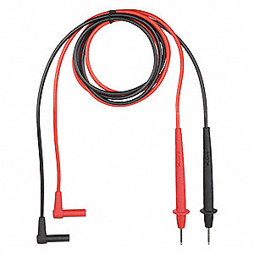

Come back to Carbon!

power supply

white paper

voltmeter

conducting paper with silver dots

Two metal tacks (press firmly onto silver dots) side down)

carbon paper (black side down)

cork board