*P*

*x*

*dQ*

*y*

$$-L/2$$

$$L/2$$

$$0$$

$$d\vec{E}$$

$$dy$$

*y*

$$θ$$

$$θ$$

*x*

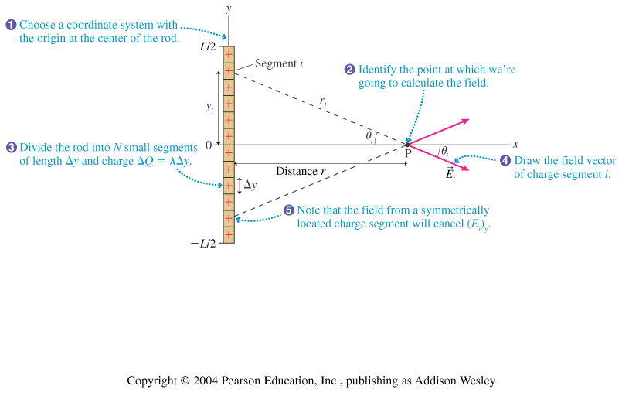

*dQ*

*dy*