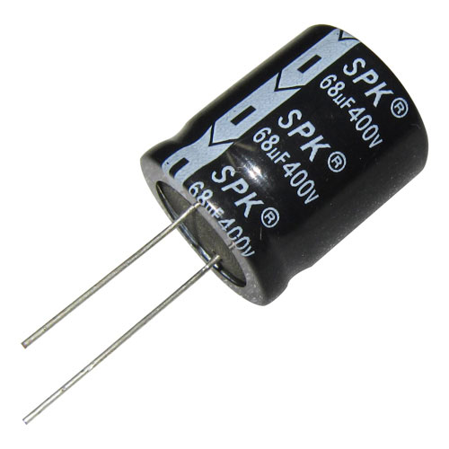

positive

negative

Stripe with “–”