Physics 132
“M” problems
Part D: Electric Current and Circuits
Note: Some of these problems are adapted or copied from published sources.
Answers to problems are at the end of this document.
MD1. Road construction to fix a break in an underground sewer line has caused a long backup on a state highway. There’s a single line of cars backed up for six miles, traveling at an average speed of just four miles per hour. There are 250 cars per mile along the road. (a) How many cars pass the construction site every hour? (b) Write a general expression for the number of cars that pass a given spot on the road per time in terms of the number of cars per length of road and the average speed $v_{avg}$ of the cars.
MD2. The density of water is 1 g/cm³, which works out to a “number density” of $n_{w}=3.34×{10}^{28}$ molecules per cubic meter. Suppose a water pipe has a cross-sectional area of $A=5$ cm². (a) How many water molecules are there in a section of pipe of length $l=2.5$meters? (b) How many water molecules are there per meter of length in the pipe? (c) Write a general expression for the number of water molecules per length of pipe in terms of $n_{w}$ and $A$. (d) If the speed of water flowing in the pipe is $v_{avg}=1.8$ m/sec, how many molecules pass through a given spot in the pipe every second? Hint: your result from problem MB1 is applicable here. (e) Write a general expression for the number of water molecules flowing per time in terms of $n_{w}$, $A$, and $v_{avg}$.
MD3. In the first circuit lab you did, a typical current through one light bulb was about 70 mA. (a) If you kept the bulb on continuously, how many electrons would enter the bulb every hour? (b) How many electrons would leave the bulb every hour? (c) For the sake of comparison, how many electrons are contained in the actual light bulb filament, a small tungsten wire with a mass of about 2 mg? (Hint: a typical tungsten atom off the street has 110 neutrons and 74 protons).
MD4. The wires in your home are probably made of copper (resistivity $ρ=1.7×{10}^{-8} Ω ∙m$) and would have a cross sectional area of 3.3 mm² (assuming it’s the common “12-gauge” stuff). (a) What is the conductivity $σ$ of copper? (b) If the electric field inside one of the wires is $6×{10}^{-3}$ V/m, find the current I through the wire. (c) Assuming there is one free electron per copper atom, the density of free electrons works out to be $n_{e}={8.5×{10}^{28} \text{m}}^{-3}$. If that’s true, what is the drift velocity of the electrons for the current you found in (b)? (d) Estimate the mean time between collisions in copper.
MD5. In class, we charged up a large, 130,000 $μ$F capacitor to a potential of 100 volts. We then discharged it very quickly by touching two wires together. It discharged so quickly that it made a giant spark and welded the two wires together! (a) Suppose that the actual discharge took place over a time of about one tenth of a second. What was the average current in the wire during the time of the discharge? (b) Suppose the wires had a cross sectional area of 1 square millimeter and were made of copper. Assuming one free electron per copper atom and a density of $8.5×{10}^{28}$ atoms per cubic meter, what was the average velocity $v_{D}$ of the electrons in the wire during the discharge? (c) Are you surprised that the velocity is so small?
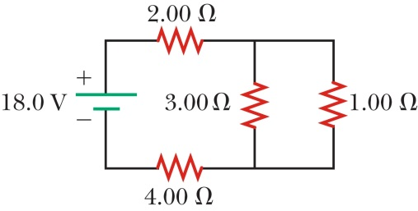
MD6. Find the current in each resistor in the circuit to the right.
MD7. For the circuit shown to the right (same picture as the previous problem), find (a) the power delivered to each resistor, and (b) the total power delivered by the battery.
MD8. For the circuit shown below, (a) What is the current in the 20 ohm resistor? (b) What is the potential difference between points a and b? (Hint: you’ll need to redraw this circuit to make it more obvious which resistors are in parallel or series with each other. You may want to make several iterations of drawings.)
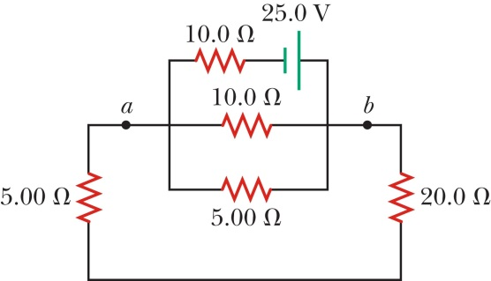
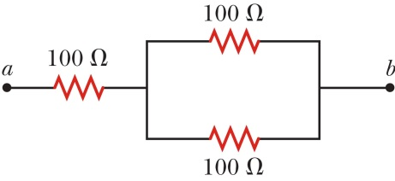
MD9. Three resistors, each with $R=100Ω$, are connected as shown. Each resistor has a maximum power rating of 25 Watts. (a) What is the maximum voltage that can be applied between the terminals a and b? (b) At that voltage, what is the total power delivered to the combination of resistors?
MD10. Suppose your hair dryer is rated at 1250 Watts, and your clothes iron is rated at 900 Watts. (a) How much current does each appliance draw when plugged into a standard US wall socket? (b) Suppose you plug both of them into two electrical outlets that are connected to the same circuit within your house. The circuit is protected by a 15-amp circuit breaker. Will the circuit breaker be tripped? (c) Could you replace the 15-amp circuit breaker with a 20-amp circuit breaker to solve your problems?
MD11. A pair of students is measuring the current and voltage across a tiny, nominally 100 ohm resistor. They obtain the following data:
Measured V | Measured I | Calculated P | Calculated R | How hot?
1.253 volts | 0.01261 amps | 15.8 mW | 99.37 ohms | not hot
9.84 volts | 0.0962 amps | 947 mW | 102.29 ohms | HOT!
Anna says “Hey, cool! It looks like the resistance increased when it got hot. That means the resistor has a positive temperature coefficient.” Bob says, “Gee, I dunno. That’s a pretty small difference. I don’t really think that counts.” After scratching their heads for a while, they look in the manual for their multimeters, and find that their current and voltage measurements all have an uncertainty of 0.5%. (a) Calculate the uncertainty in the resistances they measured. (b) Is the difference between their two calculated resistance values significant? (Hint: for help on analyzing uncertainties like this, there’s a very useful, single-page appendix in your lab manual.)
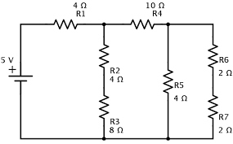
MD12. In the circuit shown to the right, find the following: (a) The current through the 10 $Ω$ resistor. (b) The power dissipated in the 8 $Ω$ resistor. (c) The power supplied by the battery. (d) The potential difference between points A and B shown in the figure. (e) If the wire breaks at point B, does the current through resistor R1 increase, decrease or stay the same?
A
B
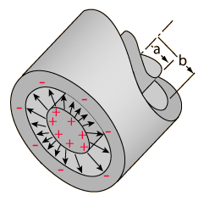
MD13. A “cylindrical capacitor” consists of two concentric cylinders. The inner cylinder is a solid conductor of radius a. The outer cylinder is a thin cylindrical shell (meaning it’s hollow), and has radius b. The cylinders both have a length L which is much longer than either of their radii, so you can safely treat them as infinitely long. (a) Suppose the inner cylinder has charge $+Q$, and the outer cylinder has charge $-Q$. Find the electric field in between the cylinders, at some radius r where $a<r<b$. (b) Based on your answer in part (a), find the potential difference $ΔV$ between the two cylinders. (c) What is the capacitance of this device?
MD14. You want to design a parallel-plate capacitor with a capacitance of $0.25$nF that can withstand a potential difference of 600 volts, but you want to make it as small and cheap as possible. For a dielectric material in between the plates, you will use Mylar, which has a dielectric constant $κ=3.1$ and a dielectric strength $E_{max}=7×{10}^{6}$ V/m. (a) What is the smallest possible separation $d$ between the plates that will still prevent charge from jumping between the plates at the maximum voltage (also called “dielectric breakdown”)? (b) What is the minimum area $A$ of the plates required? (c) What would be the smallest volume of Mylar required to make the capacitor?
MD15. A cylindrical capacitor, as in problem MD13, has radii $a=1.1$ mm, $b=3.1$ mm, and a length of $L=4$ m. It is filled with Teflon (PTFE) as a dielectric material, which has $κ=2.1$ and a dielectric strength of $E_{max}=1.9×{10}^{7}$ V/m. In this problem, you will find the maximum voltage we can place across the capacitor without bad stuff happening.
- In problem MD13, you found that the capacitance of a cylindrical capacitor is given by $C=2πϵ_{0}L/ln\left(b/a\right)$. [NOTE: on 11/30/2020, I wrote that expression incorrectly in class. I have corrected it in the pdf notes posted online with the video.] How does this expression change if the capacitor is filled with a dielectric with constant $κ$?
- If a charge is placed on the capacitor (say, $+Q$ on the inside, $-Q$ on the outside) where is the electric field strongest: at $r=a$, at $r=b$, or is it uniform everywhere?
- Use Gauss’ law to write an expression for $E$ at the surface of the inner conductor, $r=a$, in terms of $Q$, $a$, $L$, $κ$ and $ϵ_{0}$.
- Numerically, what is the largest value of $Q$ you can place on the inner conductor without exceeding the dielectric strength of the Teflon?
- What is the maximum voltage $V_{max}$ you can put across this capacitor without exceeding $E_{max}$ of the Teflon? Hint: you can use your result from part (a).
- In problem MD14, we used the relationship that $V_{max}=E_{max}d$, where $d$ was the separation between the two electrodes (the two plates). Here, the separation between the electrodes is 2 mm. Numerically, is $V_{max}=E_{max}(b-a)$ true here? Why or why not?
MD16. A 22 $μ$F capacitor is initially charged to a potential of 10 volts, is discharged through a 27 k$Ω$ resistor. (a) What is the time constant $τ$ of the $RC$ circuit? (b) How long does it take for the voltage across the capacitor to decrease from 10 volts to 2 volts? (c) At that time, what are the charges on the positive and negative plates of the capacitor? (d) When the capacitor is fully discharged, a switch is flipped that connects the capacitor through the same 27 k$Ω$ resistor to a 10 V power supply. How long does it take for the capacitor’s voltage to reach 9 volts? (e) How long would it take for the capacitor’s voltage to reach 9 volts if it had started at 2 volts?
MD17. A 22 picofarad capacitor consists of two parallel plates separated by an air gap of 2 mm. To increase its capacitance, the center is filled with a molten wax which, when solidified, has a dielectric constant of 3.5. However, in doing so, the gap between the plates is inadvertently expanded from 2 mm to 2.5 mm. (a) What is the new capacitance of the wax-filled capacitor, and (b) what is the area of the plates?
Answers:
MD1. (a) 1000 cars per hour (b) (# cars per time) = (cars per length) $×v_{avg}$.
MD2. (a) $4.18×{10}^{25}$ molecules (b) $1.67×{10}^{25}$ molecules per meter (c) # molecules per length = $n_{w}A$ (d) $3.0×{10}^{25}$ molecules per second (e) # molecules per time = $n_{w}Av_{avg}$
MD3. My number for (a) and (b) is 3.3 times my number for (c).
MD4. (a) $5.9×{10}^{7}Ω^{-1}{\text{m}}^{-1}$ (b) 1.16 amps (c) $2.6×{10}^{-5}$ m/s (d) $2.46×{10}^{-14}$ s
MD5. (a) 130 Amps. (b) About 1 cm/sec. (c) Yes, you are surprised.
MD6. $I_{2Ω}=I_{4Ω}=2.67 \text{A}$; $I_{3Ω}=0.67 \text{A}$; $I_{1Ω}=2.0 \text{A}$
MD7. (a) $P_{2Ω}=14.22$ W; $P_{4Ω}=28.44$ W; $P_{3Ω}=1.33$ W; $P_{1Ω}=4$ W (b) 48 W
MD8. (a) 227 mA (b) 5.68 V
MD9. (a) 75 V (b) 37.5 W
MD10. (c) Well, you COULD, but it would be illegal as heck and would risk burning your house down too. The whole point of having the breaker there is to prevent having too much current in the wires within your walls.
MD11. Partial answer: Properly combining the uncertainties for $V$ and $I$ in quadrature for the first resistor gives an uncertainty of about ±0.7 ohms.
MD12. (a) 0.25 Amps, (b) 0.5 Watts (c) 2.5 Watts (d) 1.75 Volts (e) Decreases
MD13. (b) $ΔV=Q ln\left(b/a\right)/2πϵ_{0}L$ (c) $C=2πϵ_{0}L/ln\left(b/a\right)$
MD14. (a) $85 μ$m (c) 67 cubic millimeters
MD15. (a) $C=2πϵ_{0}κL/ln\left(b/a\right)$ (b) strongest at $r=a$. (c) $E=Q/2πϵ_{0}κaL$ (d) $9.76 μ$C (e) 21.65 kV (f) No; that expression would give 38 kV, almost twice the $V_{max}$ you found in part e. The expression we used for the parallel plates is invalid here because the electric field is not uniform in between the cylinders.
MD16. (a) 0.594 seconds (b) 0.95 seconds (c) $±44 μ$C (d) 1.37 seconds (e) 1.24 seconds

