Physics 132
“M” problems
Part C: Electric Potential and Potential Energy
Note: Some of these problems are adapted or copied from published sources.
Answers to problems are at the end of this document.
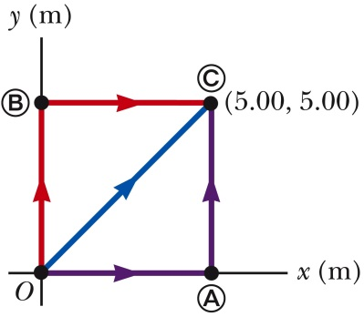
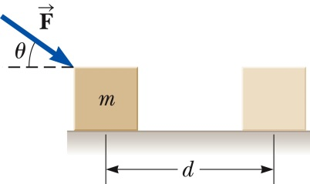
MC1. A block of mass $m=2.5$ kg is pushed a distance $d=2.2$ m along a frictionless, horizontal table by a constant applied force of magnitude $F=16$ N, directed at $θ=25°$ below the horizontal, as shown. Determine the work done on the block by (a) the applied force, (b) the normal force exerted by the table, (c) the gravitational force, and (d) the net force on the block.
MC2. A constant force $\vec{F}=\left(3\hat{i}+4\hat{j}\right)$ N acts on an object. (The force does not vary with time or with the position or velocity of the object.) Using the general definition for work done by a force $W=\int_{i}^{f}{\vec{F}∙\vec{ds}}$, calculate directly the work done by $\vec{F}$ on the particle as it moves from point O to point $C$ along each one of the three paths shown.
MC3. The potential energy function of a system in which a two-dimensional force acts on an object is given by $U=3x^{3}y-7x$. Find the force that acts at the point (x,y). (Hint: you already know that the x component of a force is given by $F_{x}=-{dU}/{dx}$. Think you can extend this to find $F_{y}$ as well?)
MC4. A particle maintains a constant velocity of 5 m/sec. (a) How far does the particle travel in 20 seconds, say between times $t=10$ s and $t=30$ s? (b) Draw a graph of $v$ vs. $t$. (c) Draw several different possible graphs of position $x$ vs. $t$. (The particle could start at several different initial positions, after all.) (d) Write a general function for $x$ as a function of $t$. Don’t forget the integration constant! (e) Write a general expression for $Δx$, as a definite integral of $v(t)$. (f) Evaluate your integral in the previous part, writing $Δx$ in terms of $v$ and $Δt$. (g) Do you need an integration constant to find $Δx$ between, say, $t=10$ s and $t=30$ s?
MC5. (This is a companion problem to MC4.) A uniform electric field is given by $\vec{E}=1000\hat{i}$ V/m (a) What is the change in electric potential $ΔV$ between the points $x=10$ cm and $x=30$ cm? (b) Draw a graph of $E$ vs. $x$. (c) Draw several different possible graphs of potential $V$ vs. $x$. (d) Write a general function for $V$ as a function of $x$. Don’t forget the integration constant! (e) Write a general expression for $ΔV$, as a definite integral of $E(x)$. (f) Evaluate your integral in the previous part, writing $ΔV$ in terms of $E$ and $Δx$. (g) Do you need an integration constant to find $ΔV$ between, say, $x=10$ cm and $x=30$ cm?
MC6. A thin rod of length $L=20$ cm, with a total positive charge $Q=10$ nC, lies on the y-axis between $y=0$ and $y=20$ cm. In this problem, you will calculate the electric potential $V$ at a point along the $x$-axis a distance $x=15$ cm from the origin. (a) First, estimate it numerically, using a spreadsheet program like Excel. Divide the rod into ten individual 1 nC charges located at $y=1$ cm, $y=3$ cm, etc., up to $y=19$ cm. Treat each as a point charge, and find the potential at the point $x=15$ cm, $y=0$ due to all of them. (b) Now solve the problem exactly, by setting up and solving an integral over the entire length of the rod.
MC7. (a) Find the electric potential a distance 1.0 cm away from a proton. (b) What is the potential difference between two points that are 1.0 cm and 2.0 cm from a proton? (c) Repeat parts (a) and (b) for an electron.
MC8. Two particles with charge 2.0 $μ$C are placed at $x=+0.8$ m and $x=-0.8$ m. A “test charge” with $q=1.28×{10}^{-18}$ C is placed at the origin. Find (a) electric field at the origin due to the two 2 $μ$C charges, (b) the force on the test charge, and (c) the electric potential at the origin due to the two 2 $μ$C charges.
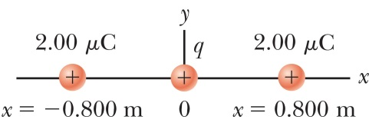
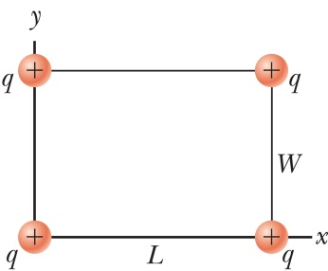
MC9. Four identical particles, all with $q=+10 μ$C are located on the corners of a rectangle ($L=0.6$ m, $W=0.15$ m) as shown. Calculate the change in electric potential energy of the system as the particle at the lower left corner of the figure is brought to this position from infinitely far away. (The other three particles remain fixed in position during the process.)
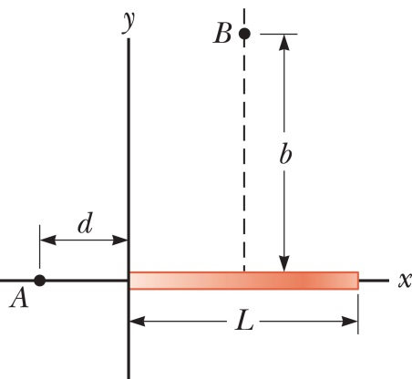
MC10. A rod of length $L$ lies along the x-axis with its left end at the origin, as shown in the figure to the right. The rod has a nonuniform charge density $λ=αx$, where $α$ is a positive constant. (That is, the charge density increases linearly over the rod, from left to right.) (a) What would be the standard SI units of $α$? (b) Calculate the electric potential at point A in the figure.
MC11. For the arrangement described in the previous problem and pictured to the right, find the electric potential at point B, which is on the perpendicular bisector of the rod a distance $b$ above the axis. (For this problem, you can leave your answer in the form of an integral.)
MC12. In some region of space, the electric potential is given by $V=5x-3x^{2}y+2yz^{2}$. (a) Write expressions for the x, y, and z components of the electric field. (b) What is the magnitude of the field at the point $\left(x=1, y=0, z=-2\right)$? (All dimensions in this problem are in meters.)

MC13. An insulating rod, 14 cm long, carrying a uniform charge of $-7.50 μ$C is bent into a semicircle. Find the electric potential at point $O$, the center of the semicircle.
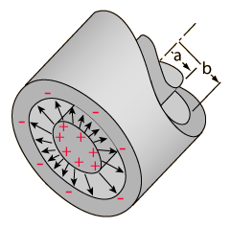
MC14. A “cylindrical capacitor” consists of two concentric cylinders. The inner cylinder is a solid conductor of radius a. The outer cylinder is a thin cylindrical shell (meaning it’s hollow), and has radius b. The cylinders both have a length L which is much longer than either of their radii, so you can safely treat them as infinitely long. (a) Suppose the inner cylinder has charge $+Q$, and the outer cylinder has charge $-Q$. Find the electric field in between the cylinders, at some radius r where $a<r<b$. (b) Based on your answer in part (a), find the potential difference $ΔV$ between the two cylinders. (c) What is the capacitance of this device?
MC15. You want to design a parallel-plate capacitor with a capacitance of $0.25$nF that can withstand a potential difference of 600 volts, but you want to make it as small and cheap as possible. For a dielectric material in between the plates, you will use Mylar, which has a dielectric constant $κ=3.1$ and a dielectric strength $E_{max}=7×{10}^{6}$ V/m. (a) What is the smallest possible separation $d$ between the plates that will still prevent charge from jumping between the plates at the maximum voltage (also called “dielectric breakdown”)? (b) What is the minimum area $A$ of the plates required? (c) What would be the smallest volume of Mylar required to make the capacitor?
MC16. The A graph of the electric field $E(x)$ in some region is shown below. (a) sketch a graph of the potential $V\left(x\right)$, where the reference is $V\left(∞\right)=0$. (b) Also using $V\left(∞\right)=0$, write an equation for the potential $V\left(x\right)$. It’ll be different for $x<2$ and $x>2$, so you’ll need to use a curly brace (“}”) to separate the cases. (Be careful with your signs and the constants….)
1 2 3 4 5 6 7 x(m)
E(N/C)
5

-5
MC17. A +4 nC charge is at the origin, and a $+7$ nC charge is at (0, $-4$ m). (a) Find the electric field at (3 m, 0). (b) Find the electric potential at (3 m, 0). (c) Which part was easier, part (a) or part (b), and why?
x(m)
+4
$$+7$$
y(m)
(0,-4)
(3,0)
MC18. A conducting metal sphere has a radius of $R$ and carries a positive charge $Q$. (a) Draw a graph of the electric field $E\left(r\right)$ covering both inside and outside the sphere. (b) Draw a graph of the electric potential $V(r)$ both inside and outside the sphere. (c) What is the value of the electric potential at the center of the sphere, assuming the usual reference point that $V=0$ at $r→∞$? (d) What can you say that is always true about the graph of electric potential inside a conductor? Hint: See workbook problem 26.7.
MC19. Three charged particles lie along the $x$ axis: a charge $+Q$ is at $x=0$, and two charges $-Q$ are at $x=a$ and $x=-a$. (a) Draw a graph of potential $V$ as a function of $x$ along the axis. (b) Draw a graph of electric field $E$ as a function of $x$ along the axis, where the sign of the field indicates its direction. (c) Is $V$ positive, negative, or zero at $x=±a/2$? (d) Is $E$ positive, negative, or zero at $x=±a/2$? Explain your reasoning for parts (c) and (d).
$$-$$
$$-$$
x
$$-a$$
$$+a$$
$$+$$
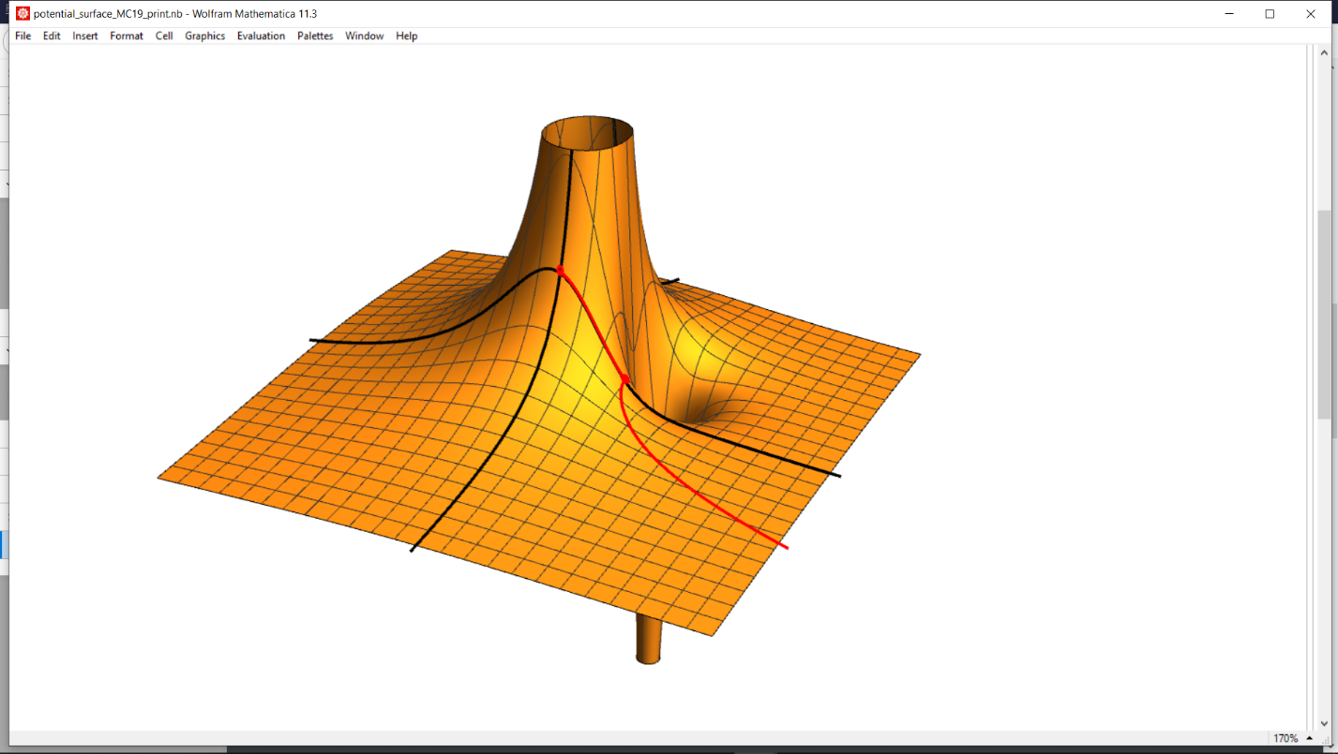
MC20. A +5 nC charge sits on the $y$ axis at (0, 3 cm), and a $-2$ nC charge sits at (3 cm, 3 cm) as shown. (a) Find the potential $V$ at points $P_{1}$ and $P_{2}$ shown. (b) What is the change in potential energy $ΔU$ of the system when a third particle, of charge $q_{3}=+3$ nC and mass $m=4 μ$g ($4×{10}^{-9}$ kg), is brought in from very far away to position $P_{1}$? (c) How much work is required to move the $+3$ nC particle from point $P_{1}$ to point $P_{2}$? (d) The $+3$ nC particle is released from position $P_{2}$, and it accelerates away from both other charges. What is the maximum velocity attained by the charge once it is very far away?
$$P_{2}$$

$$P_{1}$$

$$V(x,y)$$

$$x$$

$$y$$

y (cm)
x (cm)
$$+5$$
(0, 3)
$$-2$$
(3, 3)
$$P_{1}$$
(3, 0)
$$P_{2}$$

MC21. A small block is released from rest at the top of a frictionless, quarter-circle ramp of radius $R$. The block has a mass $m$ and a charge $q$, and is subject to a uniform external field $\vec{E}$ directed horizontally to the right. What is the speed of the particle when it reaches the bottom of the ramp?
$$R$$
$$\vec{E}$$

Answers:
MC1. Two of them are 31.9 Joules, and two of them are zero.
MC2. At least one of them is 35 Joules.
MC3. $\vec{F}=\left(-9x^{2}y+7\right) \hat{x}-3x^{3} \hat{y}$
MC4. (a) 100 m (c) Your graphs should have the same slope, but different intercepts.
(d) $x=∫v dt=vt+C=vt+x_{\text{i}}$ (e) $Δx=\int_{t_{\text{i}}}^{t_{\text{f}}}{v dt}$ (f) $Δx=\int_{t_{\text{i}}}^{t_{\text{f}}}{v dt}=v\left(t_{\text{f}}-t_{\text{i}}\right)=vΔt$ (g) no integration constant required.
MC5. (a) 200 V (c) Your graphs should have the same slope, but different intercepts.
(d) $V=-∫E dx=-Ex+C$ (e) $ΔV=-\int_{x_{\text{1}}}^{x_{\text{2}}}{E dx}$ (f) $ΔV=-EΔx$ (g) no integration constant required.
MC6. (using $k_{e}=8.99000×{10}^{9}$ Nm²/C²) (a) 493.922 Volts (b) 493.826 Volts
MC7. (a) +144 nV (b) $-72$ nV (c) $-144$ nV, +72 nV
MC8. One of the three answers begins with the digits “449”. The other two answers are zero.
MC9. 8.94 J
MC10. (a) C/m² (b): $V=k_{e}α\left[L-d \text{ln}\left(1+\frac{L}{d}\right)\right]$
MC11. The integral you end up with for this problem is $\int_{0}^{L}{\frac{k_{e}αx}{\sqrt{{\left(x-\frac{L}{2}\right)}^{2}+b^{2}}}}dx$, and as I said in the problem, it’s fine with me if you leave it that way. If you did want to evaluate this integral by hand, you can start by using a substitution $u=x-L/2$, which results in two separate integrals in forms you have seen before. Depending on how you do the algebra, you can end up with a result in several equivalent forms. Some possibilities are $V=\frac{1}{2}k_{e}αL \text{ln}\left(\frac{\sqrt{4b^{2}+L^{2}}+L}{\sqrt{4b^{2}+L^{2}}-L}\right)$, $V=\frac{1}{2}k_{e}αL \text{ln}\left(\frac{2b^{2}+L\left(L+\sqrt{4b^{2}+L^{2}}\right)}{2b^{2}}\right)$, or $V=k_{e}αL \text{ln}\left(\frac{\sqrt{4b^{2}+L^{2}}+L}{2b}\right)$.
MC12. (b): 7.07 N/C
MC13. $-1.51$ MV
MC14. (b) $ΔV=Q ln\left(b/a\right)/2πϵ_{0}L$ (c) $C=2πϵ_{0}L/ln\left(b/a\right)$
MC15. (c) 67 cubic millimeters
MC16. $V(x) =\left\{\begin{matrix}\left(-1.25 \text{V}/{\text{m}}^{2}\right)x^{2}+20 \text{V} & 0<x<2 \\ \left(-5 \text{V/m}\right)x+25\text{ V} & 2<x<5 \\ 0 & x>5\end{matrix}\right.$
MC17. (a) $\left(5.51 \hat{i}+2.01 \hat{j}\right)$ N/C (b) 24.6 volts (c) Well, one part required finding multiple components, and one didn’t…
MC18. (a) Remember, $E=0$ inside a conductor. (c) $V=k_{e}Q/R$
MC19. (c) $V\left(-\frac{a}{2}\right)=V\left(+\frac{a}{2}\right)<0$ (d) $E\left(-\frac{a}{2}\right)<0$, $E\left(+\frac{a}{2}\right)>0$
MC20. (a) 460 V and 1075 V (b) $1.38 μ$J (c) $1.84 μ$J (d) 40.2 m/s
MC21. $v_{f}=\sqrt{2R\left(g-qE/m\right)}$. (Hint: start by drawing some equipotential lines on the figure.)

