Physics 132
“M” problems
Part E: Magnetic Fields and Forces
Note: Some of these problems are adapted or copied from published sources.
Answers to problems are at the end of this document.

I
I
P
ME1. A single wire carries current I in the path shown, with a straight vertical segment and a straight horizontal segment leading to and from a $90°$ circular arc of radius R. Find the magnetic field (magnitude and direction) at point P in the center of the arc.
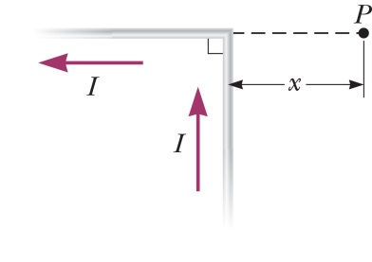
ME2. A current I flows in a single, infinitely long wire that is bent at a right angle. Find the magnetic field $\vec{B}$ (magnitude and direction) at the point P, which is a horizontal distance x away from the corner of the wire as shown. (Hint: Think about this problem the same way as you found $B$ due to a single, straight wire in lab 20 using the Biot-Savart law. In that lab, you had a single wire, running from $x=-L/2$ to $+L/2$. Here, the vertical part of the bent wire looks a lot like that lab (rotated $90°$), except that it runs from $0$ to $∞$. For the horizontal part of the bent wire, you will need to rethink how to apply the Biot-Savart law, particularly the result of the cross product $\vec{ds}×\hat{r}$.)
ME3. An otherwise straight, infinitely long wire is bent to include a single circular loop of radius R, as shown in the figure below. (a) What is the direction of the magnetic field at the center of the circular loop? (b) What is the magnitude of the magnetic field there? Hint: in both parts of this problem, you need to account for the magnetic field due to the circular part AND the two straight parts of the wire.
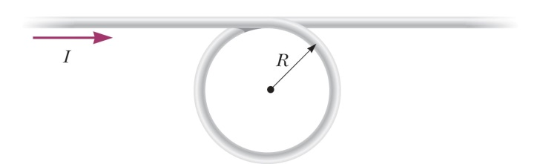
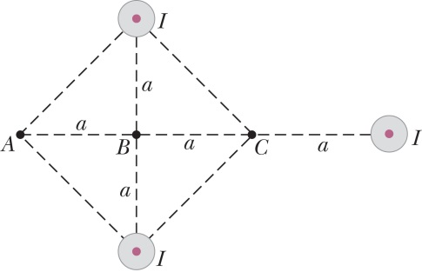
ME4. The figure to the right shows an end-on view of three very long straight wires, each carrying a current $I=2$ A out of the page. Taking $a=1.0$ cm, find the magnetic field at points A, B, and C in the picture.
ME5. A long, straight wire with a circular cross section of radius R carries a total current I, uniformly distributed within it. (That is, the current density J is the same everywhere inside the wire.) Find the magnetic field inside the wire, a distance r from the center, where $r<R$. (Hint: use Ampère’s law, and start with a good, end-on drawing of the circular wire.)
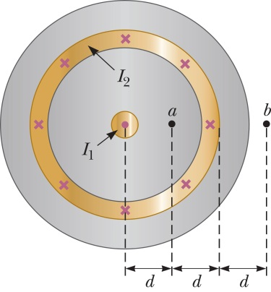
ME6. The picture on the right shows a cross-section of a “coaxial cable,” in which current $I_{1}$ flows out of the page through the central conductor, and current $I_{2}$ flows into the page through the outer hollow cylindrical shell. As with a real cable, the wires are insulated inside and out with rubber insulation. Taking $I_{1}=1$ A, $I_{2}=3$ A, and $d=1$ mm, find magnitude and direction of the magnetic field at both points a and b.
ME7. A square loop of wire with side length $2a$ carries a current $I$. (a) Find the magnetic field $B$ in the center of the loop. For this problem, you can use the result you derived in Step 7 of the lab entitled “The Biot Savart Law and a Straight Wire,” though you should also be sure you know how to derive that result again if you need to. (b) Could you use Ampère’s law to find the magnetic field in this problem? Why or why not?
I
2a
2a
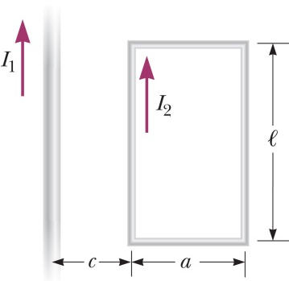
ME8. An infinitely long straight wire carries current $I_{1}$, and a rectangular loop of wire nearby it carries current $I_{2}$ as shown. (The two wires lie in the plane of the page.) (a) In general, what is the magnetic field a distance $r$ away from an infinitely long, straight wire with current $I$? (b) Find the direction of the magnetic force on each of the four legs of the rectangular loop. (c) Find the magnitude of the magnetic force of $I_{1}$ on only the closest leg of the rectangle. (d) Find the magnitude of the net force of the straight wire on the rectangular loop. Note: the way to think about this problem is that the current in one of these wires causes a magnetic field, and the other wire feels a force due to that field. In principle, you can either:
- find the field due to $I_{1}$, then find the force on the wires with $I_{2}$ due to that field, or
- find the field due to $I_{2}$, then find the force on the wire with $I_{1}$ due to that field.
One of those two options is much easier than the other; in fact, the other one is disastrous!
ME9. A horizontal ring of wire with radius r carries current I. A strong bar magnet is placed underneath it, with its north pole facing up. As the figure shows, the magnetic field lines from the bar magnet make an angle $θ$ with the vertical and have a magnitude B where they cross the ring. (a) What is the direction of the magnetic force on the specific bit o’ length $ds$ illustrated in the drawing, with current $I$ into the page? (b) What is the direction of the net magnetic force on the ring? (c) What is the magnitude of the net magnetic force on the ring? d) The ring of current is itself acting like a magnet, producing a magnetic field of its own. Is its north pole pointing up, or down? (e) If you replaced the ring of current with a permanent magnet oriented as you just said, would it attract or repel the bar magnet below it? Is this consistent with what you said in part (b)?
$$\vec{B}$$
bit o’
length
$$ds$$
$$r$$
$$\vec{I}$$
N
S
fie
$$θ$$
$$θ$$
ME10. For the situation in problem ME8 (see that figure), calculate the magnitude of the force on ONLY the top, horizontal leg of the rectangle carrying current $I_{2}$. Hint: start by writing an expression for the infinitesimal force on a tiny bit of that wire of length $dx$.
ME11. Two students are determining the mass of an electron by doing the same laboratory that you did in class. They take the following data:
- Current in Helmholtz coils $I=1.45$ Amps (multimeter readings are $±0.5\%$).
- Radius of coils $a=15.0±0.1$ cm.
- Number of coils $N=130$ exactly.
- Accelerating voltage $V=184$ Volts.
- Radius of circular path: $r=4.1±0.1$ cm.
- What is the magnetic field $B$ at the center of the coils? (b) What is the uncertainty in the magnetic field? (c) What value should they report for the mass of the electron $m_{e}$? (d) What is the uncertainty in $m_{e}$ due to only the uncertainty in $r$? (e) What is the uncertainty in $m_{e}$ due to all sources of uncertainty? (f) Write an expression for $m_{e}$ involving only quantities that you measured directly; that is, your expression should $m_{e}$ won’t have $B$ in it, but will have $I$, $a$ and $N$. (g) The current $I$ in the coils and the accelerating voltage $V$ are both measured by the same meter with an accuracy of $±0.5\%$. Which of those two has a greater effect on the overall uncertainty in $m_{e}$, and why is there a difference?

ME12. You are already familiar with the magnetic force $\vec{F}=q\vec{v}×\vec{B}$ on a single moving charge $q$, and in this problem we’ll use that as a starting point to find the force on a current-carrying wire in an external magnetic field $\vec{B}$. (“External” means that the field $\vec{B}$ is caused by something other than the current in the wire.) Our solution will use many of the following familiar quantities: $\vec{B}$, $n_{e}$, $q_{e}$, $m_{e}$, $τ$, $l$, $A$, and $v_{drift}$.
$$A$$
$$\vec{B}$$
$$l$$
- What is the total number $N$ of moving electrons in the length of wire shown in the figure, using only quantities listed above?
- What is the average speed of those $N$ electrons in the wire? (Again, from the list above.)
- Write an expression for the total force $\vec{F}$ on all $N$ electrons, using only quantities from the list.
- The current $I$ in the wire can be written in terms of many of the same variables as your expression for $\vec{F}$ in part (c). Make that substitution, to express $\vec{F}$ in terms of $I$ and just two other variables. (Hint: what is the electron current $i_{e}$ in terms of the quantities listed above?)
$$d\vec{l}$$
- Suppose that a not-at-all straight wire is in a non-uniform field. What is the bit o’ force $d\vec{F}$ on a short bit o’ wire of length $dl$?
$$\vec{B}$$
- And finally, what would be the force $\vec{F}$ on the whole squiggly thing?
ME13. Goofus and Gallant are working on the review problems for magnetism. Goofus thinks he has come up with a great way to calculate the magnetic field at the center of a circular loop of current in review problem D1. Instead of using the Biot-Savart law, he uses Ampere’s law: he draws a dotted line through the center of the circle to use as his Ampèrian loop, and calculates as follows:
$$\oint{\vec{B}}⋅d\vec{s}=μ_{0}I$$
$$B\left(2πR\right)=μ_{0}I$$
$$B=\frac{μ_{0}I}{2πR}$$
Unfortunately, Goofus realizes that his answer is apparently incorrect by a factor of $π$. Write a snarky letter from Gallant to Goofus explaining the error in his logic.
Answers:
ME1. $B={μ_{0}I}/{8R}$, into page
ME2. $B={μ_{0}I}/{4πx}$, into page
ME3. (a) into page (b) $B=\left(\frac{μ_{0}I}{2R}\right)\left(1+1/π\right)$
ME4. A: $53.3 μ$T down (towards bottom of page); B: $20.0 μ$T; C: zero
ME5. $B={{μ_{0}Ir}/{2πR}}^{2}$
ME6. (a) $200 μ$T, up (towards top of page) (b) $133 μ$T down
ME7. (a) $B={\sqrt{2}μ}_{0}I/πa$ (b) No. Can’t use Ampere’s law to find B for just one segment because Ampere’s law is only valid for physically possible current configurations (no current magically appearing from nowhere at the beginning of a finite wire). Also can’t use Ampere’s law for whole loop because B not sufficiently symmetric.
ME8. (b) All legs are pushed away from center of rectangle ($\vec{F}$ on left leg is to left, $\vec{F}$ on top leg is up, etc.) (c) $F=μ_{0}I_{1}I_{2}l/2πc$ (d) ${μ_{0}I_{1}I_{2}la}/{\left[2πc\left(a+c\right)\right]}$
ME9. (a) up and right (b) up (c) $F=2πrIB\sin{θ}$ (d) down (e) repel
ME10. $F=\frac{μ_{0}I_{1}I_{2}}{2π}ln⁡\left(\frac{a+c}{c}\right)$
ME11. (a) 1.13 mT (b) 0.0094 mT (best to round to 0.01 mT) (c) $9.33×{10}^{-31}$ kg (d) $0.46×{10}^{-31}$ kg (e) $0.49×{10}^{-31}$ kg
ME12. (d) $\vec{F}=l\vec{I}×\vec{B}$ (f) $\vec{F}=\int{I d\vec{l}×\vec{B}}$ (though “$d\vec{s}$” is sometimes better than “$d\vec{l}$”.)

