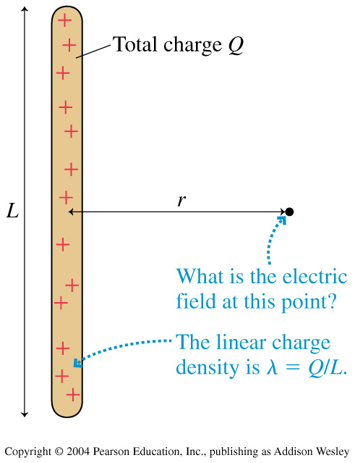
Electric field near a charged rod
x
Physics 132
Matt Trawick
P

Problem: Find the electric field  at a point P which is a distance x away from the midpoint of a thin rod of length L, total charge Q.

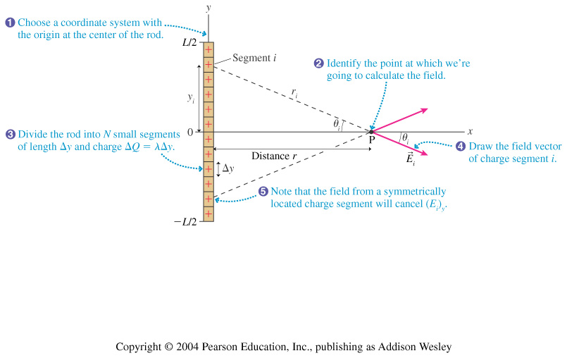
dQ
dy
Solution: Think of the rod as a bunch of teeny-tiny little point charges dQ arranged in a row. We’ll think about the sum (actually an integral) of the electric fields due to each point charge. Notice the set of coordinate axes that have been added to the drawing on the right, too.

Step 1:
x
What is the direction of the electric field at point P due to just one little bit of charge dQ shown?

What is the direction of the electric field at point P due to the whole rod?

Step 2:
What is the magnitude of the electric field 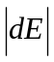 due to just the bit of charge dQ? (Write the relevant distance in terms of x and y.)
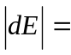
Step 3:
What is the magnitude of the x-component of 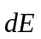 (similar to answer above, with an extra term involving  or 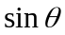.)
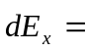

Step 4
Rewrite the above, giving or in terms of a ratio involving x, y, and/or 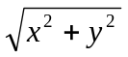.
Step 5
The linear charge density lambda of the rod is given by 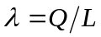. Write dQ in terms of and dy, then in terms of Q, L and dy.

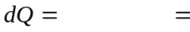
Step 6
Combine your answers to steps 4 and 5 to write as a single integral over dy which you can solve. What are the limits of the integral?

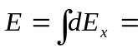
Step 7
Evaluate the integral.

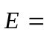

Note: one of the following might be helpful:

